Dwelling Numbers – April 2018
Building permits for 413 dwellings/units in Wyndham were issued in April 2018, as shown in the attached table and graphs.
Key Observations
- The monthly number of dwellings/units is 413
- The 3-month cumulative figure is 1,316
- The 6-month cumulative figure is 2,455
- The 12-month cumulative figure is 5,042
Comments
This is the highest number of dwelling permits issued for any April since data was first collected. The 12-month cumulative figure of 5,042 has increased from 4,953 since March 2018.
In percentage terms, the April 2018 distribution of permits between the groupings of suburbs was as follows:
- North 35% (Tarneit 18%, Truganina 15% and Williams Landing 2%)
- West 19% (Wyndham Vale 12% and Manor Lakes 7%)
- Central 19% (Werribee 19% and Hoppers Crossing 0%)
- South 27% (Point Cook 26% and Werribee South 1%)
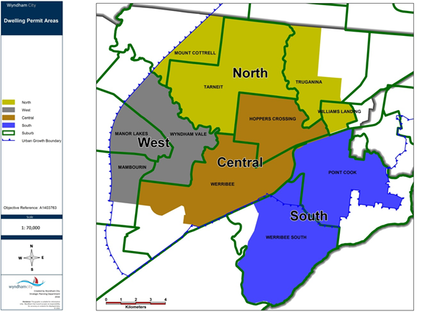

In comparing suburbs in Wyndham, Point Cook received the most building permits for dwellings (109) for this month. Tarneit (75) and Werribee (75) both received the second largest amount of building permits. The northern (Tarneit, Truganina, Williams Landing) area of Wyndham has had the largest number of building permits to date in 2018 (566).
Queries
Queries may be directed to Council’s Strategic Planning Unit on (03) 9742 0777.
This bulletin relies on data from Council’s Building Services Department, WCC Proclaim Profiler Reports and analysis by Building Services and the Strategic Planning Unit.

