Food Safety Program Records

Record keeping
This document has been designed to assist businesses, using the Version 3 Food Safety Program Template, to comply with the Food Act 1984.
As required by the Food Act 1984, all Class 2 businesses are required to:

- Have a food safety program for the business
- Maintain the food safety program onsite
- Ensure the food safety program records are kept up to date by the business demonstrating compliance with the food safety program.
Failing to maintain the food safety program and records onsite at the business is a breach of section 19F of the Food Act and may result in a penalty infringement notice being issued.
The following records are required to be maintained by businesses using the Version 3 Food Safety Program Template:
- Record 1 : My Food Suppliers
You are required to list the trading name, business address and contact phone numbers for all of your food suppliers. It is important that suppliers of raw materials, such as bulk oil, flour or rice are also included.
- Record 2: My temperature checks of food in cold or hot storage
You are required to monitor and record the temperature of at least one high risk food in each refrigeration, freezer and hot holding units within your business once per day. You can choose the way you keep the information by using the template record form or your own form that records the date, unit, and food temperature and any corrective action taken.
- Record 3: My cooking temperature checks
You are required to monitor and record that the temperature of one menu item reaches 75⁰C or above at least once per month.
- Record 4: How I use the 2 hour/4hour rule for high-risk food
You are required to write down your usual process for using the 2hour/4hour rule and make sure you and your staff understand it. This record needs to be updated if your practices change.
- Record 5: My probe thermometer accuracy checks
You are required to calibrate each thermometer at least once per year. Thermometers must be accurate to +/-1°C and corrective action logged if they fail (e.g. new batteries required or thermometer replaced).

Premises Name:

Record 1: My food suppliers
# | Trading name | Business address | Contact phone number
1
2
3
4
5
6
7
8
9
10
11
12
13
14
15

Record 2: My temperature checks of food in cold or hot storage Check one high risk food in all units once per day
Safe Temperatures: |  |  | Cold Storage: 5°C or less |  |  |  | Frozen storage: -15°C or colder |  |  |  | Hot storage 60°C or hotter
DAY | UNIT NAME | UNIT NAME |  | UNIT NAME | UNIT NAME | UNIT NAME | UNIT NAME | UNIT NAME | UNIT NAME | UNIT NAME |  | UNIT NAME | Corrective Action
1
2
3
4
5
6
7
8
9
10
11
12
13
14
15
16
17
18
19
20
21
22
23
24
25
26
27
28
29
30
31

Record 3: My cooking temperature checks – Check at least once per month.

Date | Menu item to verify cooking temperature | Internal cooking temperature reached is greater than 75°C (✓or ✗)
If temperature did not reach 75°C, record any changes to cooking process below.

Example – The 10L pot used to cook the casserole is now kept on the stove for a total of 2 hours in order to reach 75°C______________

Record 2: My temperature checks of food in cold or hot storage Check one high risk food in all units once per day
Safe Temperatures: |  |  | Cold Storage: 5°C or less |  |  |  | Frozen storage: -15°C or colder |  |  |  | Hot storage 60°C or hotter
DAY | UNIT NAME | UNIT NAME |  | UNIT NAME | UNIT NAME | UNIT NAME | UNIT NAME | UNIT NAME | UNIT NAME | UNIT NAME |  | UNIT NAME | Corrective Action
1
2
3
4
5
6
7
8
9
10
11
12
13
14
15
16
17
18
19
20
21
22
23
24
25
26
27
28
29
30
31

Record 3: My cooking temperature checks – Check at least once per month.

Date | Menu item to verify cooking temperature | Internal cooking temperature reached is greater than 75°C (✓or ✗)
If temperature did not reach 75°C, record any changes to cooking process below.

Example – The 10L pot used to cook the casserole is now kept on the stove for a total of 2 hours in order to reach 75°C_______________

Record 2: My temperature checks of food in cold or hot storage Check one high risk food in all units once per day
Safe Temperatures: |  |  | Cold Storage: 5°C or less |  |  |  | Frozen storage: -15°C or colder |  |  |  | Hot storage 60°C or hotter
DAY | UNIT NAME | UNIT NAME |  | UNIT NAME | UNIT NAME | UNIT NAME | UNIT NAME | UNIT NAME | UNIT NAME | UNIT NAME |  | UNIT NAME | Corrective Action
1
2
3
4
5
6
7
8
9
10
11
12
13
14
15
16
17
18
19
20
21
22
23
24
25
26
27
28
29
30
31

Record 3: My cooking temperature checks – Check at least once per month.

Date | Menu item to verify cooking temperature | Internal cooking temperature reached is greater than 75°C (✓or ✗)
If temperature did not reach 75°C, record any changes to cooking process below.

Example – The 10L pot used to cook the casserole is now kept on the stove for a total of 2 hours in order to reach 75°C_______________

Record 2: My temperature checks of food in cold or hot storage Check one high risk food in all units once per day
Safe Temperatures: |  |  | Cold Storage: 5°C or less |  |  |  | Frozen storage: -15°C or colder |  |  |  | Hot storage 60°C or hotter
DAY | UNIT NAME | UNIT NAME |  | UNIT NAME | UNIT NAME | UNIT NAME | UNIT NAME | UNIT NAME | UNIT NAME | UNIT NAME |  | UNIT NAME | Corrective Action
1
2
3
4
5
6
7
8
9
10
11
12
13
14
15
16
17
18
19
20
21
22
23
24
25
26
27
28
29
30
31

Record 3: My cooking temperature checks – Check at least once per month.

Date | Menu item to verify cooking temperature | Internal cooking temperature reached is greater than 75°C (✓or ✗)
If temperature did not reach 75°C, record any changes to cooking process below.

Example – The 10L pot used to cook the casserole is now kept on the stove for a total of 2 hours in order to reach 75°C_______________

Record 2: My temperature checks of food in cold or hot storage Check one high risk food in all units once per day
Safe Temperatures: |  |  | Cold Storage: 5°C or less |  |  |  | Frozen storage: -15°C or colder |  |  |  | Hot storage 60°C or hotter
DAY | UNIT NAME | UNIT NAME |  | UNIT NAME | UNIT NAME | UNIT NAME | UNIT NAME | UNIT NAME | UNIT NAME | UNIT NAME |  | UNIT NAME | Corrective Action
1
2
3
4
5
6
7
8
9
10
11
12
13
14
15
16
17
18
19
20
21
22
23
24
25
26
27
28
29
30
31

Record 3: My cooking temperature checks – Check at least once per month.

Date | Menu item to verify cooking temperature | Internal cooking temperature reached is greater than 75°C (✓or ✗)
If temperature did not reach 75°C, record any changes to cooking process below.

Example – The 10L pot used to cook the casserole is now kept on the stove for a total of 2 hours in order to reach 75°C_______________

Record 2: My temperature checks of food in cold or hot storage Check one high risk food in all units once per day
Safe Temperatures: |  |  | Cold Storage: 5°C or less |  |  |  | Frozen storage: -15°C or colder |  |  |  | Hot storage 60°C or hotter
DAY | UNIT NAME | UNIT NAME |  | UNIT NAME | UNIT NAME | UNIT NAME | UNIT NAME | UNIT NAME | UNIT NAME | UNIT NAME |  | UNIT NAME | Corrective Action
1
2
3
4
5
6
7
8
9
10
11
12
13
14
15
16
17
18
19
20
21
22
23
24
25
26
27
28
29
30
31

Record 3: My cooking temperature checks – Check at least once per month.

Date | Menu item to verify cooking temperature | Internal cooking temperature reached is greater than 75°C (✓or ✗)
If temperature did not reach 75°C, record any changes to cooking process below.

Example – The 10L pot used to cook the casserole is now kept on the stove for a total of 2 hours in order to reach 75°C_______________

Record 2: My temperature checks of food in cold or hot storage Check one high risk food in all units once per day
Safe Temperatures: |  |  | Cold Storage: 5°C or less |  |  |  | Frozen storage: -15°C or colder |  |  |  | Hot storage 60°C or hotter
DAY | UNIT NAME | UNIT NAME |  | UNIT NAME | UNIT NAME | UNIT NAME | UNIT NAME | UNIT NAME | UNIT NAME | UNIT NAME |  | UNIT NAME | Corrective Action
1
2
3
4
5
6
7
8
9
10
11
12
13
14
15
16
17
18
19
20
21
22
23
24
25
26
27
28
29
30
31

Record 3: My cooking temperature checks – Check at least once per month.

Date | Menu item to verify cooking temperature | Internal cooking temperature reached is greater than 75°C (✓or ✗)
If temperature did not reach 75°C, record any changes to cooking process below.

Example – The 10L pot used to cook the casserole is now kept on the stove for a total of 2 hours in order to reach 75°C_______________

Record 2: My temperature checks of food in cold or hot storage Check one high risk food in all units once per day
Safe Temperatures: |  |  | Cold Storage: 5°C or less |  |  |  | Frozen storage: -15°C or colder |  |  |  | Hot storage 60°C or hotter
DAY | UNIT NAME | UNIT NAME |  | UNIT NAME | UNIT NAME | UNIT NAME | UNIT NAME | UNIT NAME | UNIT NAME | UNIT NAME |  | UNIT NAME | Corrective Action
1
2
3
4
5
6
7
8
9
10
11
12
13
14
15
16
17
18
19
20
21
22
23
24
25
26
27
28
29
30
31

Record 3: My cooking temperature checks – Check at least once per month.

Date | Menu item to verify cooking temperature | Internal cooking temperature reached is greater than 75°C (✓or ✗)
If temperature did not reach 75°C, record any changes to cooking process below.

Example – The 10L pot used to cook the casserole is now kept on the stove for a total of 2 hours in order to reach 75°C_______________

Record 2: My temperature checks of food in cold or hot storage Check one high risk food in all units once per day
Safe Temperatures: |  |  | Cold Storage: 5°C or less |  |  |  | Frozen storage: -15°C or colder |  |  |  | Hot storage 60°C or hotter
DAY | UNIT NAME | UNIT NAME |  | UNIT NAME | UNIT NAME | UNIT NAME | UNIT NAME | UNIT NAME | UNIT NAME | UNIT NAME |  | UNIT NAME | Corrective Action
1
2
3
4
5
6
7
8
9
10
11
12
13
14
15
16
17
18
19
20
21
22
23
24
25
26
27
28
29
30
31

Record 3: My cooking temperature checks – Check at least once per month.

Date | Menu item to verify cooking temperature | Internal cooking temperature reached is greater than 75°C (✓or ✗)
If temperature did not reach 75°C, record any changes to cooking process below.

Example – The 10L pot used to cook the casserole is now kept on the stove for a total of 2 hours in order to reach 75°C_______________

Record 2: My temperature checks of food in cold or hot storage Check one high risk food in all units once per day
Safe Temperatures: |  |  | Cold Storage: 5°C or less |  |  |  | Frozen storage: -15°C or colder |  |  |  | Hot storage 60°C or hotter
DAY | UNIT NAME | UNIT NAME |  | UNIT NAME | UNIT NAME | UNIT NAME | UNIT NAME | UNIT NAME | UNIT NAME | UNIT NAME |  | UNIT NAME | Corrective Action
1
2
3
4
5
6
7
8
9
10
11
12
13
14
15
16
17
18
19
20
21
22
23
24
25
26
27
28
29
30
31

Record 3: My cooking temperature checks – Check at least once per month.

Date | Menu item to verify cooking temperature | Internal cooking temperature reached is greater than 75°C (✓or ✗)
If temperature did not reach 75°C, record any changes to cooking process below.

Example – The 10L pot used to cook the casserole is now kept on the stove for a total of 2 hours in order to reach 75°C_______________

Record 2: My temperature checks of food in cold or hot storage Check one high risk food in all units once per day
Safe Temperatures: |  |  | Cold Storage: 5°C or less |  |  |  | Frozen storage: -15°C or colder |  |  |  | Hot storage 60°C or hotter
DAY | UNIT NAME | UNIT NAME |  | UNIT NAME | UNIT NAME | UNIT NAME | UNIT NAME | UNIT NAME | UNIT NAME | UNIT NAME |  | UNIT NAME | Corrective Action
1
2
3
4
5
6
7
8
9
10
11
12
13
14
15
16
17
18
19
20
21
22
23
24
25
26
27
28
29
30
31

Record 3: My cooking temperature checks – Check at least once per month.

Date | Menu item to verify cooking temperature | Internal cooking temperature reached is greater than 75°C (✓or ✗)
If temperature did not reach 75°C, record any changes to cooking process below.

Example – The 10L pot used to cook the casserole is now kept on the stove for a total of 2 hours in order to reach 75°C_______________

Record 2: My temperature checks of food in cold or hot storage Check one high risk food in all units once per day
Safe Temperatures: |  |  | Cold Storage: 5°C or less |  |  |  | Frozen storage: -15°C or colder |  |  |  | Hot storage 60°C or hotter
DAY | UNIT NAME | UNIT NAME |  | UNIT NAME | UNIT NAME | UNIT NAME | UNIT NAME | UNIT NAME | UNIT NAME | UNIT NAME |  | UNIT NAME | Corrective Action
1
2
3
4
5
6
7
8
9
10
11
12
13
14
15
16
17
18
19
20
21
22
23
24
25
26
27
28
29
30
31

Record 3: My cooking temperature checks – Check at least once per month.

Date | Menu item to verify cooking temperature | Internal cooking temperature reached is greater than 75°C (✓or ✗)
If temperature did not reach 75°C, record any changes to cooking process below.

Example – The 10L pot used to cook the casserole is now kept on the stove for a total of 2 hours in order to reach 75°C_______________

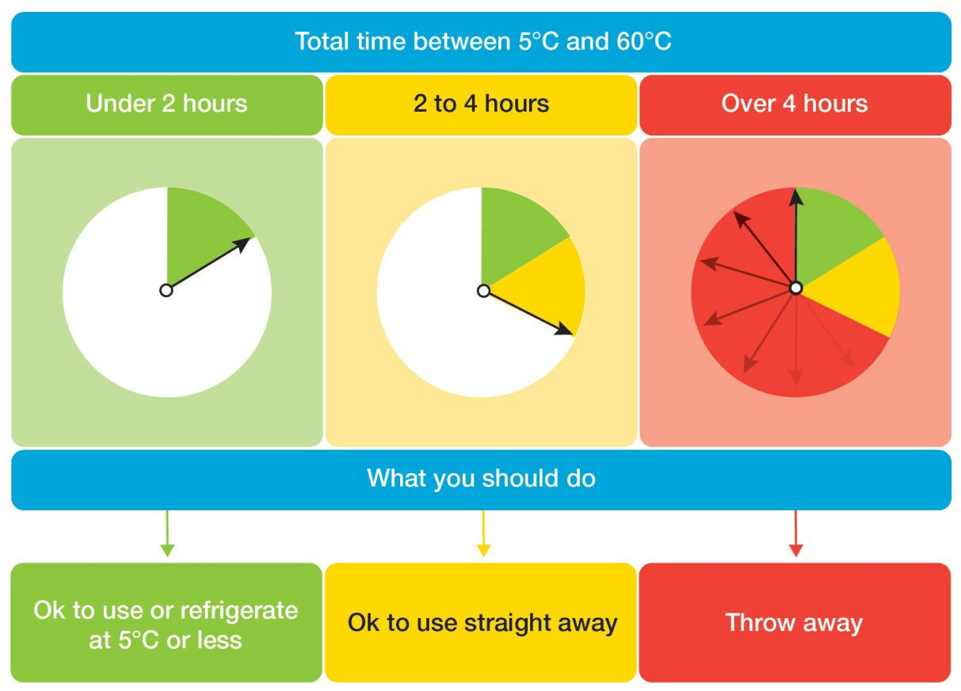
Event Example:
Premises - Tony’s Casseroles
- Chicken casserole is prepared and cooked at a registered kitchen between 9:00am and 9:30am
- The casserole is then transported to an event one hour away
- At 10:30am the casserole is returned to a heat source and the temperature is maintained above 60.0° Celsius

Fixed Premises Example:
Premises – Bean and Gone Cafe
- Sandwiches are prepared daily between 10:30am and 11:30am
- They are put on display until 2:30pm – total time out of refrigeration is four hours.
- At 2:30pm all left over sandwiches are thrown out.

Write down your usual practice here for using the 2 hour/4 hour rule. Update it if your practice changes.

Date | Thermometer ID | Temperature °C ice water (Should be between -1.0 and 1.0°C) | Temperature °C boiling water (Should be between 99°C and 101°C)

Corrective Action if temperature wrong:

