October to December 2017

Quarterly Growth Indicators

Figure 1: New dwelling approvals, requests for new garbage services and birth notices, October to December 2017
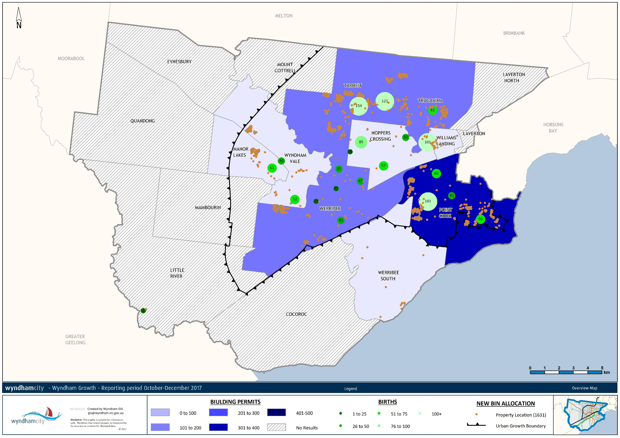
Between 2015 and 2016 Wyndham was the largest growing municipality Victoria-wide, growing by 13,216 persons to 228,088 residents. Over the next 20 years growth is expected to remain strong – the projected population in 2036 is 435,832. Large and unevenly dispersed population growth presents opportunities and challenges for service delivery and planning.
The Quarterly Growth Indicators keep track of where the growth in the city is taking place based on new dwelling approvals, requests for new garbage service, and births. The map above shows that for the October-December 2017 quarter:
- Dwelling approvals are in the blue shading. Almost a third of the 1,283 dwelling approvals were granted in Point Cook (418), and just under a fifth in Tarneit (252). In Truganina and Werribee the totals were 228 and 207. This corresponds with the large growth that is expected in these areas: between 2017 and 2036 these suburbs are estimated to grow by 44,000 dwellings.
- The requests for new bins (the orange pins) indicate that residents in Tarneit, Truganina and Point Cook are largely moving into new developments. The recent delivery of new developments in Manor Lakes, Wyndham Vale and Werribee is more evident still with a concentrations of new bin requests in these areas.
- More than a third of the 1,227 births registered at Wyndham MCH centres (in the green circles) took place in Tarneit and Truganina (437). A further 258 births took place in Point Cook MCH centres. Given the estimated future growth in these areas they will likely remain the largest suburbs for births for a while.
Two of the three indicators have seen increases with respect to the previous quarter:
- The number of building permits has dropped slightly from the previous quarter. Between October and December 2017 there were 1,283 dwelling permits – down from 1,356 in the previous quarter.
- There were 1,234 new bin requests between July and September 2017 – up from 1,140 in the previous quarter.
- There were 1,227 births between October and December 2017. That is 93.4 births per week on average, and up from a total of 1,098 in the previous quarter.
Key differences between th July-September and October-December 2017 quarters are:
- In July-September 2017 Tarneit had the highest number of dwelling approvals. The number has almost nearly halved in the October-December quarter. Meanwhile, the number of dwelling approvals in Point Cook has increased slightly.
- The pattern of bin requests between the July-September and October-December 2017 quarters is highly similar. Residents are still moving into the same developments.
- The difference between the number of births over the two quarters stems almost entirely from the increase in births in Tarneit, Truganina and Point Cook MCH centres.
The next two pages briefly discuss the July to September 2017 quarter for comparison purposes.

Figure 2: New dwelling approvals, requests for new garbage services and birth notices, July to September 2017
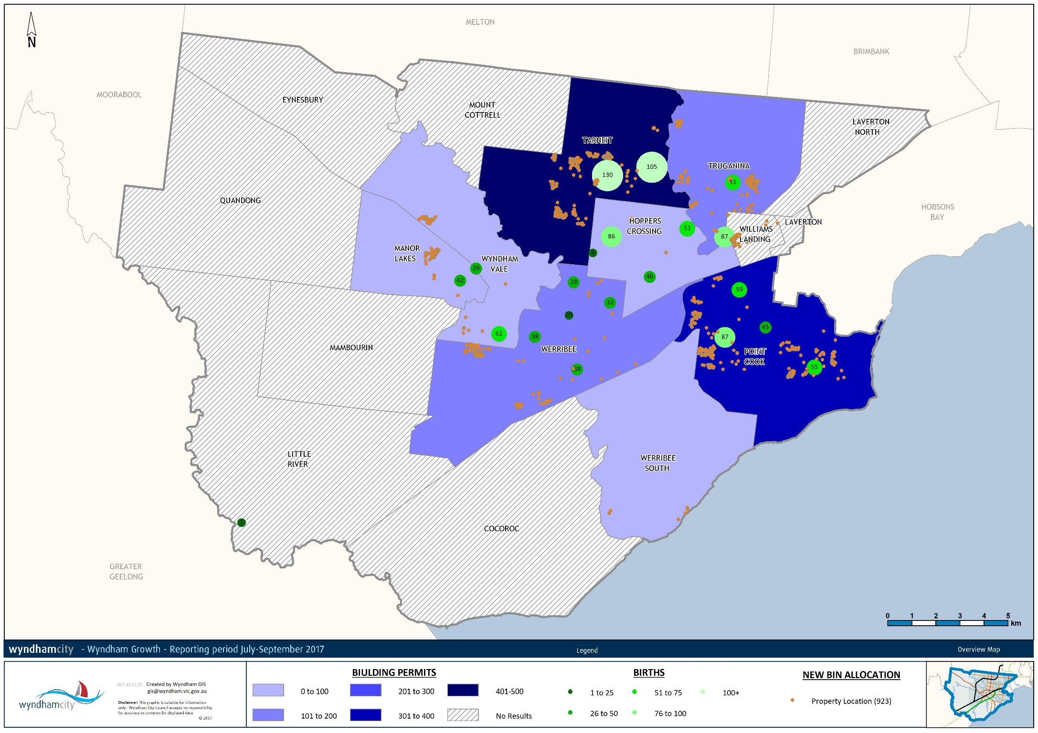

The above map for the July-September 2017 quarter shows that:
- More than half of all building approvals were granted in Tarneit (415) and Point Cook (358) as the blue shading suggests.
- The requests for new bins (the orange pins) indicate that residents are mainly moving into new developments in Wyndham Vale, Tarneit, Werribee Truganina and Point Cook.
- The largest numbers of births were in Tarneit and Point Cook as indicated by the green circles that denote the number of births registered by MCH centre.
All three indicators have seen increases with respect to the previous quarter:
- The number of building permits has set a new record for the June 2012 to September 2017 period. Between July and September 2017 there were 1,356 dwelling permits – up from 1,105 in the previous quarter.
- There were 1,234 new bin requests between July and September 2017 – up from 1,140 in the previous quarter.
- There were 1,098 births between July and September 2017 – that is 83.5 births per week on average, and up from a total of 950 in the previous quarter.

Australian Bureau of Statistics. (2017). Regional Population Growth, Australia. Cat 3218.0.
.ID Population Forecast. (2016). City of Wyndham Population and Household Forecasts 2016-2036.
New dwelling approvals identify where dwelling permits have been approved in the quarter. This indicator identifies areas where residents are expected to move in the next year. This data is available at the suburb level. Once residents move into a new dwelling they lodge a request for new garbage services. This data is available at the address level. Lastly, birth notices are available in terms of the number of births that have been registered with centres.

