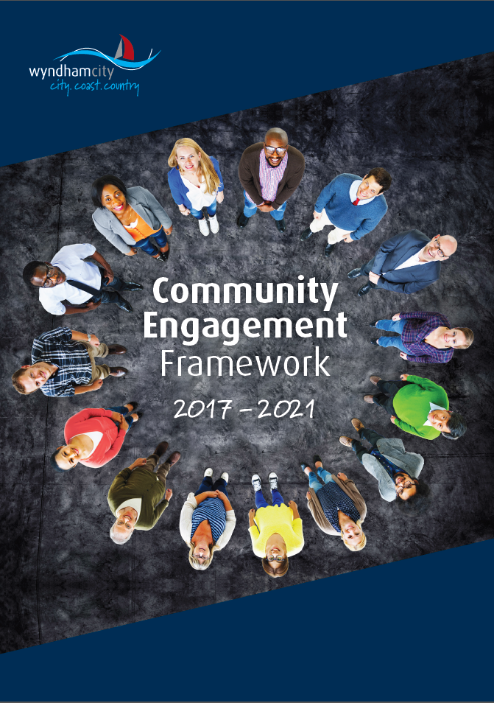
March 2018

Contents
Contents 1
Community engagement at Wyndham City Council 2
Introduction 2
Role of the Community Engagement Framework 2
Public Value and community engagement 3
Scope 4
Definitions 5
Context 6
Council policy context 6
Legislative requirements 7
Roles and responsibilities 8
Engagement at Council 8
Key stages for approval 8
Community and stakeholders 9
Engagement approach 9
Engagement principles 9
How our community likes to be engaged 11
Inclusive engagement 12
Appendices 11
Appendix one: Community and stakeholders 11
Appendix two: Hard to reach groups 15

Community engagement at Wyndham City Council

Introduction
Community engagement refers to the many ways in which Wyndham City Council (Council) connects with the Wyndham community in day-to-day interactions and in the development and implementation of policies, programs, infrastructure planning and services.
Community engagement at Council is defined as:

“A process to build capacity, strengthen relationships
and inform decision making”.

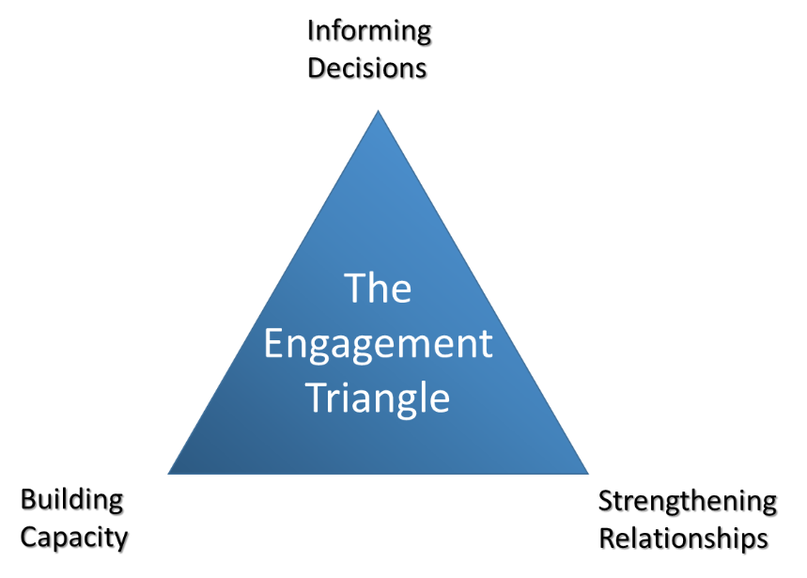
Informing Decisions: To provide opportunities for the community to contribute to decision making processes.
Building Capacity: To educate the community on a specific theme or issue to increase knowledge or change behaviours.
Strengthening Relationships: To build new relationships and/or improve relationships with the community.
Engagement Triangle, Capire Consulting: http://capire.com.au/engagement-triangle/

Role of the Community Engagement Framework
This Wyndham City Council Community Engagement Framework (the Framework) supports Council staff to undertake engagement in a transparent and meaningful manner with the community. It outlines our commitment to the community with genuine opportunities to inform projects, strategies, decisions and services that affect them.
Importantly, this Framework provides a consistent and transparent approach for how Council designs and delivers its community engagement and supports and enables Council’s strategic commitment to improve community engagement at Wyndham.

Public Value and community engagement
The Framework will embed Public Value capture into operations and decisions, particularly around service provision. Public Value Capture is defined as ‘an approach to public sector management that puts citizens at the centre of policy, service design and delivery’.
As an ongoing evaluative and planning structure, Public Value will enable us to:
- Keep our goals and direction clear in achieving maximum benefit to the community in all of Council’s work.
- Increase the success and viability of all actions and projects by ensuring the authorising environment of the community and stakeholder engagement is planned from the outset and delivered to a high standard.
This Framework will achieve Public Value outcomes through leading improvements in the following key areas:
- Facilitating and strengthening Councillor engagement with the local community through meaningful and proactive interactions on local issues and through local forums.
- A consistent approach for high level strategy development across Council, whereby effective community and stakeholder engagement is used to align the needs and aspirations of the community, key organisational partners, Councillors and the service units/departments within Council.
- Streamlining and strengthening the consultative community committee structures and processes delivered by Council, ensuring effective and meaningful engagement is achieved through these regular and on-going structures.
- Supporting consistent and effective consultation with community by officers on a range of projects, plans and initiatives to ensure community is informed, heard and engaged? for the journey of changes affecting them.
- Smart and adaptive engagement methods and technologies to ensure a wide range of community members are reached in ways that are appropriate and easy for them to access and use.
- Courage and innovation as an organisation in informing, educating, learning and deliberating with our community about complex issues impacting the future of Wyndham, including our financial planning.

Scope
This framework applies to all Wyndham City Council employees, Councillors, volunteers, consultants and contractors.
Engagement Toolkit
Community Engagement Framework

- Council consultative committees terms of reference and tools
- Listening posts and pop-ups - processes and tools

Definitions
When planning and delivering community engagement, it is important that a common language is understood. For this Framework, the following definitions apply.
Engagement | Engagement is a planned process with the specific purpose of working with individuals and groups to encourage active involvement in a project. The term engagement is very broad and the purpose of the engagement should be defined for each specific project and project stage. Engagement refers to the range of opportunities open to stakeholders and the community to participate in a project. This ranges from educating individuals or groups about a project; obtaining community feedback at a key project stage or milestone; or working collaboratively with stakeholders to address local issues.
Community | A community is a group of people who have a relationship or a shared interest. A community of place is a group of people who are connected by the area they live, work and/or visit.  This could include a community who live in the same street, neighbourhood or suburb; a community who work in the same building; or businesses located in a particular activity centre.  A community of interest is a group of people who have a shared interest. For example the natural environment, local history or contemporary art.  A community of affiliation are a group of people who are members of the same group or club including members of a sporting club, Rotary or a church group.
Stakeholder | Stakeholders are individuals or organisations which affect, or can be affected by project decisions. Stakeholders can include interest groups, government departments, media, business and industry.
Communication | Communication refers to the range of channels and formats used to disseminate information to different audiences. The purpose of communication is to build awareness and support but can also be used to make announcements, to keep people informed and to respond to media or public enquiries.
Public | Public refers to members of the general public who may not belong to a specific community relevant to the project but they still have an interest in the project.
Council | Wyndham City Council, being a body corporate constituted as a municipal Council under the Local Government Act 1989.
Councillors | Individuals holding the office of a member of Wyndham City Council.
Council Officer | Staff of Wyndham City Council.

Context
The framework reflects best practice community engagement, using the International Association for Public Participation (IAP2) Core Values for the Practice of Public Participation as a foundation for the approach.
The framework responds to the Victorian Auditor General’s Office (VAGO) Better Practice Guide: Public Participation in Government Decision-making. It also takes into consideration Local Government Rate Capping and Variation Framework (Victorian Essential Services Commission) recommendations for good practice in deliberative community engagement.

Council policy context
As a forward-looking document, this framework identifies the goals and aspirations for community engagement practice and impact in Wyndham, in relation to both the community and the organisation. These goals are aligned with the other organisational directions and the Wyndham 2040 Community Vision.
It strategically and practically aligns with the Wyndham City Plan 2017-21, the Intergovernmental Relations and Advocacy Strategy (under development) and the Customer Experience Strategy.
It is integrated as part of the Project Management Framework to ensure that all projects include community engagement considerations and plans depending on the needs of individual projects.
In the broader engagement landscape, this Framework is a part of a suite of documents that will enable and support engagement across Council.

Legislative requirements
In some instances, Council is legislatively and/or legally required to engage with the community. In these cases, we will treat the legally required level of community engagement as the minimum standard.
Delivery of community engagement beyond legally required levels will depend on the:
- Decision to be made
- Project/service to be delivered
- Community’s interest to participate
- Need to understand the community’s view
- Opportunity for the community to influence the decision
Community engagement is required under the following relevant legislation:
- Local Government Act 1989
- Road Management Act 2004
- Victorian Charter of Human Rights and Responsibilities Act 2006
- Planning and Environment Act 2007
- Health and Wellbeing Act 2008
- Commission for Children and Young People Child Safe Standards

Roles and responsibilities

Engagement at Council
Engagement occurs broadly across the whole of Council every day. This means that all funded projects will have a trigger to contact the Senior Community Engagement Officer for support and guidance in developing an engagement plan. The level of involvement from the Engagement Officer will depend on the complexity of the project.

Key stages for approval
With anything that requires items to be adopted by Council, the following stages should be used to guide the development, approvals and eventual adoption and implementation of strategies, plans and policies at Council:
 | Stage | Description | Purpose
1 | Consultation and engagement | Consultation and engagement with internal and external stakeholders | Initial consultation with stakeholders to gain input, ideas guidance and data to support plan / project / proposal / strategy.
2 | Analysis, draft and approvals | Analysis of results from stage one and draft | Draft created based on information and data gathered in stage one. Circulated through Executive Leadership Team and Councillors (via Organisational Briefing and/or Ordinary Council Meeting) to enable organisational buy-in and approvals.
3 | Validation and finalisation of draft | Public exhibition | To validate with the community that what has been created captures information and data gathered in stage one. Gives the community an opportunity to influence the outcome.
4 | Final approval and adoption | Adoption | Any feedback from stage 3 is incorporated for final approval and adoption.
5 |  | Implementation | Internal team responsible for implementation according to each project / plan / strategy.

Community and stakeholders
Council projects attract interest from a broad range of individuals and groups, particularly those who live, work, study, own land and travel through the locations of where projects occur. This framework is designed to target broad categories of stakeholders as shown in appendix one. The table identifies the name of the stakeholder group, the key members, their potential role in decision-making and level of interest in the project.

Engagement approach
Community engagement is ‘a process to build capacity, strengthen relationships and inform decisions’. This engagement approach is guided by a planned process of engagement that involves the community in the decisions that impact them.
Council will engage with the community when:
- There is a legislative requirement to do so
- A decision or plan will substantially impact the community and there is some part that is negotiable
- Community input is sought to enhance a decision, plan or opportunity
- Through campaigns that engage the community, local stakeholders and Council.
- Planning for the development of the Annual Integrated Plan and Budget, City Plan, District Plans and any other high-level plans and strategies

Engagement principles
The following engagement principles have been developed to guide the design, delivery and evaluation of community engagement projects. These principles are to be adopted for all projects no matter what size or scale to ensure consistency in approach across Council.
Each principle is supported by a series of guidelines to support the design and delivery of engagement. These are described in the table below:
Principle | How this is delivered
Confirm the engagement purpose and scope | - Clearly articulate the project scope and level of community and stakeholder influence  - Define the engagement objectives, negotiables, non-negotiables and scope  - Integrate the engagement design with internal risk management procedures.  - Agree on the evaluation criteria to measure the effectiveness of the engagement  - Gain leadership buy-in, feedback and sign-off regarding the engagement objectives and negotiables  - Agree on roles and responsibilities of key Council officers for:  - oversight of overall project  - coordinator of content  - coordinator of engagement  - logistics  - members of project team
Know the community and stakeholders’ interests, values and opportunities for engagement | - Identify stakeholders and their possible values and likely level of interest in the project  - Consider the possible ‘hard to reach’ groups  - Understand who has or has not been involved in previous related projects  - Gather awareness of other projects, opportunities or community issues that may influence community participation in the engagement
Design a tailored engagement approach | - Ask the community how they want to be involved  - Co-ordinate with other Council engagement activities  - Promote opportunities for community strengthening through education and connection  - Use a range of different engagement methods that provide people with accessible options to participate  - Select tools that collect relevant project information and data  - Agree on an approach to information management and data analysis  - Support face-to-face activities with online engagement
Engage in a respectful and genuine manner | - Provide the appropriate lead times when promoting the project to stakeholders  - Provide targeted project information in advance of engagement activities to support informed participation  - Describe to the community how their involvement will influence decision-making at the outset of the engagement  - Undertake the engagement with integrity, respect and being open to a range of different views and interests  - Deliver engagement activities at days, times and locations that meet the needs of the community and stakeholders  - Provide a timeframe of when participants can expect feedback
Analyse and interpret the engagement information | - Consolidate the data and information collected during each engagement activity  - Analyse the data and information to identify themes, priorities and preferences  - Identify gaps in participation and information to be addressed
Close the loop on the engagement process, project outcomes and decisions | - Provide feedback on the engagement process and findings to the project team including decision-makers for their consideration  - Communicate with participants and stakeholders about the engagement process, findings, outcomes and how any decisions were made  - Publish updates and final outcomes of community engagement on key communication forums and channels  - Share the engagement findings and outcomes with Council colleagues and key stakeholders
Evaluate the effectiveness of the engagement | - Measure the engagement process from the beginning  - Understand and evaluate the depth and breadth of participation to inform future engagement  - Capture and share the learnings from the engagement

How our community likes to be engaged
In 2017 we asked our community how, when and what they wanted the Council to engage them about. In total, 309 people participated in the engagement across the 6 engagement methods. The key learnings that relate to this Framework are:
- Community members believe it is very important to have impact into projects that affect them
- People want to hear from Council about engagement opportunities once a quarter
- Surveys, online engagement and pop-ups at local events are the preferred engagement methods, submissions were the least preferred method
- Roads, Transport and Parking is the issue community members most want to hear about, followed by community centres, arts and venues
- People want to hear about engagement opportunities via email and the council newsletter
Feedback from staff, Councillors and District and Portfolio Advisory Committees articulated that community engagement needs to be accessible for a wide variety of people. They believe being accessible includes:
- Having multiple methods to be informed and provide input (e.g. online and off-line engagement)
- Going to where the community are (e.g. attend community events, reach out to community a common touch points such at the doctors or immunisation sessions)
- Being highly visible (use branding, have visual tools, promote on multiple platforms such as social media and community notice boards)
- Translate information for the diverse community in Wyndham

Inclusive engagement
In delivering engagement activities Council is committed to using inclusive methods to ensure a broad spectrum of the community are reached. Some of these ‘harder to reach’ groups identified in Wyndham are:

- Culturally diverse communities
- Aboriginal and Torres Straight Islanders
- People with a disability
- Young people
- Older community members
- Young families/primary carers

These groups experience more barriers to engagement than other community members. Examples of barriers are language, physical ability, digital comprehension, lack of time and social isolation. The following table provides suggestions for how to overcome these barriers and encourage greater participation from these groups. The suggestions are informed by best practice theory and discussions with these groups.
A full list of hard to reach groups, including why they are hard to reach and engagement tools is listed in appendix two.

Appendices

Appendix one: Community and stakeholders
This framework is designed to target broad categories of stakeholders as identified in the following table. It provides the name of the stakeholder group, the key members, their potential role in decision-making and level of interest in the project. This will form a key part of the toolkit that officers will use when developing an engagement plan.
Stakeholder Group | Role in decision-making | Interest in project | Examples of Key members
Decision makers | Key influencers for Wyndham City Council by creating and implementing the relevant legislative and regulatory processes. | Decisions, actions and feedback significantly impact or influence project cost, design and delivery. | Wyndham Councillors; CEO and CEO’s Office; City Economy, Innovation & Liveability Directorate; City Operations Directorate; City Life Directorate; Relevant State and Federal Ministers; legislative decision-makers.
Key influencers | Ability to influence project decision-makers. | Impacts on communities and/or portfolios they represent. | Relevant State and Federal Members of Parliament; public commentators /experts/universities.
Project partners | These stakeholders will partner in the development and delivery of the project and, as such, have a significant role in approving project decisions. | Outcomes and impacts of the project.  Potential involvement and advice in development and delivery of the project. | Local Government; Relevant State and Federal Government; Government Agencies; Service providers; Community groups.
State government agencies | These stakeholders will have significant influence over key project decisions. Some agencies will have a significant approving role in project decisions. | Statutory requirements are met. Decisions, actions and feedback impact or influence project design and delivery.  In some cases, they are providers of grant funding for a specific outcome. | Department of Economic Development, Jobs, Transport and Resources; Department of Education and Training; Department of Environment, Land, Water and Planning; Department of Premier and Cabinet; Sustainability Victoria; Essential Services Commission; Energy and Water Ombudsman (Victoria); Department of Health and Human Services.
Local government stakeholders | Wyndham City Council projects have direct implications for numerous local Councils and will act as an enabler of further development and opportunity. | Local planning issues, community impacts, social and economic development. Decisions and actions may influence project delivery. | Other western or growth councils.
Regulators | These stakeholders will have requirements that the Wyndham City Council will need to consider and address in developing and delivering projects. | Regulatory requirements are met. | Government peak bodies: MAV; VLGA; LG Pro.
Residential customers/rate payers/service users | Ability to influence project decision makers. | Interested in new projects or policies that they may perceive to impact them. Interested in services and programs delivered by Wyndham City Council. | Wyndham City Council rate payers; service and program users; renters of Council facilities and buildings.
Business customers | Ability to influence project decision makers. | Interested in new projects or policies that they may perceive to impact them. | Local businesses in Wyndham.
Land developers | Ability to influence project decision makers. | Projects or policies that may impact or support their development projects. | Large landowners who are developing land for commercial or residential uses.
Technical stakeholders | These stakeholders will have requirements that the Wyndham City Council will need to consider and address in developing and delivering the project. | Potential impacts on assets and asset renewal plans. | Local Government planning departments; internet service providers; Catchment Management Authorities; gas and electricity providers; emergency services; VicRoads.
Directly affected stakeholders | Affected by Council projects. Their interests, concerns and preferred outcomes will be invited and taken into account in project decisions during all phases. | Directly impacted by project (for example land acquired or abutting construction zone).  Potential impacts on business operations.  Potential local community impacts (e.g. noise, road closures, parking, traffic).  Potential impacts for students and staff (access).  Potential impacts on transport network (road closures, pedestrian and cycling detours). | Private property owners/local residents; Local businesses and traders; Major retailers and businesses; Property developers; Hospitals / Health research institutes; Universities / schools; Religious groups; Commuters (road, public transport, cyclists, pedestrians).
Indirectly affected stakeholders | These stakeholders may be indirectly affected by projects either during design and/ or delivery. Their interests, concerns and preferred outcomes will be considered during planning, development and delivery. | May not be directly impacted but are interested in the design, delivery and outcomes of projects. | Local residents, business owners, schools, commuters, universities, emergency services.
Peak bodies, industry groups | Provide critical policy and delivery advice and play a central role to shaping broader perspectives. | Impacts on stakeholders they represent.
Traditional owner groups | Input into implementation and design. | Impact on cultural values and access to land. | Local Registered Aboriginal Party.
Special interest groups | Ability to influence project decision makers. Ability to enhance project outcomes. | Project impacts/benefits in relation to each group’s specific interest areas.  Potential involvement and advice in development and delivery of the project. | Resident/community groups.
Broader community | Ability to influence project decision makers. | Interested in project benefits. | General public; visitors to region.
Media | Ability to influence project decision-makers and readership. | Provide communication channels to reach other stakeholder/audience groups and can directly influence their perceptions, attitudes and behaviours. | National, metropolitan, regional and local print; television; radio and online media outlets (including social media and blogs).
Wyndham City Council Employees | Ability to influence broader perceptions of the project internally and externally. | Interested in activities of Wyndham City Council overall and those activities that have impact on their work.  Able to provide additional information about related activities for consideration. | Service Delivery; Customer Relations, etc.

Appendix two: Hard to reach groups
Group | Why they are hard to reach | Engagement tools
Culturally diverse communities | - Language can be a barrier to participation.  - They can be unfamiliar with the government and decision-making environment in Australia.  - There may be complexity with cultural differences to consider, for example, certain cultural or ethnic groups may not mix or some people may not be comfortable in a mixed gender forum. | - Do your research and understand the diversity between and within these communities  - Use existing networks and groups to connect with culturally and linguistically diverse communities  - Communicate project/issues visually for example using story boards  - Go to where they are for example, culturally diverse communities have high participation rates in sport  - Make sure the venue has appropriate multilingual signage  - Interpreters may be necessary to ensure complex issues are fully understood and information may need to be distributed in key community languages  - Provide incentive payments or vouchers for people to attend engagement events as some people may find it difficult to cover the costs such as transport and childcare  - Involve experienced members from the relevant community in the facilitation of the engagement
Aboriginal and Torres Strait Islanders | - They can have significant demands for their time and knowledge  - They may experience consultation fatigue  - They may have a history of engaging without feedback or results  - They may not feel comfortable speaking up in a mixed forum having experienced discrimination | - Do your research before commencing the engagement exercise to allow you to understand history, relationships, previous projects and the appropriate group(s). Understand and respect the differences between different groups  - The territory in the West of Melbourne is disputed between groups, seek advice about who and how to work with the different groups  - Take the time to establish strong connections and build rapport. It may be beneficial to liaise with someone who has existing connections with the community  - Be flexible in your approach as things may come up and affect your arrangement, or conversations may take longer  - Be prepared to make a space for discussions with just Aboriginal groups, without other communities’ present  - Choose a comfortable and familiar setting for your engagement activities - Indigenous communities often like to share a meal  - Understand and adhere to different cultural protocols, for example, introductory protocols and sharing of knowledge and culture protocols  - Provide incentive payments or vouchers for people to attend engagement events as some people may find it difficult to cover the costs such as transport and childcare  - Involve experienced members from the relevant community in the facilitation of the engagement
People with a disability | - People with disabilities can experience physical and/or intellectual barriers  - People with disabilities may need to be accompanied by a carer, which can be costly  - People with disabilities may be more time limited, for example can only do activities between 11am - 2pm | - Be considerate of the fact that people with disabilities may need time to voice their opinion, they may prefer to do so in written format or may need the discussion topic prior to the engagement activity to prepare their contribution  - Ensure that the venue is located near public transport and is DDA compliant - also ensure the setup of your room allows easy access for example, have enough room between tables for a wheel chair and for people who have a sight impairment to move through  - Provide incentives for carers as well as people with disabilities. In particular, transport can be expensive for people in wheelchairs, be prepared to cover maxi-taxi costs  - Be mindful of catering provisions, for example straws are good for people with reduced motor control skills  - Auslan interpreters or hearing loops may be required for meetings if people with a hearing impairment are attending  - Travel to your participants if possible, and ask about times that would suit participants  - Social media and online forums can help increase accessibility for people with a disability. However, it is important that online materials are accessible for tools such as screen readers
Young people | - Most young people are not used to participating in a public forum, and may lack the confidence to do so or find the format not stimulating  - Young people can find it difficult to make long term commitments  - Young people are very busy with school, extracurricular activities and family commitments  - Young people have less mobility and may rely on parents to transport them  - Young people are saturated with information and activities to take part in - the culture for many is to ‘sign up’ to things they are interested in but not decide until the day if they are going  - Young people are less likely to be paying for services or financially tied to property, therefore, they may not understand the projects relevance to them | - Design engagement formats that are youth friendly and stimulating  - Spend time to build confidence - provide training, support and the opportunity  - Use multiple online platforms to promote for example Facebook, Snapchat and websites - make sure the promotional material is eye-catching and appealing to young people  - Use existing school networks and youth groups  - Commitment needs to be short-term and finite  - Recognise their contribution by providing incentives, such as vouchers and provide food  - Consider opportunities such as mentoring that promote sharing ideas and can have more long-term impacts  - Be specific in communication about why your project is relevant to them and their future  - Confirm with the young people 1-2 days before the event, to remind them about the engagement and why they should participate  - Involve young people to design and lead the engagement activities
Older community members | - Older community members can feel that they are ‘too old’ to contribute and that their opinions are not relevant  - Older community members can be busy  - Older community members may not use social media or have access to the internet  - Older community members may experience physical and/or intellectual barriers  - Older community members may not feel safe going out at night  - Older community members may be less mobile, because they no longer drive | - Make sure older community members are aware that their input and ideas are valued and recognise their contribution is as important as everyone else’s  - Use existing networks, groups and clubs to connect with and engage older community members  - Send letters of invitation  - Take the time to listen to their stories - one-on-one engagement may be the best way to make sure their stories are heard  - Choose an appropriate venue, one that is familiar and comfortable and is DDA compliant  - Consider the time of day of your engagement activities - make sure it is appropriate for older community members  - Recognise that similar engagement may have been done in the past, explain why this engagement is different and how the outcomes will be used  - Provide information in hard copy formats or engage over the phone where appropriate
Young families and primary carers | - Young families and primary carers may find it difficult to attend engagement activities because they cannot leave their children or the person they are caring for, home alone  - Young families are very time poor, and may only have a few minutes to contribute to the conversation  - The family/carer may only have one car, and not always have access to it | - Consider the time of day of your engagement activities - hold activities during the day, as this may be more appropriate for families and primary carers  - Attend events, activities they are already going to e.g. immunisation sessions, park/fun days  - Provide incentives as payment, such as vouchers, as some people may find it difficult to cover the costs of childcare or to pay another carer  - Make engagement activities family friendly, hold events that families and primary carers can bring their children and/or person they are caring for - For example, always have crayons and paper with you so young children can draw or games to play with  - Make sure your engagement space/venue is safe and ideally contained so parents do not have to worry about children and traffic/sharp objects/animals etc.  - Keep engagement activities short (to five minutes or less), and easy to do with a young child in your arms

South Australian Government 2016, Public Value, Putting Citizens at the Centre of Policy, Service Design and Delivery, p.3.
IAP2 Core Values https://www.iap2.org.au/About-Us/About-IAP2-Australasia-/Core-Values
VAGO Better Practice Guide http://www.audit.vic.gov.au/publications/20150130-Public-Participation-BPG/20150130-Public-Participation-BPG.pdf

