Community Gardening in Wyndham



What is a community garden and why are they important?

Council defines Community Gardens as an area of land tended by a group of people to grow edible and non-edible plants. They are community led and not-for-profit.

Council is supportive of Community Gardens because they bring people together, allow people to share skills and learn new ones, offer people a chance to grow and enjoy fresh produce and can contribute to a healthier environment.

Get involved in a Community Garden close to you…

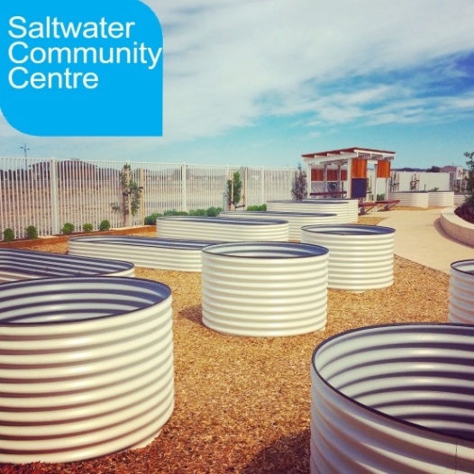

Wyndham Central

**Greening the Pipeline**

This project aims to transform the 27km heritage listed Main Outfall Sewer reserve into a linear parkland that will connect communities and provide a unique space to meet, play and relax. The project is in the early stages and we are investigating possibilities of including community gardens as part of the project. To learn more,

**Contact:** Coordinator Greening the Pipeline 8734 2736 ext.2736 or [emma.pryse@wyndham.vic.gov.au](mailto:emma.pryse@wyndham.vic.gov.au)

**Website:** greeningthepipeline.com.au/

Wyndham East

**Saltwater Community Garden**

Are you a gardener or want to learn more about gardening? Do you want to help out in the Saltwater Community Garden and meet local agronomists, horticulturists and propagators? Get in touch today.

**Location:** 153 Saltwater Promenade, Point Cook

**Contact:** 8376 5500, [Saltwatercc@wyndham.vic.gov.au](mailto:Saltwatercc@wyndham.vic.gov.au)

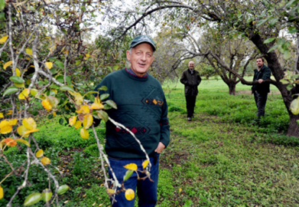

Wyndham Rural

**Werribee Mansion Kitchen Garden**

This is a partnership project between Parks Victoria, Australian Migrant Education Centre and Brotherhood of St Lawrence. Volunteers are from the Communities of Burma and others.

**Location:** K road, Werribee

**Contact:** Parks Victoria 13 19 63, [james.brincat@parks.vic.gov.au](mailto:james.brincat@parks.vic.gov.au) or

[adam.smith@parks.vic.gov.au](mailto:adam.smith@parks.vic.gov.au)

**Friends of the Werribee Park Heritage Orchard**

Fruit Tree Workshops run every Friday from 10.00am. All are welcome.

**Location:** Werribee Park, K Road, Werribee South

**Contact:** Craig Castree, 0411720283, [craigcastree@optusnet.com.au](mailto:craigcastree@optusnet.com.au)

**Website:** [www.werribeeparkheritageorchard.org.au/](http://www.werribeeparkheritageorchard.org.au/)

Wyndham West

**Iramoo Community Centre Kitchen Garden**

This garden is undertaking a makeover. To register your interest, get in touch with the community centre.

**Location:** 84 Honour Avenue, Wyndham Vale

**Contact:** 8742 3688,[www.iramoocc.org.au/](http://www.iramoocc.org.au/)

**Facebook:** [www.facebook.com/IramooCommunityCentre/](http://www.facebook.com/IramooCommunityCentre/)

**Mambourin Sensory Garden**

Two acres of beautiful landscaped garden, including a large sunken herb garden surrounded by climbing roses, are maintained by people with disabilities through an employment program. The gardens are open for all to enjoy, by appointment.

**Location:** 2 Recreation Close, Werribee **Contact:** 9731 8210

**Website:** www.mambourin.org/

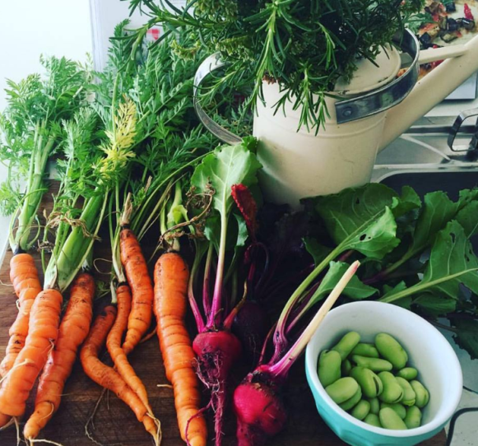

**Shoestring Gardening**

This Learner Kitchen Garden includes a chook house, aquaponics system, various composting displays and nursery at the Eco Living Centre. ‘Learner’ days are Wednesdays 10am - 3pm.

**Location:** Eco-living Centre, 28 Ridge Drive, Wyndham Vale

**Contact:** [shoestring.contact@gmail.com](mailto:shoestring.contact@gmail.com)

**Facebook:** facebook.com/shoestringgardening/

**Werribee Community & Education Centre, Wayaperi House**

Vegetable and herb plots are tended by the centre volunteers. Produce is shared between Saffron Kitchen and the volunteers.

L**ocation:** 106 Duncans road, Werribee **Contact:** Craig Spicer 9742 4013, [craigs@wyndhamcec.org.au](mailto:craigs@wyndhamcec.org.au)

**Werribee Community Garden**

Various plots are available to grow your own produce. Working bees occur every Thursday 9:30- 11am.

**Location:** Werribee Environmental Community Park, Opposite 26-28 Walls Road, Werribee (behind Ison House) **Contact:** The Secretary 0413 480 481, [info@wecpark.com](mailto:info@wecpark.com)

**Website:** [www.wecpark.com](http://www.wecpark.com)

**Werribee Community Shed**

[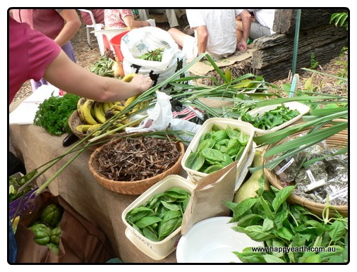](http://www.google.com.au/url?sa=i&rct=j&q=&esrc=s&source=images&cd=&cad=rja&uact=8&ved=0CAcQjRxqFQoTCNaHj4yIkcYCFSEdpgodeOoANQ&url=http://www.happyearth.com.au/food-swaps/&ei=i29-VZaWBKG6mAX41IOoAw&bvm=bv.95515949,d.dGc&psig=AFQjCNGwHQmiBzx4FGcOeE_5mbaofDTtGA&ust=1434435848792992)Volunteers tend a garden, growing vegetables and fruit.

**Location**: 57A Kookaburra Avenue, Werribee

**Contact:** 8742 6448, [james@werribeemensshed.com.au](mailto:james@werribeemensshed.com.au)

**Werribee Gardening Club**

A club for people with a love and passion for gardening. It’s an opportunity to share knowledge and learn from others. They run a series of activities and events throughout the year. They meet on the 1st Monday of every month from 12-3pm.

**Location:** Italian Sports Club of Werribee, 601 Heaths Road, Werribee **Contact:** 9741 5108

Close to Wyndham

**Laverton Community Garden**

Various plots available for hire. A waiting list may apply.

**Location:** 91 Bladin Street, Laverton

**Contact:** 0439 714 951

**Facebook:** Laverton Community Garden

**Lara Community Garden & Art Precinct Ltd**

Established in 2010, based on organic and permaculture methods with individual plots, shared areas, fruit trees, herbs and a tool shed. The garden sits within the City of Greater Geelong but is attended by some Wyndham residents.

**Location:** Scuti Court, Lara

[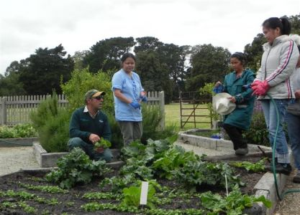](http://www.google.com.au/url?sa=i&rct=j&q=&esrc=s&frm=1&source=images&cd=&cad=rja&uact=8&docid=noYmtdqTsMfTZM&tbnid=_mY3BbF3BNd9wM:&ved=0CAUQjRw&url=http://parkweb.vic.gov.au/about-us/news/wonderful-revival-of-werribee-parks-kitchen-garden&ei=qmrgU4CKBZW78gWUrICACw&bvm=bv.72197243,d.dGc&psig=AFQjCNG8khHoJ0wVA2wZYUQguKr8_IFEoA&ust=1407302667220775)**Contact:** Natalie Vervest 0414 817 020, [lcgap@outlook.com](mailto:lcgap@outlook.com)

**Facebook:** [Lara](https://www.facebook.com/Lara-Community-Garden-Art-Precinct-101455039913132/?fref=nf) Garden Art Precinct

Food Swaps

Food Swaps are local gatherings for people to swap their excess homegrown produce which commonly includes fruit, vegetables, herbs, eggs and seeds as well as homemade preserves, pickles, chutneys, jams and worm juice. No money is exchanged- it's up to the swappers to decide what is fair. It’s a great way to meet other like-minded locals.

**Wyndham Community Garden Swap**

**Date:** The first Sunday of the month, 10 – 11am

**Location:** Mossfiel Reserve, Mossfiel Drive, Hoppers Crossing

**Facebook:** Wyndham Community Garden Swap

**Contact:** [ritaosullivan@bigpond.com](mailto:ritaosullivan@bigpond.com)

**Iramoo Community Centre Fruit & Vegetable Swap**

**Date:** The third Saturday of the Month, 11am-12pm

**Location:** 84 Honour Avenue, Wyndham Vale.

**Contact:** [happy-potter@optusnet.com](mailto:happy-potter@optusnet.com) or 8742 3688 or Coralee 0403 433 795

**Facebook:** [facebook.com/groups/wyndhamswap/](https://apac01.safelinks.protection.outlook.com/?url=https%3A%2F%2Fwww.facebook.com%2Fgroups%2Fwyndhamswap%2F&data=01%7C01%7CKarolina.Kubiak%40wyndham.vic.gov.au%7C010f62bd28104291e29408d411accd32%7Cccedce2eab9f4e51bb3d3c6e2171f03e%7C0&sdata=DWv%2FMn1JZa%2Bb0Lha8cO0v9UHHgB4uVr9c%2F%2F1v9%2FiNaU%3D&reserved=0)

**Point Cook Gardening Swap**

**Date:** The fourth Sunday of each month, 10.30-11.30am

**Location:** Jamieson Way Community Centre, 59 Jamieson Way, Point Cook.

**Contact:** Wendy0455 378 133

**Facebook:** Search; Gardening Swap Point Cook.

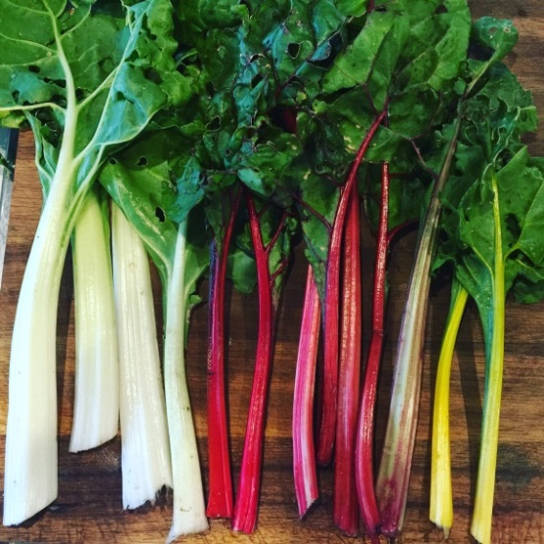

Close to Wyndham

**Altona Fruit and Vegetable Swap**

**Date:** The first Sunday of the month, 2-4pm

**Location:** Louis Joel Arts and Community Centre, 5 Sargood Street, Altona.

**Facebook**: [www.facebook.com/Altona-Fruit-and-Vegie-Swap](http://www.facebook.com/Altona-Fruit-and-Vegie-Swap)

**Maidstone Urban Harvest Share**

**Date:** The third Saturday of the Month, 11am-12pm

**Location:** Maidstone Community Centre, 21 Yardley St, Maidstone. Entry is opposite 10 Gibb Street.

**Newport Fruit and Vegetable Swap**

**Date:** The third Sunday of each month, 10.30-11.30am

**Location:** Newport Lakes. Just through the entrance from Mason St at the under-cover BBQ area on your left.

**Facebook:** www.facebook.com/NewportSwap/

Get in touch…

Email: [community.gardening@wyndham.vic.gov.au](mailto:community.gardening@wyndham.vic.gov.au) or sustainability@wyndham.vic.gov.au

Phone: Wyndham City on 9742 0777

**Little River Food Share**

**Date:** The second Sunday of each Month, 10.30am-12pm

**Location:** Little River Mechanics Hall, Rothwell Road.

**Facebook:** [facebook.com/LittleRiverShare](https://apac01.safelinks.protection.outlook.com/?url=http%3A%2F%2Ffacebook.com%2FLittleRiverShare%2F&data=01%7C01%7CClaire.Mewing%40wyndham.vic.gov.au%7C2fe3728c3c5e4ed4b79808d4b6b70e9e%7Cccedce2eab9f4e51bb3d3c6e2171f03e%7C0&sdata=EzNSv6jsvCHpmGfMePGQiGltKtmkat8hdDqKJncSJ5E%3D&reserved=0)

Farmers Markets

There are currently no farmers markets operating in Wyndham but a few close by.

**Eynesbury Farmers Market Date:** The fourth Sunday of the month, 9am-1pm

**Location:** 487 Eynesbury Road, Eynesbury **Contact:** 0400 520 042[www.eynesburyfarmersmarket.com.au](http://www.eynesburyfarmersmarket.com.au)

**Yarraville Gardens Farmers Market Date:** The fourth Saturday of the month, 8.30am-1pm

**Location:** Hanmer Reserve, Cnr Hyde & Somerville Streets, Yarraville. **Contact:** 0412 910 496

Useful Websites

The Australian City Farms and Community Gardens Network have a range of fact sheets including no-dig gardens, composting, safety in the garden and 10 steps for starting a community garden.

[www.communitygarden.org.au/](http://www.communitygarden.org.au/)

Sustainable Gardening Australia have a comprehensive community garden manual which includes advice and templates to support holding community meetings, putting together a proposal, locating/assessing a site, planning garden design and managing your group.

[www.sgaonline.org.au/](http://www.sgaonline.org.au/)

[Cultivating Community](http://www.cultivatingcommunity.org.au/research-and-information-sharing/community-garden-resources/) has a range of different links to useful sites and organisations. [www.cultivatingcommunity.org.au/](http://www.cultivatingcommunity.org.au/)

3000 Acres have information on vacant private land across Melbourne and support people to access it.

[www.3000acres.org/](http://www.3000acres.org/)