Frequently Asked Questions
Werribee city centre business parking permits &
off-street public parking redevelopments
November 2017

Where are the new Werribee City Centre Business Permit Parking locations?
As of 2 January 2018, the Business Permit Parking locations in the Werribee City Centre will be changed to only:
- Cherry Street Car Park,
- West End Car Park.
Business Permit Parking will no longer be available at the other locations.

Why are permit parking locations being removed?
To provide more parking for customers in the City Core.

Where is the West End Car Park?
The West End Car Park is located on the corner of Watton St and Werribee St, Werribee, at the western end of the Werribee City Centre.

Where is the Cherry Street Car Park?
The Cherry Street Car Park is located on the corner of Cherry St and Kelly St, Werribee, at the eastern end of the Werribee City Centre.

When will the West End Car Park be open?
The West End Car Park will be open in mid-December 2017.

How many parking spaces will be available?
The West End Car Park will have 180 parking spaces. The Cherry Street Car Park has 149 parking spaces.

What will the time limits be?
Customers are welcome to park up to 3 hours in any available space in the West End Car Park and the Cherry Street Car Park. Business permit holders are exempt from the 3 hour time limit and are welcome to park all day in any available space in the West End Car Park and the Cherry Street Car Park.

How much does a Business Parking Permit Cost?
A 12 month Business Parking Permit currently costs $140.40.

Can I purchase a Business Parking Permit at any time of year?
Yes. Permits are issued for 12 months or pro-rata if applications are received after 1 August 2017. The pro rata cost is $11.70 per month.

When do Business Parking Permits expire?
All Business Parking Permits expire on 30 June each year. A permit renewal form must be completed to renew your Business Parking Permit.

Is there a limit on the number of Business Parking Permits that one business can purchase?
Permits are issued subject to availability. It is possible for a business to purchase more than one permit. The size of the business and the number or permits available will be considered in determining the number of permits issued to one business.

How to I apply for a Business Parking Permit?
Visit the Wyndham City website at the following address, download and complete the application form, and return it with payment to the address listed on the form.
https://www.wyndham.vic.gov.au/services/local-laws-permits/laws-permits-businesses/business-parking-permits

Are Business Parking Permits issued to businesses, individuals or vehicles?
Business Parking Permits are issued to businesses, not individuals or vehicles.

Can only one person within the business use the Permit?
Anyone that works at the business named of the permit can use the permit. This allows the permit to be used flexibly within the business, depending upon who needs it at the time. Only one user is possible at one time.

Can I park in either the Cherry St Car Park or the West End Car Park with my Business Parking Permit?
No. Businesses will be issued with either a Cherry St Permit or a West End Permit. Permits cannot be used in both of the car parks.

How is it determined which car park a Business Parking Permit is designated to?
We divide the total number of permits by business location and allocate 50% to each car park. Businesses in the east of the City Centre will be designated to the Cherry St Car Park. Businesses in the west of the City Centre will be designated to the West End Car Park. The dividing line is closer to the Cherry Street Car Park.

Why can’t I choose which site I want to park at?
We want to make sure both car parks will be equally used and have equal availability of customer parking spaces.

Can I get a refund?
Yes, please send us an email requesting a refund including your permit number.

What are the Catalyst Sites?
The Catalyst Sites are currently ground level public car parks which are planned to be redeveloped into large multistorey mixed use developments. The developments are planned to include multistory public parking facilities and other uses such as, shops, offices, apartments, hotel, education, childcare and the Werribee Integrated Community Learning Hub.

Where are the Catalyst Sites located?
The map below shows the locations of the Catalyst Sites in the Werribee City Centre.

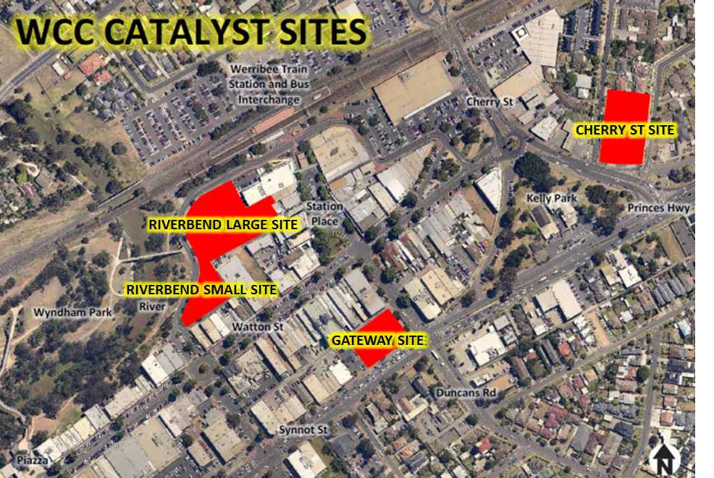

Which of the Catalyst Sites is being developed first?
The Gateway Site and Riverbend Small Sites are planned to be developed first. Construction is proposed to commence in 2018, subject to planning approval.

Which of the Catalyst Sites will have public parking facilities?
The Gateway Site, the Cherry Street Site and the Riverbend Large Site are planned to include multistory parking facilities.

How many additional parking spaces will the Catalyst Sites provide?
The Catalyst Site will increase parking in the Werribee City Centre by 400 spaces.

How can I find out further information?
If you have any questions, get in touch with the Wyndham City team on 9742 0905 or email: werribeecitycentreparkingpermits@wyndham.vic.gov.au

