July to September 2017

Quarterly Growth Indicators

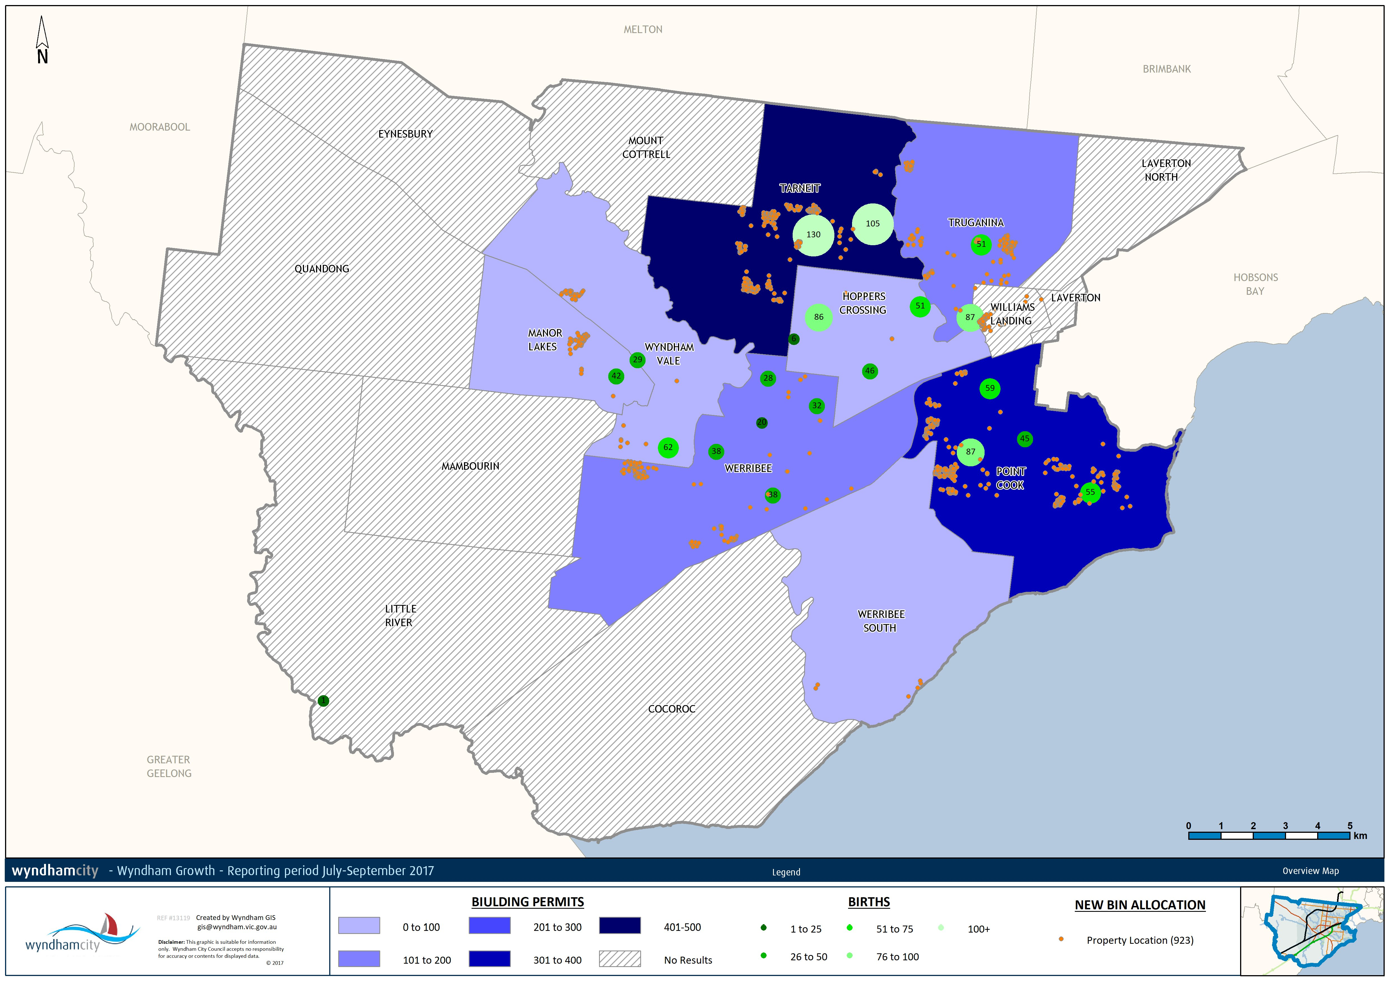

Between 2015 and 2016 Wyndham was the largest growing municipality Victoria-wide, growing by 13,216 persons to 228,088 residents. Over the next 20 years growth is expected to remain strong – the projected population in 2036 is 435,832. Large and unevenly dispersed population growth presents opportunities and challenges for service delivery and planning.
The Quarterly Growth Indicators keep track of where the growth in the city is taking place based on new dwelling approvals, requests for new garbage service, and births. The map below shows that:
- More than half of all building approvals were granted in Tarneit (415) and Point Cook (358) as the blue shading suggests. This corresponds with the large growth that is expected in these areas: between 2017 and 2036 Point Cook is estimated to grow by 17,500 residents, and Tarneit by 55,000 residents.
- The requests for new bins (the orange pins) indicate that residents are mainly moving into new developments in Wyndham Vale, Tarneit, Werribee Truganina and Point Cook.
- The largest numbers of births were in Tarneit and Point Cook as indicated by the green circles that denote the number of births registered by MCH centre. As the growth frontiers, this is not surprising.
All three indicators have seen increases with respect to the previous quarter:
- The number of building permits has set a new record for the June 2012 to September 2017 period. Between July and September 2017 there were 1,356 dwelling permits – up from 1,105 in the previous quarter.
- There were 1,116 new bin requests between July and September 2017 – up from 1,040 in the previous quarter.
- There were 1,098 births between July and September 2017 – that is 83.5 births per week on average, and up from a total of 950 in the previous quarter.

Australian Bureau of Statistics. (2017). Regional Population Growth, Australia. Cat 3218.0.
.ID Population Forecast. (2016). City of Wyndham Population and Household Forecasts 2016-2036.
New dwelling approvals identify where dwelling permits have been approved in the quarter. This indicator identifies areas where residents are expected to move in the next year. This data is available at the suburb level. Once residents move into a new dwelling they lodge a request for new garbage services. This data is available at the address level. Lastly, birth notices are available in terms of the number of births that have been registered with centres.

