Ages 12- 25
Youth Profile

Contents
Executive Summary 2
Demographics 3
Population 3
Population Forecast 3
Cultural Diversity 0
Indigenous residents 0
Country of birth 0
Language 1
English proficiency 2
Religion 3
Education 4
High School 4
Employment 5
Social 7
References 8

Executive Summary
Wyndham has a youth population of around 37,000 people, amounting to approximately 17% of Wyndham’s total population.
The youth population is set to almost double by 2036, with the 12-17 year age cohort experiencing the fastest growth.
Young Indigenous residents account for approximately 2.6% of the total youth population. This is a substantial increase from 2011, when this was 1.1%.
Wyndham’s youth population is more culturally diverse than the youth population across Greater Melbourne. In 2016, a third of 12-25 year olds (33%) in Wyndham were born overseas compared to 26% of young people in Greater Melbourne.
India, New Zealand, China and the Philippines feature in the top 5 most common countries of birth outside Australia for Wyndham and Greater Melbourne 12-17 year olds. The fifth most common country of birth in Wyndham is Thailand.
Over 100 languages are spoken by young people in Wyndham and a third (33%) of people speaks a language other than English.
According to 2016 Census data, religious affiliation is more common amongst Wyndham young people compared to young people across Greater Melbourne.
Educational attainment of young people in Wyndham is lower than that of young people across Greater Melbourne when it comes to high school and tertiary degrees.
Employment rates amongst young people are similar in Wyndham (53.4%) and Greater Melbourne (53.7%).
The proportion of young people walking or taking public transport to work is higher in Greater Melbourne compared to Wyndham.
Around 7% of Wyndham young people are disengaged from education and employment, compared to 5% across Greater Melbourne.
Compared to Greater Melbourne, a slightly larger proportion of young people in Wyndham require assistance with core activities such as communication and self-care.

Demographics

Population
Table 1: Population, 2016
 | Wyndham |  | Greater Melbourne
 | N | % total population | % total population
12-17 years | 15,766 | 7.26% | 6.75%
18-25 years | 21,379 | 9.85% | 11.60%
Total young people | 37,144 | 17.12% | 18.35%
At the 2016 Census, there were just over 37,000 young people aged 12-25 living in Wyndham, accounting for around 17% of the total population. The number of 18-25 year olds is larger than the number of 12-17 year olds. Compared to Wyndham, there are proportionally more young people living across Greater Melbourne.

Population Forecast
Figure 1: Population forecast 12-17 and 18-25 year olds, Wyndham, 2016 to 2036

There is steady growth forecast for young people over the next 20 years. The population of both 12-17 year olds and 18-25 years olds is expected to increase by over 90%. The number of young people aged 12-17 is forecast to more than double from almost 16,000 people in 2016 to over 34,000 by 2036. The population of 18-25 year olds is forecast to increase by 92%, to reach over 45,000 residents by 2036.
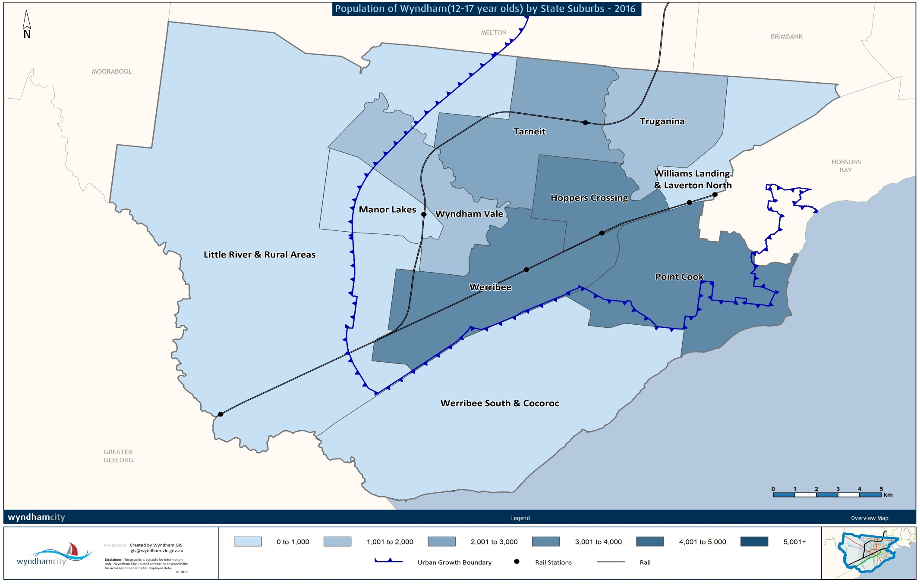
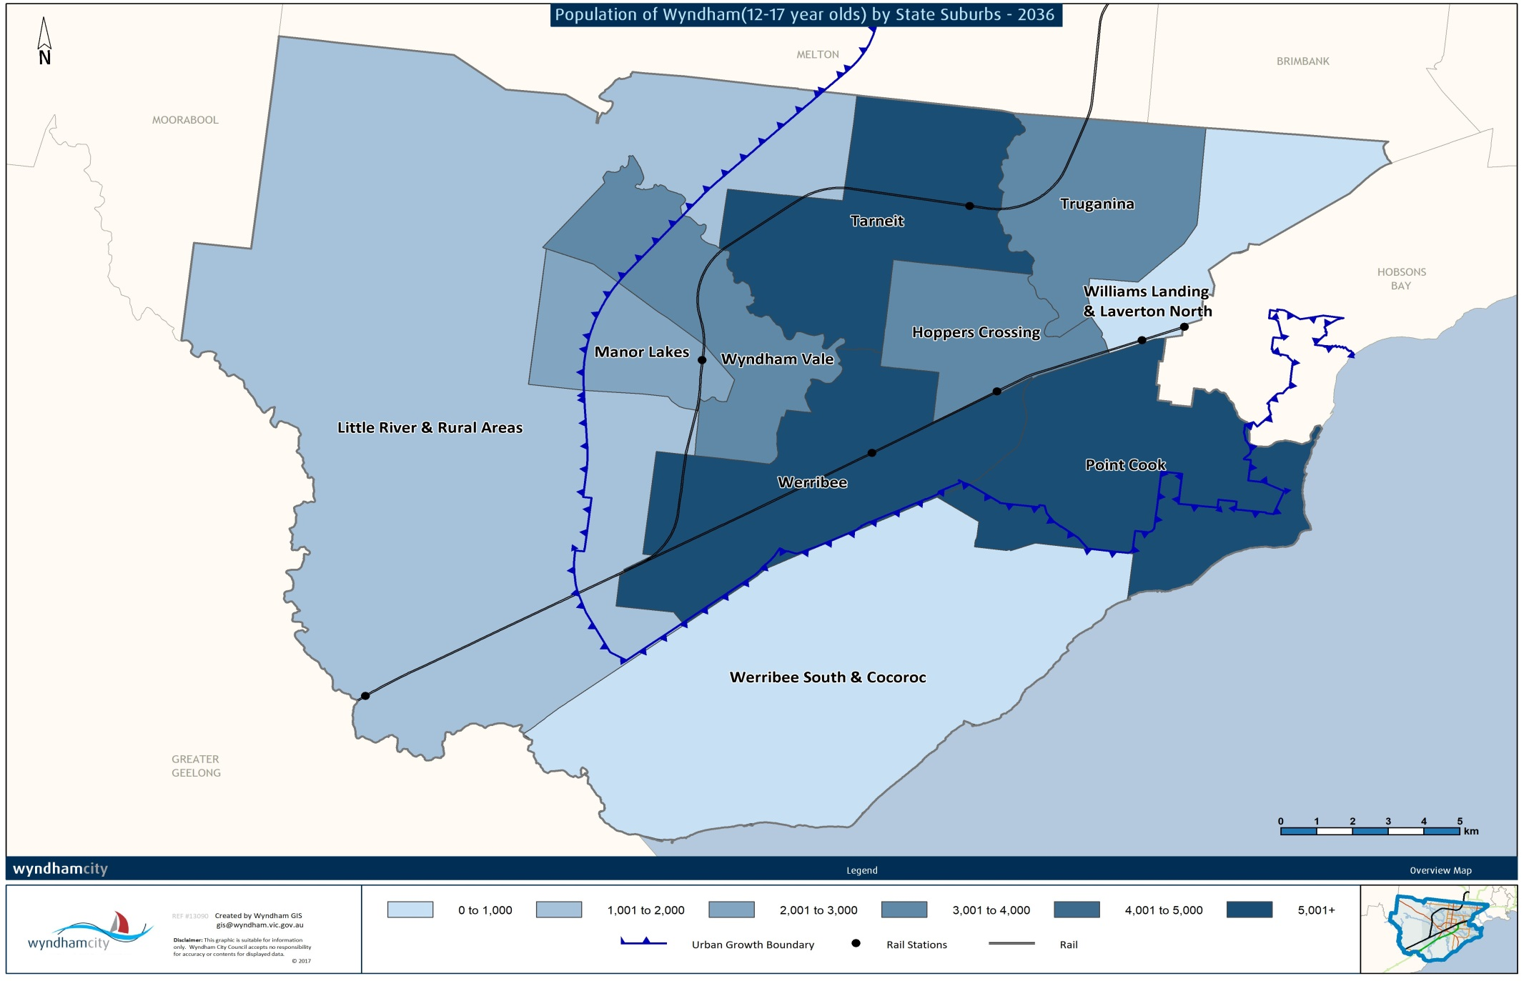

Cultural Diversity

Indigenous residents
There are 479 young people living in Wyndham aged 12 to 25 years who identify as Aboriginal, Torres Strait Islander or both Aboriginal and Torres Strait Islander. The age group of 18-25 year olds is the largest (268 people). Young Indigenous residents account for approximately 2.6% of the total youth population in Wyndham in 2016, whereas in 2011 this was as low as 1.1%.

Country of birth
Figure 2 & 3: Percentage of Overseas Born Young People, Wyndham and Greater Melbourne, 2016
Based on the proportion of people born overseas, Wyndham’s youth population is more culturally diverse than young people across Greater Melbourne. In Wyndham, 31% of 12-17 year olds were born overseas, compared to only 18% in Greater Melbourne. In the 18-25 year age group, cultural diversity is similar across both locations with around a third of residents born overseas.

Table 2: Country of Birth, 12-17 year olds, Wyndham and Greater Melbourne, 2016
 | Wyndham |  | Greater Melbourne
1 | New Zealand | 5.63% | China (excludes SARs and Taiwan) | 2.33%
2 | India | 4.11% | New Zealand | 1.76%
3 | Philippines | 2.84% | India | 1.56%
4 | Thailand | 2.04% | England | 1.33%
5 | China (excludes SARs and Taiwan) | 1.5% | Philippines | 0.84%
The top 5 countries of birth for 12-17 year olds in Wyndham and Greater Melbourne are similar. India, New Zealand, China and the Philippines feature in the top 5 for both areas. However, the proportion of residents born in these countries varies. For example, nearly 6% of Wyndham 12-17 year olds were born in New Zealand compared to less than 2% across Greater Melbourne. In Wyndham, Thailand is the fourth most common country of birth, while in Greater Melbourne, England takes fourth place.

Table 3: Country of Birth of 18-24 year olds, Wyndham and Greater Melbourne, 2016
 | Wyndham |  | Greater Melbourne
1 | India | 8.62% | China (excludes SARs and Taiwan) | 7.68%
2 | New Zealand | 4.89% | India | 3.59%
3 | Philippines | 2.77% | New Zealand | 1.86%
4 | China (excludes SARs and Taiwan) | 1.96% | Malaysia | 1.6%
5 | Thailand | 1.39% | Vietnam | 1.43%
India is the most common country of birth amongst Wyndham’s 18-25 year olds, while China is most common in Greater Melbourne. Vietnam and Malaysia are the fourth and fifth most common countries of birth in this age group across Greater Melbourne, compared to China and Thailand in Wyndham.

Language
Figure 4 & 5: Multilingual Capabilities of 12-17 and 18-25 year olds, Wyndham, 2016
In the 12-17 year age group, 32% of people speak a language other than English. There is slightly more language diversity in the 18-25 year age group with 35% of people speaking one of over 100 languages other than English.

Table 4: Language Spoken at Home by 12-17 year olds, Wyndham and Greater Melbourne, 2016
 | Wyndham |  | Greater Melbourne
1 | Arabic | 2.71% | Mandarin | 3.41%
2 | Karen | 2.16% | Vietnamese | 2.81%
3 | Mandarin | 2.09% | Arabic | 2.23%
4 | Hindi | 1.55% | Greek | 1.68%
5 | Urdu | 1.27% | Cantonese | 1.34%
For 12-17 year olds in Wyndham, Arabic is the most commonly spoken language at home (other than English), followed by Karen, Mandarin, Hindi and Urdu. Across Greater Melbourne, Mandarin is the most commonly spoken language which coincides with China being the most common country of birth. Interestingly, despite Greece not making the top 5 most common countries of birth, Greek was the fourth most commonly spoken language amongst 12-17 year olds across Greater Melbourne.
Table 5: Language Spoken at Home by 18-25 year olds, Wyndham and Greater Melbourne, 2016
 | Wyndham |  | Greater Melbourne
1 | Punjabi | 4.14% | Mandarin | 8.47%
2 | Mandarin | 2.49% | Vietnamese | 3.06%
3 | Arabic | 2.36% | Cantonese | 2.30%
4 | Hindi | 2.06% | Arabic | 1.93%
5 | Karen | 1.98% | Punjabi | 1.46%
The language profile of 18-25 year olds in Wyndham reflects the country of birth trends, where India is the most common country of birth and Punjabi, a language native to India, is the most commonly spoken language other than English.

English proficiency
Figure 6: English Proficiency of 12-25 year olds, Wyndham and Greater Melbourne, 2016
Another indicator of the cultural diversity is the proportion of people who speak only English at home. Young people aged 18-25 years in Wyndham and Greater Melbourne is the most diverse, with around 59% of residents who only speak English. In the 12-17 year age group, 63% from Wyndham only speak English, and 69% in Greater Melbourne. A relatively similar proportion of people can speak another language and English very well or well across both locations and all age groups.

Religion
Figure 6: Religious Affiliation of 12-17 year olds, Wyndham and Greater Melbourne, 2016
According to 2016 Census data, religious affiliation is more common amongst Wyndham young people compared to young people across Greater Melbourne. Nearly 70% of 12-17 year olds in Wyndham were affiliated with a religion, compared to 60% of 12-17 year olds across Greater Melbourne. A much larger proportion of young people across Greater Melbourne reported no religion on the 2016 Census compared to young people in Wyndham (31% and 24% respectively).

Figure 7: Religious Affiliation of 18-25 year olds, Wyndham and Greater Melbourne, 2016
Religious affiliation amongst 18-25 year olds in Wyndham is relatively high compared to Greater Melbourne. 63% of Wyndham’s 18-25 year old population were affiliated with a religion, compared to just over 50% across Greater Melbourne. Christianity was the most popular religion in Wyndham, followed by Islam and Hinduism.

Education

High School
Table 7: Highest Year of School Completed of 20-25 years, Wyndham and Greater Melbourne 2016
 | Wyndham | Greater Melbourne
Year 12 or equivalent | 71.90% | 79.78%
Year 11 or equivalent | 8.10% | 5.34%
Year 10 or equivalent | 8.79% | 1.45%
Year 9 or equivalent | 2.23% | 0.78%
Year 8 or below | 1.33% | 0.48%
Did not go to school | 0.41% | 6.5%
Total | 100.0% | 100.0%

High school retention rates in Wyndham are lower than across Greater Melbourne. In 2016, 72% of Wyndham residents aged 20-25 years had completed year 12 or equivalent, compared to 80% of 20-25 year olds across Greater Melbourne.
Figure 8: Highest Level of Education Attained by 18-25 year olds, Wyndham and Greater Melbourne, 2013
In Wyndham, the most common qualification held by young people is a certificate (18%), followed by Bachelor degrees (11%) and Advanced diplomas/diplomas (7%). Across Greater Melbourne, education attainment is higher, with 18% of young people with a bachelor degree or higher, compared to 13% of Wyndham young people.

Employment
Figure 9: Employment Status of 15-25 year olds, Wyndham and Greater Melbourne, 2016

Employment rates amongst young people are relatively similar between Wyndham and Greater Melbourne. In 2016, 49% of Wyndham 15-25 year olds were employed compared with 51% of 15-25 year olds across Greater Melbourne. Similarly, around 35% of young people in both Wyndham and Greater Melbourne were not in the labour force. This is not equivalent to an unemployment rate given that many young people are enrolled in an educational institute.
Table 8: Most Common Industries of Employment of 15-25 year olds, Wyndham and Greater Melbourne, 2016
Industry | Wyndham | Industry | Greater Melbourne
Retail Trade | 21.5% | Retail Trade | 20.7%
Accommodation and Food Services | 17.9% | Accommodation and Food Services | 18.7%
Construction | 9.3% | Construction | 8.6%
Health Care and Social Assistance | 6.9% | Health Care and Social Assistance | 7.4%
Transport, Postal and Warehousing | 5.9% | Education and Training | 6.0%
The most common industries of employment for young people in Wyndham and Greater Melbourne are retail and accommodation and food services. Both of these industries facilitate part time work that students can perform while attaining an education.

Table 9: Method of Travel to Work of 15-25 year olds, Wyndham and Greater Melbourne, 2016
 | Wyndham | Greater Melbourne
Car, as driver | 53.5% | 48.9%
Car, as passenger | 16.9% | 12.2%
Train | 12.4% | 12.3%
Bus | 5.3% | 5.1%
Walk | 2.2% | 4.6%
Bicycle | 0.6% | 1.4%
The proportion of young people walking to work is higher in Greater Melbourne compared to Wyndham (4.6% and 2.2% respectively). The vast majority of employed young people in Wyndham either drove to work or was the passenger in a car (70.4%). Compared with all Wyndham residents who travel to work, young people are more likely to walk or take the bus (1.5% and 7.5% respectively), and less likely to drive to work. This indicates that it is likely that young people’s place of employment is usually closer to home.

Table 9: Most Common Occupations of 15-25 year olds, Wyndham and Greater Melbourne, 2016
 | Wyndham |  | Greater Melbourne
1 | Sales Workers | 25.3% | 1 | Sales Workers | 24.1%
2 | Labourers | 14.8% | 2 | Community and Personal Service Workers | 17.3%
3 | Technicians and Trades Workers | 14.6% | 3 | Technicians and Trades Workers | 13.7%
4 | Community and Personal Service Workers | 13.8% | 4 | Professionals | 12.7%
5 | Clerical and Administrative Workers | 10.5% | 5 | Labourers | 12.5%
The employment profile of young people in Wyndham and Greater Melbourne is relatively similar. There is a large proportion of youth working in sales, and as technicians and in trades. Interestingly, nearly 7% of young people across Greater Melbourne work in professional occupations making it the 4th most common occupation type. In Wyndham, professional jobs do not make the top 5 most common occupations; only 8% of Wyndham young people are employed in professional occupations.
Figure 10: Percentage of 15-25 year old who Volunteer, Wyndham and Greater Melbourne, 2016
Compared with Greater Melbourne a lower proportion of young people in Wyndham are volunteers. The difference is small: 14.7% of young people across Greater Melbourne volunteer, while this is 14% for young people in Wyndham.

Social
Table 10: Number of Young Mothers, Wyndham, 2016
 | Wyndham LGA |  | Less than 1% of 12-17 year olds in Wyndham have given birth. The 6 young mothers have all given birth to 1 child.  Over 1,200 women aged 18-25 have given birth to 1 or more children.
Number of Children Ever Born | 12-17 years | 18-25 years
1 child | 6 | 778
2 children | 0 | 348
3 children | 0 | 74
4 children | 0 | 25
5 children | 0 | 7
6 children | 0 | 3

Table 11: Youth Disengagement amongst 15-25 year olds, Wyndham and Greater Melbourne, 2016
 | Wyndham |  | Greater Melbourne
 | N | % | N | %
Disengaged Youth | 3,432 | 11.8% | 53,585 | 8.0%
Youth disengagement is more prevalent in Wyndham compared to Greater Melbourne. In 2016, nearly 12% of 15-25 year olds were not studying or working, compared to 8% of 15-25 year olds across Greater Melbourne.

Figure 8: Percentage of Young People with a Need for Assistance, Wyndham and Greater Melbourne, 2016

A slightly larger proportion of young people in Wyndham require assistance with core activities including communication and self-care. In 2016, 3.5% of 12-17 year olds and 2% of 18-25 year olds from Wyndham required assistance.

References
Australian Bureau of Statistics, Census of Population and Housing (2016). Analysed by Wyndham City Council via TableBuilder
ID Consulting. (2016). Population Forecasts - Wyndham

