Early Years Profile

Children aged 0-4 years

Contents
Executive Summary 2
Demographics 3
Population 3
Population Forecast 3
Cultural Diversity 0
Indigenous Status 0
Country of Birth 0
Parents Country of Birth 0
Religion 1
References 2

Executive Summary
There are 21,381 infants and young children aged 0-4 years living in Wyndham. This age group is one of Wyndham’s largest, accounting for nearly 10% of the total population.
The population of 0-4 year olds is forecast to reach over 36,200 residents by 2036.
There are 213 Indigenous early years residents in Wyndham, accounting for around 1% of the total 0-4 year old population.
It is more common for early years children in Wyndham to be affiliated with a religion through their families, compared to early years children across Greater Melbourne.
The vast majority of 0-4 year olds in Wyndham and Greater Melbourne were born in Australia (88% and 89% respectively). India and New Zealand were the top 2 most common countries of birth outside Australia amongst Wyndham and Greater Melbourne early years children.
A large proportion of early years children are first generation Australians. In 2016, 69% of children had one or both parents born in an overseas country.
Around 30% of 0-4 year olds can speak another language and English to varying degrees. Punjabi and Mandarin are the two most commonly spoken languages other than English amongst Wyndham and Greater Melbourne 0-4 year olds.

Demographics

Population
Figure 1: Percentage Total Population, Wyndham and Greater Melbourne, 2016

There are an estimated 21,381 infants and young children aged 0-4 years living in Wyndham. This age group is one of Wyndham’s largest, and has been steadily increasing from just over 8% in 2006 to nearly 10% in 2016. Compared to Greater Melbourne, Wyndham has a proportionally larger population of early years children (9.85% and 6.40% respectively). Furthermore, the percentage contribution of 0-4 year olds to the total overall population in Greater Melbourne has remained relatively stable over the past 10 years.

Population Forecast
Figure 2: Population Forecast 0-4 year olds, Wyndham, 2016 to 2036

Steady growth is forecast in the 0-4 year age group over the next 20 years. The largest growth is forecast to occur between 2016 and 2021, when an additional 4,960 0-4 year olds are expected to join the Wyndham community. By 2036, it is expected that over 36,200 Wyndham residents will be aged 0-4 years. This amounts to a growth of over 80% between 2016 and 2036.
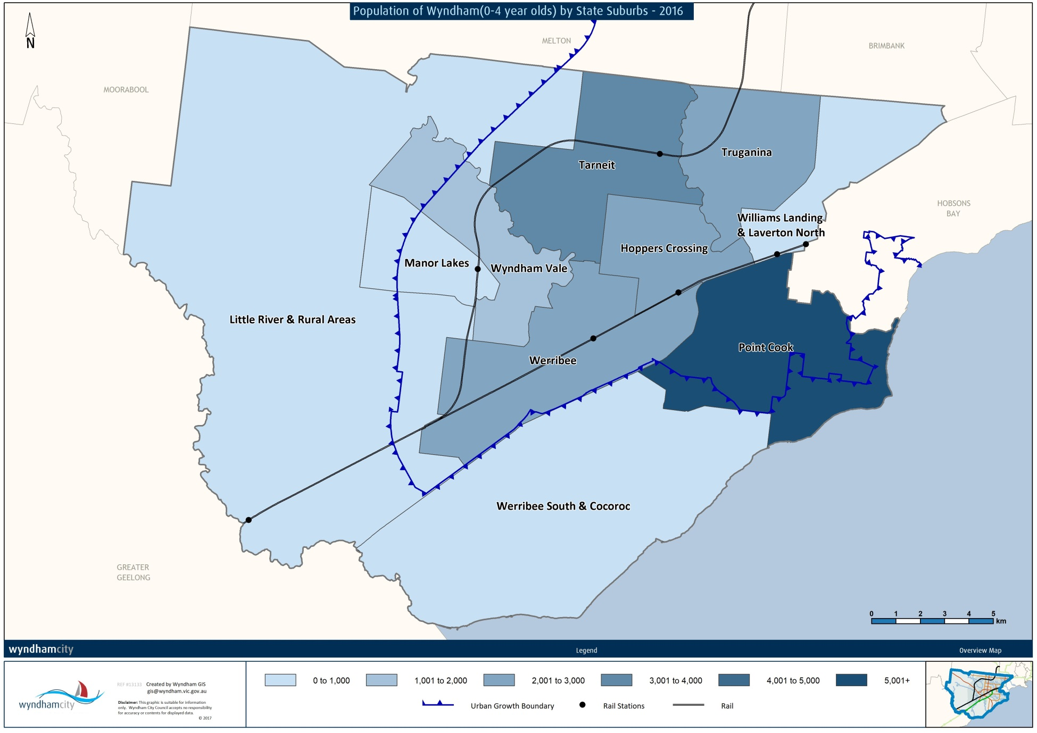
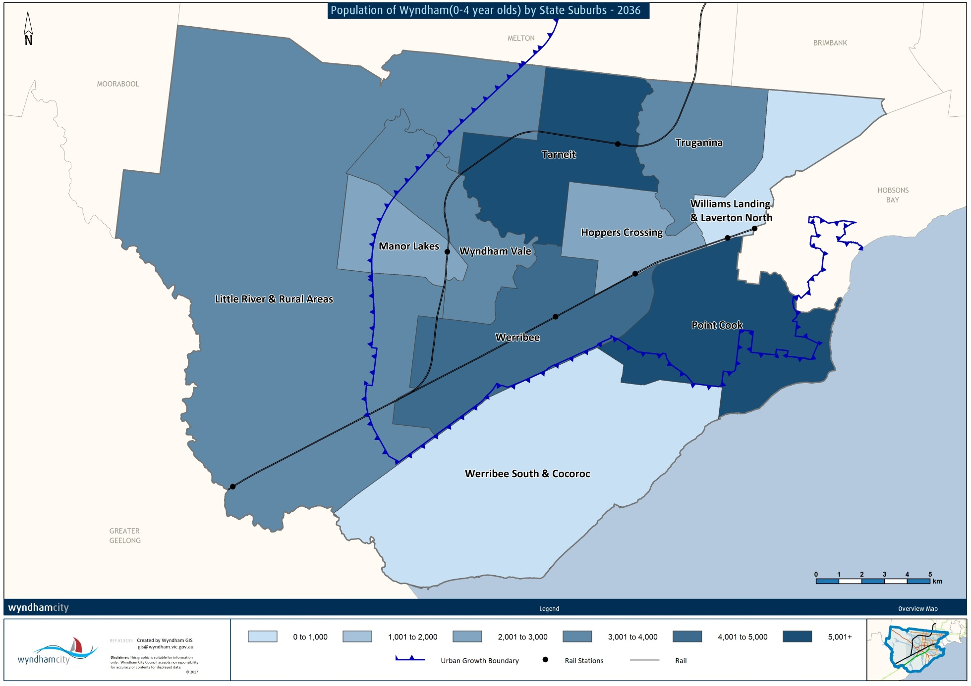

Cultural Diversity

Indigenous Status
There are 213 early years children in Wyndham who identify as Aboriginal, Torres Strait Islander or both Aboriginal and Torres Strait Islander. Young Indigenous residents account for approximately 1% of the total early year’s population, and 12.3% of the total Indigenous population.

Country of Birth
Table 1: Country of Birth, Wyndham and Greater Melbourne, 2016
Wyndham |  |  | Greater Melbourne
Country |  | % | Country |  | %
Australia |  | 88.15% | Australia |  | 89.43%
1 | India | 2.24% | 1 | India | 1.13%
2 | New Zealand | 1.28% | 2 | New Zealand | 0.5%
3 | Pakistan | 0.36% | 3 | China | 0.44%
4 | China | 0.35% | 4 | England | 0.36%
5 | Malaysia | 0.31% | 5 | Pakistan | 0.22%
The vast majority of 0-4 year olds in Wyndham and Greater Melbourne were born in Australia (88% and 89% respectively). India and New Zealand were the top 2 most common countries of birth outside Australia amongst Wyndham and Greater Melbourne early years children. China and Pakistan also featured in the top 5 for each area.

Parents Country of Birth
Table 2: Parents Country of Birth, Wyndham and Greater Melbourne, 2016
 | Wyndham | Greater Melbourne
Both parents born overseas | 56.31% | 34.47%
Father only born overseas | 6.83% | 8.85%
Mother only born overseas | 5.86% | 8.24%
Both parents born in Australia | 26.22% | 43.28%
A large proportion of early years children are first generation Australians. In 2016, 56% of Wyndham’s 0-4 year olds had both parents born overseas. In total, 69% had one or both parents born in an overseas country. In Greater Melbourne, just over half of all 0-4 year olds had one or both parents born overseas.
Table 3: Language Spoken at Home, Wyndham and Greater Melbourne, 2016
Wyndham |  |  | Greater Melbourne
English |  | 52.11% | English |  | 63.25%
1 | Punjabi | 4.56% | 1 | Mandarin | 4.05%
2 | Mandarin | 4.2% | 2 | Punjabi | 1.98%
3 | Hindi | 3.4% | 3 | Arabic | 1.95%
4 | Urdu | 2.65% | 4 | Vietnamese | 1.93%
5 | Gujarati | 2.09% | 5 | Cantonese | 0.99%

More than half of all 0-4 year olds in Wyndham speak English, however considering the cultural diversity amongst their parents, it is likely a number of these children are bilingual. According to the 2016 Census, around 30% of 0-4 year olds can speak another language and English to varying degrees. Punjabi and Mandarin are the two most commonly spoken languages other than English amongst Wyndham and Greater Melbourne 0-4 year olds.

Religion
It is more common for early years children in Wyndham to be affiliated with a religion through their families, compared to early years children across Greater Melbourne. Christianity is the most popular religion across both areas, while Hinduism and Islam are popular in Wyndham. At the 2016 Census, 13% of 0-4 year olds were affiliated with the Hindu religion, and 11% with Islam. Interestingly, 38% of 0-4 year olds across Greater Melbourne are not affiliated with any religion compared to 26% in Wyndham.

References
Australian Bureau of Statistics, Census of Population and Housing (2016). Analysed by Wyndham City Council via TableBuilder
ID Consulting. (2016). Population Forecasts - Wyndham

