Middle Years Profile

Ages 5-11 years

Contents
Executive Summary 2
Population 3
Forecast Population 0
Indigenous Status 0
Country of Birth 0
Language Spoken at Home 1
Religion 2
References 2

Executive Summary
At the 2016 Census, there were over 24,400 5-11 year olds living in Wyndham; approximately 11.26% of Wyndham’s total population.
Wyndham is in the midst of the greatest forecast growth for this age group, where between 2016 and 2021 more than 6,700 5-11 year olds will be added to the population.
At the 2016 Census, there were 278 people who identified as Aboriginal and 6 people that identified as Torres Strait Islander. In total, Indigenous children account for around 1.1% of the population of 5-11 year olds.
5-11 year old children in Wyndham are more diverse than children across Greater Melbourne. In 2016, around 20% of Wyndham 5-11 year olds were born overseas in countries such as New Zealand, India and Thailand.
More than half of Wyndham 5-11 year olds had both parents born overseas, and over 60% at least one parent born overseas. In comparison, only 31% of 5-11 year olds parents in Greater Melbourne were both born overseas.
Compared to Greater Melbourne, a smaller proportion of Wyndham 5-11 year olds speak English at home. This may be due to the high proportion of parents born outside Australia speaking their native languages to their children.
It is more common for 5-11 year olds in Wyndham to be affiliated with a religion compared to children across Greater Melbourne.

Population

Table 1: Population Summary, Wyndham, 2016
 | Wyndham
Age | No. | % total population
5-11 years | 24,442 | 11.26%
At the 2016 Census, there were over 24,400 5-11 year olds living in Wyndham; approximately 11.3% of Wyndham’s total population. As seen in Figure 1 below, the proportion of children living in Wyndham is higher than across Greater Melbourne. Just over 8.5% of the population of Greater Melbourne are aged 5-11 years, compared to 11.3% of Wyndham’s population. This highlights the young age profile of Wyndham. The number of 5-11 year olds in Wyndham has almost doubled in the past 10 years; however the overall contribution to the population has remained at around 11%.

Figure 1: Population 5-11 Year Olds, Wyndham and Greater Melbourne, 2016

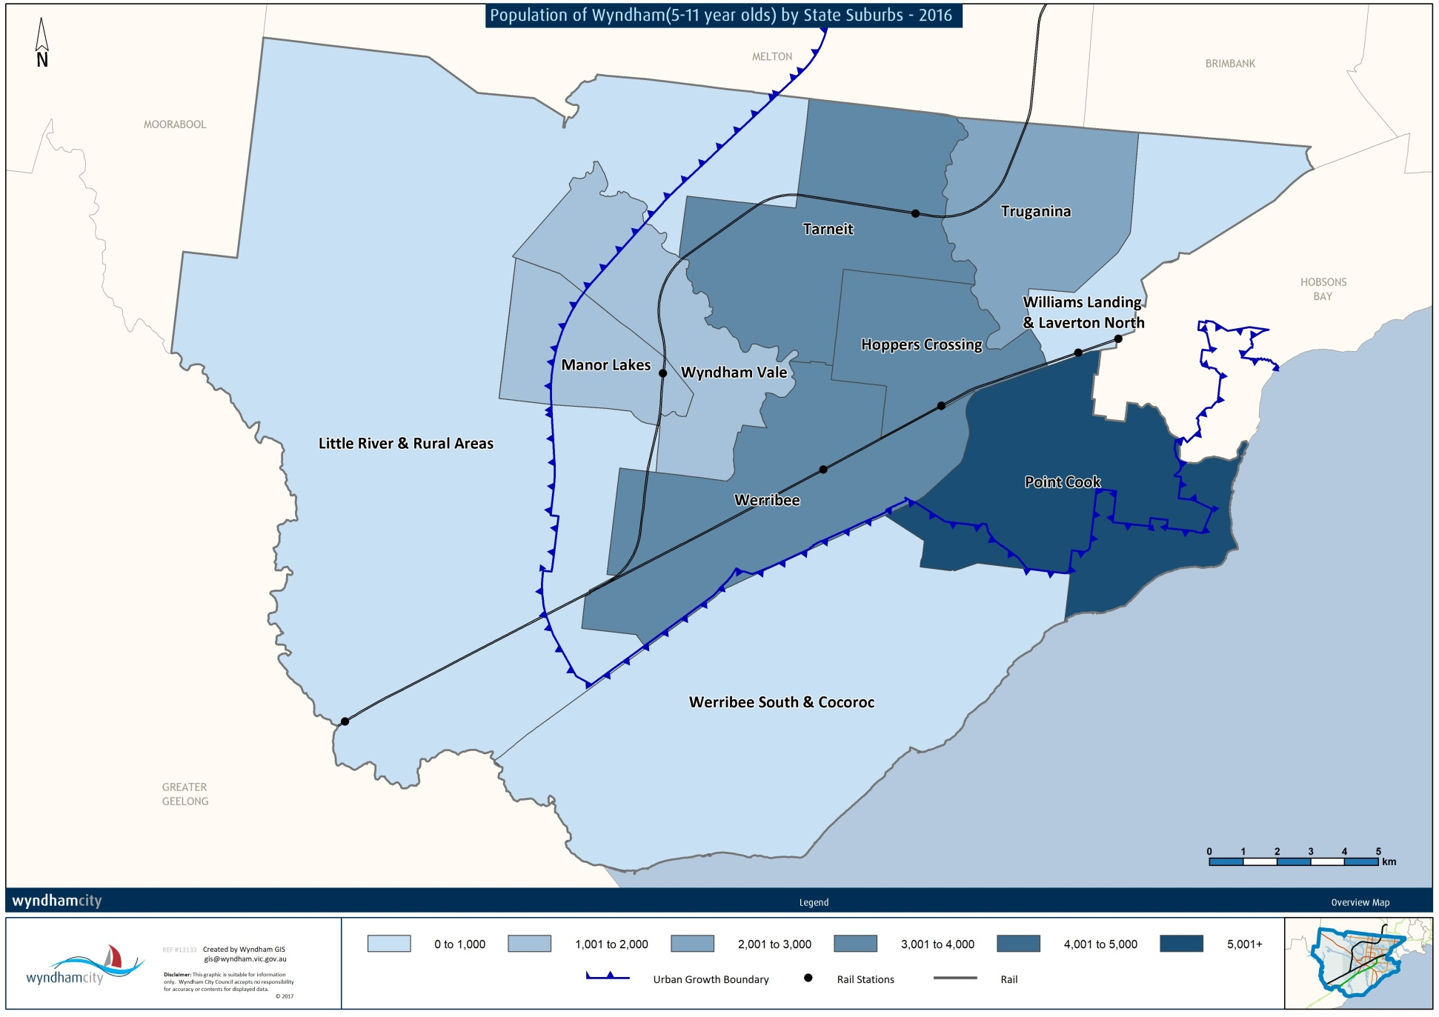
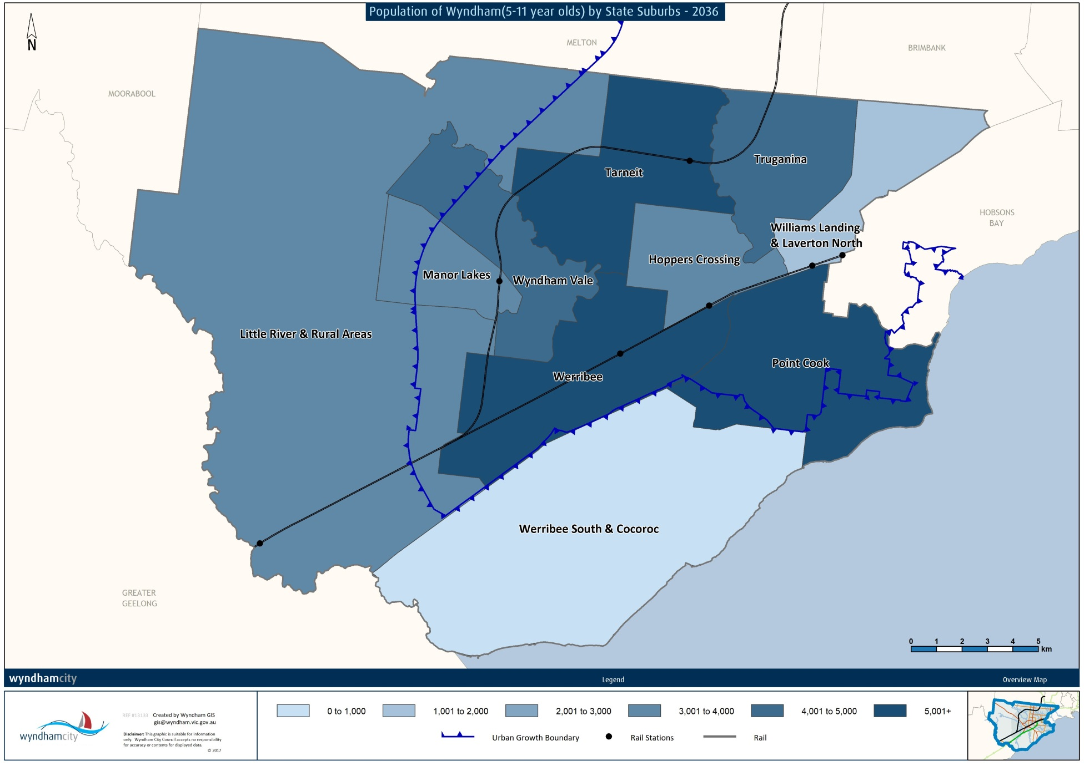

Forecast Population
Figure 2: Forecast Population, Wyndham, 2016 to 2036

The population of 5-11 year olds is forecast to increase by over 22,000 people in the next 20 years. Wyndham is in the midst of the greatest forecast growth for this age group, where between 2016 and 2021 more than 6,700 5-11 year olds will be added to the population. In only 5 years, the size of this age group will increase by over 29%.

Indigenous Status
There is a small Indigenous population of 5-11 year olds in Wyndham (284 people). At the 2016 Census, there were 278 people who identified as Aboriginal and 6 people that identified as Torres Strait Islander. In total, Indigenous children account for around 1.1% of the population of 5-11 year olds in Wyndham, and 16% of the total Indigenous population.

Country of Birth
Table 2: Country of Birth, Wyndham and Greater Melbourne, 2016
Wyndham |  | % | Greater Melbourne |  | %
Australia |  | 75.06% | Australia |  | 82.84%
1 | New Zealand | 4.21% | 1 | India | 1.72%
2 | India | 4.17% | 2 | New Zealand | 1.49%
3 | Thailand | 1.12% | 3 | England | 1.13%
4 | Philippines | 1.01% | 4 | China | 0.97%
5 | England | 0.99% | 5 | Sri Lanka | 0.52%
5-11 year old children in Wyndham are more diverse than children across Greater Melbourne. In 2016, around 20% of Wyndham 5-11 year olds were born overseas, the top three countries being New Zealand, India and Thailand. Across Greater Melbourne, around 13% of 5-11 year olds were born overseas. The most common countries for Greater Melbourne children are India, New Zealand and England.
To further highlight the cultural diversity of the Wyndham 5-11 year old population, figure 3 below identifies the proportion of children whose parents were born overseas. More than half of Wyndham 5-11 year olds had both parents born overseas, and over 60% at least one parent born overseas. In comparison, only 31% of 5-11 year old parents across Greater Melbourne were both born overseas.
Figure 3: Proportion of Parents Born Overseas, Wyndham and Greater Melbourne, 2016

Language Spoken at Home
Table 3: Language Spoken at Home, Wyndham and Greater Melbourne, 2016
Wyndham |  |  |  | Greater Melbourne
English |  | 58.75% |  | English |  | 68.85%
1 | Hindi |  | 2.89% | 1 | Mandarin | 2.87%
2 | Arabic |  | 2.77% | 2 | Arabic | 2.29%
3 | Urdu |  | 2.75% | 3 | Vietnamese | 2.12%
4 | Punjabi |  | 2.61% | 4 | Greek | 1.54%
5 | Mandarin |  | 2.42% | 5 | Punjabi | 1.07%

Compared to Greater Melbourne, a smaller proportion of Wyndham 5-11 year olds speak English at home. This may be due to the high proportion of parents born outside Australia speaking their native languages to their children. Languages originating in India, including Hindi, Urdu and Punjabi are the most common in Wyndham, while Mandarin, Arabic and Vietnamese are common across Greater Melbourne.

Religion
Figure 4: Religious Affiliation, Wyndham and Greater Melbourne, 2016
It is more common for 5-11 year olds in Wyndham to be affiliated with a religion than it is for children across Greater Melbourne. Christianity is the most popular religion across both areas, while Hinduism and Islam are more popular in Wyndham. At the 2016 Census, 9% of 5-11 year olds were affiliated with the Hindu religion, and 12% with Islam. 32% of 5-11 year olds across Greater Melbourne are not affiliated with any religion compared to 23% in Wyndham.

References
Australian Bureau of Statistics, Census of Population and Housing (2016). Analysed by Wyndham City Council via TableBuilder
ID Consulting. (2016). Population Forecasts - Wyndham

