October 2017 Update

Housing in Wyndham

Housing diversity

House type and size

Dwelling types
There are a total of 75,184 dwellings in Wyndham. Across Greater Melbourne municipalities the number of dwellings is higher only in Casey (102,049), Mornington Peninsula (89,110) and Melbourne (75,805).
More than four out of five dwellings in Wyndham (83.1%) are separate houses and a further 14% are semi-detached houses (Table 1). Furthermore, there is a low proportion of flats and apartments (2.5%) and caravans, cabins and houseboats (0.4%). Less than a tenth of a per cent of dwellings are attached to shops, and less than a tenth of a per cent are improvised homes and tents. Wyndham differs quite substantially from Greater Melbourne in terms of dwelling structure due to its status as a growth council and land availability for separate and semi-detached houses. The key difference is that Greater Melbourne has a higher proportion of flats and apartments (16.1%). In three municipalities, flats and apartments form the majority of all dwellings: Melbourne (84%), Port Phillip (67%) and Stonnington (53%), with Yarra not far behind at 47%.
The overall growth in Wyndham dwellings between 2006 to 2011 was higher than in the 2011-2016 period. In 2006, there were just under 41,000 dwellings in Wyndham, increasing to just over 59,000 in 2011 and just over 75,000 in 2016. Semi-detached houses have grown particularly quickly; the stock in 2016 is more than triple the 2011 level. Between 2006 and 2011 the growth in separate houses accounted for almost all of the growth in the total number of dwellings. Between 2011 and 2016 separate houses comprised 59.5% of growth in the total number of dwellings, and semi-detached houses 44%.
Table 1: Dwelling structure, Wyndham, 2006-2016
 | Number |  |  | Growth
Dwelling type | 2006 | 2011 | 2016 | 2006-2011 | 2011-2016
Separate house | 36,174 | 52,951 | 62,480 | 46.4% | 18.0%
Semi-detached house | 2,347 | 3,433 | 10,504 | 46.3% | 206.0%
Flat or apartment | 2,056 | 2,589 | 1,877 | 25.9% | -27.5%
House or flat attached to a shop, office, etc. | 18 | 27 | 19 | 50.0% | -29.6%
Caravan, cabin, houseboat | 271 | 163 | 283 | -39.9% | 73.6%
Improvised home, tent, sleepers out | 10 | 12 | 21 | 20.0% | 75.0%
Total | 40,876 | 59,175 | 75,184 | 44.8% | 27.1%

To a large extent the housing stock in Wyndham is similar across suburbs. In all suburbs except Laverton and Werribee South, separate and semi-detached houses comprise between 92% and 100% of the dwelling stock. In Werribee South some 11% of dwellings are flats or apartments, and 22% are caravans, cabins and houseboats – Wyndham Harbour. Laverton North also differs in that the majority of dwellings are caravans, cabins or houseboats – Laverton North is largely an industrial area with Honey Hush Caravan Park being the main area where people can live.
Table 2: Dwelling structure, Wyndham suburbs, 2016
 | Separate house | Semi-detached house | Flat or apartment | House or flat attached to a shop, office, etc. | Caravan, cabin, houseboat | Improvised home, tent, sleepers out | Total
Hoppers Crossing | 84.2% | 8.0% | 7.8% | 0% | 0% | 0% | 100%
Laverton North | 4.9% | 13.1% | 0% | 0% | 82.0% | 0% | 100%
Little River | 100% | 0% | 0% | 0% | 0% | 0% | 100%
Mambourin | 100% | 0% | 0% | 0% | 0% | 0% | 100%
Mount Cottrell | 100% | 0% | 0% | 0% | 0% | 0% | 100%
Point Cook | 84.5% | 13.6% | 1.9% | 0% | 0% | 0% | 100%
Tarneit | 80.1% | 19.0% | 0.9% | 0% | 0% | 0% | 100%
Truganina | 72.8% | 26.6% | 0.5% | 0.1% | 0.0% | 0% | 100%
Werribee | 80.8% | 17.6% | 1.3% | 0% | 0.1% | 0% | 100%
Werribee South | 61.5% | 5.2% | 11.2% | 0% | 22.1% | 0% | 100%
Williams Landing | 85.9% | 14.1% | 0% | 0% | 0% | 0% | 100%
Wyndham Vale | 96.5% | 3.3% | 0.2% | 0% | 0% | 0% | 100%

Dwelling size
Many of the new estates in Wyndham have been designed for the needs of a moderately sized family. Two developments have likely accelerated the prevalence of separate and semi-detached houses in Wyndham. The first of these is a surge in covenants during the 1980s that regulated minimum floor space size and limited the building of dual occupancies. The second is the low median house price relative to large parts of Greater Melbourne which has attracted young families to areas such as Point Cook and Truganina.
The dwelling structure in Wyndham follows the pattern observed in dwelling types above, and reflects Wyndham’s status as a growth area in a different way. As can be seen in Figure 1, more than 84 per cent of dwellings in Wyndham have three or four bedrooms, and just over 8 per cent of dwellings have fewer than three bedrooms. In contrast, more than a quarter of dwellings in Greater Melbourne have fewer than three bedrooms while only around two thirds of dwellings have three or four bedrooms.
Dwelling structure in Wyndham has remained constant since 2006 and 2011 because of the consistent development of family-suitable housing throughout the period. In contrast, there has been a marked change in Greater Melbourne where three and four bedroom dwellings have made way for dwellings with fewer than three bedrooms.
Figure 1: Dwelling structure, Wyndham, 2016
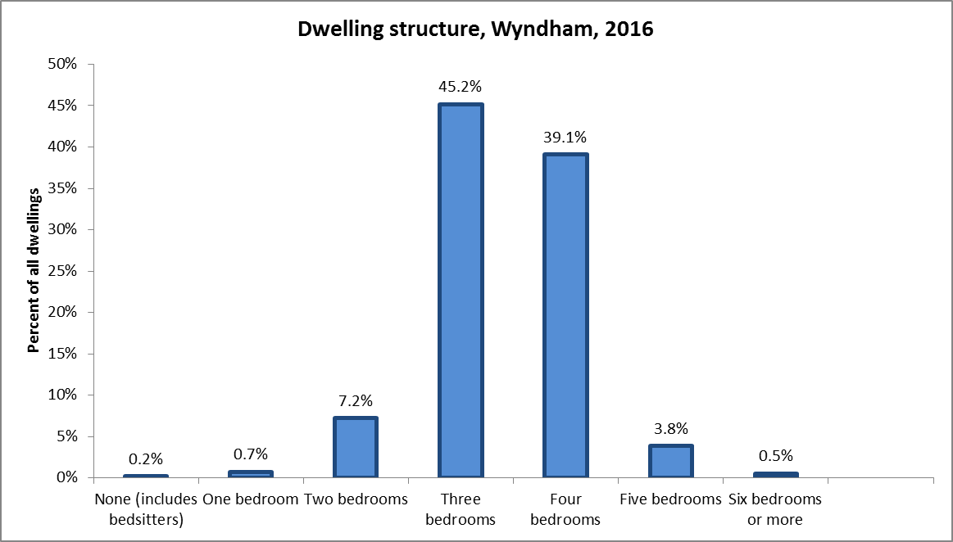
Dwelling size across suburbs in Wyndham is largely consistent as Table 3 shows. The notable exceptions are that in the established areas of Hoppers Crossing and Werribee there is a relatively large number of dwellings with fewer than three bedrooms. Similarly, recent developments have caused Werribee South (Wyndham Harbour) to be an outlier. On the other end of the spectrum Williams Landing and Point Cook have higher proportions of dwellings with five bedrooms or more. As is indicated later, these two areas are also the ones with the highest median income levels across Wyndham.
Table 3: Dwelling structure by suburb, Wyndham, 2016
 | 0 to 2 bedrooms | 3 or 4 bedrooms | 5 bedrooms or more
Hoppers Crossing | 6.4% | 88.4% | 5.2%
Williams Landing - Laverton | 5.2% | 84.1% | 10.7%
Tarneit | 6.3% | 89.2% | 4.5%
Truganina | 4.9% | 91.5% | 3.6%
Werribee | 14.7% | 81.7% | 3.6%
Werribee South | 22.2% | 74.1% | 3.7%
Wyndham Vale | 4.6% | 92.0% | 3.5%
Point Cook | 4.1% | 89.5% | 6.3%

Figure 2 displays the distribution of moderately sized family homes (three or four bedrooms) across Wyndham at the most detailed geography available (SA1).The map shows the overall suburb patterns as in Table 3, and indicate also several pockets within the suburbs.
Figure 2: Map of three and four bedroom dwellings, Wyndham, 2016
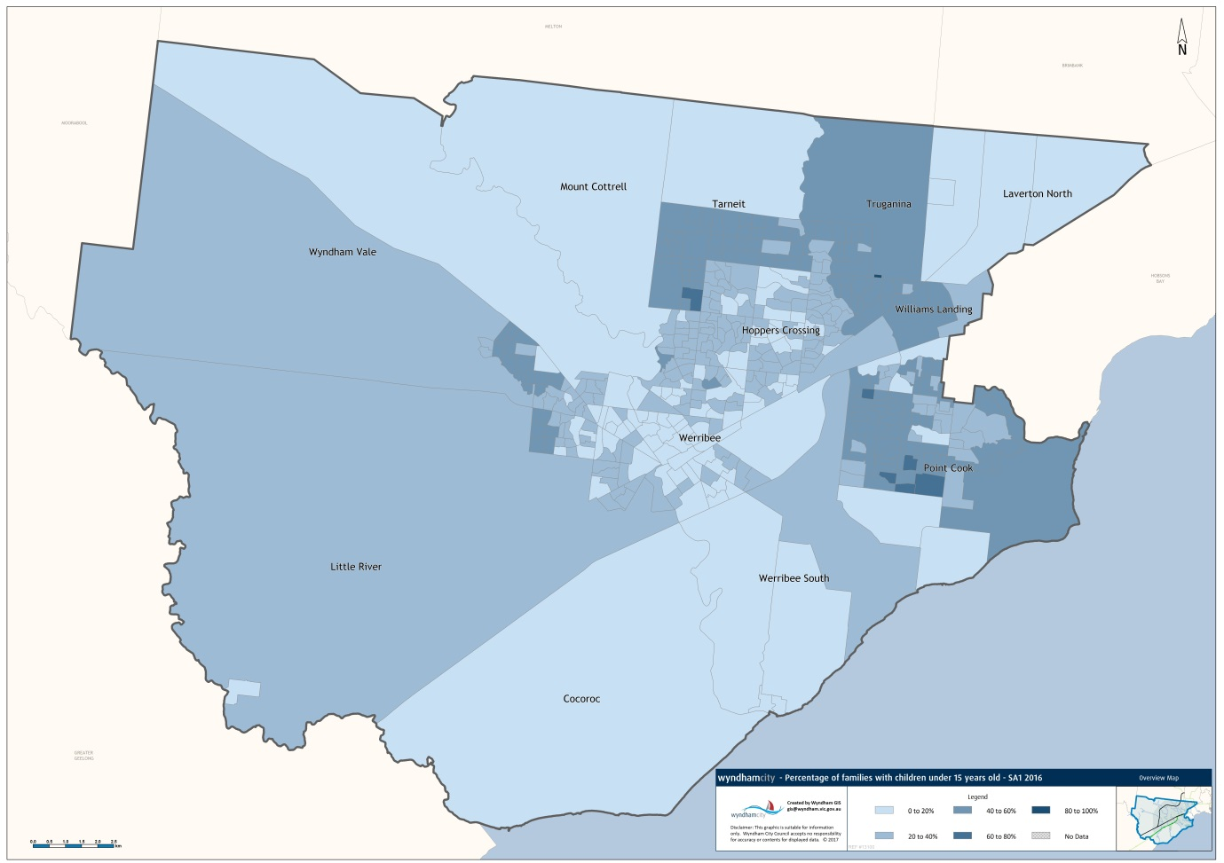

Dwelling occupancy
Not all dwellings are occupied. In 2016, around 6.6 per cent of Wyndham’s dwellings are unoccupied; lower than the 9.1 per cent rate in Greater Melbourne. In addition, while the percentage of unoccupied dwellings has increased steadily in Greater Melbourne (Figure 3), in Wyndham it is at around the same proportion as in 2006 after an increase in 2011.
Since 2011, the number of unoccupied houses in Wyndham has increased while the number of unoccupied flats/apartments has decreased. This likely at least in part represents families choosing to buy a house in Wyndham to live in rather than buying for investment purposes. Households may also be unoccupied because they are for sale, newly completed, under repair, or holiday homes (less likely in Wyndham compared with other bayside suburbs due to the lack of waterfront-adjacent properties).
Figure 3: Percentage of dwellings that are unoccupied, Wyndham and Greater Melbourne, 2006-2016
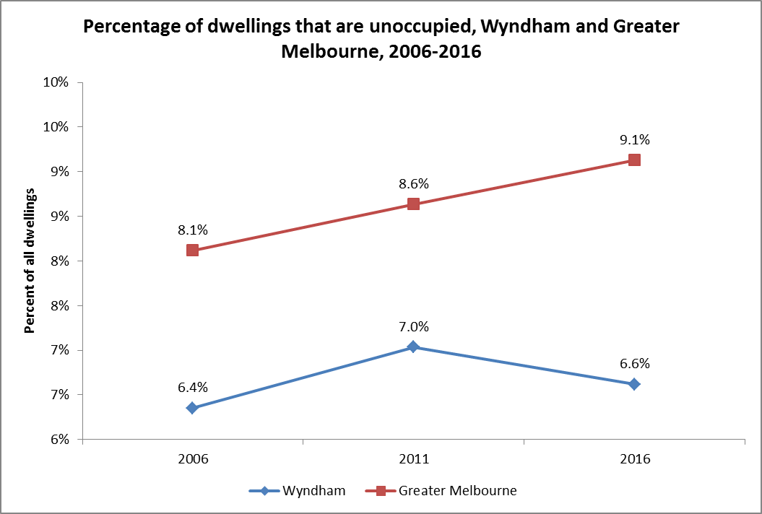

Density
Wyndham has very few high density areas as Figure 4 demonstrates. Across the 445 smallest statistical areas against which it is possible to map data, only 4 areas have high density dwellings.
Figure 4: High density housing as a percentage of all dwellings, Wyndham, 2016
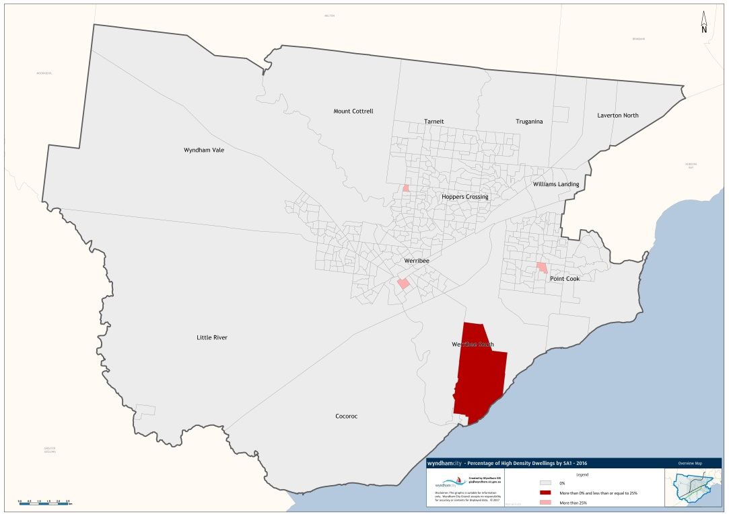
The key differentiation between densities in Wyndham is between medium density housing (ranging from 25 to 80 dwellings per hectare) and low density housing (generally between 8 to 15 dwellings per hectare). Figure 5 below maps the distribution of medium density housing. The denser pockets are near local town centres.
Figure 5: Medium density housing as a percentage of all dwellings, Wyndham, 2016
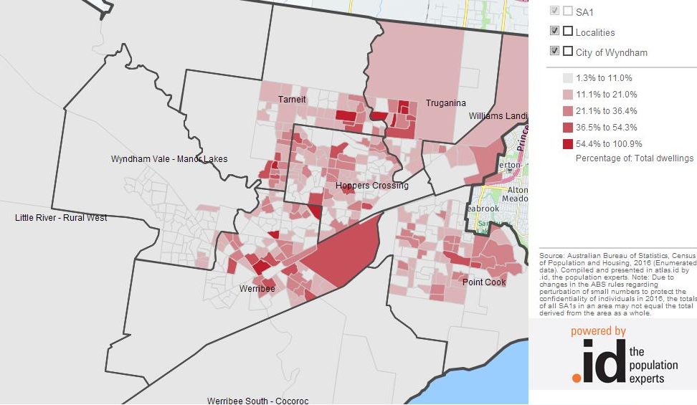

Families

Household size
Household size in Wyndham has increased more rapidly than in Greater Melbourne since 2011, and now sits at an average household of 3.1 people. This is up from 2.9 in 2006 and 2011. In Greater Melbourne, average household size has increased to 2.7 in 2016 from 2.6 in 2006 and 2011.
While Wyndham has the largest population of Aboriginal and Torres Strait Islander residents in Greater Melbourne, it does not have the largest number of households with Aboriginal and/or Torres Strait Islander residents. In Wyndham 762 such households exist, behind Casey’s 810. In addition, the average size of these Wyndham households is 3.4 – higher than the overall household average size of 3.1. In total, 1 per cent of Wyndham households are households with an Aboriginal and/or Torres Strait Islander resident.

Family structure
Almost half of the households in Wyndham (excluding visitor and unclassifiable households) are made up of couple families with children as Figure 6 shows. This is more than in Greater Melbourne, where just over a third of households are made up of couples with children. In addition, while in Greater Melbourne the proportion of couple families with no children is about equal to the proportion of lone person households, in Wyndham there are more couple families with no children than lone person households. Figure 6 also indicates that there are (proportionally) slightly more one parent families in Wyndham than in Greater Melbourne.
Figure 6: Family household structure, Wyndham, 2016
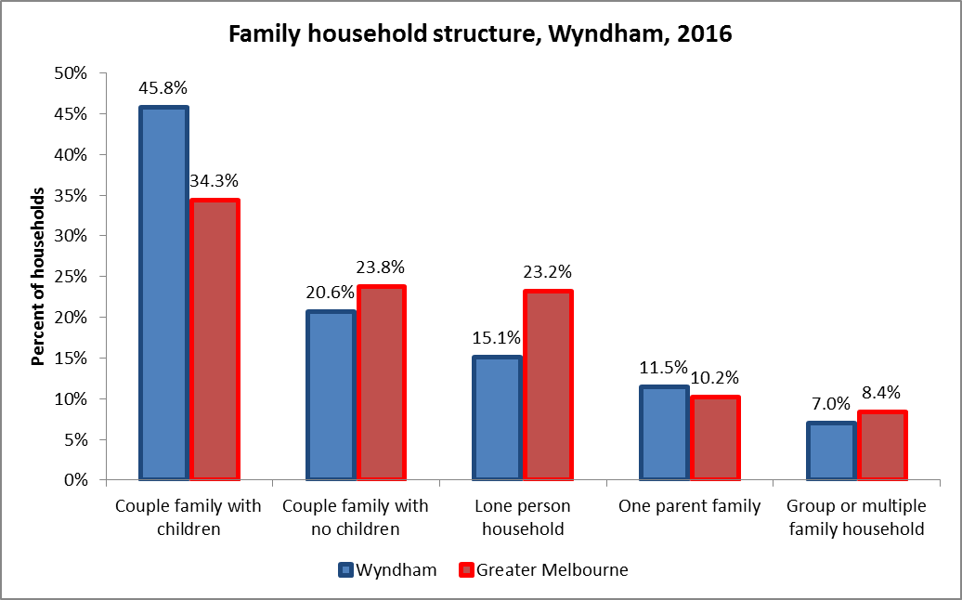
Over the past 10 years, the proportion of Wyndham households that are made up of couples with children has remained above the Greater Melbourne average by a fair margin (Figure 7). While this margin was approximately the same in 2011 as it was in 2006, a divergence has taken place between 2011 and 2016. While Greater Melbourne’s trend is linear, Wyndham has seen a sharp increase, particularly in the growth suburbs i.e., Point Cook, Tarneit and Wyndham Vale. It follows that Wyndham has one of the highest proportions of couple families with children in Greater Melbourne: only Nillumbik is higher at 47.8 per cent of households.
Figure 7: Percentage of dwellings occupied by couples with children, Wyndham and Greater Melbourne, 2006 to 2016
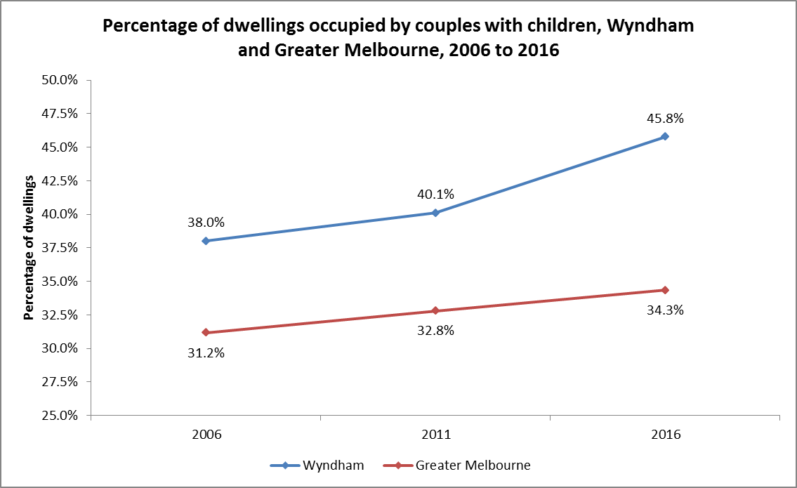
The map in Figure 8 shows where the couples with children reside in 2016 as a proportion of all households. The map clearly identifies that Tarneit, parts of Truganina and Point Cook, and small pockets in Wyndham Vale and Werribee are the locations of choice for these families – all areas that have been developed relatively recently.
Figure 8: Couples with children as a percentage of all households, Wyndham, 2016
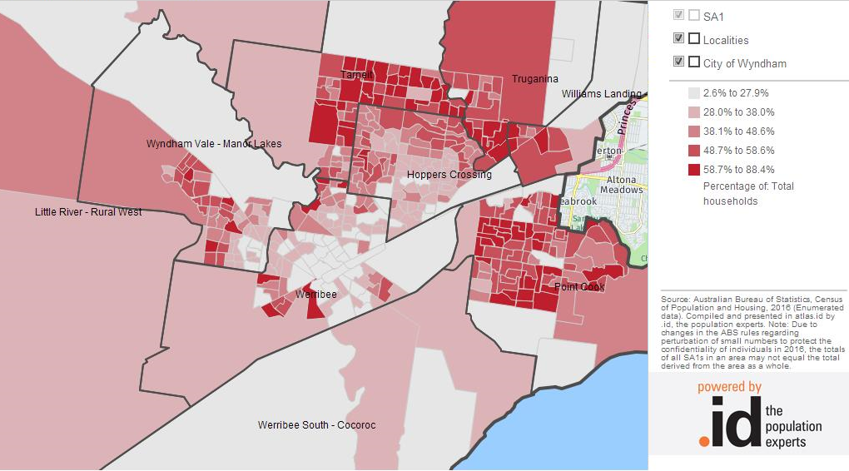

House prices

Median house price
Before discussing median house prices in Wyndham, note that this section discusses houses only, and does not discuss units. The definition of what a house is follows from the Australian Valuation Property Classification Codes. In brief, a house has a torrens title while a unit has a strata title. In the former case, the title holder owns the land and the building. In the latter case, the title holder owns the building, but not the land. The data discussed below is comparable across Victorian LGAs and suburbs.
This section discusses real houses prices instead of nominal house prices. Nominal prices measure the dollar value of a house in the year it was purchased. Real prices are adjusted for general price level changes over time, i.e., inflation or deflation. For example, a house in Greater Melbourne in 1986 cost $82,000, but that $82,000 in 1986 due to inflation is equivalent to $209,000 in 2016. The real house price therefore means that house prices are adjusted for inflation so as to make them comparable over time.
A major reason for Wyndham’s relatively large population growth is the median house price. In 2016, Wyndham had one of the lowest median house prices in Greater Melbourne, ahead of only six other municipalities and sitting at 70 per cent of the Greater Melbourne median of $635,000 (Figure 9). Despite high apparent demand for houses the median house price has not increased as much as in other areas. Much like other growth areas across Greater Melbourne this is likely in part due to the availability of developable land and the relative absence of transport infrastructure investments to increase the accessibility of Melbourne’s CBD.
Figure 9: Median house price by municipality, 2016
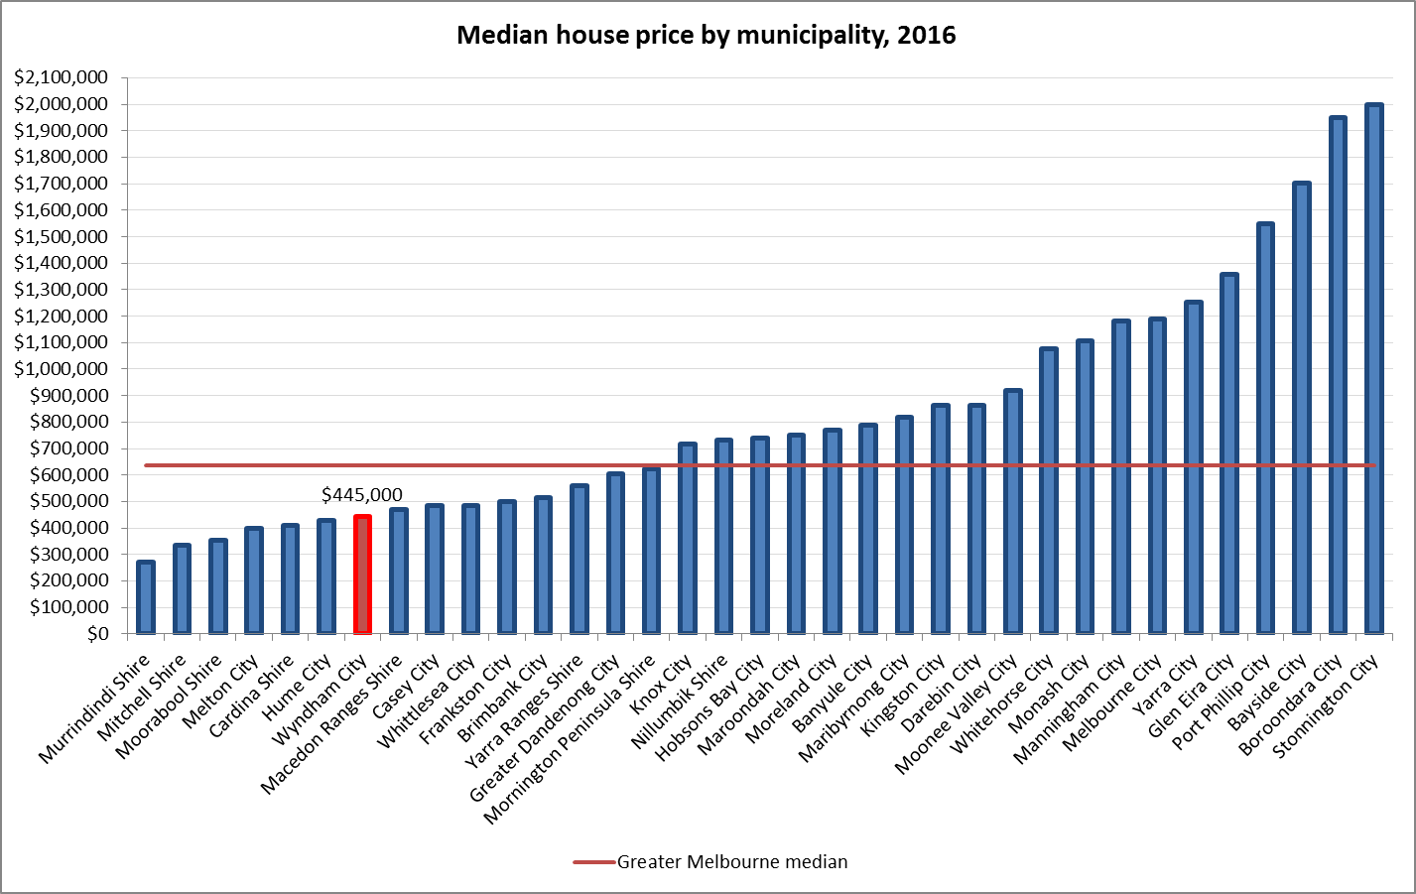

It is no secret that house prices have grown significantly over the last 30 years. In Greater Melbourne, house prices more than tripled, increasing from around $209,000 in 1986 to $635,000 in 2016. The median house price in Wyndham increased from around $180,000 to $445,000 over the same period – a growth of 147.6 per cent. Measured in ten year periods, house prices growth in Wyndham has consistently been lower than Greater Melbourne’s growth (Figure 10).
Figure 10: Real median house prices and ten year growth rates, Wyndham and Greater Melbourne, 1986-2016
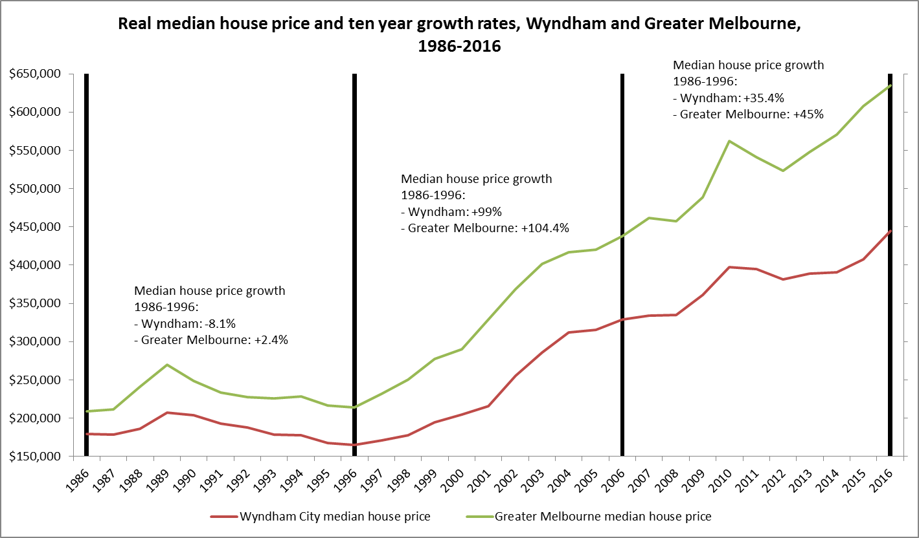

Median house price growth rates since 2014 for Greater Melbourne have been fairly level, hovering around 5 per cent per year (Figure 11). For Wyndham, however, the three most recent years have seen an upwards trend from 0.4 per cent in 2014 to 4.2 per cent in 2015, reaching 9.3 per cent in 2016. With the majority of Greater Melbourne consisting of established areas it is likely that the 5 per cent yearly growth is the current equilibrium price growth. With Wyndham being a growth area where families will continue to choose to move in the foreseeable future house prices are likely to continue increase at a greater pace than in Greater Melbourne.
Figure 11: Real median house price growth (%), Wyndham and Greater Melbourne, 2006-2016
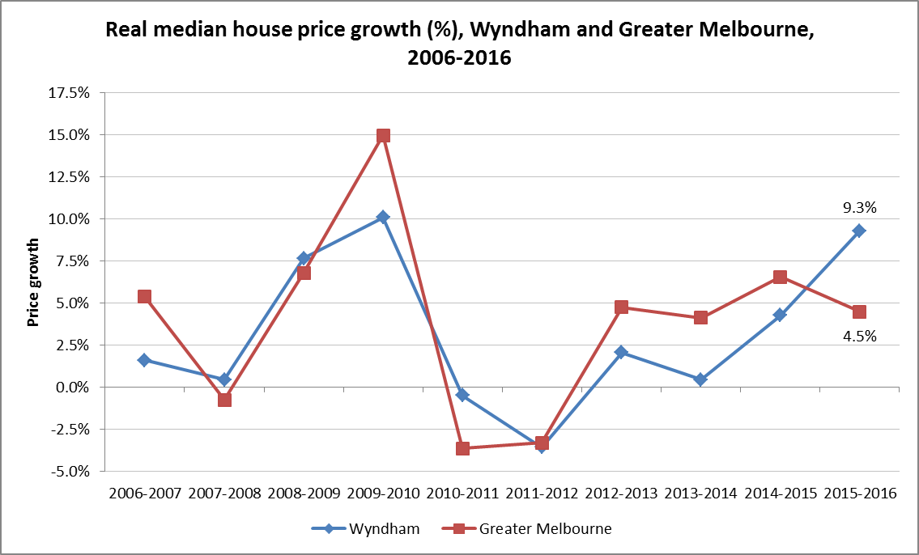

Suburbs
Across Wyndham suburbs there is variation around the median Wyndham house price (Figure 12). Two suburbs have median prices well above the overall median. They are Point Cook ($539,000) and Williams Landing ($591,000). A further four suburbs are within $30,000 of the overall median (Hoppers Crossing, Manor Lakes, Tarneit and Truganina), and two are $60,000 and $80,000 below the overall median (Werribee and Wyndham Vale respectively). The higher median prices in Point Cook and Williams Landing correlate with the relatively higher dwelling sizes in these suburbs (see Table 3). Most of all, these two suburbs are close to the freeway and are closer to Melbourne’s CBD than any of the other suburbs. This is in contrast to Wyndham Vale, which does not have easy access to the freeway, is the most distant suburb from Melbourne’s CBD, and does not have much surrounding infrastructure other than housing.
Figure 12: Median house price across Wyndham suburbs, 2016
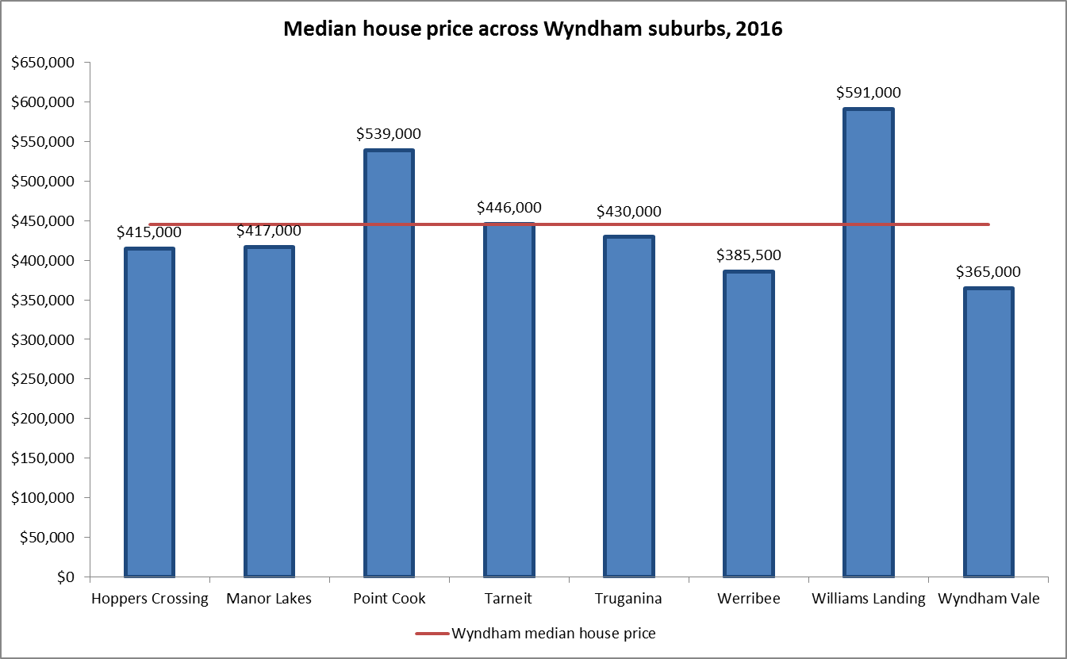

The two suburbs with the highest current median prices have also consistently had higher median prices compared with the other suburbs (Figure 13). In 2012 Williams Landing overtook Point Cook as the suburb with the highest median house price. Note also that Hoppers Crossing has seen a more rapid increase in median house price since 2015 than the other suburbs (except Point Cook and Williams Landing). This is likely due to the lower level of developable land in Hoppers Crossing compared with other suburbs, and its convenient access, relative to other suburbs, to infrastructure such as a metro line train station and Pacific Werribee shopping complex.
Figure 13: Real median house price across Wyndham suburbs, 2006-2016
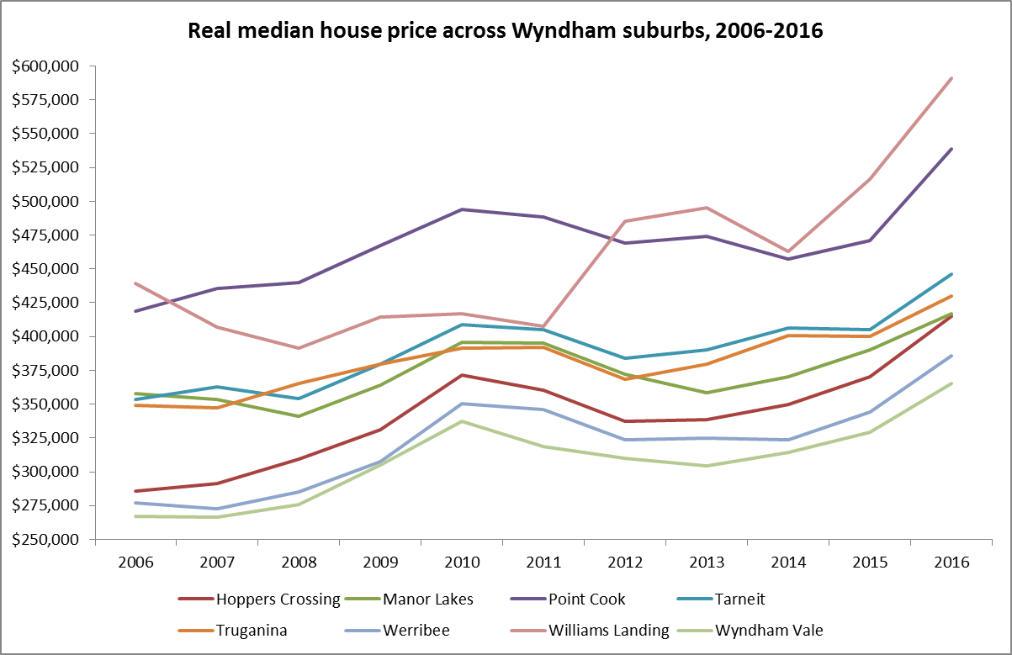

Housing costs

Tenure type
A little over a fifth of dwellings in Wyndham are fully owned by their occupants (20.5 per cent), and almost half of dwellings are mortgaged (49.5 per cent) as Figure 14 indicates. A further 28.4 per cent of dwellings are rented from a private owner, similar to Greater Melbourne, and there is proportionally less public housing in Wyndham than in Greater Melbourne (0.9% versus 2.3% respectively). While homeownership across Wyndham and Greater Melbourne are broadly similar (70% and 68.1% respectively), there is a stark difference between the type of ownership. Reflective of Wyndham’s status as a growth area there are proportionally more houses that are currently mortgaged.
Figure 14: Tenure type, Wyndham and Greater Melbourne, 2016
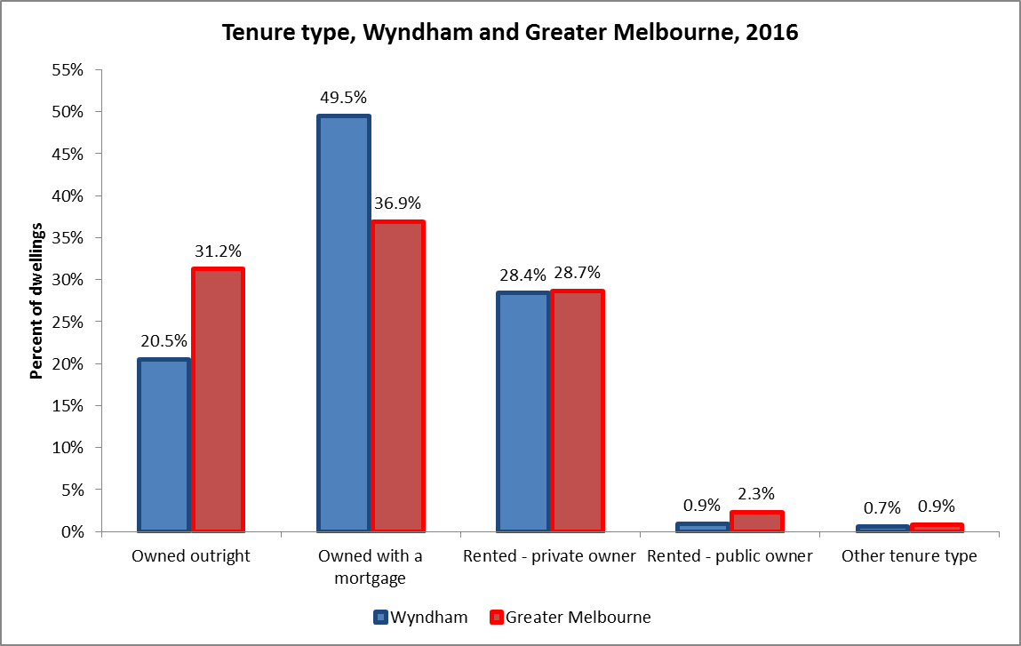

Social housing
Relative to all housing in Wyndham, there is a low proportion of social housing (Figure 15). A total of 632 residences exist across Wyndham – less than 1 per cent of the housing stock – and more than half of them are located in Werribee. The map below indicates the number of social housing dwellings and their locations. The number of rented social housing dwellings is lower than the Greater Melbourne median of 1.7 per cent.
Figure 15: Distribution of social housing in Wyndham at SA1 level, 2016
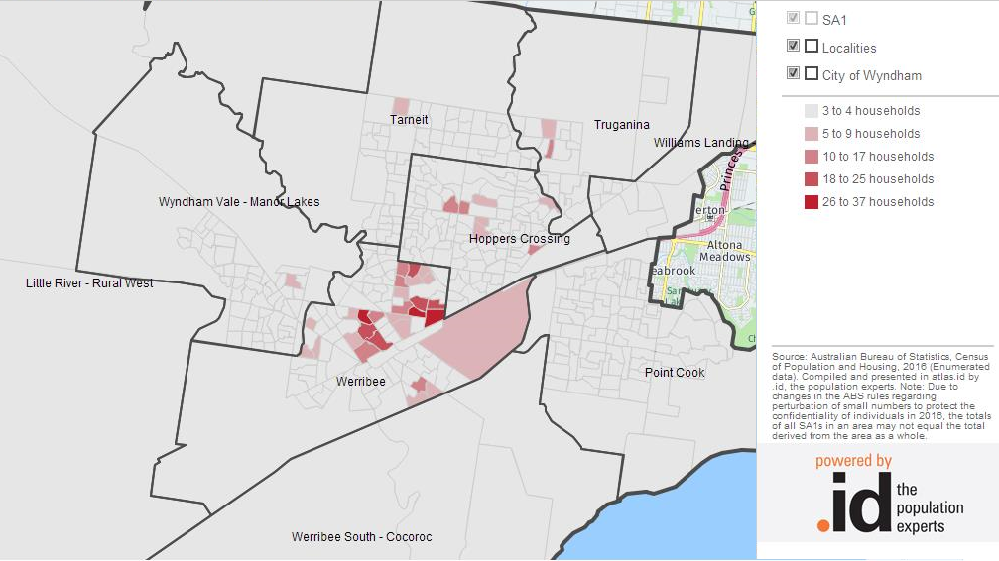

Homeownership and renters
Homeownership in Wyndham has decreased from over 79 per cent in 2006 to 70 per cent in 2016 (Figure 16). This drop is greater than the one observed in Greater Melbourne, where homeownership declined from 73 per cent in 2006 to just over 68 per cent in 2016. The proportion of renters has gone up by about the same degree as homeownership has fallen. While house prices in Wyndham are lower than in Greater Melbourne this does not necessarily mean that they are affordable for all those who choose to move to Wyndham. The decrease in homeownership is in line with affordability trends discussed in a later section.
Figure 16: Home-owners and renters over time, Wyndham and Greater Melbourne, 2006 to 2016
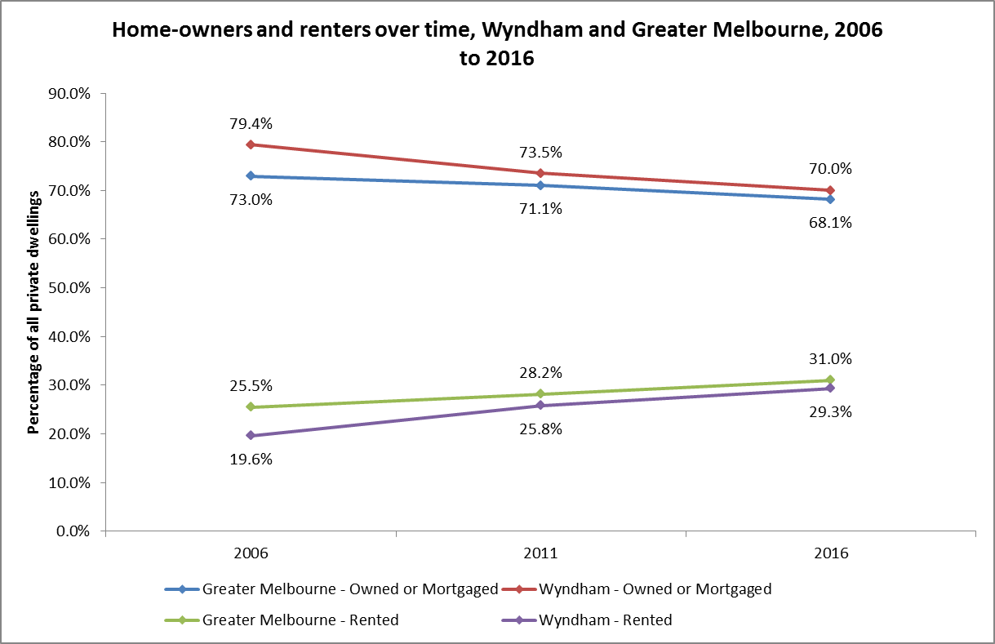

Rent
Median rent in Wyndham is $320, lower than the Greater Melbourne median of $354. The rent increase pattern from 2006 is similar between Wyndham Greater Melbourne (accounting for inflation) as Figure 17 shows. A spike occurred between 2006 and 2011 which saw the Wyndham median rent increase from $228 to $311. In the next five year period median rent increased to $320. According to the Victorian Department of Health and Human Services’ Rental Report 2017 the large increase between 2006 and 2011 is largely due to a rental price growth of five to eight per cent between 2006 and 2008, and almost four per cent in 2010. From 2011 to 2013 however, growth was around zero, followed by a period of consistent three per cent price growth.
Figure 17: Real median weekly rent, Wyndham and Greater Melbourne, 2006-2016
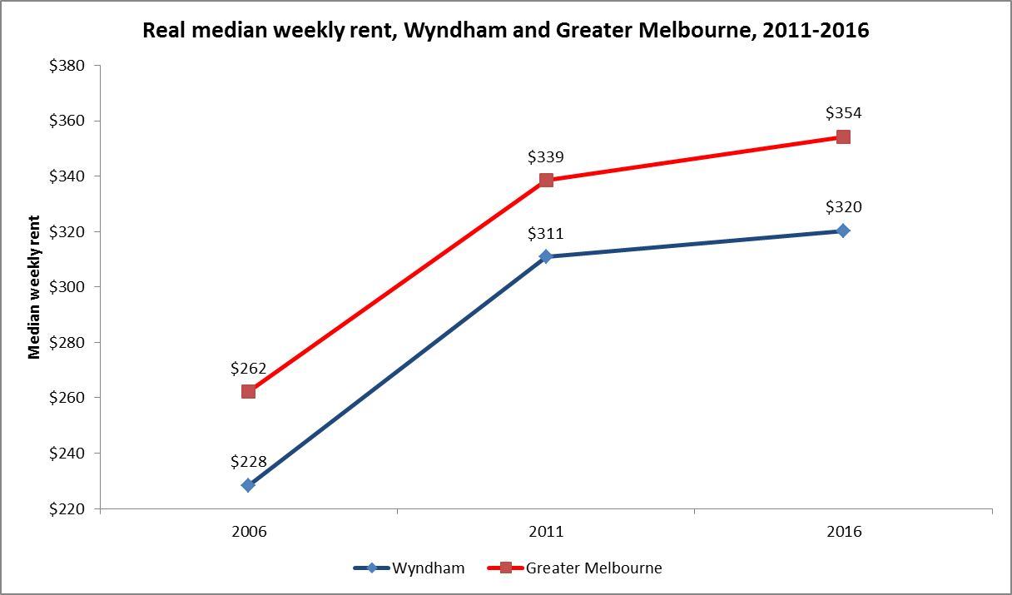
Rent differs by dwelling structure, although the pattern in Wyndham is opposite to that observed in Greater Melbourne (Figure 18). In Wyndham, flats or apartments have lower weekly rent than semi-detached houses, which in turn have lower weekly rent than separate house: $284, $310 and $327 respectively. In Greater Melbourne, flats and apartments have the highest median weekly rent ($359) followed by semi-detached houses ($355) and separate houses ($352). Flats in Greater Melbourne are usually located near urban centres, driving up prices due to proximity to amenities. Similarly, semi-detached housing is more often found in established suburbs around Melbourne’s CBD which are also close to amenities. Separate houses are more often found in outer suburbs.
Figure 18: median weekly rent by dwelling type, Wyndham and Greater Melbourne, 2016
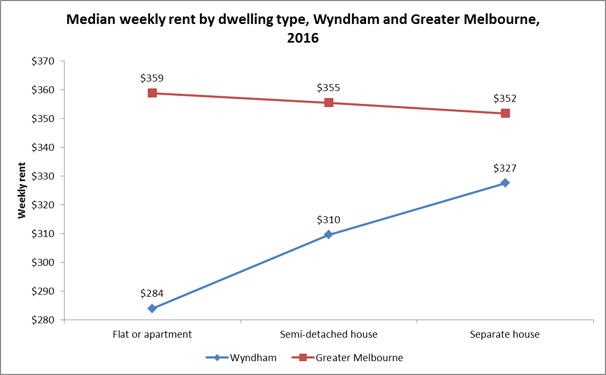

Housing affordability, stress and homelessness

Housing affordability
Housing affordability in Australia has declined since the early 1980s, especially in the major cities. Figure 19 below compares median house price and median household income growth between 2006 and 2011, and 2011 and 2016. If house prices increase more than household income, housing affordability declines. As the figure shows, house price growth is approximately three times higher than median household income growth for both Wyndham and Greater Melbourne.
In Wyndham, house prices grew 2.9 times faster than household income between 2006 and 2011. This increased to 3.5 between 2011 and 2016, indicating that housing affordability has worsened in Wyndham. In Greater Melbourne, house prices still grew faster than household income but less so between 2011 and 2016 than between 2006 and 2011. The low house prices in Wyndham relative to Greater Melbourne will attract buyers making it likely that housing affordability in Wyndham will decrease further.
Figure 19: Real median house price growth and real median household income growth, Wyndham and Greater Melbourne, 2006-2016
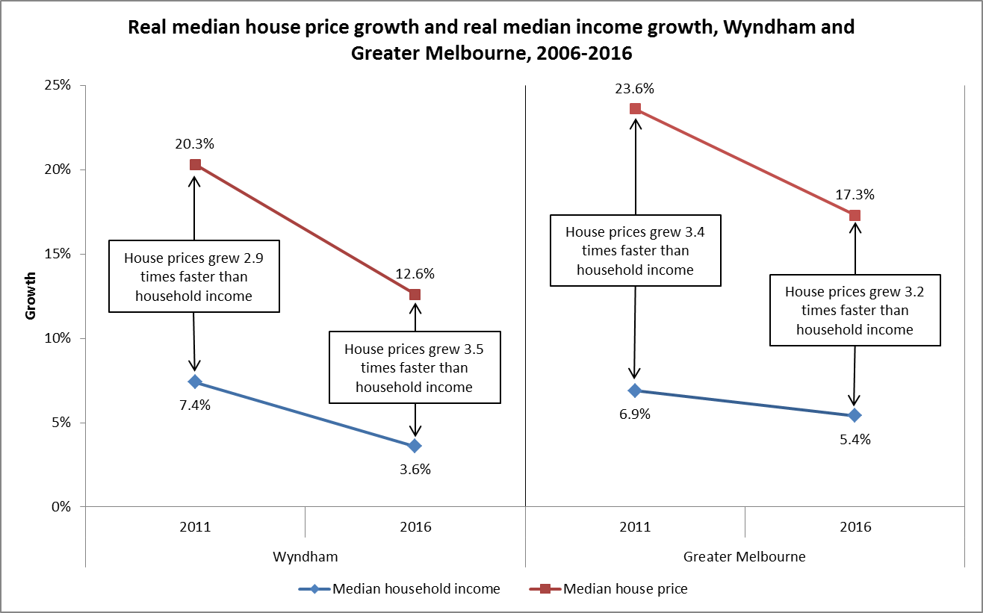

Housing stress
Housing stress is defined as per the NATSEM (National Centre for Social and Economic Modelling) model as households in the lowest 40% of incomes who are paying more than 30% of their usual gross weekly income on housing costs.
The distribution of housing stress across Wyndham is mapped in Figure 20. Truganina appears to have the largest proportion of households in housing stress, with large pockets also existing in Tarneit, Hoppers Crossing and Werribee, and, to a lesser extent, Wyndham Vale.
Across all of Wyndham, some 13.5 per cent of households are experiencing housing stress, up from 12.9 per cent in 2011. In contrast, around 11.7 per cent of households in Greater Melbourne are experiencing housing stress – up from 10.7 per cent in 2011. Note, though, that the proportion of households experiencing housing stress in Wyndham did not increase as quickly as in Greater Melbourne. Between 2011 and 2016, the proportion of households in housing stress increased by 4.7 per cent in Wyndham and 9.3 per cent in Greater Melbourne.
Figure 20: Housing stress map by SA1, Wyndham, 2016
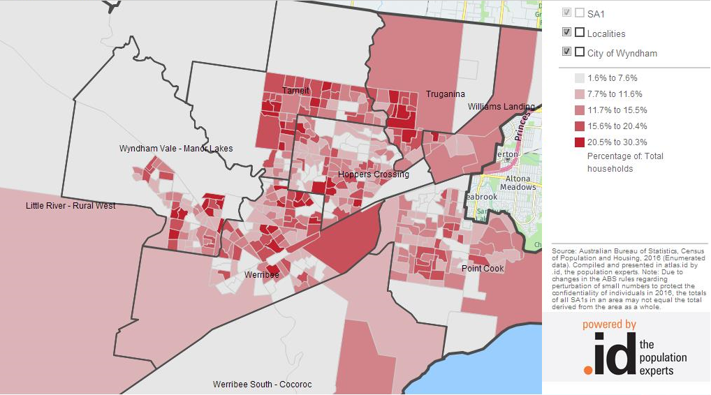
Almost half of Wyndham households have a mortgage. The distribution of mortgage stress across Wyndham is mapped in Figure 21. Mortgage stress is almost uniformly spread throughout Wyndham with the exception of Williams Landing and Point Cook. Tarneit and Truganina have the highest mortgage stress rates.
Across all of Wyndham, some 13.3 per cent of households are experiencing mortgage stress. This has not increased much since 2011, when it was 13.1 per cent. Mortgage stress in Wyndham is larger than in Greater Melbourne, where 11.2 per cent of households are experiencing mortgage stress – down from 11.7 per cent in 2011. The decrease in Greater Melbourne is in part due to the relatively small increase in the number of new houses with a mortgage compared with Wyndham. When assessing housing stress in Greater Melbourne, mortgage stress should be viewed in conjunction with rental stress due to house price and rental tenancy trends in recent years that have not favoured first home buyers.
Figure 21: Mortgage stress map by SA1, Wyndham, 2016
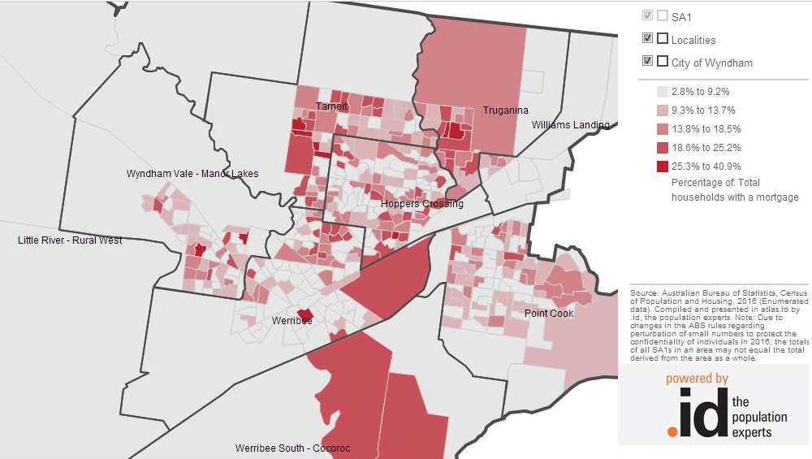
The last element of housing stress is rental stress, mapped in Figure 22. No clear pattern emerges, except perhaps the small patches of high rental stress in the established areas.
Overall, 26.9 per cent of households that rent are experiencing rental stress, up slightly from 26.7 per cent in 2011. Rental stress is proportionally lower in Wyndham than in Greater Melbourne, where 27.4 per cent of renting households were experiencing rental stress in 2016. The proportion of households in rental stress increased from 24.9 per cent in 2011 – an increase of around 10 per cent. In Wyndham, the proportion of households in rental stress increased by less than a per cent.
The rental and mortgage stress dynamics in Greater Melbourne are such that due to low and decreasing affordability of houses, families are forced to rent for longer. At the same time, the increasing median house price pushes up weekly rent for those families. In Wyndham this problem is almost absent due to the relative affordability of houses.
Figure 22: Rental stress map by SA1, Wyndham, 2016
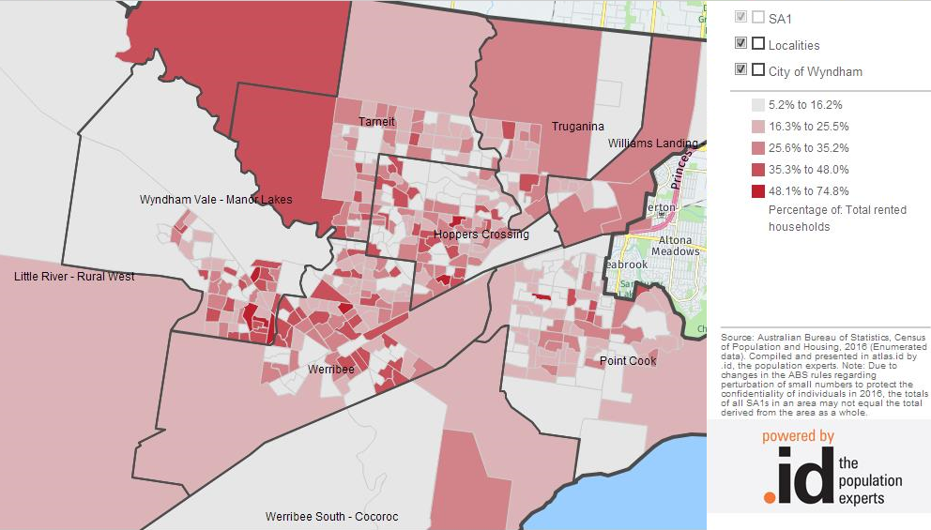

Homelessness
According to the Australian Bureau of Statistics (ABS) a person is homeless if they do not have suitable accommodation alternatives and their current living arrangement:
- is in a dwelling that is inadequate, or
- has no tenure, or if their initial tenure is short and not extendable, or
- does not allow them to have control of, and access to space for social relations (refers to overcrowding).
Factors associated with homelessness include low income/unemployment, housing affordability and access to public transport, domestic violence/relationship breakdown, mental illness, and drug and alcohol abuse.
Figure 23: Homelessness by Wyndham suburb, 2011
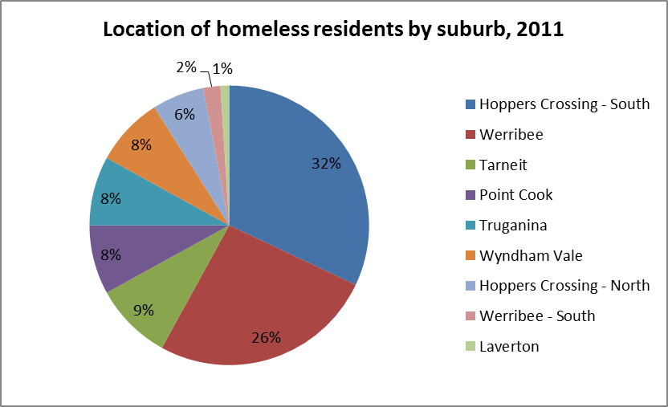
At the 2011 Census, there were 420 people homeless in Wyndham. This is almost 4 times more people than at the 2001 Census (107). However, due to accommodation type, this figure is expected to be considerably larger. For example, homelessness may not be recorded if individuals and families turn to living in caravan parks, cars, are squatting, couch surfing or camping. The lack of crisis accommodation in Wyndham means that around 95% of government assisted individuals that require immediate housing are placed outside of Wyndham, typically away from family and friend support networks. Those housed in the municipality are often directed to local motels. In 2011, the majority of people experiencing homelessness were from the established parts of Wyndham – Werribee and Hoppers Crossing (Figure 23). People experiencing homelessness in the growth areas of Wyndham together comprised around a third of the people counted on Census night. Research shows that rates of homelessness are higher in areas with affordable housing, thus highlighting what’s affordable for some is not for others.

All data is from the 2016 ABS Census of Population and Housing unless otherwise indicated.
Note that the definition of homelessness extends beyond those living in improvised homes and tents and that the actual population of homeless people is larger. The profile addresses this total population later on.
Source: DELWP’s Victorian Property Sales Report, September 2017 release
The maps and data in this section are from .id’s social atlas resource, consulted in October 2017.
The ABS produces statistics on homeless based on the Census in publication 2049.0 – Census of Population and Housing: Estimating homelessness. The figures based on the 2016 Census will not be available until December at the earliest, and the 2011 contains the most recent information on this topic.

