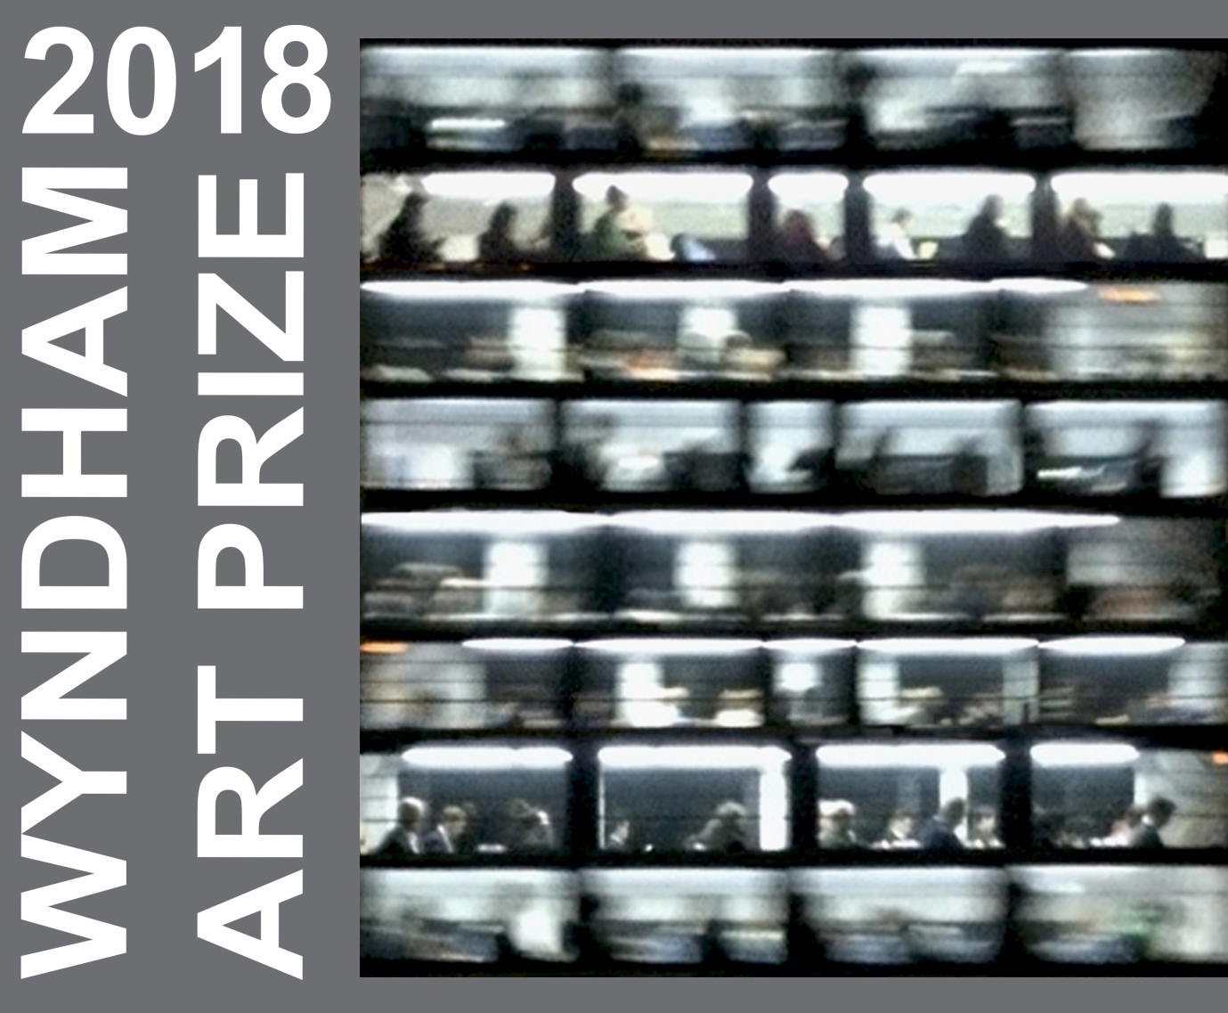
Image: Tina Barahanos – Commuter - Winner of 2017 Wyndham Art Prize.

Wyndham Art Prize 2018
Wyndham Art Gallery
29 March to 10 June - 2018

Terms and Conditions + Pre-selection Form

Non-acquisitive prize of $10,000
$6,000 of bursary opportunities from Deakin University
*conditions apply
People’s Choice Award of $2,000
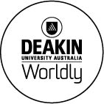
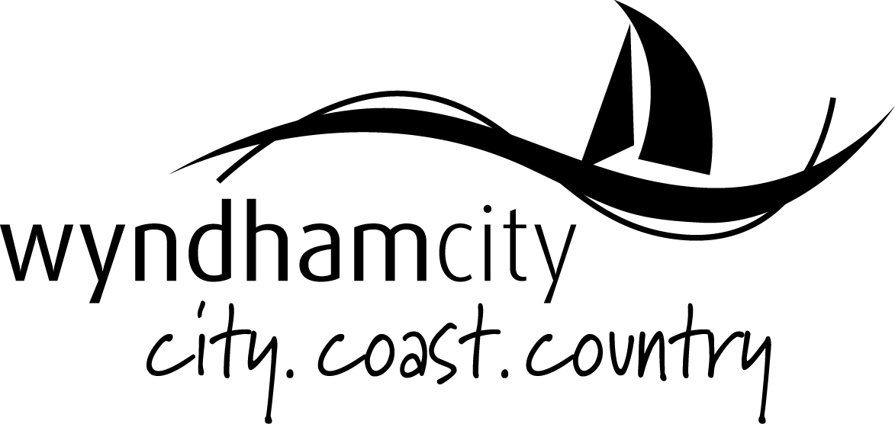
Important dates:

Entries Close
9.00am Monday 12 February 2018

Artists Advised of Selection
Monday 26 February 2018

Delivery of Artworks
Between 10am and 4pm to Wyndham Art Gallery, 177 Watton Street, Werribee
Wednesday 14 March, 2018
Thursday 15 March. 2018
Friday 16 March, 2018

Exhibition Opening
Announcement of Prize and Deakin Bursaries
6:30pm – 8:30pm
Thursday 29 March, 2018

Exhibition Dates
Thursday 29 March to Sunday 10 June, 2018

Notification of the People’s Choice Award
Thursday 21st June - 6.30 to 8.30pm
Wyndham Art Gallery, 177 Watton Street, Werribee

Collection of Artworks
Monday 11 to Tuesday 12 June
Between 10.00am and 4.00pm

For Further Information
Contact Visual Art Curators:

Megan Evans
Maree Clarke
Email: wyndhamartgallery@wyndham.vic.gov.au
Phone: 03 8734 6021

Wyndham Art Prize 2018

Terms & Conditions
Information on how to enter forms part of these Terms and Conditions. By entering entrants agree to be bound by these Terms and Conditions and entries must comply with these Terms and Conditions to be valid. This competition is governed by the laws in force in the State of Victoria

About the Wyndham Art Prize

- The WYNDHAM ART PRIZE (the Prize) is an open prize and exhibition. The prizes are:

  - First Prize - $10,000 non-acquisitive prize
  - People’s Choice Award - $2,000 through popular vote

- The Prize is conducted by Wyndham City Council at Wyndham Art Gallery – 177 Watton Street Werribee.

- The Prize - a cash prize of $10,000 for the winning work - is judged by an independent arts professional appointed annually by Wyndham City Council. Council officers do not have any bearing on the outcome of the prize.

- The Prize Judge reserves the right not to select any work if works are not, in her/his opinion, of sufficient merit. The judge’s decision is final and no correspondence will be entered into.

- A People’s Choice Award of $2,000 is awarded by popular vote. Voting for the People’s Choice Award closes at 4pm on Friday 8 June 2018. The winner is announced on Thursday 21 June 2018.

- In addition to the WYNDHAM ART PRIZE a CREATE@DEAKIN BURSARY will be offered by Deakin University to one artist in each of the following categories*
- $2,000 bursary for study of Honours or Masters of Creative Arts at Deakin University
- $4,000 bursary for PhD candidature in creative arts at Deakin University
To be eligible for a bursary the artist must meet Deakin’s enrolment requirements and must enrol at Deakin in the applicable course within 12 months of being awarded the bursary.
Works selected for exhibition will be judged by representatives of Deakin University
Bursaries may not be redeemed for cash payment and the decision of the judges is final.
No correspondence will be entered into.

Entry Process and Eligibility

- The Prize is open to all Australian artists (citizens of Australia or residents for at least 12 months).

- Employees of Wyndham City Council or Deakin University and members of their immediate families are ineligible to enter.

- Works chosen for the exhibition are pre-selected from digital images submitted at time of entry. Artists may enter a maximum of two works completed since 1 January 2016. All artworks submitted must be available for exhibition.

- Entries must be received by 9.00am Monday 12 February 2018. Late or incomplete entries will not be accepted. A valid entry consists of:

  - No more than two high quality digital images – (2MB maximum each, JPEG format)
  - An artist CV (two pages maximum)
  - 100 word artist statement
  - Completed pre-selection form
  - Payment of an administrative fee of $30 per artist.

Wyndham City Council reserves the right to exclude any entry from exhibition.

- Digital images should not exceed 2MB each in size and should be saved with a file name format of surname_firstname_title.jpg

- Images submitted must be of works created since 1 January 2016. Slides, photographs, photocopied reproductions, or any other representation of the work will not be accepted.

- The administrative fee of $30 is non-refundable. Any entry not accompanied by payment of the fee will be ineligible. The fee is payable online or via the Wyndham Cultural Centre Box Office. Receipts will not be mailed unless requested.

  - Online via Eventbrite
  - Box Office 9.00am -4.00pm Monday – Friday (03) 8734 6000

- Entries must be submitted via email to wyndhamartgallery@wyndham.vic.gov.au

- Submitted works should not exceed 1.5 x 1 metres in any given dimension (including frame). Sculptures should not exceed 1 metre in any dimension. A work can consist of multiple parts but must not exceed overall size limits.

Works exceeding these dimensions will only be accepted at Wyndham City Council’s discretion.

Selection and Delivery of Works

- All artists will be notified of pre-selection outcome by Monday 26 February, 2018

- Artists selected for exhibition will allow their works to be reproduced by print and electronic media in the advertising and promotion of the exhibition. The Gallery reserves the right to reproduce the winning entry in relation to the Prize.

- Selected works must be professionally prepared for hanging/installation and must be marked clearly on the back with artist’s name, address, title of work with installation instructions included (if applicable).

- It is intended that the works selected will be shown in an exhibition at the Gallery. Should space prevent the display of work, Wyndham City Council will advise the entrant.

- All entries selected for exhibition must be available for continuous display at the Gallery for the period of the exhibition. Artists and/or their representatives cannot remove an artwork from display prior to Sunday 10 June 2018.

- Works must be delivered to 177 Watton Street Werribee between 10am and 4pm on the following days:

  - Wednesday 14 March 2018
  - Thursday 15 March 2018
  - Friday 16 March 2018

Under special circumstances an alternative time can be arranged – this is subject to staff availability and cannot be guaranteed. Contact wyndhamartgallery@wyndham.vic.gov.au or call (03) 8734 6021 to enquire.

- Work(s) must be collected from 177 Watton Street Werribee between 10am and 4pm on the following days:

  - Monday 11 June 2018
  - Tuesday 12 June 2018

- Works arriving by or being collected by courier must be clearly labelled on the outside of the packaging with the artists name and a return address and include packaging sufficient for the return of the artwork. Entrants must instruct courier companies of the timeframes for delivery and collection of work.

- Wyndham City Council will not accept any artworks unless delivered free of all freight and other charges.

- Wyndham City Council is not responsible for the sale of works. Any enquiries regarding sale of work from the general public will be directed to the artist and/or their agent, no commission will be sought or given.

Insurance and Liability Waiver

- Wyndham City Council is not responsible for any loss or damage suffered to any work in its possession or under its control. Each entrant shall indemnify Wyndham City Council against loss or damage suffered to his or her work. All care will be taken, however Wyndham City Council waives responsibility for any loss or damage, howsoever caused.

- Insurance of artwork during transport is the sole responsibility of the artist.

- Following failure or omission to remove a work from the Gallery within one month of the close of the exhibition, Wyndham City Council will at its discretion sell or otherwise dispose of such work. Reasonable attempts will be made to notify the artist of this, however Wyndham City Council waives liability to the artist in respect of any work destroyed or disposed of.

- Artists warrant that each of their submissions is an original work and does not infringe the rights, including without limitation intellectual property rights of any third party.

- Artists grant to each of Wyndham City Council and Deakin a perpetual, irrevocable non-exclusive licence to use, reproduce and communicate their submission by any means and in any format for the purposes of operating the competition and for promotional purposes. This applies to all submissions and not merely the winning submission.

- Artists consent to each of Wyndham City Council and Deakin University using their name, image or voice for promotional purposes. Artists agree to make themselves available for photograph and interview in the event their work is awarded a prize or bursary.

Note

*CREATE@DEAKIN bursary of $2000 for winner who enrols in Hons or Masters (MCA) and $4000 for winner who enrols in PhD, paid in regular instalments over the course of the degree. The winner must be enrolled in the applicable Deakin degree within 12 months of winning the prize in order to receive the bursary and must remain enrolled to receive the bursary.

Pre-Selection Form – 2 Pages
Return this form via email by 5pm Friday 9 February 2018, together with:
- Up to two JPEG images (2MB maximum each)
- An artist CV (2 page maximum)
- 100 word artists statement

Please ensure that payment of administration fee has been made at time of entry. Any entry that does not include all of the above plus payment of administration fee will be ineligible.

All requested information on this form must be completed.

Your personal information is being collected by Wyndham City Council to administer the Wyndham Art Prize 2018 and to communicate with you about the prize and the exhibition.
If you have expressed an interest in being considered for a CREATE@DEAKIN bursary you are also consenting to Council providing yours details to Deakin University.

Your information will be stored in Council’s Customer Database and used to identify you when communicating with Council and for the delivery of services and information. For further information on how your personal information is handled, visit Council’s Privacy Policy at: https://www.wyndham.vic.gov.au/privacy-policy
Your Details

Name

Address
State
Postcode

Email
Phone Number

Gallery / Dealer
(if applicable)

Telephone

Email

Entry Checklist

Entry Fee Paid
Entry Form Completed
2 x JPEGs Attached via email
2 Page CV Attached
100 Word Artist Statement Attached
*Do you wish to be considered for a CREATE@DEAKIN bursary?
Yes
No
If Yes – Please select which level of study
Honours
Masters of Creative Arts
PhD.

Detail of Entries
1.Title:

Date:

Medium:

Size (h) cm X (w) cm:

Insurance Value of artwork
Retail value of artwork

2.Title:

Date:

Medium:

Size (h) cm X (w) cm:

Insurance Value of artwork
Retail value of artwork

Declaration:
I have read the terms, conditions and information accompanying this application and agree to abide by them. I am an Australian citizen or have been a resident of Australia for at least 12 months.
I declare that the artwork(s) submitted by me are original and have been executed since 1 January 2016.

Artist’s signature

Artist’s name

Date

Email this completed form to wyndhamartgallery@wyndham.vic.gov.au by 5pm Friday 9 February 2018

