# Contents

1. 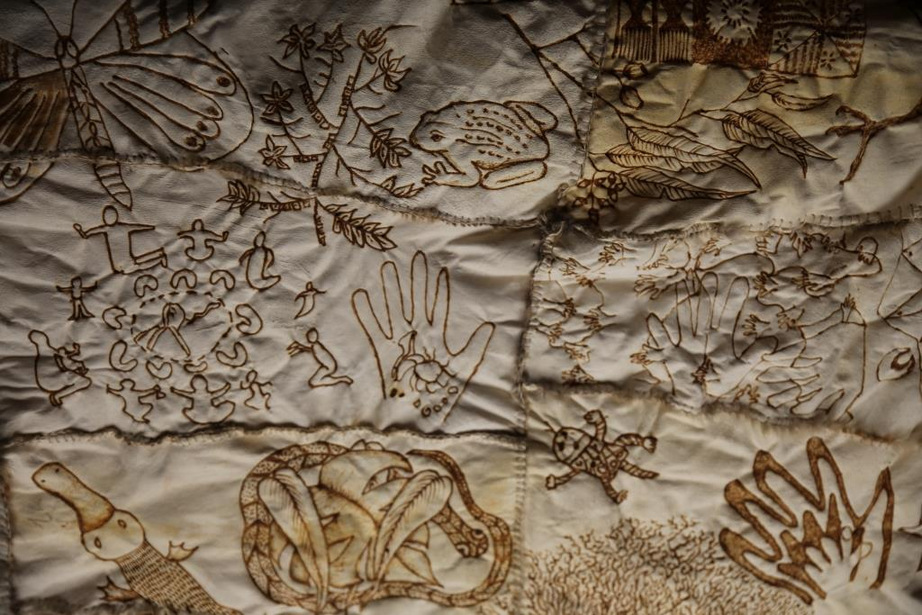Acknowledgement of Country
2. Messages from the Mayor, the Chief Executive Officer, the Wyndham Reconciliation Advisory Committee and the Senior Cloak Maker
3. Acknowledging Our Past
4. Our Business Today
5. Our Role
6. Our Vision for Reconciliation
7. A Snapshot of the Wyndham Aboriginal Community
8. The *Reconciliation Australia* Journey
9. A Timeline for Reconciliation in Wyndham City
10. Our Reconciliation Journey
11. Managing the Reconciliation Action Plan
12. Wyndham Reconciliation Advisory Committee
13. *Case Study: Reconciliation in Action – Arts and Cultural Development*
14. Wyndham’s Reconciliation Action Plan
15. Relationships
16. Respect
17. *Case Study: Reconciliation in Action - Kindergartens*
18. Opportunities
19. *Case Study: Reconciliation in Action – Libraries and Community Learning*
20. Monitoring and Evaluation

**WARNING: Aboriginal and Torres Strait Islander peoples are warned that the following document contains images of deceased persons.**

# Description: \\civicfile2\redirected$\kgodbold\Desktop\New folder\Cloak detail - Crow.jpgAcknowledgement of Country

*Wyndham City Council recognises Aboriginal and Torres Strait Islander peoples as the First Custodians of the lands on which Australia was founded. Council acknowledges the Wathaurong, Woiwurrung and Boonwurrung peoples[1] of the Kulin Nation as the Traditional Owners of the lands on which Wyndham City is being built.*

*For tens of thousands of years, the Werribee River has been a significant meeting place for Aboriginal people to build community, exchange resources, and share responsibility for its lands.*

*Council pays respect for the wisdom and diversity of past and present Elders. We share commitment to nurturing future generations of Elders in Aboriginal and Torres Strait Islander communities.*

**The First Peoples of the lands on which Wyndham City is being built[2]**

The basalt plains around the Werribee River have been home to a diversity of Aboriginal people, families and communities for countless generations. Their range of knowledge and complex skills, shared through generations of story-telling, are evident in the grasslands, trees, stones and waterways. Although limited in view, written records by the Europeans who came later acknowledge the presence of distinct Aboriginal societies that managed the land sustainably. The *Marpeang bulluk* lived west of the river and spoke the Wathaurong language; to the east of the river, the*Kurung jang balluk* spoke the Woiwurrung language whilst the*Yalukit willam* lived close to the bay, speaking Boonwurrung. The Kulin Nation exercised local lore and formed regional alliances to build healthy and robust economies around the Werribee River as the “backbone”[3] of life. They describe two main Ancestral Beings that influence relationships and responsibilities: Bunjil the creator, the Wedge-tailed Eagle; and Waa the protector, the Crow[4] . Education through living culture practices such as art, story-telling and dance continue to strengthen local Aboriginal communities and maintain their connections to the land today.

## Message from the Mayor

Wyndham City acknowledges that Aboriginal people have lived in this area for over 60,000 years. The lands and rivers on which this City is being built tell us about its rich and diverse Aboriginal cultural heritage. It has been a centre of economic activity and a place to build community. In this way, Wyndham has always been a place for people.

That is why, if we are to imagine a reconciled future for Wyndham, we must acknowledge and address the challenges of history.

Our Reconciliation Action Plan seeks to identify the next steps Council can take to keep building a city that is inclusive and equitable for Aboriginal and non-Aboriginal people.

Wyndham recognises its own former Mayor and Councillor Frank Purcell and his commitment to social justice throughout the 1960’s and 70’s taking part in the first ever Aboriginal land rights case to be conducted in an Australian court.

Council has committed to the implementation of this Reconciliation Action Plan in its City Plan (2017-2021). This significant step formalises a process of Reconciliation between Aboriginal and non-Aboriginal people that aims to redress injustices, increase equity and access to services to improve the wellbeing of the whole Wyndham community.

We are excited to present our RAP and are confident the actions and goals will assist Council embed Reconciliation in its core business, and benefit the community who call Wyndham home.

## Message from the CEO

The City of Wyndham has a rich and vibrant Aboriginal history. Our vision for Reconciliation is built on this history and core to Wyndham’s Statement of Commitment (2015). It is with great pride that I introduce Wyndham City Council’s first Reconciliation Action Plan.

It is important for Council, as leaders of our community to understand how we can work together to shape our future, but also acknowledge the injustices of the past to ensure we move forward in partnership with the Aboriginal Community to make a real difference in Wyndham City.

This two year Innovate RAP identifies how council will respect, build relationships and create opportunities with Aboriginal and Torres Strait Islander peoples. It will lead the way in developing processes and structures that pay respect to their peoples, cultures, lands and rights and provide opportunities that support economic development in Aboriginal households across Wyndham.

The development of our RAP has included extensive consultation with staff and Wyndham’s Aboriginal and Non-Aboriginal Community. I thank those who have contributed for taking us on this journey.

I look forward to continuing to work in partnership with the Aboriginal community to conserve our Aboriginal heritage and ensure Wyndham is an inclusive, welcoming City that celebrates our diverse heritage and cultures now and in the future.

## Message from the Wyndham Reconciliation Advisory Committee

The journey towards a Reconciliation Action Plan commenced with the launch of Wyndham City Council’s *Statement of Commitment* (2015). This set the framework for Council’s first Innovate RAP to be created. In 2016 the Wyndham Aboriginal Reconciliation Advisory committee was established, and as a committee we have worked closely with Council to develop this RAP.

Our committee, originally chaired by Councillor Bob Fairclough, is currently co-chaired by the Mayor, Councillor Henry Barlow and Aboriginal community member Tricia Williams, and made up of Aboriginal and non-Aboriginal volunteer community members chosen to advise and assist the planning of the RAP and its implementation.  As a committee, we have had the hard conversations about the impact of colonisation, oppression and assimilation. We have discussed the present circumstances and impacts on the Aboriginal community and the positive impact the RAP will have not only for the Aboriginal community now, but also for the wider Wyndham community.

In collaboration with Wyndham City staff and the Mayor we have a united vision to ensure the positivity of the RAP continues to evolve to its highest elevation in the present and also for future generations to come.

We are proud and humbled to be sitting on such a committee, with the views and the voices to allow Wyndham City to become a culturally safe place for our Aboriginal community, recognising their contributions within the community, and sharing this journey together through the implementation of a strong RAP within Wyndham City Council.

## Message from Senior Artist and Possum Skin Cloak Maker

The Possum Skin Cloak was developed to create a living document to trace and track community involvement in the writing of the Reconciliation Action Plan. Throughout 2016, Len Tregonning and I led workshops with Aboriginal and non-Aboriginal people of all ages: cutting and sewing the pelts, designing images to represent their concept of reconciliation, burning and painting these onto the cloak, preparing the ochre paints. In the shared work of its making, the conversations it made possible, the relationships it created space for, the Cloak mediated reconciliation.

Len generously invited people to be photographed in his own Possum Skin Cloak as a powerful act of reconciliation. Megan Evans filmed community members talking about what reconciliation meant to them and creating the Cloak. Images from the Possum Skin Cloak project are used throughout this Reconciliation Action Plan and the voices and views of the people who created it have shaped these steps toward Reconciliation over the next two years.

Maree Clarke and Len Tregonning wrapped in culture

# Our Business Today

The Shire of Wyndham was established in 1864 and became Wyndham City in 1994. The Councillors elect the Mayor and “set the strategic directions, decide on council policies and resources, and monitor council performance”[5]. This municipality in western metropolitan Melbourne is rapidly growing and culturally-diverse[6]. Over 220 000 people live in rural districts, established town centres and newly-built suburbs. This Reconciliation Action Plan (RAP) identifies the opportunity that Council has to create a rightful place for increased participation of Aboriginal[7] people in the building of strong democracy in this municipality.

Population growth and substantial housing development present social and environmental challenges that also threaten Aboriginal cultural heritage. In response to these challenges, Council is guided by the vision in its [Wyndham City Plan 2017-2021](https://www.wyndham.vic.gov.au/about-council/your-council/plans-policies-strategies/wyndham-city-plan-2017-2021) for a healthy, livable city that:

* 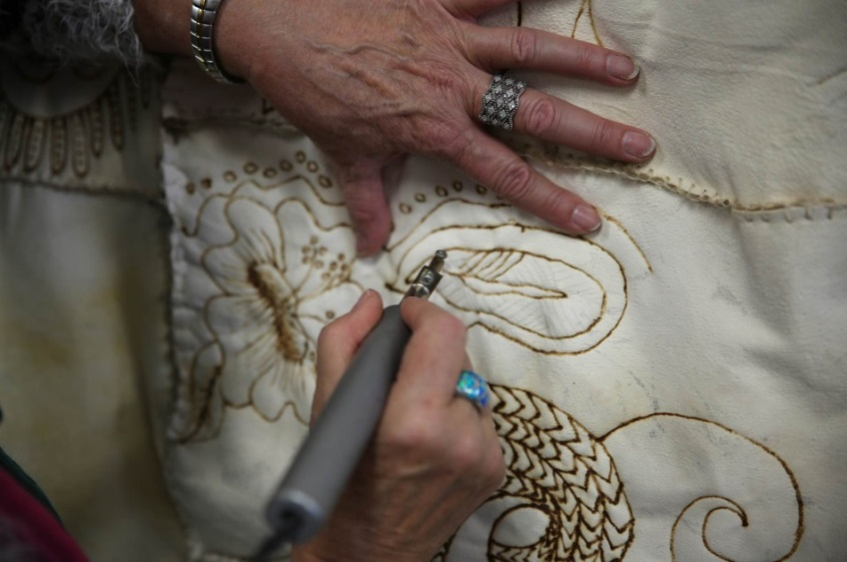Is future focused and plans for sustainable development
* Embraces diversity and is welcoming and inclusive
* Consists of connected, vibrant neighbourhoods that provide for the cultural, social, economic and recreational needs of the community
* Encourages a healthy and active lifestyle
* Supports the diverse educational needs of the community
* Empowers the community to lead

In this RAP, Council seeks to ensure that Aboriginal communities fully participate in the achievement of this vision alongside all residents of the City.

Wyndham City hosts industrial and retail precincts that present opportunities for Council to support participation of Aboriginal people in strong local economies through employment and enterprise. With over 1 500 employees, Council is one of the largest employers in the municipality. In 2017, Council’s formal data indicates that three employees have formally identified themselves as Aboriginal and/or Torres Strait Islander. Council knows from informal networks that this under-represents the actual number of people employed. Council has had Aboriginal-identified project positions in recent years and more of these are planned in key priority areas during the life of this RAP. They will form one part of the integrated employment strategy that Council will develop with the aim of building a strong Aboriginal workforce across all levels and departments over the next two years.

# Our Role

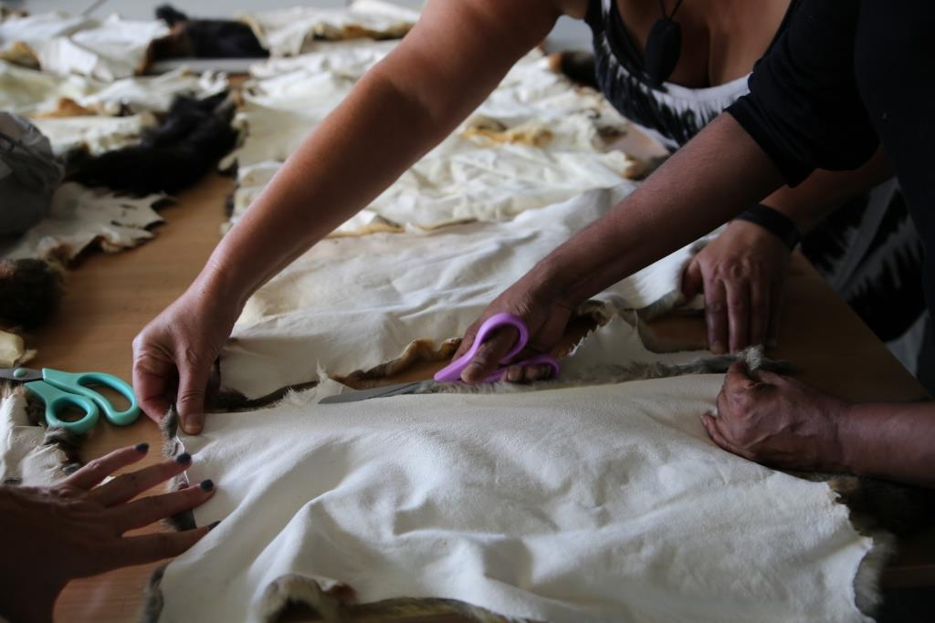The *Victorian Aboriginal Local Government Action Plan (2016)* recognises Councils as employers and procurers, service providers, planners and public authorities that can support Aboriginal community development and self-determination, improved Aboriginal health outcomes across life-stages, and partnership with Traditional Owner organisations in Aboriginal cultural heritage management.

Accordingly, this RAP is underpinned by the following principles to guide Council business:

* RESPECT for the diversity of Aboriginal communities and living cultural heritage
* A RIGHTFUL PLACE for Aboriginal communities to exercise power in their own matters and determine a future in which their children flourish
* JUSTICE that addresses wrongs of the past and delivers EQUITY so that Aboriginal communities have access to achieve the same outcomes as all Wyndham City residents
* AGREEMENT to work in PARTNERSHIP with Aboriginal communities on the priorities that local Aboriginal people determine over the next two years.

Council commits to working with Aboriginal networks and organisations to ensure that Aboriginal people that have been made vulnerable to disadvantage have access to the cultural and community resources they need to achieve healthy futures for their children, families and community.

# Our Vision for Reconciliation

Council and the community have built a vision to guide its work for Reconciliation in Wyndham City for the next two years that includes three core elements:

* Acknowledgement of past injustices and their ongoing harmful impacts today
* Respect for the land and the rights of Aboriginal people to determine their future
* Healthy Aboriginal families strengthened by culture and community

This vision builds on the [Wyndham 2040](https://www.wyndham.vic.gov.au/about-council/your-council/plans-policies-strategies/wyndham-2040) (pp.11-14) vision of a city in which

*We will share stories that challenge and inspire.*

*We will acknowledge the Aboriginal heritage of the land.*

Wyndham will be a vibrant, cohesive and respectful community that includes all.  Reconciliation will be achieved when diverse Aboriginal voices have a rightful place and Aboriginal communities thrive at levels equal to all Wyndham City residents.

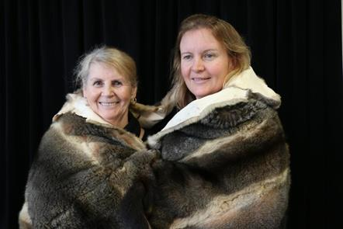

The [Wyndham 2040](https://www.wyndham.vic.gov.au/sites/default/files/2016-06/Wyndham%202040%20Vision%20-%20Resource.pdf) vision is to **“**Support further development of safe cultural spaces for Wyndham’s Aboriginal community to meet and gather” (p.13)

*I hope to see Wyndham embrace its rich and diverse Aboriginal culture from the past and in the present as well as the multitude of other cultures its residents bring to create a vibrant, cohesive and respectful community that shines brightly.*

Jamie, Point Cook

Marlene Cameron (Deadly Kitchen Elder) and Lisa de Santa-ana (Koorie Engagement Support Officer), Mother and Daughter, Stolen Generation members of the Aboriginal Community.

# Acknowledging Our Past

*It is “most important to … provide understanding … about the hidden history of the country and allow respect that comes from a learning and listening to occur so that non-Aboriginal people can begin to understand their part in restitution as both individuals and as a collective.*

Consultation participant, 2016

We acknowledge that Aboriginal people were the first custodians of the lands, waterways and coast on which this city is being built. The displacement of Traditional Owners led to Aboriginal people being dispossessed of their lands and culture. Despite this, their spiritual connection to these 542 square kilometres of grasslands and rich basalt soils surrounding the Werribee River remain strong.

Some of the earliest conflicts between Aboriginal and European peoples occurred in what is now being called Wyndham City. Aboriginal people, settled here for thousands of years, resisted invasion and the permanent takeover of their lands[8]. The region’s squatters and founding shire councillors led industrial and economic growth that displaced and dispossessed them of livelihoods, land and undermined their system of lore.

Wyndham City is central to a huge “*tract of country … (that) was obtained for a trifle…”*[9]by the Port Phillip Association in 1835. Events at Mt Cottrell[10] in 1836 marked the breakdown of relations between Aboriginal and European peoples that led to the exclusion of the former from the foundation of Victoria[11]. Places, such as the Werribee Park Mansion and Point Cook Coastal Park and Homestead, are significant sites of ancient Aboriginal occupation that became the wealthy estates of European businessmen who displaced and dispossessed the original custodians[12].

John Henry Wedge, a Port Phillip Association surveyor, noted the richness and abundance of Aboriginal community life around the Werribee river, their management of natural resources, and fierce resistance to foreign occupation. Aboriginal place-names were recognised in early town planning[13] but their protests against the “disappearance” [14] of their communities from the land were excluded from written records. The Aboriginal community memory of harm caused continues in their contemporary stories. An important purpose of this RAP is to ensure respectful recognition and acknowledgement of Aboriginal histories in this land.

# A Snapshot of the Wyndham Aboriginal Community

Wyndham City is home to a large and diverse Aboriginal population.  In recent years, Aboriginal people from all over Australia have moved here: 41% of the population in 2011 lived elsewhere in Australia in 2006.  According to 2016 Census estimates, Wyndham City has the highest number of people identifying as Aboriginal and/or Torres Strait Islander in Greater Melbourne.  This marked an increase from just over 700 in the 2006 census to almost 1200 in 2011 and 1735 in 2016, representing 0.8 of the Wyndham City total population.

Statistical data is limited and fraught with difficulty for Aboriginal people who have experienced harm through participation in government identification processes in the past. However, respectful engagement can help provide evidence to inform service planning, targeted employment strategies, and community development priorities.  Many Aboriginal people in Wyndham City are among the 47 per cent of Aboriginal Victorians who have a relative that was forcibly removed from their families under Stolen Generation policies, according to state government research (2015)[15]. Council can play a role in recognising and addressing the profound and complex costs of this intergenerational trauma in the Aboriginal community.

The following observations from Wyndham City 2011 and 2016 census data[16] suggest priorities to explore and clarify with Aboriginal communities:

Around 46% of the Aboriginal population are under 19 years old.  Therefore, Council seeks to give priority to planning and developing comprehensive services for Aboriginal children and young people.   The Victorian Aboriginal Child Care Agency (Western) is an important partner with Council in providing access to culturally safe services.

In 2011, whilst only 5% of Aboriginal people held tertiary qualifications, significantly higher numbers were completing secondary schooling and vocational qualifications than in 2006. This suggests targets for employment and training strategies.

Local Koorie Engagement Support Officers (Department of Education and Training) and the Victorian Aboriginal Education Association Inc. are important partners that Council works with to improve and increase pathways to education and employment.

Aboriginal Household Incomes in Wyndham City

Between 2006 and 2011, there was an almost 60% increase in the number of Wyndham Aboriginal people in the workforce.

In 2016, around a quarter of Aboriginal household incomes were classified as low (less than $972 per week), and over 60% of Aboriginal households earned higher incomes of $1,000 or more per week.  This suggests a widening range of income levels between Aboriginal households and differing issues surrounding access to services.  Council seeks to work with the Aboriginal community to understand the specific nature of disadvantage and its sources of strength and resilience, in order to identify priority areas to address over the next two years.

In this municipality, the state justice system runs correctional facilities in which Aboriginal people are over-represented and long-term outcomes are poor.

As more recent census figures become available, it will be possible to learn more about the dynamic and diverse Aboriginal communities of Wyndham.  The current data provides a profile of the strengths and resources of Wyndham Aboriginal communities, as well as the nature of some of the barriers that exist and disadvantage they experience. Sustained engagement with the range of Aboriginal people who are, and are not, represented in these statistics will play a central role in the cycles of planning, implementation, monitoring and evaluation of work towards reconciliation in Wyndham City.

# The *Reconciliation Australia* Journey

*Reconciliation Australia*, established in 2001, is the lead body for reconciliation in the nation. It is an independent not-for-profit organisation which promotes and facilitates reconciliation by building relationships, respect and trust between the wider Australian community and Aboriginal and Torres Strait Islander peoples.

The RAP program that *Reconciliation Australia* has developed provides a structure for organisations to commit, implement and measure practical actions that build respectful relationships and create opportunities for Aboriginal and Torres Strait Islander peoples. It leads organisations through four stages on the journey towards reconciliation.

For Wyndham City Council, the *Statement of Commitment* (2015) became its *Reflect* RAP marking completion of a first milestone. This *Innovate* RAP represents the second stage on that journey with *Reconciliation Australia.* An *Innovate* RAP (2 years) provides a framework for Council to trial new approaches and different ways of working together in early stages of developing policies surrounding Aboriginal community engagement.

# Our Reconciliation Action Plan timeline

A

# Description: \\civicfile2\redirected$\kgodbold\Desktop\New folder\Cloak detail - river.jpgOur Reconciliation Journey

For many years, teams at Council have been working towards Reconciliation. By 2013, Council was flying the Aboriginal flag permanently at the Civic Centre, acknowledging Country at Council meetings, engaging with Traditional Owner organisations about cultural heritage matters and supporting the development of local Aboriginal organisations. A NAIDOC Week flag-raising ceremony and National Reconciliation Week events were fixed in the annual civic calendar.

For Reconciliation Week in 2013, Council and Aboriginal community members met at *Kirrip Wurrung Biik[17]* and walked together to the Werribee river, sharing stories of the scarred Red Gums. From this time, Wyndham City began working with an Aboriginal community working group to co-host a *Strengthening Community, Connecting Services* forum.

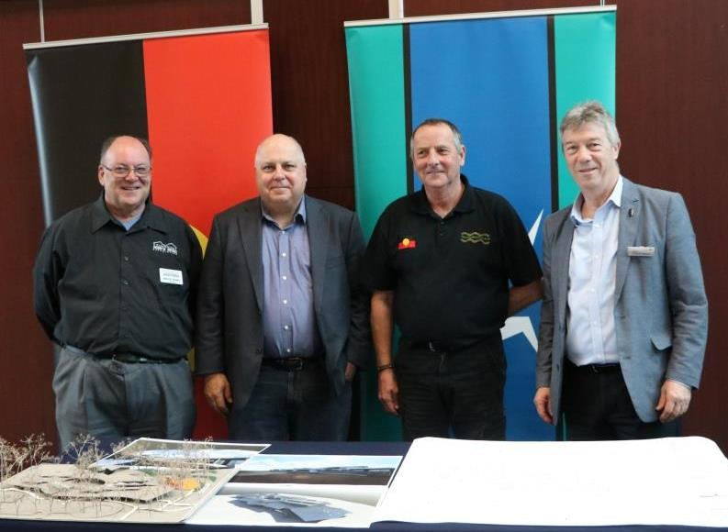Following this, the [Wyndham Aboriginal Community Centre Committee](https://www.wyndham.vic.gov.au/services/community-support/waccc-wyndham-aboriginal-community-centre-committee) (WACCC) formed to represent Aboriginal stakeholders and collaborate with Council to establish a culturally safe place for strengthening community and cultural development, and improving access and coordination of services and programs for Aboriginal people.

Various state government departments have subsequently supported this Council and Aboriginal Community partnership project with various grants to support different phases of the work. In 2014, an Aboriginal Project Officer position was established to support the WACCC and coordinate an interim space. In 2015, an Aboriginal consultant was engaged to conduct an Infrastructure Feasibility Study. Subsequently, the Wyndham Aboriginal Community Centre became a major capital project for Council with land, budgets and human resources allocated.

The WACCC is working with Council to ensure the involvement and influence of a diversity of Aboriginal stakeholders in every stage of development. Central to this RAP, the Aboriginal Community Centre is due to open in 2019. Alongside this Centre work, consultation about the RAP was conducted with a range of Aboriginal stakeholders.

L-R: Bruce Ward (Victorian Men’s Shed Association), Tim Pallas MP, Rob Monohan (WACCC, WRAC, Council employee) and Mayor Cr. Henry Barlow celebrating a state government grant for establishing a Men’s Shed at the WACC. 15th September, 2017. Photographer: Eliel Sotero

Staff across Directorates volunteered as Reconciliation Champions to deliberate over the meaning and implications of Reconciliation in our workplace. The [Statement of Commitment (2015)](https://www.wyndham.vic.gov.au/sites/default/files/2016-06/Leading%20Communities%20-%20Statement%20of%20Commitment%20FINAL%20for%20web%20or%20email%20smaller_5.pdf) expresses shared understandings that emerged from this process and imagines a new era for Council and Aboriginal community relations that:

* Acknowledges policies and practices that have harmed relationships between Aboriginal peoples and different levels of government, for the wider community with Aboriginal peoples, and amongst Aboriginal people themselves[18]
* Commits to address discrimination and disadvantage caused by injustice; and
* Supports Aboriginal self-determination in partnerships that respect multiple perspectives and solutions

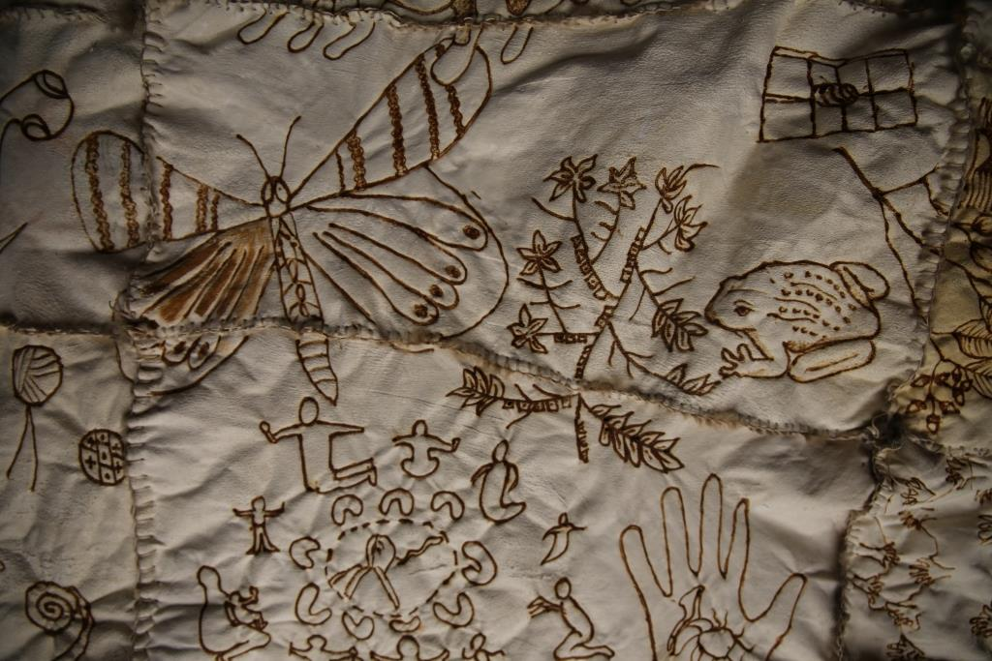Throughout 2016, key departments developed Reconciliation implementation plans that have contributed to this organisational RAP.

Council commissioned the creation of a Possum Skin Cloak to map the journey of conversations and friendship amongst Aboriginal and non-Aboriginal people, Council and community, during this time. Elements of this re-imagining of Reconciliation are woven throughout this document. Traditional Owner organisations were also formally consulted and their recommendations are translated into actions in this plan. In adopting the Reconciliation Australia Innovate model for this RAP, Council has focussed on a reconciling process that trials new ways of building relationships, showing respect and creating opportunities for Aboriginal and Torres Strait Islander peoples.

In the Wyndham City Plan 2017-2021, Council expresses commitment to the next stage in its Reconciliation journey.

# Managing the RAP

A RAP Management Group has been established with senior staff representation from each Council Directorate and Aboriginal staff to ensure implementation and oversee evaluation of this RAP. The group is comprised of

* 1. Executive sponsor: Director, City Life
  2. Manager, Community Planning and Development, City Life

1. Coordinator, Community Wellbeing and Inclusion
2. Wyndham Aboriginal Community Centre Project Officer
3. Policy and Planning Officer (Reconciliation)
   1. Manager, Community Support, City Life
   2. Manager, Libraries and Community Learning, City Life
   3. Manager, Environment and Water, City Economy, Innovation and Liveability
   4. Manager, Project Management Office, City Economy, Innovation and Liveability
   5. Manager, Facilities and Open Space, City Operations
   6. Manager, Contracts Procurement and Risk Management, City Operations
   7. Manager, People and Capability, CEO Office
   8. Aboriginal employees from different Council sectors

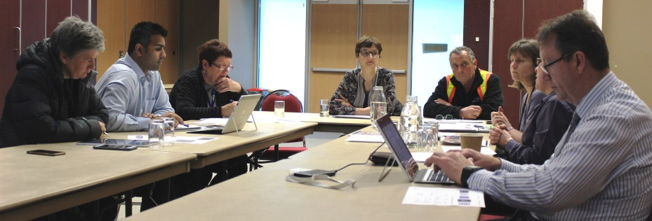Aboriginal and non-Aboriginal employees have taken up various opportunities to be involved at each stage of this Action Plan’s development. They have exercised leadership and contributed in the Reconciliation Champions program, their department Reconciliation implementation planning, Advisory and Working Groups.

RAP Management Meeting

28th September, 2017. Photographer: Pradeep Peteti

# Wyndham Reconciliation Advisory Committee

This Committee was formed in August 2016 with a range of community stakeholders to advise Council through the adoption of its first RAP. Co-chaired by a Wyndham City Councillor and an Aboriginal community member, it provides a forum for ongoing engagement between Aboriginal and non-Aboriginal community members with Council about shared concerns relating to Reconciliation in Wyndham. Council departments will report progress in implementing their Reconciliation actions to the Committee for feedback and advice.

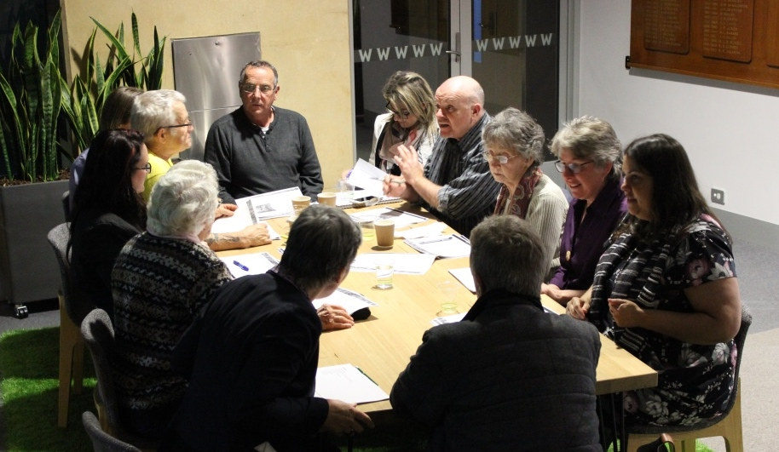

The WRAC providing feedback about the RAP.

14th September, 2017. Photographer: Pradeep Peteti

# Case Study: Reconciliation in Action

Wyndham Art Gallery exhibits the work of Aboriginal artists throughout the year, as well as curating exhibitions during NAIDOC week that are related to the issues that affect Aboriginal people.

In 2012, the *Respect* exhibition showcased artwork created by the local Aboriginal and Torres Strait Islander community during community cultural workshops

In 2015, the *War* exhibition examined the experience of frontier wars in Australia, alongside and beyond the two world wars. A range of prominent Aboriginal artists presented in dialogue with others who have experienced violent conflict.

In 2016, the RACE exhibition incorporated a program of events in the Gallery and across Community Centres, culminating in a public forum entitled UNpacking RACE.

In 2017, the *Referendum* - *Human Status* exhibition, with its series of life- sized portraits, depicted eleven people who were born before the 1967 referendum when Australians voted to change the Constitution with the hope of endorsing equal citizenship.

Across all their work, the Arts and Cultural Development team supports Aboriginal artists and industry development to create spaces for the diversity and dynamism of Aboriginal cultural expression in Wyndham City.

***Arts and Culture team***

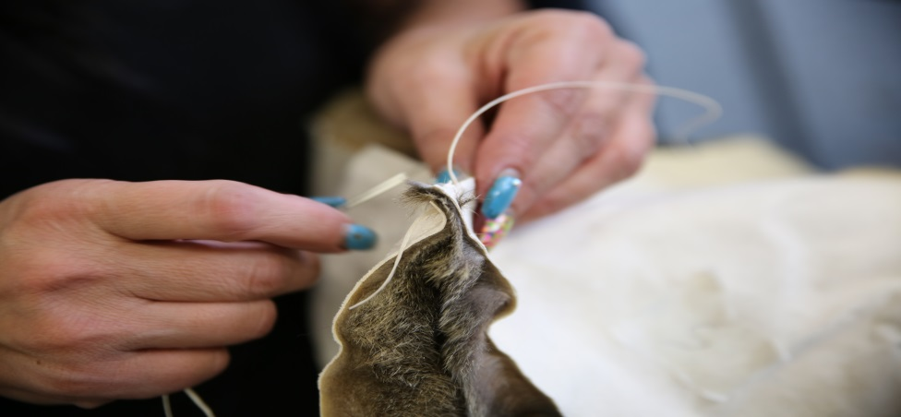

# Wyndham’s Reconciliation Action Plan

Council is implementing an Innovate RAP of 2-years duration that will commence when the RAP is formally endorsed by Reconciliation Australia.

The RAP model focusses the commitment of Council to Reconciliation on achieving outcomes under the three themes of:

* **Relationships**
* **Respect**
* **Opportunities**

The RAP has 4 columns to describe how Council will deliver its actions:

* The **Action** describes the broad action and includes the objective that Council will focus on achieving.
* **Deliverables** should be activities and initiatives that will enable Council to achieve its objective.
* **Timelines** are specific dates allocated to each deliverable throughout the RAP life. If the action is ongoing, the date listed indicates the date that Council will review the action for effectiveness or when Council expects to have achieved milestones.
* The **Responsibility** to delivering Council’s commitments is distributed across the organisation, to promote shared ownership to delivering the Actions. Responsibilities are allocated to specific management roles to increase accountability.

# Relationships

At its core, Reconciliation is about people building strong relationships of mutual respect and being prepared to deepen our understanding of the rich history of the First Nations people of this country. On this basis, Council can make better decisions about what is needed for communities to thrive. It begins with Council acknowledging the politics that have caused intergenerational harm and listening to the diversity of Aboriginal perspectives about what an equitable future looks like and how it can be achieved. Our *Statement of Commitment* details specific Council actions that are relevant to this:

* Support active participation of Aboriginal people in decision-making regarding both broad community and specific Aboriginal issues
* Increase opportunities for civic participation and leadership of Aboriginal people in the Wyndham community
* Work with the diversity of Aboriginal stakeholders to improve justice, health, housing and education outcomes
* Create partnerships with Traditional Owner organisations to protect and manage the rich Aboriginal cultural heritage of Wyndham City for future generations

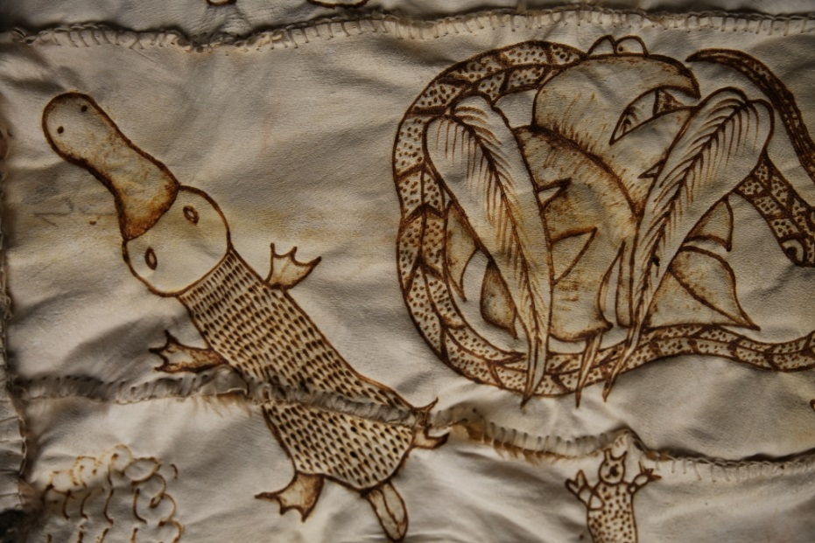**Current initiatives and achievements**

Council is building relationships with a range of Aboriginal stakeholders for various long-term projects that address different aspects of the work of Reconciliation in this municipality. The Wyndham Aboriginal Community Centre Committee works in partnership with Council to build and manage a centre for diverse Aboriginal people to build community connections, strengthen cultural identities and improve access to services. The Wyndham Reconciliation Advisory Committee brings Aboriginal and non-Aboriginal allies together with Council to develop, monitor, evaluate and review its RAP. The Aboriginal Cultural Heritage Working Group is forming to strengthen partnerships between Council departments, Traditional Owner organisations, developers and state government to ensure that the Aboriginal cultural heritage of Wyndham City enriches our relationship to the land for future generations.

We look forward to continuing to learn together, through relationships, what will lead to Reconciliation.

|  |  |  |  |
| --- | --- | --- | --- |
| * + - 1. **Relationships – Build a Community of Reconciliation** | | | |
| **Action** | **Deliverables** | **Timelines** | **Responsibility** |
| 1. A Senior Management Group monitors development, implementation, evaluation and reporting of the RAP across the organisation. | 1. Oversee the development, endorsement and launch of the RAP 2. Ensure representation from Aboriginal and/or Torres Strait Islander employees as members 3. Establish a Terms of Reference 4. Meet a minimum of two times each year to monitor and report on implementation | 1. December, 2017 2. December, 2017 3. December, 2017 4. June, 2019 | Coordinator, Community Wellbeing and Inclusion |
| 1. Establish mechanisms for Aboriginal community members to provide advice and guidance in the development and monitoring of the RAP. | 1. Continue to support the *Wyndham Reconciliation Advisory Committee* to identify ways to integrate the RAP across all Council 2. Meet with the *Wyndham Reconciliation Advisory Committee* a minimum of four times a year to monitor and evaluate this RAP 3. Ensure the Wyndham/Hobsons Bay *Local Aboriginal Network* receives an annual progress report about the RAP and provides feedback | 1. December, 2017 2. June, 2018 and June, 2019 3. June, 2018 and June, 2019 | Manager, Community Planning and Development |

|  |  |  |  |
| --- | --- | --- | --- |
| 1. Raise internal and external awareness of our RAP to promote reconciliation across our business and sector. | 1. Develop and implement a strategy to communicate our RAP and promote reconciliation through ongoing active engagement with all internal and external stakeholders 2. Include a *Reconciliation @ Wyndham* presentation in the Corporate Induction 3. Design and deliver an annual organisational RAP workshop on the staff training calendar 4. Deliver a *Reconciliation in Wyndham* session in the Council community leadership program 5. Design and launch an interactive online presentation on the public website about the RAP and the Possum Skin Cloak for Reconciliation. 6. Install the Possum Skin Cloak for Reconciliation in a place of significance at the Civic Centre 7. Design and publish a summary that presents our RAP in an accessible format | 1. November, 2018 2. November, 2018 3. December, 2018 4. December, 2018 5. June, 2018 6. June, 2018 7. June, 2018 | 1. Coordinator, Community Wellbeing and Inclusion 2. Manager, People and Capability 3. Coordinator, Community Wellbeing and Inclusion 4. Coordinator, Community Strengthening Programs 5. Manager, Community Planning and Development; Manager, Libraries and Community Learning 6. Manager, Community Planning and Development 7. Coordinator, Community Wellbeing and Inclusion |

|  |  |  |  |
| --- | --- | --- | --- |
| * + - 1. **Relationships – Participate in National Reconciliation Week** | | | |
| **Action** | **Deliverables** | **Timelines** | **Responsibility** |
| 1. Organise, support and promote internal and external events that bring people together and promote Reconciliation during National Reconciliation Week. | 1. Organise displays and activities in Wyndham Libraries that raise awareness about the history of Reconciliation, celebrate Aboriginal leadership and explore current issues during National Reconciliation Week 2. Recognise National Reconciliation Week in the Art Gallery, Libraries, Community Centres, Maternal and Child Health Centres, Kindergartens and the Depot 3. Organise an annual public Reconciliation event that brings Aboriginal and non-Aboriginal people together to build respectful friendship and mutual understanding around shared goals, such as tree planting and arts-based activities 4. Collaborate with the *Western Region Local Government Reconciliation Network* to promote and coordinate a range of National Reconciliation Week events across the region 5. Register our public events on the *Reconciliation Australia* and *Reconciliation Victoria* websites | 1. June 2018 and June 2019 2. June 2018 and June 2019 3. June 2018 and June 2019 4. June 2018 and June 2019 5. June 2018 and June 2019 | 1. Manager, Libraries and Community Learning 2. Manager, Community Planning and Development; Manager, Community Support; Manager, Libraries and Community Learning 3. Manager, Community Planning and Development: 4. Coordinator, Community Wellbeing and Inclusion 5. Coordinator, Community Wellbeing and Inclusion |

|  |  |  |  |
| --- | --- | --- | --- |
| 1. The RAP Management Group participates in events to recognise and celebrate National Reconciliation Week | 1. Support staff to facilitate events across the range of Council workplaces to bring staff together and raise awareness about the themes of National Reconciliation Week 2. Ensure RAP Management Group members promote and participate in an external event for National Reconciliation Week | 1. June 2018 and June 2019 2. June 2018 and June 2019 | * + 1. Manager, Community Planning and Development     2. RAP Management Group |
| 1. Support Community-led Reconciliation events. | 1. Promote the grants offered by *Reconciliation Victoria* and Council to enable community groups to organise local activities that bring residents together to recognise National Reconciliation Week | * + 1. June 2018 and June 2019 | Coordinator, Community Strengthening Programs |

|  |  |  |  |
| --- | --- | --- | --- |
| 1. **Relationships – Engage the diversity of Aboriginal stakeholders with their distinctive Reconciliation priorities** | | | |
| **Action** | **Deliverables** | **Timelines** | **Responsibility** |
| 1. Develop and maintain mutually beneficial relationships with Aboriginal and Torres Strait Islander peoples, communities and organisations to support positive outcomes in their specific areas of interest. | 1. Meet with local Aboriginal organisations to develop guiding principles for future engagement 2. Develop and implement an Aboriginal stakeholder engagement plan to inform City policies and projects 3. Maintain updates to our Aboriginal stakeholder directory | 1. June, 2019 2. June, 2018 3. August, 2019 | 1. Coordinator, Strategy and Stakeholder Engagement 2. Coordinator, Community Wellbeing and Inclusion 3. Coordinator, Community Wellbeing and Inclusion |

|  |  |  |  |
| --- | --- | --- | --- |
| 1. Work to ensure participation and partnership with the range of Aboriginal stakeholders in every stage of development of a *Wyndham Aboriginal Community Centre* that achieves community aspirations. | 1. Negotiate partnership agreements with the *Wyndham Aboriginal Community Centre Committee* to define roles and responsibilities for each year of work 2. Ensure that Aboriginal stakeholders inform and influence the design of the Centre 3. Prepare a Service Coordination plan for the Centre with key Aboriginal stakeholders 4. Work with the *Wyndham Aboriginal Community Centre Committee* to establish a Committee of Management for the Centre that supports Aboriginal community governance 5. Invite community to help design the adjoining Integrated Family Centre.   Council ensures that the Centre   1. Provides a range of employment and training opportunities 2. Increases procurement of goods and services from Aboriginal businesses 3. Promotes access to community and cultural resources and services for vulnerable Aboriginal children and families | 1. January, 2018 2. June, 2017 3. June, 2019 4. June, 2019 5. June, 2019 6. June, 2019 7. June, 2019 8. June, 2019 | 1. Coordinator, Community Infrastructure 2. Manager, Project Management Office 3. Manager, Service Planning, Partnership and Reform 4. Manager, Community Planning and Development 5. Manager, Community Support 6. Manager, People and Capability 7. Coordinator, Integrated Risk and Procurement 8. Manager, Community Support |

|  |  |  |  |
| --- | --- | --- | --- |
| 1. **Relationships - Consolidate and develop networks to improve justice, health, housing and education outcomes for Aboriginal people** | | | |
| **Action** | **Deliverable** | **Timeline** | **Responsibility** |
| 1. Strengthen collaboration between local government and Aboriginal communities at regional and state levels. | 1. Participate in the Western Region Local Government Reconciliation Network[19] 2. Maintain the Wyndham City page on the [Maggolee website](http://www.maggolee.org.au/local-government-areas-view-by-list/wyndham/)[20] that is hosted by *Reconciliation Victoria* to share resources and support collaboration between Councils with Aboriginal communities 3. Ensure Council’s RAP is aligned with the priority areas of the Wyndham/Hobsons Bay Local Aboriginal Network Five Year Plan (2016-2020) | 1. June 2019 2. August, 2018 3. June, 2019 | 1. Coordinator, Community Wellbeing and Inclusion 2. Coordinator, Community Wellbeing and Inclusion |
| 1. Strengthen local and regional networks to promote collaboration and improve access to culturally-appropriate services with Aboriginal people across the life stages. | 1. Resource, facilitate and continue to support the development of the *Wyndham Aboriginal Service Providers* Network 2. Participate in the *Regional Aboriginal Justice Advisory Committee* (Department of Justice) to support implementation of the Regional Justice Plan (2013-2018) 3. Participate in the *Indigenous Family Violence Regional Action Group* (DHHS) and ensure that its priorities inform Council’s *Gender Equity* strategy 4. Through the *Wyndham Best Start in Life Alliance*, engage with service providers that work with vulnerable Aboriginal children and their families to facilitate collaboration and referral pathways to access early childhood services 5. Engage with Aboriginal Community-Controlled Organisations and other providers of programs for Aboriginal people to improve service-planning, coordination and partnership in the delivery of   culturally-appropriate programs in Wyndham City | 1. April, 2019 2. April, 2019 3. April, 2019 4. April, 2019 5. June, 2019 | 1. Coordinator, Community Wellbeing and Inclusion 2. Coordinator, Community Wellbeing and Inclusion 3. Coordinator, Community Wellbeing and Inclusion 4. Manager, Community Support 5. Manager, Service Planning, Partnership and Reform |

|  |  |  |  |
| --- | --- | --- | --- |
| 1. **Relationships - Partnerships to protect and promote the rich, living Aboriginal cultural heritage of Wyndham City** | | | |
| **Action** | **Deliverable** | **Timeline** | **Responsibility** |
| Support collaboration with Registered Aboriginal Parties and Traditional Owner organisations for the protection of Aboriginal cultural heritage and land management through the formation of an internal *Aboriginal Cultural Heritage Working Group.* | 1. Establish a Terms of Reference 2. Meet a minimum of three times each year 3. Prepare principles and guidelines for supporting collaboration and agreement-making with and between Traditional Owner organisations 4. Develop an Aboriginal Cultural Heritage Management Toolkit for Staff 5. Provide a minimum of two Aboriginal Cultural heritage workshops for staff by Aboriginal cultural heritage specialists 6. Improve access to resources, information and interpretive signage about sites of Aboriginal significance in the municipality to guide Council employees in their work and residents in their interactions with these sites 7. Meet with Traditional Owner organisations twice a year to provide overview of planning and negotiate agreements about specific cultural heritage management projects | 1. June, 2018 2. June, 2019 3. August, 2018 4. June, 2019 5. June, 2019 6. November, 2018 7. June, 2019 | Manager, Community Planning and Development; Manager, Facilities and Open Space; Manager, Urban Futures; Manager, Assets and Roads; Manager, Planning and Building; Manager, Project Management Office; Manager, Environment and Water |

|  |  |  |  |
| --- | --- | --- | --- |
| 1. **Relationships – Governance for Aboriginal self-determination and civic participation** | | | |
| **Action** | **Deliverable** | **Timeline** | **Responsibility** |
| 1. Support Aboriginal people to build capacity for governance and leadership in Wyndham City. | 1. Promote participation of Aboriginal residents in  [Community Leadership Program](https://www.wyndham.vic.gov.au/services/community-support/building-blocks-community-leadership-program/about-building-blocks)s 2. Promote the free [*Volunteer and Community Group Training*](https://www.wyndham.vic.gov.au/services/volunteering-grants/volunteer-and-community-group-training) calendar to the Aboriginal community 3. Promote the [*Community Pathways Scholarships*](https://www.wyndham.vic.gov.au/services/volunteering-grants/how-apply-grant/community-pathways-scholarships) through Council’s Grants program to support Aboriginal sports people, artists, community champions and students to pursue their field of expertise 4. Provide access to Aboriginal community governance training and resources | * + 1. December, 2018     2. January, 2018     3. June, 2019     4. June, 2019 | 1. Coordinator, Community Strengthening Programs 2. Coordinator, Community Strengthening Programs 3. Coordinator, Community Strengthening Programs 4. Coordinator, Community Strengthening Programs |
| 1. Promote participation of Aboriginal people in Council governance structures to enable involvement in decision-making about the whole of Wyndham City as   well as issues specific to the Aboriginal community. | 1. Promote participation of Aboriginal residents in Council [Committees](https://www.wyndham.vic.gov.au/portfolio-committees) that relate to individual areas of interest, expertise, location and experience 2. Promote opportunities for Aboriginal residents to gain advice and make informed choices about standing as a local government candidate[21] 3. Promote participation of young Aboriginal residents in the range of place-based and issue-related Wyndham [*Youth Committees*](https://www.wyndham.vic.gov.au/services/youth-services/networks-committees/youth-committees), and the state-wide [*Koorie Youth Council*](https://www.yacvic.org.au/about-us/projects-and-services/koorie-youth-council) to build their skills and networking capacities 4. Raise awareness of State Government Treaty negotiations and their implications in Wyndham 5. Promote Council awareness of federal government deliberations with the Prime Minister-appointed [*Referendum Council*](https://www.pmc.gov.au/indigenous-affairs/constitutional-recognition/referendum-council) to prepare Wyndham residents to participate in the proposed Referendum for Constitutional reform about recognition of Aboriginal voices in Australian systems of government | * 1. June, 2019   2. June, 2019   3. June, 2019   4. June, 2019   5. November, 2018 | 1. Manager, Community Planning and Development 2. Coordinator, Neighbourhood Hubs 3. Coordinator, Neighbourhood Hubs 4. Coordinator, Community Wellbeing and Inclusion 5. Coordinator, Community Wellbeing and Inclusion |

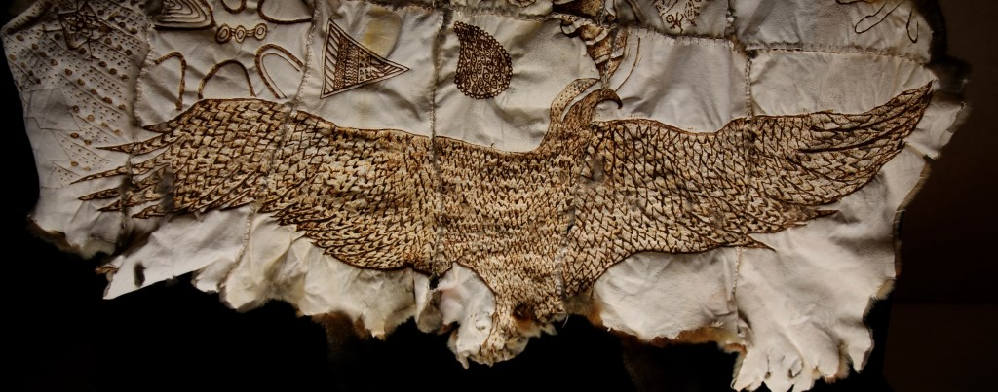

# Description: \\civicfile2\redirected$\kgodbold\Desktop\Possum Skin Cloak photos\Stephen Walsh & Judy Dalton-Walsh.jpgRespect

The[Victorian Aboriginal Local Government Action Plan (2016) explains](http://www.delwp.vic.gov.au/local-government/strengthening-councils/victorian-aboriginal-local-government-action-plan) thekey role that Councils can play as a *Local Leader* in developing organisational processes and structures that pay respect for Aboriginal and Torres Strait Islander peoples, cultures, lands, waters, histories and rights. Our*Statement of Commitment* calls us to demonstrate this respect by

1. Supporting initiatives that combat racism and discrimination against Aboriginal people
2. Advocating and partnering with Aboriginal communities, organisations and key stakeholders to help achieve justice, health, housing and education outcomes for Aboriginal people
3. Providing services that are culturally responsive and proactive in meeting the needs of Aboriginal people across the life stages
4. Raising awareness across Council and in the broader Wyndham community to increase understanding, recognition and respect of about the diversity of backgrounds, beliefs, expression of cultures and connections to traditional lands and practices amongst Aboriginal people that have a connection to Wyndham

Stephen Walsh (Gunai, Taungurung) and Judy Dalton-Walsh (Wauthaurong)

Aboriginal Engagement Officers (State government);

Long-time Wyndham residents.

Reconciliation Community Exchange Dinner, 1st June, 2017.

Photographer: Xavier Smerdon

**Current initiatives and achievements**

Each year, Council hosts a civic flag-raising ceremony during NAIDOC Week at which community members lead celebration of their achievements and communicate their key messages for the municipality. Council supports Aboriginal community-led initiatives to run events that address the key themes of NAIDOC Week.

Various Council departments contract different Aboriginal trainers and consultants to facilitate workshops related to specific areas of Council business such as cultural heritage management, early childhood education and service provision. In this RAP, Council seeks to integrate this tailored-training approach across the organisation and embed respect based on understanding for all staff of the distinct status and priorities of Aboriginal communities. This includes equipping staff to offer respectful acknowledgement of Country and its diversity Traditional Owners.

|  |  |  |  |
| --- | --- | --- | --- |
| * + - 1. **Respect - Build understanding and respect about Aboriginal cultures and histories across Council** | | | |
| **Action** | **Deliverables** | **Timelines** | **Responsibility** |
| Engage employees in cultural learning opportunities to increase understanding and appreciation of Aboriginal and Torres Strait Islander cultures, histories and achievements. | 1. Promote Reconciliation Australia’s [*Share Our Pride*](http://shareourpride.reconciliation.org.au/) online tool to all employees 2. Develop and implement a strategy that provides opportunities for staff at all levels, including Management Group members and other key leadership staff, to participate in Aboriginal cultural awareness training through different learning modes (online, workshops, cultural immersion) that are tailored to their particular areas of work 3. Maintain a guide to Aboriginal consultants, education providers and resources that increases opportunities to tailor training to the needs of each Directorate | 1. December, 2018 2. December, 2018 3. February, 2019 | Manager, People and Capability |

|  |  |  |  |
| --- | --- | --- | --- |
| * + - 1. **Respect - Respectful acknowledgement and engagement with Traditional Owners across all our business** | | | |
| **Action** | **Deliverables** | **Timelines** | **Responsibility** |
| 1. Engage Council in recognising the First Peoples of Australia and the names of the Traditional Owners of the lands on which Wyndham City is being built. | 1. Develop, implement and communicate a cultural protocol document and contact directory for Welcome to Country and Acknowledgement of Country 2. Organise an Acknowledgement of Country ceremony for a minimum of one Ordinary Council Meeting and another significant civic event each year 3. Incorporate Acknowledgement of Country statements into Council communications: 4. the public website 5. promotional materials for Council events 6. Council public policies and plans 7. Fly the Aboriginal flag outside the Civic Centre, within Council Chamber, at the Refuse Disposal Facility and Depot throughout the year; and the Torres Strait Islander flag for both Reconciliation and NAIDOC Weeks 8. Provide an Acknowledgement of Country statement for staff email signatures 9. Ensure Council community facilities, venues, hubs and the Depot display an Acknowledgement of Country in reception areas | * + 1. July, 2018     2. July, 2018     3. February, 2018     4. June, 2018     5. June, 2019     6. August, 2018 | 1. Coordinator, Strategic Communications and Marketing 2. Coordinator, Community Wellbeing and Inclusion 3. Manager, [Corporate Affairs](http://wyndhamnet/intranet/quikfind/quikfind-results.asp?searchQF=Corporate%20Affairs) 4. Coordinator, Strategic Communications and Marketing 5. Coordinator, Strategic Communications and Marketing 6. RAP Management Group |
| 1. Explore opportunities for incorporating Aboriginal place-names, languages, design features and cultural heritage information in a wide-range of existing infrastructure and future developments. | 1. Engage the Victorian Aboriginal Corporation for Languages to provide guidelines and resources for respectful naming processes in proposal outlines, tenders and selection criteria for projects related to naming new and existing community infrastructure 2. Collaborate with the Victorian Aboriginal Corporation for Languages, Traditional Owner organisations and Wyndham Aboriginal communities to create a name for the Wyndham Aboriginal Community Centre that communicates its cultural significance 3. Encourage external stakeholders to recognise Aboriginal languages in place-naming through promotion of the principles and guidelines provided by the Victorian Department of Environment, Land, Water and Planning[22] | 1. June 2018 2. June, 2019 3. June, 2019 | 1. Manager, Service Planning, Partnership and Reform 2. Coordinator, Community Infrastructure 3. Aboriginal Cultural Heritage Working Group |

|  |  |  |  |
| --- | --- | --- | --- |
| * + - 1. **Respect – Recognise NAIDOC Week** | | | |
| **Action** | **Deliverables** | **Timeline** | **Responsibility** |
| 1. Provide opportunities for Aboriginal and Torres Strait Islander people in the community and workplace to engage with NAIDOC Week events. | 1. Provide opportunities for all Aboriginal and Torres Strait Islander staff be active in their cultures and communities during NAIDOC Week 2. Review HR policies and procedures to support to staff participating in NAIDOC Week activities 3. Incorporate NAIDOC Week into the Arts, Culture and Events program 4. In partnership with local Aboriginal groups, host an annual NAIDOC Week flag-raising ceremony 5. Promote the Council and NAIDOC grants programs to Aboriginal community groups wishing to organise and participate in NAIDOC Week activities 6. Recognise NAIDOC Week across Council facilities and services, including the Art Gallery, Libraries, Community Centres, Maternal and Child Health Centres, Kindergartens and the Depot 7. Develop an annual calendar of NAIDOC Week activities with the Western Region Local Government Reconciliation Network 8. Promote public events organised by Council on the NAIDOC website 9. Provide opportunities for Council staff and the community to learn about Aboriginal political history and current issues during NAIDOC Week 10. Produce recommendations about key Reconciliation messages to inform Council communications and event planning, with particular attention to national days of significance in Reconciliation Week, NAIDOC Week and Australia Day | 1. August, 2018 2. September, 2018 3. September, 2018 4. August, 2019 5. August, 2019 6. June 2019 7. August, 2019 8. August, 2019 9. August, 2019 10. August, 2019 | 1. Manager, People and Capability 2. Manager, People and Capability 3. Coordinator, Arts, Culture and Events 4. Coordinator, Community Wellbeing and Inclusion 5. Coordinator, Community Strengthening Programs 6. Manager, Community Planning and Development; Manager, Community Support; Manager, Libraries and   Community Learning   1. Coordinator, Community Wellbeing and Inclusion 2. Coordinator, Community Wellbeing and Inclusion 3. Manager, People and Capability; Coordinator, Community Wellbeing and Inclusion 4. Coordinator, Strategic Communications and Marketing |
| 1. Recognise and acknowledge historic sites and stories of past injustices, during NAIDOC Week and throughout the year. | 1. Acknowledge the costs of frontier conflict at the annual NAIDOC ceremony 2. Collaborate with Traditional Owner representatives to deliver a project that pays respect to sites of past injustices | 1. July, 2019 2. July, 2019 | Coordinator, Arts, Culture and Events |

|  |  |  |  |
| --- | --- | --- | --- |
| * + - 1. **Respect - Integrate respect for Aboriginal communities and Reconciliation priorities into all our planning** | | | |
| **Action** | **Deliverable** | **Timeline** | **Responsibility** |
| 1. Ensure that Reconciliation priorities are incorporated into the City Plan and integrated into all strategic plans and policies. | 1. Incorporate consultation with Aboriginal stakeholders and other RAP priorities into review processes for strategic plans and policies in each Directorate and department. 2. Develop biennial Reconciliation Implementation Plans with departments in each Directorate | 1. June, 2019 2. June, 2019 | 1. Coordinator, Community Wellbeing and Inclusion 2. RAP Management Group |
| 1. Ensure that strategic planning and service coordination is informed by current Aboriginal and Torres Strait Islander population data for Council to support improved outcomes in health, education and employment. | 1. Collect current demographic data and research to build understanding of change and growth in the Aboriginal populations of Wyndham 2. Produce a Wyndham City Aboriginal and Torres Strait Islander community profile to inform priorities for planning and service reform in Council departments | 1. February, 2018 2. July, 2018 | 1. Coordinator, Strategy and Stakeholder Engagement 2. Manager, Service Planning, Partnership and Reform |

|  |  |  |  |
| --- | --- | --- | --- |
| **5. Respect – Support education that contributes to Reconciliation** | | | |
| **Action** | **Deliverables** | **Timelines** | **Responsibility** |
| a) Promote education by and about Aboriginal people and cultures in early years. | 1. Model service-delivery in the Maternal and Child Health Wellness Unit with the Indigenous-led [*Australian Model of the First 1000 Days*](https://www2.aifs.gov.au/cfca/knowledgecircle/discussions/children-and-young-people/australian-model-first-1000-days)*[23]* for Aboriginal children from pre-conception to two year of age 2. Align Council Early Education and Family Services, and Maternal and Child Health Wellness Unit planning and delivery with the [*Marrung Aboriginal Education Plan 2016 – 2026*](http://www.education.vic.gov.au/about/programs/aboriginal/Pages/marrung.aspx) (Victorian Department of Education and Training) 3. All Council Kindergartens implement the [*Narragunnawali: Reconciliation in Schools and Early Learning*](http://www.reconciliation.org.au/narragunnawali/) program in partnership with Reconciliation Australia 4. Facilitate annual professional development workshops to equip Kindergarten staff to establish, implement and evaluate progress of their Narragunnawali program 5. Organise and fund the annual Aboriginal cultural immersion program for all Kindergarten families in partnership with Aboriginal businesses 6. Fund and facilitate attendance of representative Kindergarten staff to attend the annual Early Childhood Australia Reconciliation Symposium 7. Promote Aboriginal businesses that provide early childhood resources | 1. December, 2018 2. April, 2018 3. June, 2018 and June, 2019 4. November, 2018 5. June, 2019 6. June, 2019 7. June, 2019 | 1. Manager, Community Support 2. Coordinator, Kindergarten Services 3. Coordinator, Kindergarten Services 4. Coordinator, Kindergarten Services 5. Coordinator, Kindergarten Services 6. Manager, Community Support 7. Manager, Community Support |

|  |  |  |  |
| --- | --- | --- | --- |
| b) Promote ongoing learning about Aboriginal cultures, histories and politics. | 1. Engage Aboriginal businesses to provide a workshop about Aboriginal approaches to land and resource management with the *Wyndham Teachers Environment Network* (biennial) 2. Maintain and promote the *Rivers to Recognition* Education Resource Directory with the Western Region Local Government Reconciliation Network and the Koorie Education Support team (Department of Education and Training) 3. Promote community awareness of Aboriginal peoples and understanding of Reconciliation issues in Wyndham by creating a regular feature in local Community Centre newsletters 4. Provide opportunities for non-Aboriginal residents to have increased understanding and knowledge of Aboriginal cultures, histories and politics through activities, including art-based projects, at Community Centres | 1. June, 2019 2. May, 2018 and May, 2019 3. June, 2018 4. December, 2018 | 1. Coordinator, Environment and Sustainability 2. Coordinator, Community Wellbeing and Inclusion 3. Coordinator, Neighbourhood Hubs 4. Coordinator, Neighbourhood Hubs |
| 1. Support implementation of the *Marrung Aboriginal Education Plan 2016-2026* to improve education outcomes for local Aboriginal people at every stage of their learning and development journey from early childhood through school and the transition into post-school pathways. | 1. Promote development of cultural safety in education and training organisations across Wyndham City so that services are inclusive, responsive and respectful of Aboriginal people. 2. Support partnership between educational institutions in Wyndham City and the [Local Aboriginal Education Consultative Group](http://vaeai.org.au/who-we-are/dsp-default.cfm?loadref=14)[24] as a vehicle through which Aboriginal community members can have a say about all matters relating to their and their children's education | 1. June, 2019 2. June, 2019 | 1. Manager, Community Support 2. Manager, Community Wellbeing and Inclusion |

# Case Study: Reconciliation in Action

***Council Kindergartens team – A Narragunnawali story***

Around 20 years ago, some Council Kindergarten educators began organising an annual cultural immersion program for families. This program continues today, led by Aboriginal educators, on Aboriginal sites of significance. With every Council Kindergarten involved, educators embed its learnings into activities throughout the year.

As each day begins across Council Kindergartens, children sit in Yarning Circles and acknowledge the Traditional Custodians and Country on which they meet to learn and play. Here is an example of an acknowledgement that each Kindergarten has created with the children:

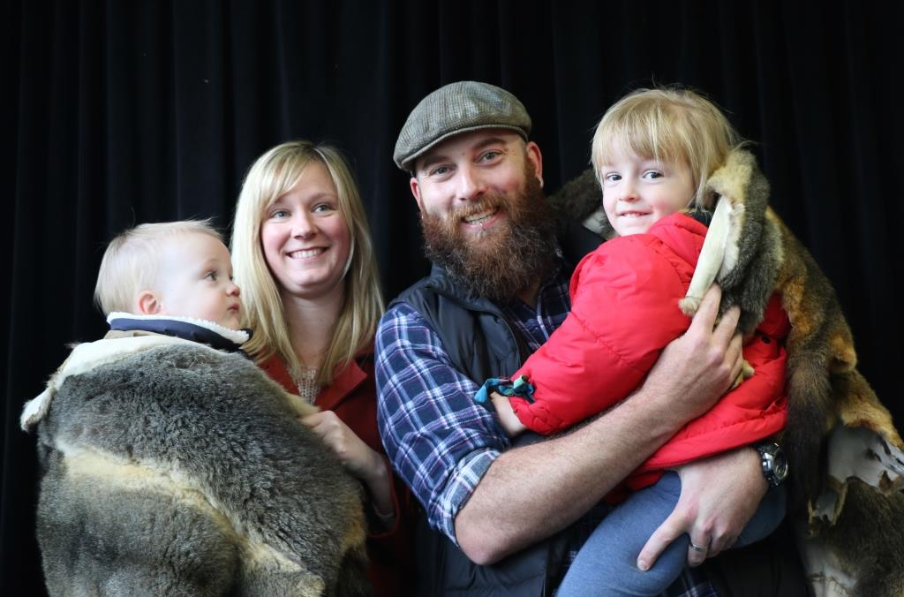*Here is the land.*

*Here is the sky.*

*Here are my friends*

*and here am I.*

*We’d like to thank the*

*People of the Kulin Nation*

*for the land on which*

*we learn and play.*

Kindergartens are building a range of resources to embed learning about Aboriginal people and cultures, past and present. Aboriginal businesses are engaged as partners to lead and resource activities. Wherever possible, input from Traditional Owner organisations and local Aboriginal residents are being sought about design features of Kindergarten facilities, old and new.

The Greig family (L-R: Angus, Lisa, Stewart and Penny) enjoyed taking part in the Possum Skin Cloak project when Penny was learning about Aboriginal history and culture through songs, stories and art in Kindergarten and Stew was an Area Leader in Kindergarten Services.

Council Kindergartens are playing a vital role in ensuring that all Wyndham families understand and respect Aboriginal cultures and histories.

# Opportunities

Council recognises that supporting economic development in Aboriginal households is key to Reconciliation in Wyndham City. The actions in this section emerge from understanding the role that Council can play in encouraging Aboriginal enterprise, increasing access to a range of employment opportunities, and procuring goods and services from Aboriginal and Traditional Owner businesses at the local level[25].

Our Statement of Commitment (2015) also recognised the central role of local government in

* The active participation of Aboriginal people in decision-making regarding both broad community and specific Aboriginal issues
* 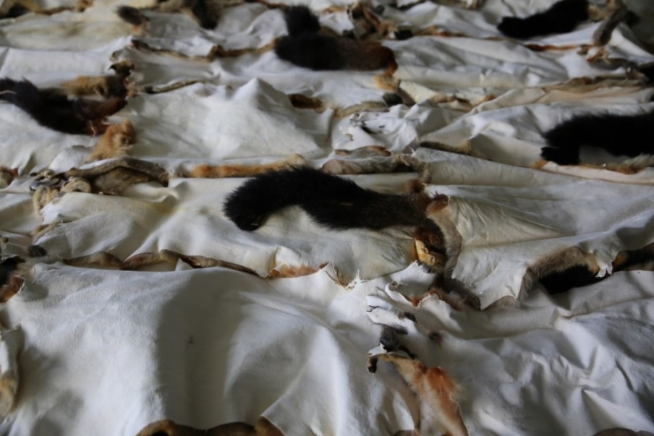Increasing the civic participation of Aboriginal people at all levels and providing opportunities for Aboriginal Elders and leaders to play an active role in the broader Wyndham community.

**Current initiatives and achievements**

Key departments across the core business areas of Council have developed commercial relationships with a range of Aboriginal businesses. For a number of years, Aboriginal people have been contracted as artists, architects, training providers, early childhood educators, cultural heritage advisors and community consultants, and ceremonial leaders and performers. Council is proactive in promoting a range of Grants to support Aboriginal community groups and organisations to lead activities that strengthen cultural identity, environmental conservation, reconciliation and social inclusion.

The Wyndham Arts and Culture Team is an example of reconciliation in practice on a daily basis. Staffed by Aboriginal and non-Aboriginal artists, curators and cultural development officers, working in partnership, this team promotes participation of Aboriginal people in every aspect of the industry. This empowers Aboriginal people to express their living cultures and connection to country, engage community histories and reconciliation priorities, through a contemporary arts lens.

The building of the Wyndham Aboriginal Community Centre, alondside an Integrated Family Centre, is creating opportunities for contracting various Aboriginal businesses for procurement of goods and services. Preparing for employment of Aboriginal people across management and operations of the Centre will inform the development of an Aboriginal employment strategy for the whole of Council.

|  |  |  |  |
| --- | --- | --- | --- |
| 1. **Opportunities – Strengthen Aboriginal employment** | | | |
| **Action** | **Deliverables** | **Timelines** | **Responsibility** |
| Investigate opportunities to improve and increase Aboriginal and Torres Strait Islander employment outcomes within our workplace. | 1. Apply the [Municipal Association of Victoria Aboriginal Employment framework](http://www.mav.asn.au/policy-services/social-community/indigenous/aboriginal-employment/Pages/default.aspx) to develop and implement an Aboriginal and Torres Strait Islander Employment strategy which identifies and addresses barriers in order to attract applicants to our workplace 2. Explore use of the [Reconciliation Australia’s Workplace Ready](http://workplace.reconciliation.org.au/)  toolkit 3. Develop and deliver an effective process for collecting information about current Aboriginal and Torres Strait Islander staff to inform future employment opportunities. 4. Engage with agencies that provide Aboriginal employment programs to increase access for Aboriginal candidates to advertised vacancies 5. Establish an *Aboriginal Employee Advisory* *Group* to engage and consult with existing Aboriginal and Torres Strait Islander staff about recruitment, retention and professional development strategies 6. Engage with local stakeholders in the [*Wurreker*Vocational Education and Training Strategy](http://www.vaeai.org.au/education/dsp-default.cfm?loadref=130)*[26]* to implement an Aboriginal employment pathways program based on projected employment and industry growth within the region 7. Advertise all vacancies in Aboriginal and Torres Strait Islander networks and media, for example, the *Koori Mail* 8. Include in all job advertisements, ‘Aboriginal and Torres Strait Islander people are encouraged to apply’ 9. Develop and implement an Aboriginal employment pathways program, including traineeships and mentoring in departments identified as priority areas 10. Establish and support Aboriginal-identified roles in strategic priorities areas, for example Youth Services and Maternal and Child Health | 1. June, 2019 2. January, 2018 3. February, 2018 4. June, 2018 5. August, 2018 6. September 2018 7. June, 2019 8. June, 2019 9. June, 2019 10. June, 2019 | Manager, People and Capability |

|  |  |  |  |
| --- | --- | --- | --- |
| 1. **Opportunities – Support Aboriginal economic development** | | | |
| **Action** | **Deliverables** | **Timelines** | **Responsibility** |
| Align Council business development strategies with the aims of the state government *Tharamba Bugheen* Aboriginal Business Strategy[27] to   * + - 1. improve the accessibility of business support       2. improve the visibility and networks of Aboriginal businesses in the region       3. strengthen the entrepreneurial culture and business experience of Aboriginal people in Wyndham       4. increase the number and diversity of Aboriginal suppliers within Council. | 1. Develop a social procurement policy that promotes supply of goods and services from Aboriginal and Torres Strait Islander businesses in our organisation 2. Increase the number and diversity of commercial relationships with Aboriginal-owned businesses across Council departments 3. Promote Council engagement with [Supply Nation](http://www.supplynation.org.au/indigenous_businesses/Indigenous_Business_Direct) and the Victorian Aboriginal Business Directory to facilitate integration of Indigenous businesses into the supply chain across Council Directorates 4. Work with the *Local Aboriginal Network* to develop and promote a list of Aboriginal businesses in the region to guide procurement of goods and services 5. Promote to local Aboriginal businesses the opportunity to participate in Council’s [Business Training and Events calendar](https://www.wyndham.vic.gov.au/services/business-investment/business-training), include items of interest in the monthly e-newsletter *Business Matters in Wyndham*, and network opportunities 6. Promote engagement across the organization with the activities of Kinaway Chamber of Commerce Victoria[28] 7. Support local Aboriginal businesses to promote economic development through participation in Victorian networks and national organisations, such as [*Indigenous Business Australia*](http://www.iba.gov.au/) 8. Provide business development support and mentoring opportunities to Aboriginal artists and arts administrators through the Wyndham Arts Incubator 9. Engage with the Victorian Aboriginal Economic Board for advice about procuring goods and services through Aboriginal businesses for completion of the Wyndham Aboriginal Community Centre project | 1. September, 2018 2. September, 2019 3. September, 2018 4. September, 2018 5. September, 2019 6. September, 2019 7. June, 2019 8. January, 2019 9. January, 2019 | Coordinator, Integrated Risk and Procurement |

|  |  |  |  |
| --- | --- | --- | --- |
| 1. **Opportunities - Maximise opportunities to improve Justice outcomes with the Wyndham Aboriginal Community** | | | |
| Maintain a partnership approach with Aboriginal community networks to ensure that Aboriginal people experience improved outcomes in any developments with regard to correctional facilities and services related to the Justice system in Wyndham City. | 1. Work with State Government and the Regional Aboriginal Justice Advisory Committee to ensure that the objectives of the *Regional Aboriginal Justice Agreement Phase 3* influence infrastructure planning of the proposed Justice Precinct 2. Work with State Government to ensure that local Aboriginal stakeholder engagement informs and influences service-planning for the proposed Justice Precinct 3. Promote access to Aboriginal community and cultural resources and Justice services for vulnerable Aboriginal children, young people and their families 4. Ensure that the Wyndham Aboriginal Community Centre is positioned to play a role as a focal point for Aboriginal people who are engaged with the Justice system to access a range of services, cultural strengthening activities and community connections | 1. June, 2019 2. June, 2019 3. June, 2019 4. June, 2019 | 1. Manager, Community Wellbeing and Inclusion 2. Manager, Community Wellbeing and Inclusion 3. Manager, Community Wellbeing and Inclusion 4. Coordinator, Community Infrastructure |

# Description: \\civicfile2\redirected$\kgodbold\Desktop\RAP photos\Artwork Libraries - Deanne Gilson.jpgCase Study: Reconciliation in Action

***Libraries and Community Learning*: a river with many branches**

In 2015, in partnership with Aboriginal Victoria (Department of Premier and Cabinet), Libraries hosted the launch of the Victorian Aboriginal Honour Roll. This celebration marked a milestone for Libraries teams in their journey towards Reconciliation that would place recognition of Aboriginal achievements and building respectful relationships with local Aboriginal community members at its heart.

The Libraries team now attends the Local Aboriginal Network and community activities. Recommendations from the Aboriginal community are now incorporated into the Library Children’s and Youth and Adult Frameworks and the Library Business Plan. Some steps toward Reconciliation that can be seen in Libraries include:

* A commissioned artwork by an Aboriginal artist that celebrates Aboriginal knowledge systems.

Deanne Gilson,

*Birthing and Knowledge Tree Surrounded by Water Spirit.*

Wyndham City Libraries.

Photographer: Heath Worsley, Hstudios.

* Visits to Aboriginal community playgroups to provide resources and a Story Time.
* A webpage guide to [Early Years resources that celebrate Aboriginal and Torres Strait Islander peoples and cultures](https://www.wyndham.vic.gov.au/services/libraries/early-years/early-years-resources).
* Opportunities to learn about Aboriginal cultures and histories through film nights and story times during Reconciliation Week and NAIDOC Week
* Increasing numbers of staff engaging with [*Cultural Connections*](https://membership.alia.org.au/events/event/cultural-connections-2016)training

This department celebrates the strengthening of relationships with the Wyndham Aboriginal Community and maintains a commitment to creating Libraries that welcome the contributions and participation of Aboriginal people of all generations

# Monitoring and Evaluation

|  |  |  |  |
| --- | --- | --- | --- |
| **Tracking progress and reporting** | | | |
| **Action** | **Deliverable** | **Timeline** | **Responsibility** |
| Report RAP achievements, challenges and learnings to *Reconciliation Australia.* | 1. Complete and submit the RAP Impact Measurement Questionnaire to Reconciliation Australia annually 2. Investigate participating in the RAP Barometer | 1. 30 September, annually 2. May 2018 | RAP Management Group |
| Report RAP achievements, challenges and learnings internally and externally. | 1. Report to the Wyndham Reconciliation Advisory Committee and Local Aboriginal Network 2. Conduct a public review of progress against RAP outcomes and report at the ordinary Council Meeting closest to Reconciliation Week | 1. December, annually 2. May, 2019 | Manager, Community Planning and Development |
| Review, refresh and update RAP. | 1. Liaise with *Reconciliation Australia* to develop a new RAP based on learnings, challenges and achievements 2. Send draft RAP to Reconciliation Australia for review and feedback 3. Submit draft RAP to Reconciliation Australia for formal endorsement | 1. January, 2019 2. September, 2019 3. October, 2019 | Manager, Community Planning and Development |

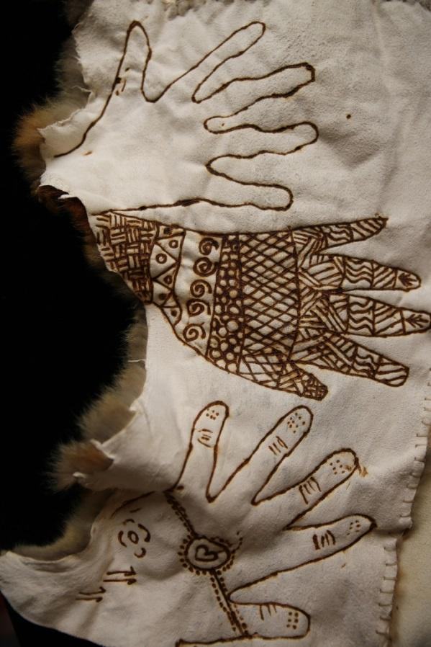

For more information about this Reconciliation Action Plan, contact the Community Wellbeing and Inclusion Unit at Wyndham City Council.

**Phone:** 9742 0777

**Email:**[Communitywellbeing&inclusion@wyndham.vic.gov.au](mailto:Communitywellbeing&inclusion@wyndham.vic.gov.au)

Copies of this Reconciliation Action Plan Copies can be downloaded from <https://www.wyndham.vic.gov.au/reconciliation> and can be made available in alternate formats.

For assistance, please phone 9742 0777 or email [mail@wyndham.vic.gov.au](mailto:mail@wyndham.vic.gov.au).

For Translating and Interpreting Services, call 131 450 and ask for connection to Wyndham City on 9742 0777.

For those who are deaf of have a hearing or speech impairment contact Wyndham City through the National Relay Service:

* + - 1. TTY user phone 133 677 then ask for 9742 0777
      2. Speak and Listen (speech-to-speech relay) users phone 1300 555 727

and ask for 9742 0777

* + - 1. Internet relay users connect to <http://relayservice.gov.au/> and ask for 9742 0777

**Reconciliation**

As the gum leaf smoke of welcome rises high,

The truth of our belonging is a sword-thrust –

We based Australia’s history on a lie.

‘Empty country’ we proclaimed to a southern sky,

Years in thousands still discounted in our lust

As the gum leaf smoke of welcome rises high.

Invaders, my ancestors, would not try

To respect Law, culture, language. Accept we must,

We based Australia’s history on a lie.

Colonial chains and massacres passed by,

But our justice still is coloured and unjust

As the gum leaf smoke of welcome rises high.

We voiced apologies, acknowledgements, but why

Were they abandoned like machinery to rust?

We based Australia’s history on a lie.

Action now! We cannot still deny

It’s time to gain and build a mutual trust

As the gum leaf smoke of welcome rises high.

We based Australia’s history on a lie.

*Margaret Campbell*

Wyndham Reconciliation Advisory Committee , 2017

# Endnotes

1. To assist with correct pronunciation, the *Victorian Aboriginal Corporation for Languages* suggests these spellings for the three different language groups. Council acknowledges the right of Aboriginal people to choose various English spellings to communicate names that were passed down orally. The choice of spelling here refers to the language groups and is not intended to show preference for any one contemporary Traditional Owner organisation over another
2. For more information, see the [Wyndham History website](http://www.wyndhamhistory.net.au/items/show/1528) or book Wyndham: Our Story (pp. 31 – 50)
3. European settlers of Wyndham recorded “weariby”, meaning “backbone”, to be the Aboriginal name for the river. See [Wyndham History](http://www.wyndhamhistory.net.au/exhibits/show/european-settlement/wyndham-develops)
4. For more information from Aboriginal Victorian perspectives, see [Bunjilaka Aboriginal Cultural Centre](https://museumvictoria.com.au/bunjilaka/whats-on/first-peoples/), Museums Victoria website.
5. [Municipal Association of Victoria – The role of Council](http://www.mav.asn.au/about-local-government/stand-for-council/whats-it-take/Pages/councils-role.aspx)
6. For detailed demographic profiles, see the [Council website](https://www.wyndham.vic.gov.au/about-council/wyndham-community/demographics-population-overview) and [Profile.id](http://profile.id.com.au/wyndham)
7. Throughout this document, the term ‘Aboriginal’ is used to refer collectively to Aboriginal and Torres Strait Islander peoples as the first peoples of Australia, without denying their distinctiveness or sovereignty. ‘Indigenous’ is used in a similar way. While ‘Koori’ can refer to Aboriginal people from the south-eastern part of Australia, many Aboriginal people living in Wyndham City originate from outside this region.
8. Geoff Hocking, [Wyndham – Our Story](http://catalogue.nla.gov.au/Record/6155228)*,* 2013:31-49
9. [Werribee Shire Banner, Thursday 3 January 1924, page.6](http://trove.nla.gov.au/newspaper/article/74706914).
10. For accounts and analysis, see Geoff Hocking, [Wyndham – Our Story](http://catalogue.nla.gov.au/Record/6155228)*,* 2013:43-49; David Moloney, [Shire of Melton heritage study: stage](http://www.melton.vic.gov.au/Services/Building-Planning-Transport/Strategic-planning/Studiesstrategiesguidelines/Melton-Heritage-Study/Volume-2-The-Environmental-Thematic-History) 2. Melton Council, 2007:15-21.
11. The [Victorian Constitution Act (Section 1a, 2004)](http://www.austlii.edu.au/au/legis/vic/num_act/coapa200473o2004512/s3.html) acknowledges that the colony was established “without proper consultation, recognition or involvement of the Aboriginal people of Victoria”.
12. For more information, see the Wyndham History website for references to [Kulin Nation](http://www.wyndhamhistory.net.au/items/show/1528) and [European](http://www.wyndhamhistory.net.au/exhibits/show/topic-3---who-were-the-settler/thechirnsidesandwerribeepark) settlement of specific sites in the region.
13. The [Wyndham History website](http://www.wyndhamhistory.net.au/items/show/189) cites Bulban, Cocoroc, Mambourin, Tarneit and Werribee as examples.
14. For example, “But the blacks disappeared from the district very suddenly. When asked how this happened, a member of the Wedge family related that one night they stole a bag of flour containing arsenic, and their screams could be heard for a mile away.” in “Recollections of Mr W. Ison of Werribee” (Bacchus Marsh Express, [12 September 1903, page 4](http://trove.nla.gov.au/newspaper/article/90579304)) and “Early History of Werribee” ([Werribee Shire Banner, Thursday 3 January 1924, page 6](http://trove.nla.gov.au/newspaper/article/74706914?searchTerm=arsenic%20wedge%20werribee&searchLimits=).
15. “Mental health and Aboriginal people and communities. 10-year mental health plan technical paper.” State of Victoria, Department of Health and Human Services; August, 2015. Available at [www.mentalhealthplan.vic.gov.au](http://www.mentalhealthplan.vic.gov.au)
16. For more information, see <http://profile.id.com.au/wyndham/indigenous-profile>
17. This black limestone artwork at the Wyndham Cultural Centre represents the complex interweaving of traditional trade routes, ceremonies, cultural heritage, languages and 'country' that make up Kulin Nation life.  Permission was sought through representatives of each clan before the artwork was created and each clan was invited to contribute to the design for their specific image.  The clans are represented by large gum leaves, used in welcoming ceremonies, where visitors are accepted onto ‘country’. Symbols within this gum leaves represent tools, weapons, cloaks and food items exchanged along the trade routes; Scar Trees where canoes or shields have been craved; rain and the birthplace of Rivers from the Great Dividing Range; and the ocean, all items found within the boundaries of each of the individual clans. Within the artwork, leaves have been placed in a circular pattern to depict the motion of the generations passing through and the continuation of culture. For more information, see <https://www.wyndham.vic.gov.au/venues/kirrip-wurrung-biik-friend-mouth-country>
18. Mick Gooda outlines this multilateral nature of reconciliation that is required in Australia in the [Social Justice Report, (Human Rights and Equal Opportunity Commission, 2011](https://www.humanrights.gov.au/our-work/aboriginal-and-torres-strait-islander-social-justice/publications/social-justice-report-3):52).
19. This network consists of six councils across Melbourne’s western metropolitan region with Local Aboriginal Network and Reconciliation Victoria representatives. It aims to strengthen collaboration in local government areas to implement Reconciliation Action Plans, as well as undertake regional projects. See (profile in [Victorian Aboriginal and Local Government Action Plan](http://delwp.vic.gov.au/local-government/strengthening-councils/victorian-aboriginal-local-government-action-plan), p19)
20. This website has been developed by Reconciliation Victoria, with funding from Victorian Government, as a resource for local councils to work more closely with Aboriginal communities. The site includes information on policy and programs, protocols and cultural awareness, key contacts, relevant local data, news and events.

    It contains information about each of the 79 Victorian local government areas, and about actions councils can take across key function areas to build closer relationships with Aboriginal and Torres Strait Islander communities and to progress reconciliation. Reconciliation Victoria developed and maintains this site in collaboration with the Municipal Association of Victoria, the Victorian Local Governance Association, LGPro, the Koori Youth Council, Aboriginal Victoria and Local Government Victoria.
21. See, for example, the Victorian Local Government Association film “[Your Community, Country and Council – Aboriginal Women standing for Council](http://www.vlga.org.au/What-were-doing/Women-in-local-government/Your-Community-Country-and-Council-%E2%80%93Aboriginal-women-standing-for-council)”.
22. For more information, see [Naming rules for places in Victoria](https://www.propertyandlandtitles.vic.gov.au/naming-places-features-and-roads/naming-rules-for-places-in-victoria) on the Department of Environment, Land, Water and Planning website
23. The Australian Model of the First 1000 Days is an Indigenous-led initiative which seeks to provide a coordinated, comprehensive intervention to address the needs of Aboriginal and Torres Strait Islander children from (pre)conception to two years of age and their families. It is an engaging model that assists parents to achieve health outcomes for their children by strengthening their extended family and community to realise the potential of all children. It also supports service providers to act on evidence and build service and regional level capacities to respond. For more information, see <https://www2.aifs.gov.au/cfca/knowledgecircle/discussions/children-and-young-people/australian-model-first-1000-days>
24. These are facilitated by the Victorian Aboriginal Education Association Inc. with the Department of Education and Training. 
25. [*Victorian Aboriginal Local Government Action Plan* (2016)](http://www.delwp.vic.gov.au/local-government/strengthening-councils/victorian-aboriginal-local-government-action-plan);
26. A Victorian State Government strategy developed through partnership with the Victorian Aboriginal Education Associan Inc.
27. <http://www.vic.gov.au/aboriginalvictoria/policy/victorian-aboriginal-economic-development.html>
28. “Kinaway Chamber of Commerce Victoria is a registered company based in Melbourne that aims promotes the involvement of Aboriginal and Torres Strait Islander entrepreneurs in trade and commerce in Victoria and provides policy, advocacy and representation services to Aboriginal businesses and entrepreneurs. Kinaway will also provide services, support and/or products to assist Aboriginal and Torres Strait Islander businesses and entrepreneurs to be commercially sustainable, profitable and innovative.” *Tharamba Bugheen* Aboriginal Business Strategy, State of Victoria, March, 2017, p.25