Thursday 31 August 2017
Wyndham Workers
with Young People Network

Minutes
- Welcome & Introduction
by Ruth Mihelcic, Youth Project Officer – Wyndham City Council Youth Services

- Presentation – YSAS MhAP Project
Presented by Neil Corcoran, YSAS Team Leader MhAP Project

Mobile Health Access Point (MhAP) Outreach program

A Partnership between CoHealth and YSAS
Based across the communities of Werribee, Melton and Sunshine, the MhAP outreach program provides a flexible and mobile response to vulnerable young people presenting with alcohol and drug issues, and their families.

The outreach bus is staffed by a multidisciplinary team including a nurse, AOD counsellors and youth workers, targetting areas where young people frequent.

Hours of operation: Wednesday to Friday 12.00pm to 6.00pm

The MhAP service is inclusive of:
- Health education, including NSP
- Access to Hepatitis C diagnosis and treatment
- Clinical nursing service providing support around immediate and long term health issues
- Brief interventions and counselling provided
- Assistance with referrals to external agencies
- Counselling and support to families

Contact: Neal Corcoran
Team.MHAP@cohealth.org.au
Tel: 0408 742 433

Contact: Susan Thompson
Team.MHAP@cohealth.org.au
Tel: 0427 099 512

- Presentation – Karingal St Laurence
Presented by Jaime-Lee Demmer, Manager

Vision: To build inclusive communities
Mission: To create and deliver innovative services and supports that empower people to reach their full potential.

They work with:
- Youth Services
- Adventure Programs
- Australia Disability Enterprises
- Disability Support
- Employment Services
- Community-based Disability Services
- Supported Accommodation
- Respite Services
- Housing Supports
- Vocational Training
- Mental Health Services

KSL Community Access:
Small Group Activities:
- Reaching Goals
- Developing Skills
- Community Participation
Activities Include:
- Independent Living Skills
- Arts
- Travel Training
- Community Kitchens
- Library
- Men’s Group/Women’s Groups
- Woodwork
- Social Skills
- Literacy & Numeracy
- Computers
- Community Access
- Ready for Work
- Volunteering
- Gym
- Learner’s Permit Programs

KABLE – Karingal Adventure Based Learning Experiences:
- Small Groups
- Personal Development
- Relationship and Team Building
- Build on Self-Esteem and Confidence
- Challenging and Rewarding
- Mentoring and Peer Support
- Leadership Development
Activities Include:
- Bikes
- Canoeing
- Hiking/Bush Walking
- Fishing
- Bush Craft
- Sport and Recreation

Adventure:
Activities Include:
- Holiday Programs
- Friday Nights Out on The Town
- Event Days
- Camps – Victoria, Australia, International

Accredited Training:
With over 20 years’ experience, KSL’s RTO (Karingal Training) proudly offer training and education programs reflecting the mission of KSL – to create and deliver innovative services and supports that empower people to reach their full potential.
Activities Include:
- Foundation Skills – Certificate 1 in Transition Education & Certificate 1 in Work Education
- Certificate II to Diploma Qualifications
- Short Courses – Provide First Aid, Prepare and Serve Espresso Coffee, Food Handlers, RSA, Work Ready Hospitality
Individualised Community Access:
KSL offer individualised supports to people who want to work towards specific goals
- On Site
- In the Community
- In a Classroom
- In Your Home
Activities Include:
- Community Access – Increasing Your Independence
- Study/Course Support
- Learners Permit Programs
- Gym Fitness
- Literacy & Numeracy

Employment Pathways:
Offers individualised supports to help participants get ready for work and plan their pathway to employment. Supports are tailored to individualised needs and employment goals.
Aims to:
- Lead to sustainable long term employment
- Build on Participants Hard and Soft Skills
- Increase Participants confidence and career aspirations
Activities Include:
- Work Experience Opportunities in Open Employment
- Employment Related Training and Evaluations
- Travel Training
- Individualised Employment Support
- Employment Preparation and Supports in a Group

Support Coordination:
Our Support Coordination Team provide people with advocacy, partnerships and choice to support them to reach their goals having a positive impact on their future. We have a strong commitment to enriching people’s lives by making a difference, creating opportunities and working towards a fully inclusive community.
Services Include:
- Support People to Implement their ISP or NDIA Plans
- Support people to actively Participate in their Community
- Enhance Capacity Building to Promote Independence
- Financial Administration
- Coordinating Your Service Options, Ensuring Providers are meeting their needs

Tenancy and Housing Supports:
Having the right place to live is important. KSL will work with you, real estate agents and providers of specialist disability accommodation to find and secure improved living arrangements best suited to your needs.

We provide support in finding and keeping you tenancy whether you are living independently or in shared supported accommodation.

Matchworks:
Among Australia’s leading providers of Job Active and Disability Employment Services, MatchWorks has successfully connected 98,000 people with the right jobs since 1998.

We focus on the individual and find meaningful work suited to their skills and abilities.

Contact: KSL Karingal St Laurence
Address: Wyndham Park House
53a Kookaburra Avenue, Werribee 3030
Tel: (03) 9974 9671
Web: www.karingal.org.au

- Presentation – Autism Spectrum Australia (Aspect) in Wyndham
Presented by Irma Hilkens, Team Coordinator

Lifestyles Program – Specialised Respite in the Western Region

Introduction to Aspect in Victoria:
- Choose and Connect
- Positive Behaviour Support
- Therapy Team
- Lifestyles Program – Respite

Lifestyles Program – Criteria:
- Diagnosis of Autism Spectrum
- Living in the Area of: Melton, Wyndham, Brimbank
- Participant is in the age of 15 – 25 years of age
- Presenting with Complex behaviours

What Aspect offers within the Lifestyle Program:
- Facility Based Respite
- Home to Community Respite
- In Home Support
- Camps – Date to be advised
Great Positives of our Lifestyles Program:
- Respite is FREE
- FREE Pickup and drop off
- Transition, matching with fellow participants and staff are all based on your child’s individual needs
- Gives you a break
- Facility based respite is custom built for individuals with a diagnosis of the Autism Spectrum
- You are the expert and we want to ensure you as a parent are comfortable with the decisions you make for your child

Address: 142 Rosella Avenue in Werribee

Aspect Choose and Connect Services:
- Community participation activities (all day and after hours for all ages)
- Access to multiple Community Centres
- Access to Sports Organisations in the area
- In home support to prepare for transition to community
- Home to community activities – early NDIS funds (complex individuals)
- Social Groups for higher functioning individuals

Aspect Choose and Connect Services aim:
- Person centred plans and individualised programs
- Goal is to develop life skills matching the individual’s needs, interest and life goals
- Overcome barriers of community access with individuals with ASD
- Build healthy relationships with members of the community
- Use a holistic approach, working closely with families and stakeholders

Aspect Choose and Connect Capacity Building Areas (All ages)
- Social skills development
- Vocational skills development – job readiness, work
- Behaviours Support – implementing strategies together
- Transition Support
- Daily life support (life skills education – independent living skills)
- Independent travel
- Improve communication skills and pathways
- Other

Contact: Irma Hilkens – Regional Coordinator
ihilkens@autismspectrum.org.au
Tel: 0413 950 330 (Tue, Wed, Thur)
Shannon Gregory, Recreational and Respite Coordinator
sgregory@autsimspectrum.org.au
Tel: 0466 455 661

- Presentation – IMVC Making Alternatives Possible Program
Presented by Ashleigh Morffew, Pathway Support Worker

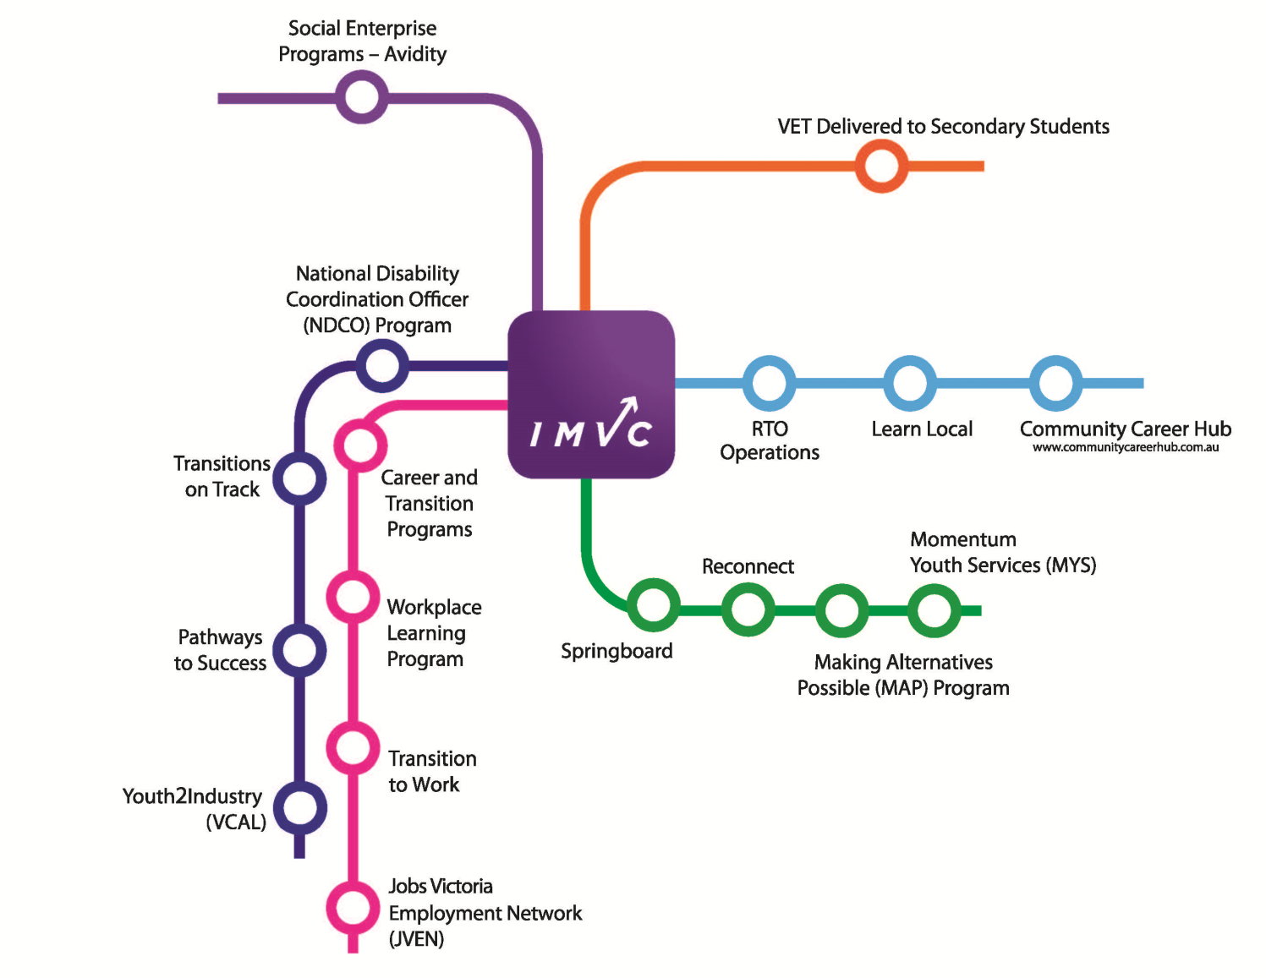

- 10 week re-engagement program
- Aims to support disengaged young people 15-18 to break down barriers to education and gain life skills
- Young people are supported to transition into sustainable pathways

Job Training:
Content:
- Research Pathways and Learning Plans
My Profile, Goals, My Aptitude, Further Education, Who would employ me? Event management and project management
- Numeracy
Percentages, Maths in the kitchen, budgeting in daily life. Maths will be tailored to individual needs
- Literacy
Search me, Writing a Bio, Learning Online, Learning Styles, Wiki, Quizzes, planning an event

- Ready Set Work
Job Matching, Employability skills, Job Advertisements, Networking, Job Investigation, Resume and Cover letters, Interviews, How to stay employed
- Work Placement
One day a week for five weeks

Re-engagement Activities:
- Project based learning/interactive activities
- Industry Visits
- Education Provider tours (eg TAFEs, alternative providers)
- Pathway Planning
- Guest Speakers
- Case management and wellbeing support

Program Structure:
Duration: 9 October – 14 December
Contact Hours: Monday, Wednesday, Thursday, Class: 9:00am – 3.00pm
Work Experience: One day a week – last 5 weeks
Class Size: Maximum of 15 students to ensure significant personal attention
Cost: $44 for eligible students (concession)
$220 for eligible students (non- concession)

MAP in 2016:
- 13 students successfully completed the MAP program
- One student returned back to their original school
- One student did not commence MAP and was referred to case management support

Contact: Ashleigh Morffew
amorffew@imvc.com.au
Tel: 0423 710 538

Please contact Wyndham’s Youth Project Officer for further information regarding this network or to present: ruth.mihelcic@wyndham.vic.gov.au or 8734 1355

For information sharing please email: wyndhamyouthnetwork@wyndham.vic.gov.au
Website: Wyndham Workers with Young People Network – click here

Youth in Wyndham has a Facebook Page
https://www.facebook.com/youthinwyndham

Youth in Wyndham has an Instagram Page
https://www.instagram.com/youthinwyndham/

