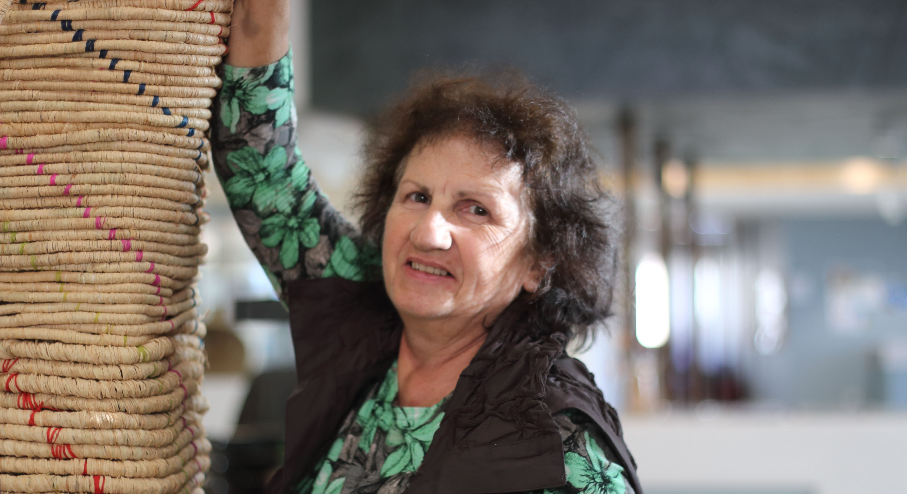

Saltwater Community Centre

Council works to ensure activities in community centres meet with local needs and interests. Priorities for activities have been developed for each community centre based on local demographic data, what residents have told us is important to them along with an assessment of current activities. This sheet provides an overview of all this information and the related local priorities.

Who lives in and around Saltwater?
- 59% of residents in the Saltwater Coast where born in a country outside of Australia
which is almost 20% higher than the suburb of Werribee
- Point Cook is the 5th fastest growing suburb in Australia with young families being 16.8% higher than the State average.

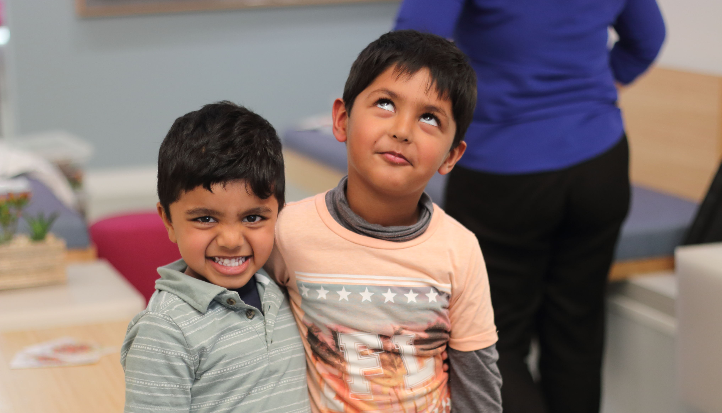
Wyndham 2040
Wyndham East District Goals
- Opportunities for entrepreneurs and small business owners, especially makers and artisans;

- Increase community understanding of "eco-actions” and promote the actions in daily life activities

- Develop arts projects to exchange cultural understandings
What are we hearing from our community?
- “With so many local artists, i would like to see boutique writers and music festivals in my neighbourhood”

- “A social enterprise café which offers hospitality training would be great”
- “We just moved to Saltwater with our young children. How can we get involved?”
2018 Neighbourhood Activity Priorities
- Increase usage of community garden through cooking groups, social enterprise cafe’s, hospitality courses etc.

- Cultural gatherings and Boutique arts festivals making use of the whole centre for an immersive experience, Arts facilitation that makes use of unique resources such as amphitheatre, kiln, art studio etc.

- Activities for all life stages, particularly families with young children

