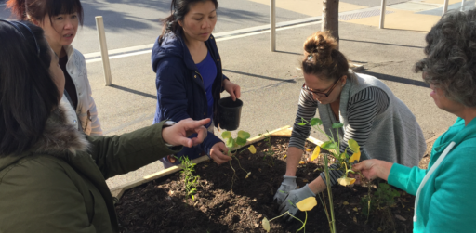

Featherbrook Community Centre

Council works to ensure activities in community centres meet with local needs and interests. Priorities for activities have been developed for each community centre based on local demographic data, what residents have told us is important to them along with an assessment of current activities. This sheet provides an overview of all this information and the related local priorities.

Who lives in and around Featherbrook?
- Over 21% of Point Cook’s population is under 9 years of age, compared to 18% across Wyndham
- Almost 60% of residents of Point Cook were born in a country outside Australia which is almost 20% higher than the suburb of Werribee
- Compared to adults in Victoria (17%), a greater proportion of Wyndham adults (20%) are socially isolated.

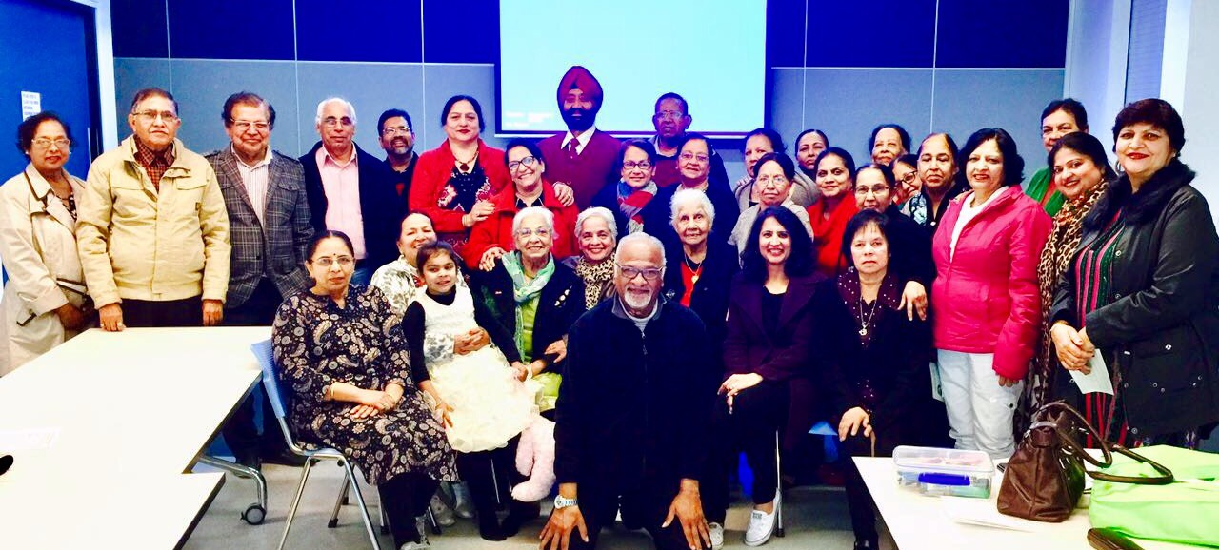
Wyndham 2040
Wyndham East District Goals

- Projects that connect people and community groups, local organisations and Council.

- Events and activities that bring together people from different cultures.

- Projects with a strong educational component or which engage schools as partners.

What are we hearing from our community?
- “We need structured and unstructured activities for the 0-9 age group and seniors“

- “A wide variety of active and recreational activities options are needed given the lack of facilities in Point Cook South”
- “We want more opportunities to connect with others, and share culture food, dance and fun”

2018 Neighbourhood Activity Priorities

- Programs that foster cross cultural sharing, awareness and connection to Country

- Skills development and play based learning for residents, early years through to seniors

- Activities that build community resilience and improve health and wellbeing

