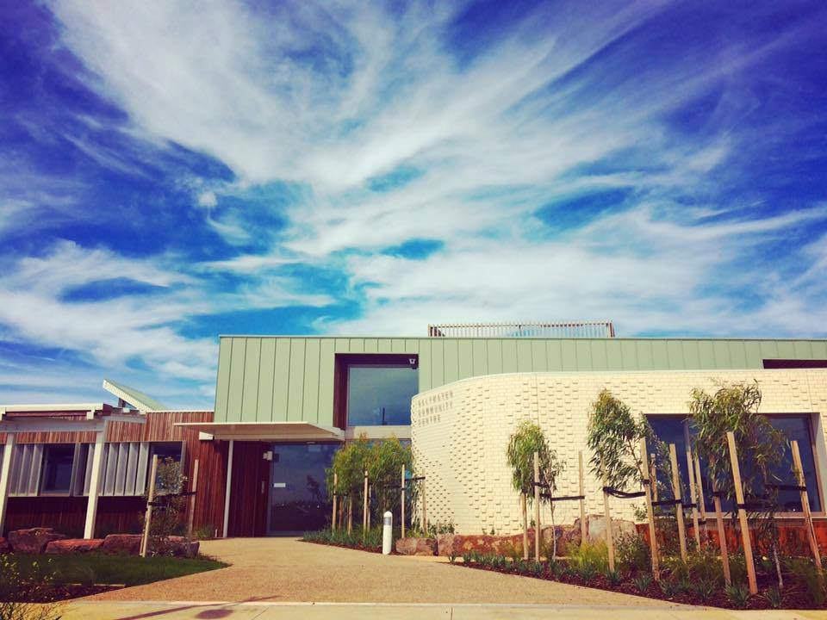

Saltwater Residency
Video Artist EOI

WYNDHAM ART SPACES – SALTWATER RESIDENCY
Wyndham City is seeking expressions of interest from artists working in new media, film, or video to undertake a residency at Saltwater Community Centre as part of the Wyndham Art Spaces program.
This residency is located within Wyndham City’s newest community centre; home to a dedicated art studio with its own kiln and co-located with Kindergarten and Maternal & Child Health Services.
What We Are Looking For
We are looking for a video/film artist to create new work that imagines and responds to Point Cook’s urban environment as it develops and experiences change.
We require you to be independent and interested in engaging with people and communities who access and visit Saltwater Community Centre.
Your video/film works will be presented on TV monitors and included in an exhibition to be presented in February 2018 at Saltwater Community Centre.
The Residency - Conditions
- Work from the Saltwater Art Studio 8 hours per week for a minimum of 8 weeks in Term 4: 9 October – 22 December 2017.
- The residency includes use of and access to:
  - Saltwater Art Studio with basic art materials
  - Apple 21” iMac with Adobe Photoshop Suite located at Wyndham Arts Incubator – 49 Watton Street, Werribee.
  - A small room is available to establish a pop-up studio if desired.

- Proactively engage with any interested communities and people whilst working at Saltwater Community Centre
- Deliver a minimum of one community engagement at Saltwater Art Studio; to be negotiated with Wyndham City Arts and Culture staff.
- Participate in a group exhibition at Saltwater Community Centre in February, 2018.
- The residency has an attached stipend of $3,000 and a negotiated materials fee.

Selection Criteria
- Evidence of artistic merit and competency to undertake residency.
- A written document detailing your intended approach to the residency - to create work that is locally relevant and responds to the urban environment.
- Capacity to be onsite for at least 8 hours per week for a minimum of 8 weeks or an alternative commensurate program as proposed and negotiated.
The EOI Process
The deadline for submissions is 9.00am Monday 25 September.
Applications should include the following:
- Artist portfolio with up to 10 images saved as a single PDF and/or links to online examples of your work
- Curriculum Vitae
- Residency outline – see above
Please forward application to: arts@wyndham.vic.gov.au or deliver to Saltwater Community Centre: 153 Saltwater Promenade, Point Cook.
Expression of Interest outcome will be advised Wednesday 27 September.
Further Information
If you would like to discuss the residency and your application please contact:
Rahima Hayes, Arts Activation Officer
Email: rahima.hayes@wyndham.vic.gov.au
Phone: 9742 8180

