Wyndham’s Pasifika Community
July 2017 update

The Pasifika community includes residents born in the Pacific Islands. The population referred to as Pasifika in this profile are from 26 countries in Melanesia, Micronesia and Polynesia, and excludes Hawaii and New Zealand.
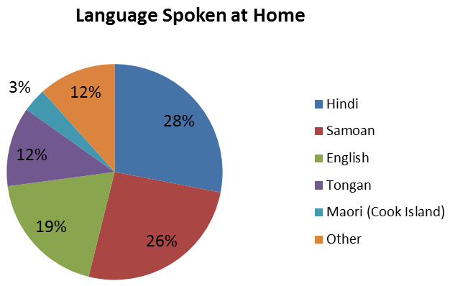
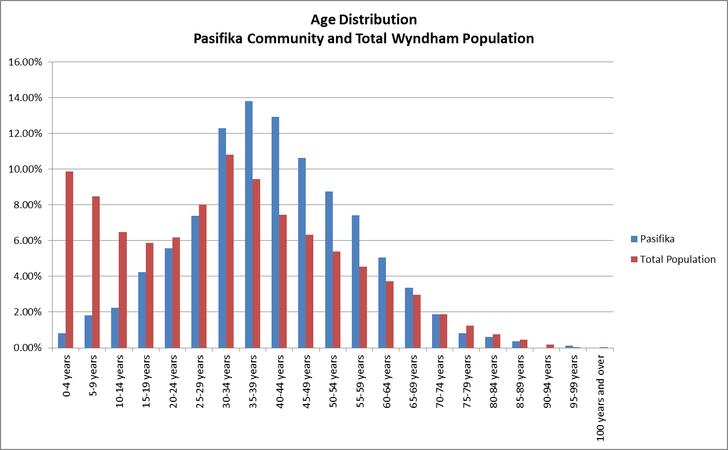
At the 2016 Census, there were 2,199 people in Wyndham who were born in countries across the Pacific (except New Zealand and Hawaii). This group equated 1% of Wyndham’s total population. The first 3 people arrived in 1966, and gradually the population of Pasifika born residents has grown. More than 50% of those living in Wyndham in 2016 had arrived since 2006 (52%). Tarneit, Point Cook, and Truganina are home to the majority of Pasifika born residents. Two thirds (66%) of Pasifika born residents are between 30 and 59 years of age. In contrast, only 44% of the whole population of Wyndham falls within this age group. Furthermore, compared to the Pasifika born group Wyndham has a much larger proportion of young people under 24 years of age (15% to 37% respectively).
At the 2016 Census the most commonly spoken language in the homes of Pasifika born residents was Hindi (28%). Samoan was the second most common (26%), followed by English (19%), Tongan (12%) and Cook Island Maori (4%). Approximately 75% of Pasifika born residents speak English well or very well, and fewer than 5% are not able to speak English well or at all.
Christianity is the most common religion amongst Pasifika born residents (57%). Within this broad category, 21% are Western Catholic, followed by other Christian religions not further defined (19%), the Uniting Church (12%), the Latter Day Saints (10%), and others (38%). The next largest religion after Christianity is Hinduism at 24%, which is in line with the percentage of Pasifika people who speak Hindi at home. Only 8% of Pasifika born residents reported no religion at the 2016 Census compared to 23% for Wyndham.
In 2011, Advanced Diplomas, Diplomas, and Certificates were the most common qualification obtained by Pasifika born residents over 15 years of age (28%). Approximately 16% of these residents had obtained a Bachelor degree or other higher education qualification. Almost 20% of the Pasifika born residents aged 15 and over work in professional and managerial positions and just under 20% work in labour and machinery operator positions.

In the 2016 Census, they are Fiji, Samoa, Tonga, Cook Islands, Solomon Islands, New Caledonia, Vanuatu, Niue, Norfolk Island, Nauru, Tokelau, Kiribati, French Polynesia, Samoa, American, Tuvalu, Guam, Marshall Islands, Oceania and Antarctica, nfd, Micronesia, nfd, Northern Mariana Islands, Micronesia, Federated States of, Palau, Wallis and Futuna, Pitcairn Islands, Polynesia (excludes Hawaii), nfd, Polynesia (excludes Hawaii), nec.
This is the result of Indian immigration to the Pacific Islands as part of indentured labour flows between 1879 and 1916.
Demographic data sources for this profile are the Australian Bureau of Statistics. (2011 and 2016). Census of Population and Housing

