Maori Community Profile
July 2017 Update

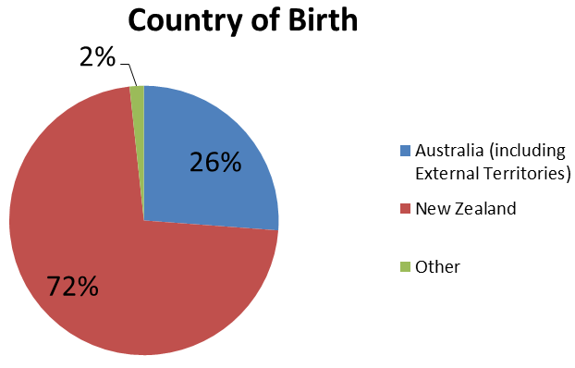
Wyndham has the largest population of residents with Maori ancestry in Victoria. Some 15.6% of Victorians with Maori ancestry were living in Wyndham in 2016. From 2011, the population has increased by almost 50%. At the 2016 Census, there were 3,270 Wyndham residents with Maori ancestry. Approximately 72% of these individuals (2,358 people) were born in New Zealand, and 26% (856) in Australia.
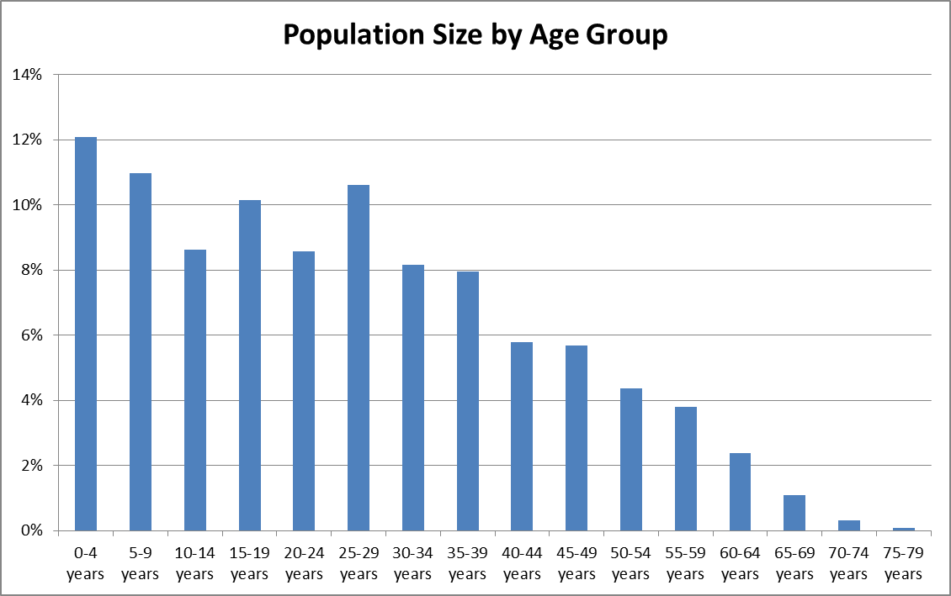
The Wyndham Maori community is young overall. Over 75% of this population are 39 years or younger, while less than 2.5% are over 60. The largest proportion of the Maori community are aged 0-4 years old (12%). There are also large proportions of individuals aged 5-9 (11%), 25-29 (11%) and 15-19 (10%). There are no Maori residents over 80 years of age.
The majority of Maori residents speak English at home (88%), and 9% speak Maori.
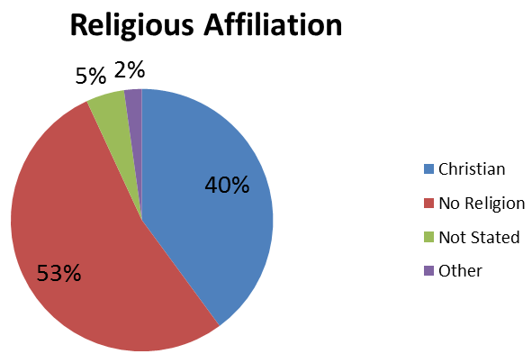
41% of Maori residents over 15 years of age had completed year 12 or equivalent in 2016, compared to 59% of Wyndham residents over 15. At the 2011 Census, there was also a much smaller proportion of residents with Maori ancestry (over 15 years of age) who had completed a Bachelor degree or higher, compared to the whole of Wyndham (3% and 19%, respectively). In addition, none of the Maori community over 15 years of age had obtained a postgraduate qualification in the 2011 Census.
Machinery Operators and Drivers was the most common occupation in 2011 and less than 5% of residents were employed in professional occupations (4%). Level of education obtained is reflected in the occupations held by residents with Maori ancestry.
Less than half of the Maori community of Wyndham reported having a Christian faith (40%), lower than for the whole of Wyndham (46%). The majority of Maori residents held no religious affiliation (53%), more than twice the proportion as the whole of Wyndham (23%). Very few belonged to non-Christian religions (1%).

This profile discusses people with Maori ancestry rather than people who identify as Maori. The Census does not have a question that allows a resident to indicate whether they identify as Maori. The Census does ask this for Aboriginal and Torres Strait Islander people in the form of the following question: ‘Is the person of Aboriginal or Torres Strait Islander origin?’. For data on the Maori community the question on ancestry is used (‘What is the person’s ancestry?’). As such, this profile does not capture the whole Maori community because the Census does not collect information on cultural affiliation.
The Census differentiates between Cook Island and New Zealand Maori languages. The number of residents who speak these languages at home is 5 and 300, respectively.
Demographic data sources for this profile are the Australian Bureau of Statistics. (2011 and 2016). Census of Population and Housing

