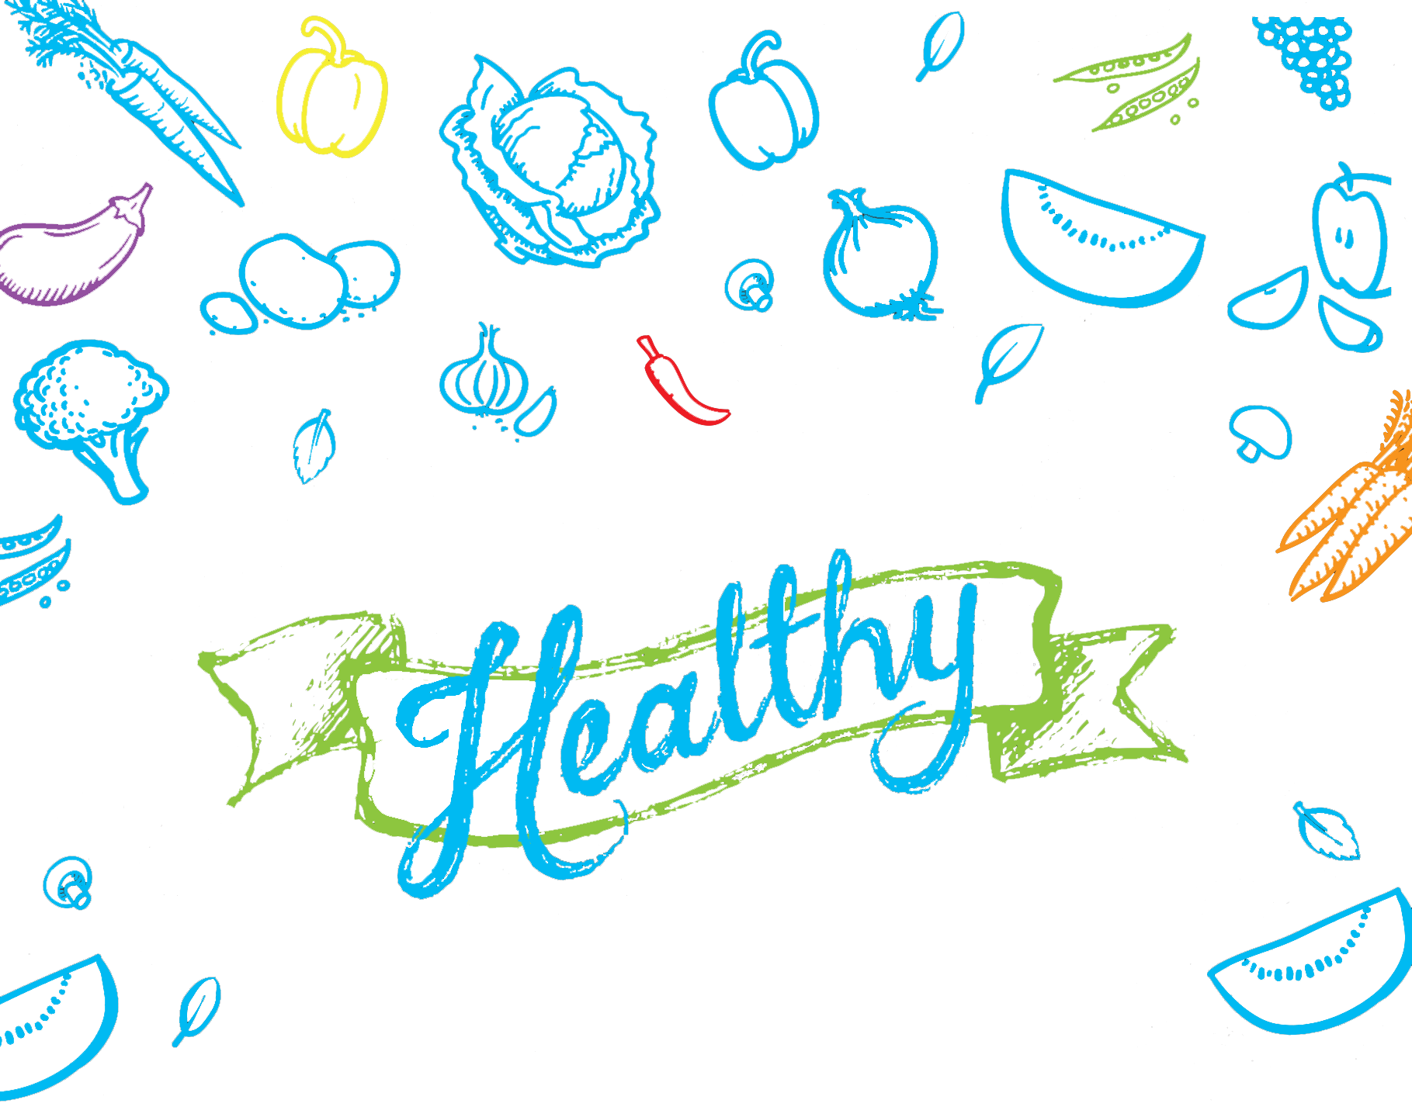

BBQ Kit

A healthier approach to your next barbecue

Contents
About this Kit 3
Tips for Making your Barbecue Healthier 4
Food Safety 7

Cheat Sheets:

Better BBQ Menu Ideas 10
Easy Budgeting for a Healthy BBQ 11
Cheap, Easy, Healthy BBQs - Eight Basic Tips 12
for Healthier BBQ Catering

.

About this Kit
Barbecuing is one of Australia’s favourite cooking methods and is embedded within modern Australian culture. A simple, traditional barbecue typically consists of sausages, onion, white bread and tomato sauce, which is a meal low in fibre and high in saturated fat, oil and salt, with limited nutritional value. However, with a little thought and a few small changes, the barbecue can be a healthy and tasty cooking method.
This Healthy BBQ Kit is designed to provide guidance and ideas for making easy changes to the traditional barbecue, providing nutritious options suitable for children and families.
Good nutrition is key to a healthy, active and enjoyable life. Children need a nutrient rich diet for healthy bones, joints and muscles, and brain development. Good nutrition among adults can help prevent diseases such as heart disease, diabetes and some cancers. Reducing the consumption of high energy foods and drinks can also prevent obesity.
How your healthy Barbecue can impact your community
- A healthy barbecue is a great opportunity to contribute to the health and wellbeing of your community
- Show your community that you value their health and wellbeing
- Reinforce important health messages to children and their families
- Provide personal satisfaction of being a positive role model
- People generally enjoy eating tasty healthy foods, however if other more familiar foods are also available (e.g. sausages and other fatty meats), these can still sell in high quantities. Support healthy eating by making the healthier options the only options

Acknowledgements
This kit was developed in 2015 as part of Healthy Together Wyndham, a project funded by the Victorian Government.
We acknowledge the OPAL program for their original development of this resource and Healthy Together Mildura for their Victorian adaptation. OPAL is a joint initiative of the Australia Government, SA Health and Local Governments.
Artwork developed by Minka Creative with adaption by Healthy Together Mildura.

Tips for Making your Barbecue Healthier

Small changes can make a big difference
Providing healthy food options doesn’t mean having to make a lot of big changes. By reducing saturated fat and salt intake, increasing vegetable, fruit and fibre consumption and using healthier cooking methods, you can make a big difference to the nutritional and energy value of the foods you provide.

Reduce saturated fat and salt
A high intake of saturated fat and salt is associated with increased risk of cardiovascular disease. Animal products including meats and butter can contain high amounts of saturated fat and salt with burgers, chops and sausages often containing the highest amounts. If providing meat, choose lean and reduced salt options. All cooking oils are also high in fat so it is best to use the least amount possible.

Top tips for meat:
- Skinless chicken, minute steaks, lean meat kebabs, seafood and kangaroo are good options
- Limit burgers, chops and sausages. Ask your butcher to provide low fat and low salt varieties. Aim for less than 10g of total fat per 100g of meat
- Trim off any visible fat from meat before cooking
- Lean meats can become dry when cooking, use a marinade for moisture and flavour
- Limit meat servings to the palm size of an adult’s hand
- Vegetarian options are generally low in fat and salt

Top tips for oil, dairy and spreads:
- Reduce the amount of oil used for cooking and choose healthier options such as canola or sunflower oil. Skip the butter and margarine on bread and provide reduced salt sauces, mustards and other condiments that provide flavour instead
- If avocado is in season consider using as a spread instead of butter and margarine
- If serving dairy such as cheese, milk and yoghurt, choose reduced fat options

Increase fibre
Dietary fibre plays an important role in keeping the digestive system healthy. High amounts of fibre can be found in whole foods including whole grains, vegetables and fruits.

Top tips for breads and grain products:
- Instead of plain white varieties, use wholegrain and wholemeal breads, rolls, pita bread orenglish muffins
- When selecting bread or wraps, look for options that have more than 3g of fibre per 100g
- If plain white bread is required, choose options that have added fibre
- Keep the skin on for vegetables such as potatoes and carrots for an easy way to boost fibre

Increase fruit and vegetables
Eating plenty of fruit and vegetables is one of the easiest and tastiest ways to stay healthy. Fruit and vegetables are high in vitamins, minerals, antioxidants and fibre.

Increase fruit (daily recommendation 2 serves)
Having fruit served fresh or grilled is a great healthy sweet addition to your barbecue. Fruit can be fresh, frozen, dried or canned.

Top tips for fruit:
- Buy fruit in season to reduce costs.
- Provide fresh sliced fruit or diced fruit salad. Serve with reduced fat or natural yoghurt
- Pineapple rings or stoned fruits like peaches, nectarines and apricots can be lightly seared on the barbecue plate and added to burgers or chopped up in salads
- If using canned fruit, choose options with natural juice or no added sugar rather than syrup

Increase vegetables (adult daily recommendation 5-6 serves)
Vegetables add freshness and flavour to a meal. Add them to the main meal or serve on the side. Use fresh, frozen, dried or canned in juice (rinse before use).

Top tips for vegetables:
- Buy vegetables in season to reduce costs. Corn on the cob is very popular and can be cooked a variety of ways such as steaming, wrapping in aluminium foil and cooking in the oven or grilling on a barbeque
- Serve salad - such as tomato, cucumber, grated carrot or lettuce - on bread options (e.g. burgers and steak sandwiches)

- Ask your butcher to add grated vegetables to lean meat patties – it can bulk up the serve and reduce the overall cost
- Try bean, lentil, chickpea or vegetable patties, burgers and falafels and marinated firm tofu burgers/steaks
- Try mixed vegetable skewers. Bamboo skewers need to be soaked in water before use to prevent splintering
- Vegetables such as capsicum, zucchini, sweet potato or eggplant are easily barbecued
- Jacket potatoes can be cooked wrapped in aluminium foil (for barbecues with closable lids only) and filled with salads and reduced fat cheese or yoghurt
- Provide a variety of fresh salads. Avoid using meat, cheese or egg as these will need to be kept
- cold. Try adding beans, chickpeas and other legumes
- Ask your supplier to pre-slice tomatoes and lettuce to make salad preparation easier

Flavour with sauces, dressings, herbs and spices
These additions are a great way to add flavour and aroma to food. Choose reduced salt sauces and dressings. Experiment with a range of common fresh or dried herbs and spices.

Top tips for adding flavour:
- Use dressings with lemon juice, vinegar, mustard and herbs such as pepper, parsley, basil and mint, with a dash of a plant oil such as olive oil
- For commercial dressings, choose ‘no oil’ or reduced fat and sugar varieties
- Try natural yoghurt to replace common creamy dressings
- Add herbs and spices to meats or marinades
- Popular herbs include parsley, basil, thyme, dill, rosemary, oregano and chives
- Popular spices include ginger, paprika, pepper, nutmeg and cinnamon. Avoid chilli unless you know it will be enjoyed by everyone
- Use Worcestershire sauce or salsa instead of barbeque and tomato sauces

Choose healthier cooking methods
Healthier cooking methods include grilling, steaming and roasting, where little or no oil, butter or margarine is used. Butter and margarine are generally high in fat and salt. All cooking oils are also high in fat, making it important to use sparingly.

Top tips for frying foods:
- If frying, oil is healthier than butter or margarine. Some oils are healthier than others. Plant oils including canola, sunflower and olive oil are good options
- A cooking oil spray can help control the amount you use, which will also reduce costs. Be careful when spraying close to gas grill plates
- Use the grill plate instead of the flat plate where possible to allow fat to drip away
- Toss onions and other vegetables in a bowl with a small amount of oil before cooking rather than pouring oil directly on the barbecue plate
- Drain oil-based marinades off meats before cooking

Use the ‘Australian Dietary Guidelines’ as a reference for providing healthy options. Visit https://www.eatforhealth.gov.au/guidelines
for a copy.

Provide Water
Water is the healthiest drink option for people of all ages and is the most effective drink to quench thirst. Other drink options such as juice, soft drink, flavoured milks and energy drinks generally contain a lot of sugar and energy and provide little or no nutrition.
Top tips for drinks:
- Always have water on display and kept cold if possible.
- Try sparkling water with lemon wedges and fresh mint for a refreshing drink.
- If providing drinks other than water, keep them out of sight and provide upon request only.

Food Safety
Community food premises classes
Community groups can hold fairs, fêtes, dinners, barbecues, and a range of other activities to raise funds. A community group must be non-profit and all staff must be volunteers.
At these activities, the risk of food becoming unsafe depends on the type of food, and how and where it is stored, prepared, handled and transported. Because these activities involve different levels of risk, community food activities may fall within class 2, 3 or 4 under the Food Act.
Your group’s classification will depend on the food safety risks involved in handling the type of foods you plan to sell. For example:
- Class 4 low risk foods do not require refrigeration such as bottled water or cakes without cream.
- Class 3 foods are foods that require refrigeration or foods that are cooked and served immediately such as a bbq, sandwiches, fried foods.
- Class 2 foods are foods that are prepared and then served or re-heated at a later date such as pre-cooked rice or casseroles.

A community group must receive approval from Council’s Environmental Health Department before operating.
A community group operating a food stall or van can apply for registration online at https://streatrader.health.vic.gov.au
Please note that there are no registration fees for a non-profit, volunteer run food stall.

Basic food safety tips
With any type of food preparation and serving, it is always important to maintain food safety and hygiene. Here are a few ways to help ensure you are serving safe and healthy food to your community:

- Ensure there is somewhere for food handlers to wash their hands such as a portable hand wash station. This can be a water container with a tap supplied with liquid soap and paper towels
- Ensure all staff and volunteers wash their hands regularly especially after handling raw foods, after using the toilet or after handling rubbish
- Keep foods cold before use such as in an esky or refrigerator

- Store foods at the appropriate temperature:
  - Keep cold foods below 5°C
  - Always cook foods thoroughly to above 75°C
  - Keep hot foods hot until serving, especially meat to above 60°C
- Never use the same plate or tongs for raw and cooked foods
- Keep raw meat away from any ready to eat foods such as vegetables, fruits and cooked foods
- Protect food from dust or insects by keeping food wrapped or in sealed containers
- Wash all fresh fruit and vegetables before use
Free food safety resources
Do food safely: free online learning program for food handlers: http://dofoodsafely.health.vic.gov.au
Food safety guide for community groups: https://www2.health.vic.gov.au/public-health/food-safety/food-safety-information-for-community-groups
Food stalls and vans online registration:https://streatrader.health.vic.gov.au

For further advice and registration requirements please contact Council’s Environmental Health Department on 9742 0777 or by email at mail@wyndham.vic.gov.au

Better BBQ Menu Ideas
Tasty, healthy menu ideas for your next barbecue.
Main meal
Steak sandwich - tenderised minute steak served on wholegrain bread, topped with tomato and lettuce
Australian burger - lean mince or vegetable patty served with tomato, lettuce, fresh or barbecued pineapple rings and sliced beetroot
Skewers - marinated lean meat, tofu or haloumi, and thread onto skewers with capsicum, mushroom, cherry tomatoes, and zucchini brushed/sprayed with healthy oil
BBQ wrap/yiros - thinly sliced lean meat or falafels served on wholemeal pita bread with fresh salad and tzatziki sauce
BBQ toasties - pre-make toasties with wholegrain bread and toppings such as reduced fat cheese, tomato, avocado or lean ham. Lightly brush bread with oil before barbecuing each side on the hot plate until golden
BBQ stirfry - finely sliced meat or tofu, mixed vegetables and hokkien noodles. Marinade the meat for extra flavour

BBQ vegies
Corn on the cob - although not necessary, you can thread the corn onto skewers for easy cooking and eating
Marinated garlic mushrooms - brush/spray or toss large mushrooms with healthy oil and a small amount of crushed garlic, then grill
Vegetable kebabs - brush/spray or toss capsicum, zucchini, cherry tomatoes and mushroom with healthy oil and herbs then thread onto skewers
Grilled vegetables - brush/spray or toss chopped vegetables such as capsicum, zucchini, sweet potato or eggplant and grill or barbecue
Jacket potatoes - cooked potatoes in wrapped foil on BBQ, then top with salad or vegetables and low fat cheese or yoghurt

Salads
Coleslaw - shredded carrot, cabbage, celery, and radish tossed in a reduced fat yogurt, lemon juice and parsley dressing
Tabouli - cracked wheat, parsley, mint, onion, tomatoes, lemon juice and a small amount of olive oil
Pasta salad - cooked pasta, tomatoes and spring onions tossed in balsamic vinegar
Potato salad - cooked potato and spring onions dressed in a mixture of reduced fat yoghurt, mustard and black pepper or alternatively reduced fat yoghurt, fresh mint, garlic and lemon

Marinades – for meat, tofu and vegetables
Classic soy - reduced salt soy sauce, small amount of sesame oil, ginger and garlic
Lemon and chilli - garlic, reduced salt soy sauce, lemon juice and sweet chilli sauce
Tandoori - reduced fat yoghurt with chilli, coriander, garlic, cumin and turmeric
Honey soy - garlic, honey and reduced salt soy sauce
For the best result let your items marinate overnight or for at least two hours

Item | Cost | Sale Price A | Sale Price B | Sale Price C | Sale Price D | Sale Price E | Sale Price F
Lean Steak Sandwich
Total | $2.02 | $2.50 | $3.00 | $3.50 | $4.00 | $4.50 | $5.00
Multigrain bread | $0.47 | $0.47 | $0.47 | $0.47 | $0.47 | $0.47 | $0.47
Lean minute steak | $1.10 | $1.10 | $1.10 | $1.10 | $1.10 | $1.10 | $1.10
Lettuce mixed leaves | $0.30 | $0.30 | $0.30 | $0.30 | $0.30 | $0.30 | $0.30
Sliced tomato (20g) | $0.15 | $0.15 | $0.15 | $0.15 | $0.15 | $0.15 | $0.15
% Profit | 0.00% | 19.20% | 32.67% | 42.29% | 49.50% | 55.11% | 59.60%
Vegetable Burger
Total | $2.05 | $2.50 | $3.00 | $3.50 | $4.00 | $4.50 | $5.00
Multigrain Roll | $0.70 | $0.70 | $0.70 | $0.70 | $0.70 | $0.70 | $0.70
Vegetable burger pattie | $0.90 | $0.90 | $0.90 | $0.90 | $0.90 | $0.90 | $0.90
Lettuce mixed leaves | $0.30 | $0.30 | $0.30 | $0.30 | $0.30 | $0.30 | $0.30
Sliced tomato (20g) | $0.15 | $0.15 | $0.15 | $0.15 | $0.15 | $0.15 | $0.15
% Profit | 0.00% | 18.00% | 31.67% | 41.43% | 48.75% | 54.44% | 59.00%
Lean Beef Burger
Total | $2.35 | $2.50 | $3.00 | $3.50 | $4.00 | $4.50 | $5.00
Multigrain Roll | $0.70 | $0.70 | $0.70 | $0.70 | $0.70 | $0.70 | $0.70
Lean hamburger pattie (100g) | $1.20 | $1.20 | $1.20 | $1.20 | $1.20 | $1.20 | $1.20
Lettuce mixed leaves | $0.30 | $0.30 | $0.30 | $0.30 | $0.30 | $0.30 | $0.30
Sliced tomato (20g) | $0.15 | $0.15 | $0.15 | $0.15 | $0.15 | $0.15 | $0.15
% Profit | 0.00% | 6% | 21.67% | 32.86% | 41.25% | 47.78% | 53.00%
Corn cob 1/2 | $0.40 | $0.50 | $1.00 | $1.50 | $2.00
% Profit | 0.00% | 20.00% | 60.00% | 73.33% | 80.00%
Bottled water 600mL | $0.83 | $1.00 | $1.50 | $2.00 | $2.50
% Profit | 0.00% | 17.00% | 44.67% | 58.50% | 66.80%
These costs are an estimate of supplier prices in 2015
Ask your supplier for discounts to support your healthy event

Easy Budgeting for a Healthy BBQ

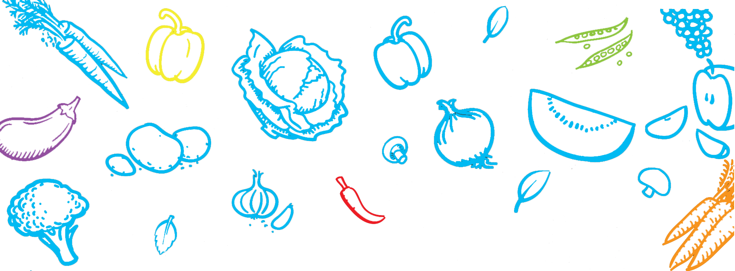

Cheap, Easy, Healthy BBQs
Eight basic tips for healthier BBQ catering

Cut down on the fat
Try
- Minute steaks
- Lean meat kebabs
- Skinless chicken
- Vegetable burgers

Remove any visible fat from meats before cooking.

If using sausages and meat patties, ask your butcher for reduced fat and reduced salt options (less than 10g fat per 100g).

Choose healthier cooking oils
- Use healthier plant oils such as canola
- Limit use
- Use spray oil to manage quantity

Add vegetables and fruits
- Corn on the cob is very popular among all age groups and is an item that can make a large profit
- Always serve salad items such as sliced tomatoes and lettuce on bread options (eg burgers and steak sandwiches)
- Sliced watermelon is another popular item which can make a large profit

Swap the seasoning
Use herbs and spices to flavour meats instead of salt
Use salt-reduced foods such as:
- Sauces
- Dressings (also check sugar content on dressings, especially low fat options)

Ditch the drink options
Always have water on display and keep cold if possible. Other drinks such as soft drink, sport drinks, juice and flavoured milks often contain high amounts of sugar and have little or no nutritional value.

Provide better bread
Use multigrain breads, rolls, wraps etc.

Make healthy eating easy
People generally enjoy eating tasty healthy foods, however if other more familiar foods are also available (e.g. sausages and other fatty meats), these can still sell in high quantities. Support healthy eating by making the healthier options the only options.

Get the numbers right
To help you achieve your planned profit, you want to avoid a lot of leftovers – it may be better to under cater than over cater.

Trial new options. Start by offering a few healthy options (such as vegetable burgers, grilled corn etc) and increase supply once you know how popular each option will be.

Fruit or Vegetable | All year | Summer | Autumn | Winter | Spring
Apple
Banana
Blueberries
Cherries
Grapes
Kiwifruit
Mandarin
Melons (Honeydew)
Melons (Rockmelon)
Melons (Watermelon)
Orange (Valencia)
Orange (Navel)
Peach
Pear
Plum
Raspberries
Strawberries
Asparagus
Green beans
Beetroot
Broccoli
Capsicum
Carrot
Mushrooms
Chilli
Cucumber
Lettuce
Peas
Potato
Pumpkin
Spinach
Sweet corn
Tomato
Zucchini

Seasonal Fruit and Vegetables Guide

