Wyndham Council Wards

## Chaffey Ward

The Chaffey Ward is situated in the centre of the Wyndham municipality and includes the suburbs of Tarneit, and parts of Werribee and Hoppers Crossing. Similar to all other areas of Wyndham, the population residing in the Chaffey Ward is forecast to increase considerably over the next 20 years.

* The Chaffey Ward population in 2016 is estimated to be around 75,404 people.
* Just over half the Chaffey population were born in Australia.
* India, New Zealand, the Philippines, England and Myanmar were the top 5 most common countries of birth outside Australia.
* Punjabi is the most commonly spoken language other than English in the Chaffey ward. Hindi, Arabic, Urdu and Gujarati (Indian origins) make up the top 5.

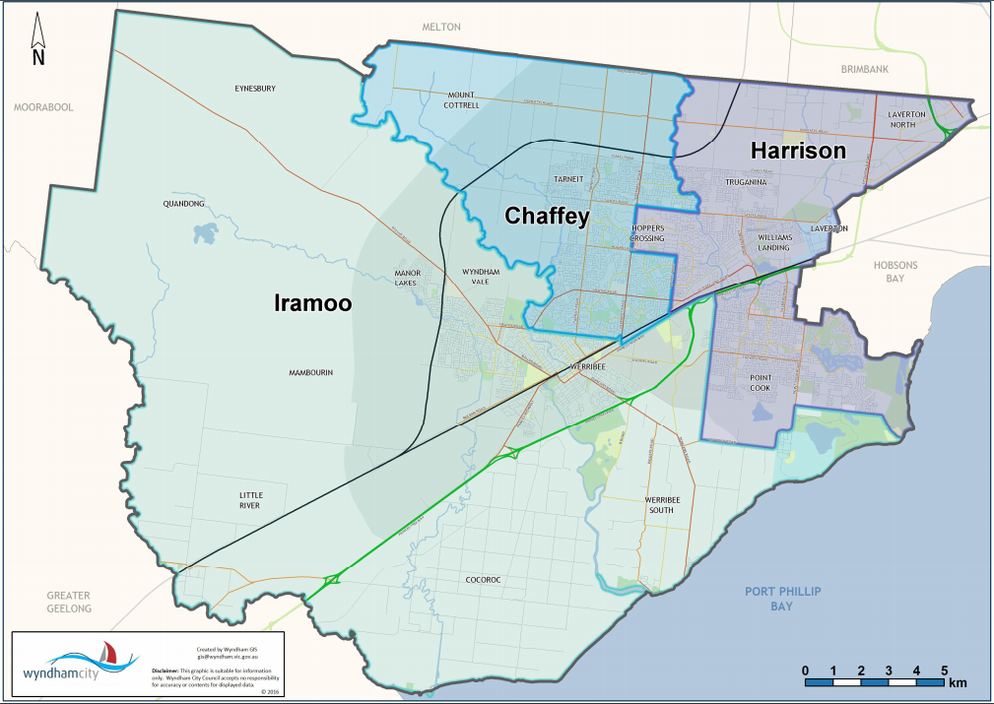

## Harrison Ward

The Harrison Ward is situated in the east of Wyndham. It is home to a highly diverse population, as well as a large number of businesses, particularly those in the industrial sector.

* The Harrison Ward includes industrial precincts in Laverton, Laverton North, and Truganina, as well as residential areas in Point Cook, Truganina, Williams Landing and some parts of Hoppers Crossing.
* At August 2016, the estimated population was 90,812 residents.

The Harrison Ward is Wyndham’s most culturally diverse ward.

* Less than half those living in Harrison Ward were born in Australia.
* India, China, New Zealand, the Philippines and England were the most common countries of birth outside Australia, similar to the cultural profile Wyndham wide.
* Mandarin is the most commonly spoken language other than English amongst Harrison ward residents, followed by Hindi, Punjabi, Arabic and Urdu.

## Iramoo Ward

Wyndham City’s Iramoo Ward includes the suburbs of Werribee, Werribee South, Cocoroc, Little River, Mambourin, Manor Lakes, Wyndham Vale, Quandong and Eynesbury. It is the largest ward in Wyndham by land size.

* The Iramoo Ward is home to almost a quarter of the Wyndham population (24%). In terms of population size, it is the smallest ward, with a population of around 51,421 people.
* Almost two thirds of residents in the Iramoo ward were born in Australia (64%).
* The top 5 most common countries of birth outside Australia included India, England, New Zealand, the Philippines and Italy.
* Amongst residents in the Iramoo Ward, Italian was the most common language spoken at home other than English, followed by Karen, Punjabi, Hindi and Mandarin.