July 2017 Update

Aboriginal and Torres Strait Islander Population Data Wyndham

Data on migration, employment and place of work will not be available until October 2017. The most recently available data, for 2011, is used in this update wherever 2016 Census data is not available.

Population
Wyndham has a larger proportion of the population identifying as Aboriginal and Torres Strait Islander (0.80%) than Greater Melbourne (0.54%) in 2016 (Table 1).
Table 1: Aboriginal and Torres Strait Islander and Non-Aboriginal and Torres Strait Islander Population in Wyndham and Greater Melbourne, 2016
 | Wyndham |  | Greater Melbourne
 | Number | Percentage | Number | Percentage
Non-Aboriginal and Torres Strait Islander | 204,554 | 94.21% | 4,215,757 | 94.00%
Aboriginal and Torres Strait Islander | 1,733 | 0.80% | 24,058 | 0.54%
Not stated | 10,827 | 4.99% | 245,385 | 5.47%
Total | 217,118 | 100.00% | 4,485,210 | 100%

In 2016 Wyndham has the largest Aboriginal and Torres Strait Islander community in the Western Region with a total of 1,733 persons. As a proportion of total population, the Aboriginal and Torres Strait Islander population in Wyndham is the second largest in the Western region (0.80%), behind Melton (0.95%). Figure 1 illustrates this.
Figure 1: Aboriginal and Torres Strait Islander Population Number and Percentage – Wyndham and Western Region Municipalities, 2016
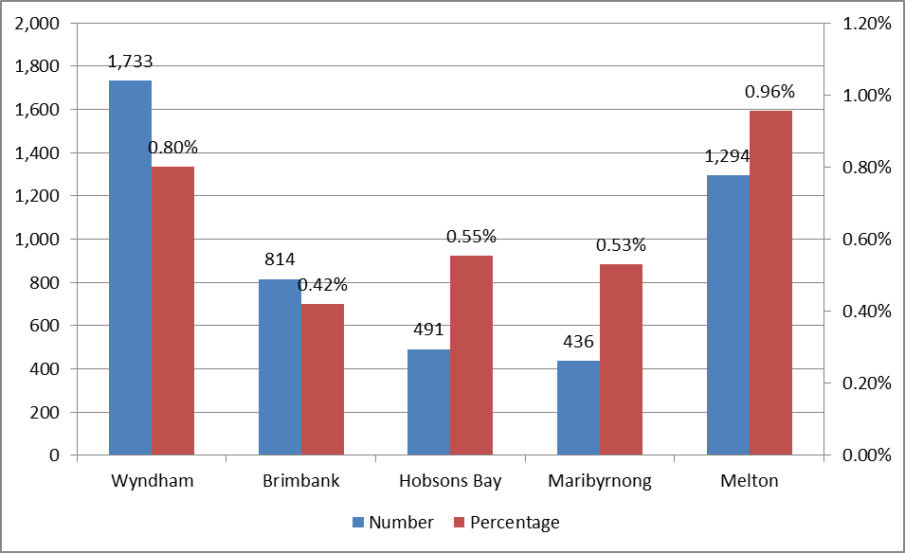
Table 2 enumerates the size of the Aboriginal and Torres Strait Islander and non-Aboriginal and Torres Strait Islander populations in 2011 and 2016. It splits up the Census data into people who identify as Aboriginal, Torres Strait Islander, and both. However, because the sample sizes for Torres Strait Islanders and people who identify as both Aboriginal and Torres Strait Islander are very small they cannot be used to draw inferences from. These three communities are therefore discussed together in this report.
Wyndham’s Aboriginal and Torres Strait Islander population increased by 51.4% (588 people) from 2011 to 2016. The non-Aboriginal and Torres Strait Islander population increased by 33.9% (51,823 people). The growth in the number of Aboriginal and Torres Strait Islander people in Wyndham was 1.5 times faster than the growth in the number of non-Aboriginal and Torres Strait Islander people.
Table 2: Aboriginal and Torres Strait Islander and Non-Aboriginal and Torres Strait Islander Population in Wyndham, 2011 and 2016
 | 2011 |  | 2016
 | Number | Percentage | Number | Percentage
non-Aboriginal and Torres Strait Islander | 152,731 | 94.50% | 204,554 | 94.21%
Aboriginal | 1,064 | 0.66% | 1,663 | 0.77%
Torres Strait Islander | 60 | 0.04% | 41 | 0.02%
Both Aboriginal and Torres Strait Islander | 20 | 0.01% | 29 | 0.01%
Not stated | 7,700 | 4.80% | 10,827 | 4.99%
Total | 161,576 | 100.00% | 217,118 | 100.00%

Figure 2: Aboriginal and Torres Strait Islander Population and Non-Aboriginal and Torres Strait Islander Population Change – Wyndham, 2011 to 2016
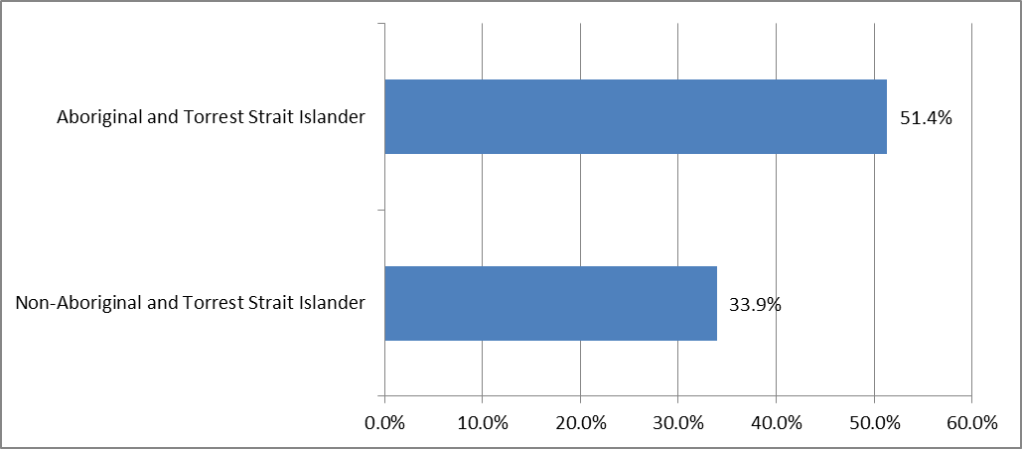
Werribee is home to the largest Aboriginal and Torres Strait Islander community in Wyndham with 447 people living in the suburb in 2016. Hoppers Crossing, Wyndham Vale, Point Cook, Truganina and Tarneit are also home to sizeable populations of Aboriginal and Torres Strait Islander residents (Figure 3).
Figure 3: Aboriginal and Torres Strait Islander Population (Number) in Wyndham Suburbs, 2016
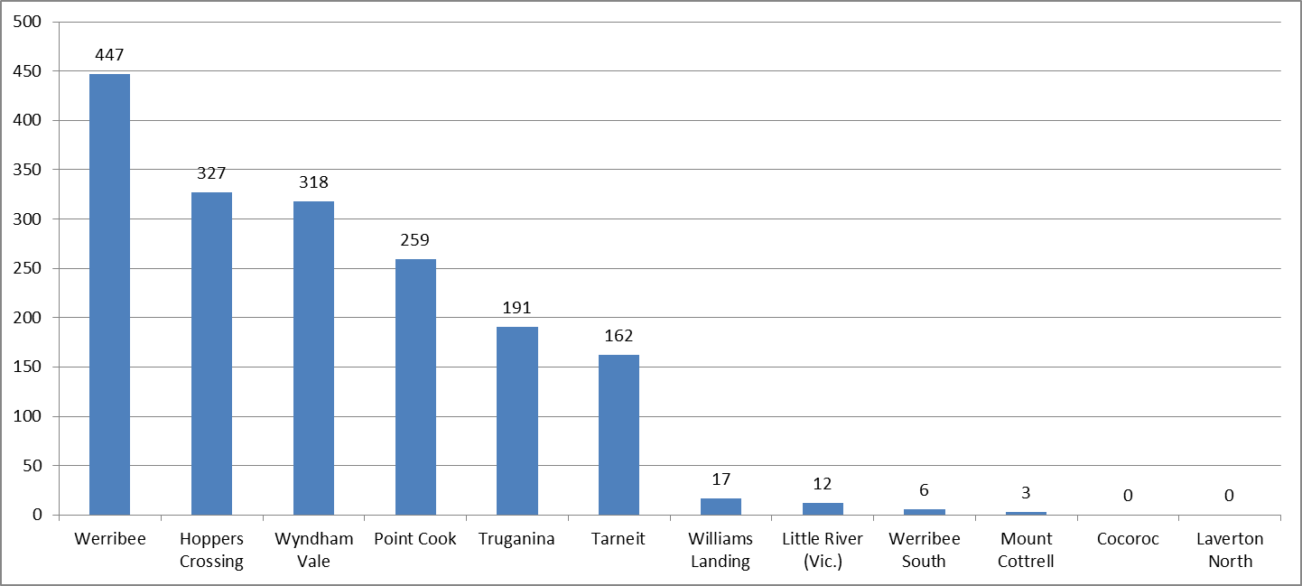
In relation to overall population sizes, the suburbs with the largest proportions of Aboriginal and Torres Strait Islander residents are Wyndham Vale (1.37%), Werribee (1.11%), Truganina (0.92%), Little River (0.91%) and Hoppers Crossing (0.84%). The pattern in Figure 4 is highly similar to that in 2011. Laverton North is an exception as no residents who identified as Aboriginal and Torres Strait Islander reside there in 2016, compared to 4 in 2011.
Figure 4: Aboriginal and Torres Strait Islander Population (Percentage) in Wyndham Suburbs, 2016
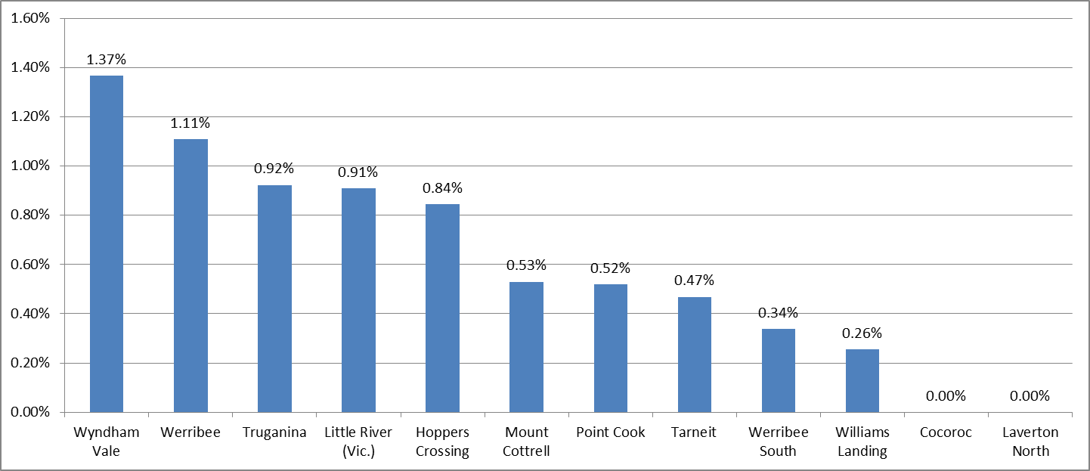

Age
In 2016 the Wyndham Aboriginal and Torres Strait Islander community has a larger proportion of people under 15 years and smaller proportions of people over the age of 60 years than the Victorian Aboriginal and Torres Strait Islander community. Generally, the Wyndham Aboriginal and Torres Strait Islander Community has a younger age profile than the Wyndham non-Aboriginal and Torres Strait Islander community and the Victorian Aboriginal and Torres Strait Islander community as Figure 5 shows.
Figure 5: Age Profile of Aboriginal and Torres Strait Islander and Non-Aboriginal and Torres Strait Islander Population, Wyndham and Victoria, 2016
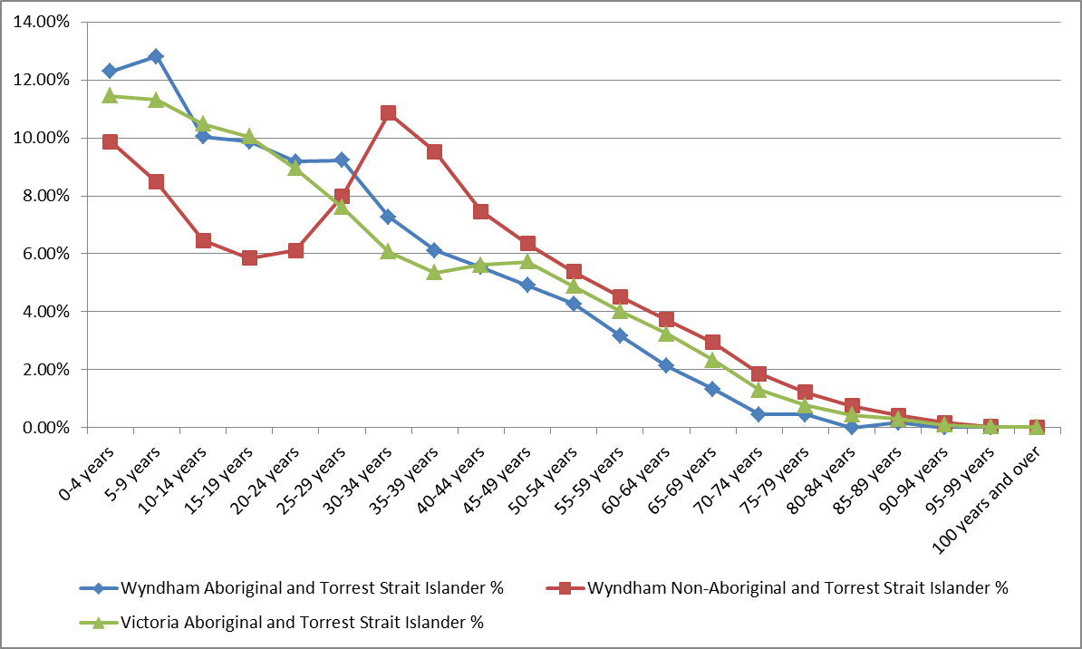

In 2016, the median age of the Aboriginal and Torres Strait Islander population in Wyndham is 24.2. This is 8 years below the median age of the non-Aboriginal and Torres Strait Islander population (32.3). The median age of both population cohorts is lower than in Greater Melbourne (Table 3).
Table 3: Median age of Aboriginal and Torres Strait Islander and Non-Aboriginal and Torres Strait Islander Population, Wyndham and Greater Melbourne, 2016
 | Wyndham | Greater Melbourne
Aboriginal and Torres Strait Islander | 24.2 | 28
Non-Aboriginal and Torres Strait Islander | 32.3 | 37.6

Table 4 displays some selected age cohorts for the Aboriginal and Torres Strait Islander and non-Aboriginal and Torres Strait Islander populations in Melbourne.
Table 4: Selected Cohorts of Aboriginal and Torres Strait Islander and Non-Aboriginal and Torres Strait Islander Population - Wyndham, 2016
 | non-Aboriginal and Torres Strait Islander | Aboriginal and Torres Strait Islander
0-17 years | 28.4% | 41.8%
18-24 years | 8.4% | 13.2%
25-34 years | 18.8% | 16.0%
35-49 years | 23.3% | 16.5%
50-64 years | 13.6% | 9.3%
65+ | 7.4% | 1.8%

The Aboriginal and Torres Strait Islander community has a larger proportion of residents under 18 years (41.8%) than the non-Aboriginal and Torres Strait Islander population (28.4%). Around 50% of the Aboriginal and Torres Strait Islander population in Wyndham is 21 or younger, while non-Aboriginal and Torres Strait Islander people aged 21 or below make up only a third of the total non-Aboriginal and Torres Strait Islander population.
The proportion of residents aged 65+ is smaller in the Aboriginal and Torres Strait Islander community (1.8%) than the non-Aboriginal and Torres Strait Islander community (7.4%). For context, the percentages for Greater Melbourne are 5% and 13.9% respectively. This is indicative of the life expectancy gap that exists between Aboriginal and Torres Strait Islander and non-Aboriginal and Torres Strait Islander people nationally. The gap between Greater Melbourne and Wyndham 65+ Aboriginal and Torres Strait Islander residents is probably partly explained by the life expectancy gap, and partly by the generally low proportion of 65+ residents who reside in Wyndham relative to Greater Melbourne.

Ancestry
In the Census, the questions that relate to ancestry have two response options. Because they are not ordered, no primary and secondary ancestry can be derived. Multi-response ancestry totals both ancestry responses for each resident, and this is the count used in Table 5 and Figure 6.
The majority of Aboriginal and Torres Strait Islander residents in Wyndham report having Australian and/or North-West European ancestry (1,077 and 919 respectively). The number of Aboriginal and Torres Strait Islander residents who indicate Australian Aboriginal and Torres Strait Islander ancestry is far lower (166). The set of ancestry responses of non-Aboriginal and Torres Strait Islander residents is more varied, and reflective of the general demographic profile of Wyndham.
Table 5: Ancestry of Aboriginal and Torres Strait Islander and Non-Aboriginal and Torres Strait Islander Population (Number) – Wyndham, 2016
 | Non-Aboriginal and Torres Strait Islander | Aboriginal and Torres Strait Islander | Not stated | Total
Australian | 42699 | 1077 | 362 | 44139
Australian Aboriginal and Torres Strait Islander | 26 | 166 | 0 | 184
Maori | 3238 | 14 | 28 | 3278
Other Oceania Ancestry Groups | 6711 | 46 | 42 | 6802
South-East Asian | 17341 | 12 | 62 | 17417
North-West European | 79593 | 919 | 572 | 81083
Southern and Eastern European | 33879 | 108 | 237 | 34227
North African and Middle Eastern | 7713 | 13 | 70 | 7787
Other ancestry groups | 68290 | 34 | 328 | 68670
Not stated | 149618 | 1077 | 19953 | 170645
Total population | 204554 | 1733 | 10827 | 217114

Figure 6 below displays the numbers in Table 5 as a proportion of the total Aboriginal and Torres Strait Islander and non-Aboriginal and Torres Strait Islander populations. This shows the widely diverging patterns between the two cohorts.
Figure 6: Ancestry by Aboriginal and Torres Strait Islander and Non-Aboriginal and Torres Strait Islander Population (Percentage) – Wyndham, 2016
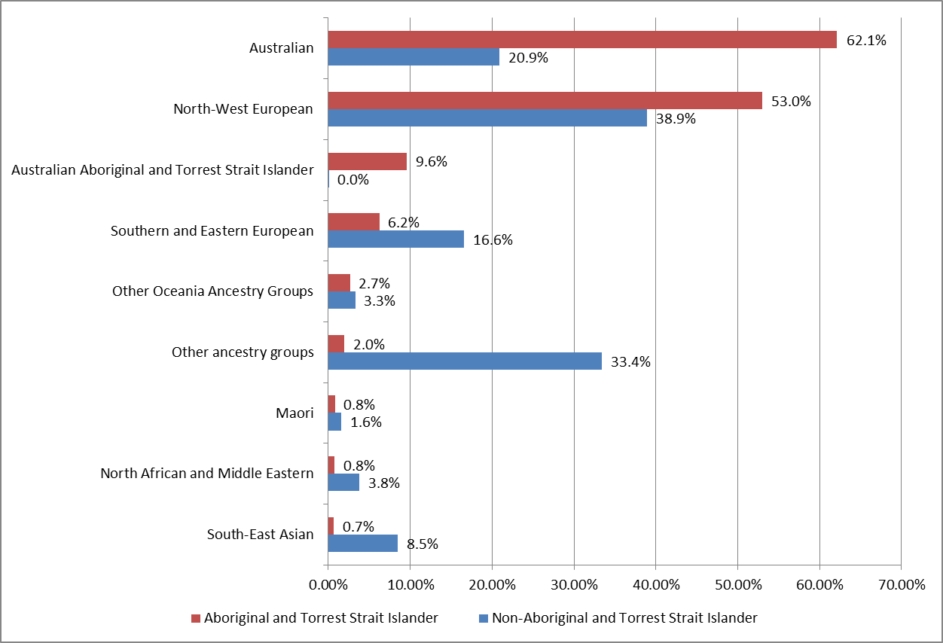

Religious Affiliation
As Figure 7 indicates, less than half of the Aboriginal and Torres Strait Islander population in Wyndham reports having a Christian faith (40.2%) in 2016, which is lower than the non-Aboriginal and Torres Strait Islander population (48.2%). The majority of Aboriginal and Torres Strait Islander people in Wyndham indicate having ‘secular beliefs and other spiritual beliefs and no religion’. At 43.7%, this is almost twice the proportion as the non-Aboriginal and Torres Strait Islander population (23.9%).
Figure 7: Religious Affiliation of the Aboriginal and Torres Strait Islander and Non-Aboriginal and Torres Strait Islander Population – Wyndham, 2016
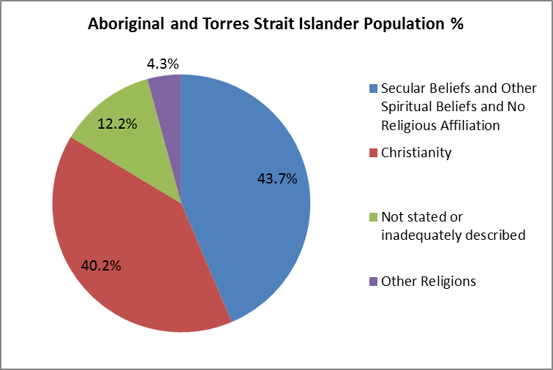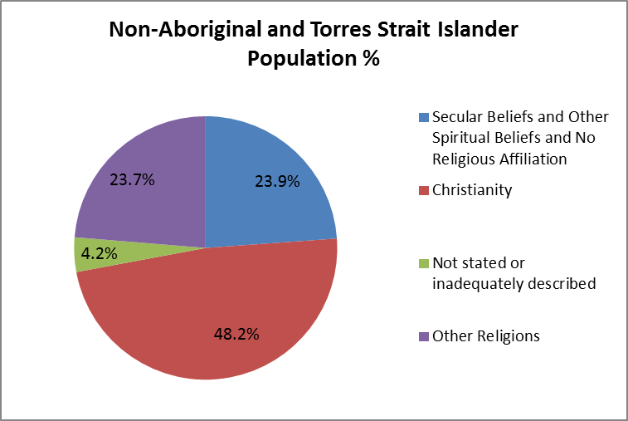

Language Spoken at Home
The ‘Not stated’ category notwithstanding, there are 8 languages spoken at home by the Wyndham Aboriginal and Torres Strait Islander population. By far the largest is English, which 86.7% of the population speaks (Table 6). The appearance of Auslan (a sign language) in this table is consistent with findings that the Aboriginal and Torres Strait Islander population suffers from hearing loss to a greater degree than non-Indigenous people do due to disadvantage and poverty, a number of environmental factors, individual genetics and microbial genomic factors.
Table 6: Language Spoken at Home by Aboriginal and Torres Strait Islander Residents - Wyndham, 2016
Language | Aboriginal and Torres Strait Islander population | Aboriginal and Torres Strait Islander population (%)
English | 1,503 | 86.7%
Arabic | 16 | 0.9%
Spanish | 5 | 0.3%
Italian | 5 | 0.3%
Vietnamese | 4 | 0.2%
Auslan | 4 | 0.2%
Guugu Yimidhirr | 3 | 0.2%
Other Australian Indigenous Languages | 3 | 0.2%

The language profile of non-Aboriginal and Torres Strait Islander residents in Wyndham is very different. A total of 172 languages are represented, and a much lower proportion speaks English at home (55.2%). In addition, languages from the Indian subcontinent are prevalent in the top 8 languages spoken – a reflection of Wyndham’s overall demographic make-up.

Migration
Figure 8 displays data on the location of Wyndham 2011 residents in 2006. Over half (52.8%) of Wyndham’s 2011 Aboriginal and Torres Strait Islander residents lived in the municipality in 2006, which is less than the proportion of Wyndham non-Aboriginal and Torres Strait Islander residents (58.9%). One quarter of 2011 Aboriginal and Torres Strait Islander residents had migrated into Wyndham between 2006 and 2011. This compares to 29% for the non-Aboriginal and Torres Strait Islander population (Figure 8). The Wyndham Aboriginal and Torres Strait Islander community in 2011 had a larger proportion (9.5%) of its population living in other parts of Australia in 2006 than the non-Aboriginal and Torres Strait Islander community (3.2%).
The ‘Not applicable’ category largely covers children born between 2006 and 2011. The Aboriginal and Torres Strait Islander community has a larger proportion of non-applicable residents than the non Aboriginal and Torres Strait Islander population (13.6% and 9.2% respectively). This is connected to the younger age profile of the Aboriginal and Torres Strait Islander community discussed earlier (see Tables 3 and 4).
Figure 8: Location of 2011 Wyndham Residents in 2006
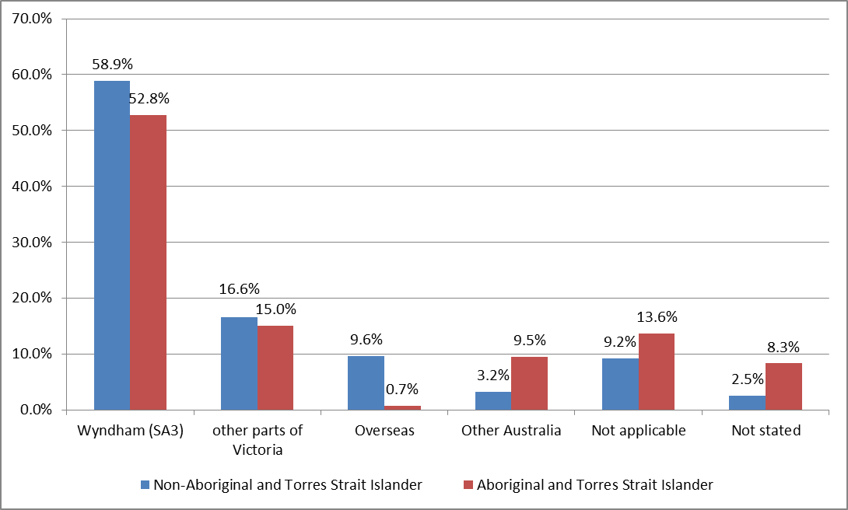
The data in Figure 9 displays the location in 2011 of those who were Wyndham residents in 2006. This data does not include people who have moved overseas and who have died between 2006 and 2011.
The figure shows that a larger proportion of Aboriginal and Torres Strait Islander residents had left Wyndham (21.7%) than non-Aboriginal and Torres Strait Islander residents (15.8%) between 2006 and 2011.
In the 2006 Census 708 residents identified as being Aboriginal and Torres Strait Islander. However, from the 2011 Census, 768 Aboriginal and Torres Strait Islander residents said they were living in Wyndham in 2006, a positive difference of 60. A likely explanation for this difference is that people are becoming more confident in identifying as Aboriginal and Torres Strait Islander.
Figure 9: Location of 2006 Wyndham Residents in 2011
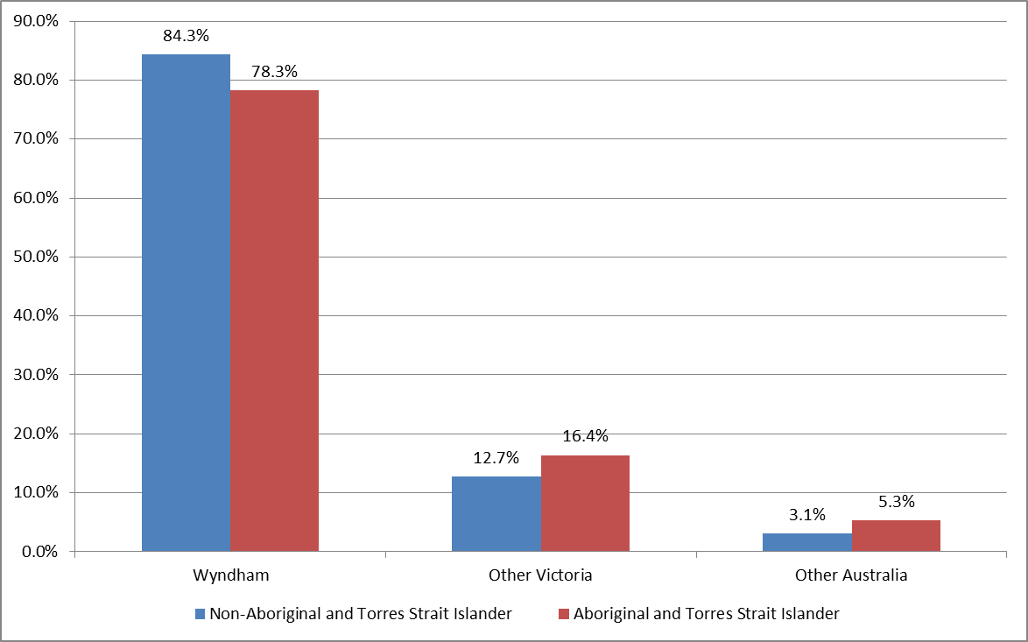

Household Type
In 2016 a larger proportion of the Aboriginal and Torres Strait Islander population (29.8%) are living as single parent family households than Wyndham’s total population (10.2%). The proportion is also higher than for the Victorian Aboriginal and Torres Strait Islander population (25.5%). As a result, the average household size for Wyndham Aboriginal and Torres Strait Islander people is 2.27, while for the non-Aboriginal and Torres Strait Islander population this is 2.74. As shown in Table 7, Aboriginal and Torres Strait Islander Wyndham residents are more likely to live in group households, and are less likely to live alone, than the overall Wyndham population. The percentages in Table 7 for the Wyndham Aboriginal and Torres Strait Islander population have remained largely unchanged since 2011.
Table 7: Household Type Aboriginal and Torres Strait Islander and Total Population - Wyndham, 2016
Household type | Wyndham Aboriginal and Torres Strait Islander |  | Wyndham Total Population |  | Victoria Aboriginal and Torres Strait Islander
 | Number | Percentage | Number | Percentage | Number | Percentage
Couples with children | 105 | 13.8% | 13,824 | 18.4% | 6,960 | 29.3%
Couples without children | 281 | 36.9% | 30,639 | 40.7% | 4,033 | 17.0%
One parent families | 227 | 29.8% | 7,688 | 10.2% | 6,070 | 25.5%
Other families | 35 | 4.6% | 11,337 | 15.1% | 1,221 | 5.1%
Group households | 41 | 5.4% | 1,708 | 2.3% | 1,746 | 7.3%
Lone persons | 73 | 9.6% | 10,114 | 13.4% | 3,753 | 15.8%
Total households | 762 | 100.0% | 75,310 | 100.0% | 2,3783 | 100.0%

Tenure
Homeownership rates among Wyndham Aboriginal and Torres Strait Islander residents have gone down since 2011 - from 48.6% in 2011 to 43.9% in 2016. The percentage of renters has gone up by about the same percentage as ownership has decreased. When it comes to tenure type in 2016 (Table 8) a lower proportion of Aboriginal and Torres Strait Islander residents owns their home (43.9%) than all Wyndham residents (61.1%).
Table 8: Household Tenure by Population Cohort – Wyndham, 2016
Tenure | Wyndham Aboriginal and Torres Strait Islander |  | Wyndham Total Population
 | Number | Percentage | Number | Percentage
Owned outright | 79 | 10.4% | 13,479 | 17.9%
Owned with a mortgage | 255 | 33.5% | 32,547 | 43.2%
Rented (public) | 53 | 7.0% | 607 | 0.8%
Rented (private) | 341 | 44.8% | 18071 | 24.0%
Other | 9 | 1.2% | 1,018 | 1.4%
Not stated | 23 | 3.0% | 4582 | 6.1%

In 2016 a larger proportion of Aboriginal and Torres Strait Islander households are living in public rental dwellings (7.0%) than the total population (0.8%), though it is still lower than the Victorian Aboriginal and Torres Strait Islander population proportion of 12.9% (Figure 10). Also notably higher is the proportion of Aboriginal and Torres Strait Islander households living in private rental dwellings: 44.8% compared with 24% of all Wyndham households, and 36.6% of all Victorian households.
Figure 10: Household Tenure, Aboriginal and Torres Strait Islander Population and Non-Aboriginal and Torres Strait Islander Population - Wyndham and Victoria, 2016
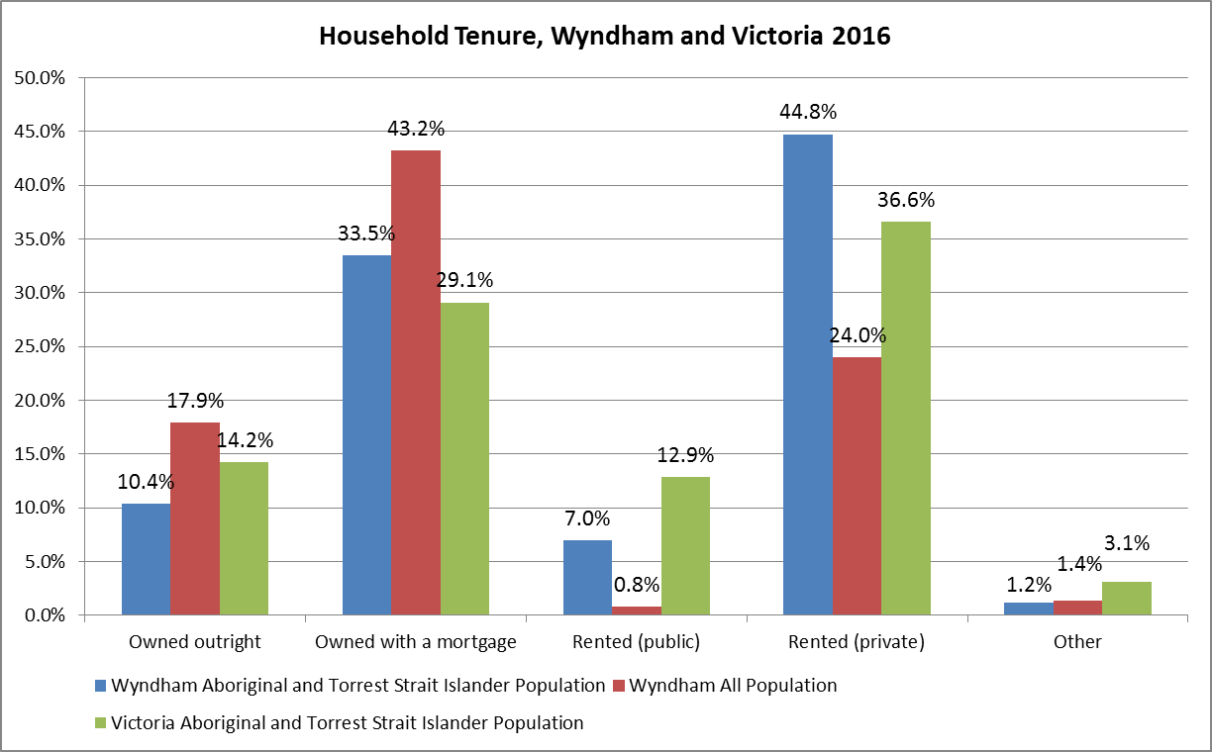

Education
In terms of educational attainment, Year 12 completion rates differ starkly between Aboriginal and Torres Strait Islander and non-Aboriginal and Torres Strait Islander residents (Table 9). In 2016, 34.3% of Aboriginal and Torres Strait Islander residents over 15 years of age had completed year 12 or equivalent. This is almost twice as low as non-Aboriginal and Torres Strait Islander residents over 15 (62.3%). In addition, while educational attainment for non-Aboriginal and Torres Strait Islander Wyndham residents is similar to Greater Melbourne and higher than in Victoria, Aboriginal and Torres Strait Islander Wyndham residents experience lower educational attainment rates than Aboriginal and Torres Strait Islander residents in Greater Melbourne and Victoria.
Table 9: Year 12 Completion Rates by Aboriginal and Torres Strait Islander and Non-Aboriginal and Torres Strait Islander Population over 15 Years old, 2016
 | Wyndham | Greater Melbourne | Victoria
Aboriginal and Torres Strait Islander | 34.3% | 42.3% | 35.2%
Non-Aboriginal and Torres Strait Islander | 62.3% | 63.6% | 58.5%

Employment
According to Census 2011 data, Clerical and Administrative Workers (19.1%) and Technicians and Trades Workers (15.8%) were the largest occupation types for employed Aboriginal and Torres Strait Islander people in Wyndham (Table 10).
Table 10: Occupations, Aboriginal and Torres Strait Islander Population – Wyndham, 2011
Occupation | Number | Percentage
Clerical and Administrative | 69 | 19.1%
Technicians and Trades | 57 | 15.8%
Community and Personal Services | 41 | 11.4%
Machinery Operators and Drivers | 41 | 11.4%
Professionals | 36 | 10.0%
Labourers | 35 | 9.7%
Sales Workers | 34 | 9.4%
Managers | 28 | 7.5%
Inadequately described | 20 | 5.5%

Comparing Wyndham Aboriginal and Torres Strait Islander residents’ industries of employment with Wyndham’s total population, the most evident differences are in the categories for Professionals and Managers, where Aboriginal and Torres Strait Islander residents are proportionally less represented. Comparing Aboriginal and Torres Strait Islander residents in Wyndham with those in Victoria, employment proportions across all but two occupations differ greatly.
Figure 11: Occupations, Aboriginal and Torres Strait Islander and Non-Aboriginal and Torres Strait Islander Population - Wyndham and Victoria, 2011
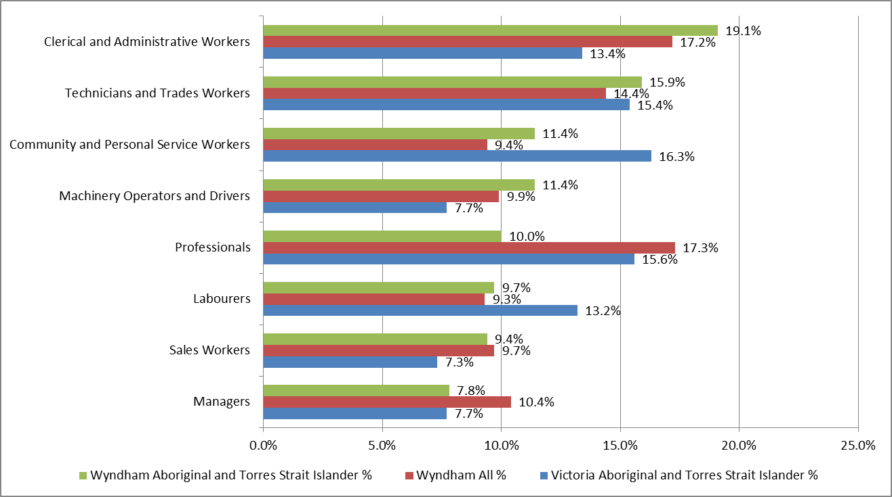

Place of Work
A larger proportion of Aboriginal and Torres Strait Islander residents work locally in the municipality (35%) than non-Aboriginal and Torres Strait Islander residents do (31%), as Figure 12 shows. On the other hand, proportionally more non-Aboriginal and Torres Strait Islander residents work in the City of Melbourne.
Figure 12: Top ten Places of Work, Aboriginal and Torres Strait Islander and Non-Aboriginal and Torres Strait Islander, Employed Residents – Wyndham, 2011
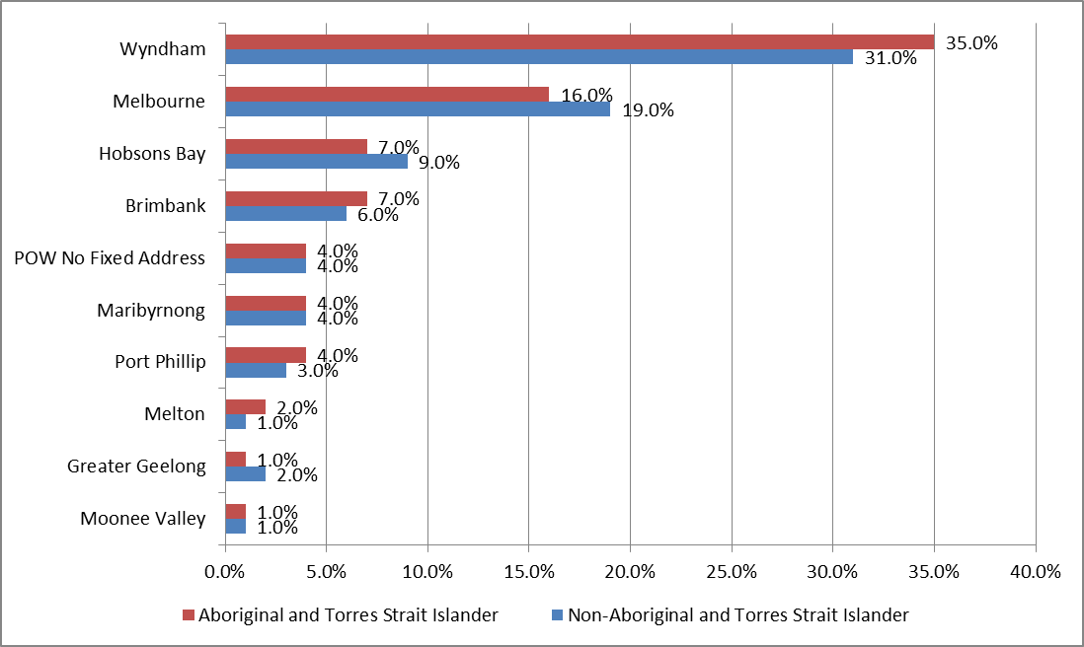

References
Australian Bureau of Statistics. (2011 and 2016). Census of Population and Housing. Retrieved from https://auth.censusdata.abs.gov.au/webapi/jsf/login.xhtml
Australian Bureau of Statistics. (2011 and 2016). Census of Population and Housing. Retrieved from .id Consulting http://profile.id.com.au/wyndham

Life expectancy for Indigenous people in Australia is around 10 years below that of non-Indigenous people (http://www.aihw.gov.au/deaths/life-expectancy/#indigenous).
ABS, 4727.0.55.001 - Australian Aboriginal and Torres Strait Islander and Torres Strait Islander Health Survey: First Results, Australia, 2012-13.
Closing the Gap Clearinghouse (AIHW & AIFS) 2014. Ear disease in Aboriginal and Torres Strait Islander children. Resource sheet no. 35. Produced by the Closing the Gap Clearinghouse. Canberra: Australian Institute of Health and Welfare & Melbourne: Australian Institute of Family Studies.

