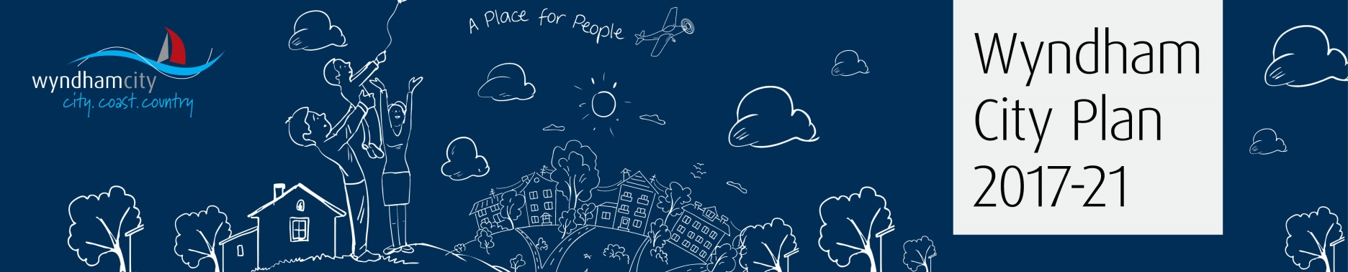

Public Feedback & Formal Submission Printable Form
Draft Wyndham City Plan 2017-21
How to Provide Feedback
This simple printable form has been designed for members of the Wyndham community to provide direct feedback on the Draft Wyndham City Plan 2017-21. An online form is also available at www.wyndham.vic.gov.au/cityplan.
You’re invited to view the Draft and submit your feedback to Council between 3-31 May, 2017.
Access to the Draft
The Draft Wyndham City Plan 2017-21 is available electronically via www.wyndham.vic.gov.au/cityplan, or you can pick up a printed copy at your local Wyndham Library, Community Centre or Civic Centre.
General Feedback and Formal Submissions
You will first be asked to select whether your feedback should be considered as general feedback or a formal submission. If you select the latter, your feedback and name will be included in a publically available report to Council.
Formal submissions will be presented to Council at a Special Council Meeting on 13 June, 2017 from 7pm at the Wyndham Civic Centre. Community members are welcome to attend the meeting. General feedback provided through this form will also be considered, however, will not be published publically and identification is optional.
It is recommended that you read the Draft City Plan first and have a copy with you as you proceed. You will be asked to provide feedback under each of the four City Plan Themes:
- People & Community
- Places & Spaces
- Earning & Learning
- Leadership & Participation
You can skip to the next section if you do not have specific comments for a theme.

Please email your completed form to cityplan@wyndham.vic.gov.au or post to:
Chief Executive Officer
Wyndham City council
PO Box 197
Werribee VIC 3030
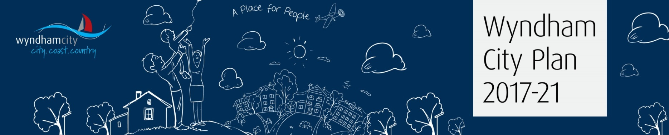

1. Would you like this feedback to be presented at a Special Council Meeting as a formal submission? [please tick Yes or No below, and if “yes” the supplementary question]
Yes, I would like my feedback to be treated as a formal submission to Council
Do you also wish to appear in person (or by a person acting on your behalf) on Tuesday 13 June, 2017 from 7.00pm at Wyndham Civic Centre in support of your written submission?
Yes, please No, thank you
No, I would prefer my feedback to be considered as general feedback

For these questions, please refer to the People & Community theme in the Draft Wyndham City Plan 2017-21

2. How well do the directions outlined within this theme align with your hopes & aspirations for the Wyndham community? [please tick one of the boxes in the scale below]
doesn’t align somewhat aligns aligns strongly aligns
3. Please share your comments regarding the Strategic Objective, Health Wellbeing & Safety Goal, and Strategies under this theme

For these questions, please refer to the Places & Spaces theme in the Draft Wyndham City Plan 2017-21

4. How well do the directions outlined within this theme align with your hopes & aspirations for the Wyndham community? [please tick one of the boxes in the scale below]
doesn’t align somewhat aligns aligns strongly aligns
5. Please share your comments regarding the Strategic Objective, Health Wellbeing & Safety Goal, and Strategies under this theme

For these questions, please refer to the Earning & Learning theme in the Draft Wyndham City Plan 2017-21

6. How well do the directions outlined within this theme align with your hopes & aspirations for the Wyndham community? [please tick one of the boxes in the scale below]
doesn’t align somewhat aligns aligns strongly aligns
7. Please share your comments regarding the Strategic Objective, Health Wellbeing & Safety Goal, and Strategies under this theme

For these questions, please refer to the Leadership & Participation theme in the Draft Wyndham City Plan 2017-21

8. How well do the directions outlined within this theme align with your hopes & aspirations for the Wyndham community? [please tick one of the boxes in the scale below]
doesn’t align somewhat aligns aligns strongly aligns

9. Please share your comments regarding the Strategic Objective, Health Wellbeing & Safety Goal, and Strategies under this theme

10. When considering the overall Draft Wyndham City Plan, how confident are you that it provides appropriate direction to Council for the next 4 years? [please tick one of the boxes in the scale below]
not confident somewhat confident confident highly confident

10. Do you have any other comments to share in relation to the Plan?

Contact Details

Providers of General Feedback: By providing your preferred contact details we will be able to update you regarding the outcome of the City Plan. Your details will be stored securely according to Wyndham City’s Privacy Policy. For questions relating to Privacy, please contact Wyndham’s Privacy Officer on (03) 9742 0777.

Providers of Formal Submissions: to make a formal submission you must provide your contact details. Formal submissions are public documents and form part of the Council meeting agenda and minutes. Submitters’ names and addresses cannot be suppressed and will become part of the public record.

Name:____________________________________________________________________________

Organisation (if representing one):_____________________________________________________

Address:___________________________________________________________________________
__________________________________________________________________________________

Email:_____________________________________________________________________________

Phone Number:_____________________________________________________________________

Thank you for your feedback!
If you would like further information about the City Plan or our stakeholder consultation process, please email cityplan@wyndham.vic.gov.au or contact the Senior Community Engagement Officer on 9742 0777.

