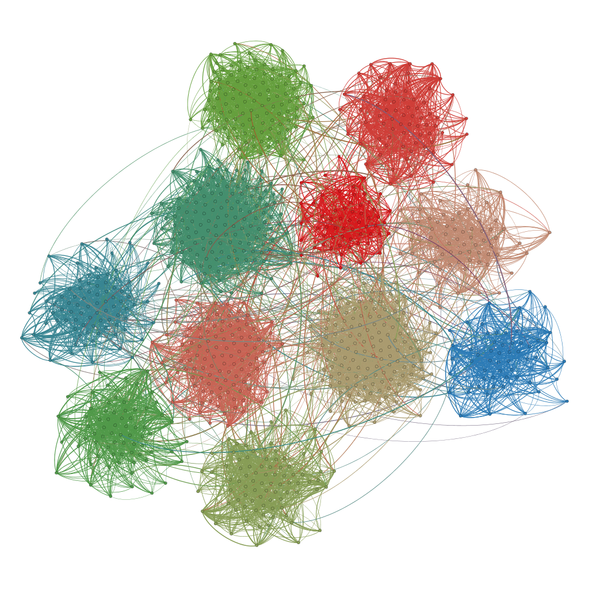

Wyndham Arts Incubator
Artist EOI 2017

WYNDHAM ARTS INCUBATOR
Wyndham City is seeking expressions of interest for the Wyndham Arts Incubator program designed to seed artist-led projects, spaces and groups.
This program has been created in response to feedback from local artists that space, networks and opportunities to present work are key priorities for the ongoing development of local industry.
Artists are encouraged to propose projects that support the development of local networks, support skill-sharing or provide opportunities for community participation.
What is being “Incubated”?
We’re continuing to seed two models of artist-led space in 2016. Incubators will run for between 3 - 12 months then artists will be invited to give their feedback about what aspects of each model were successful or unsuccessful.
The intention of this program is to seed artist-led projects that can become self-sustaining in the longer term. Participating artists will be mentored in the development and delivery of their projects, and have access to marketing support.

What support is available?
Expressions of interest should detail any project costs – as a general guide, cash contributions of between $500 - $1000 will be considered. Financial support is not available for artists who have previously received support from the Incubator program.
Marketing support is offered for all projects and programs – this includes Wyndham City’s social media sites, website and Arts eNewsletter, listing on What’s On and Arts Hub where appropriate. Support to create and produce a marketing plan and marketing collateral is also offered.
All participating artists can access ongoing advice as well as connection to other artists participating in the program. Regular co-working days are also scheduled to support access to Wyndham City’s Arts and Culture team.
The EOI Process
The deadline for initial EOIs is 5pm Monday 3 April. More details about what to include is listed under each incubator opportunity.
Artists should email their proposal/s to:
Bec Cole
Arts Development Officer
bec.cole@wyndham.vic.gov.au

- Wyndham Arts Incubator – Old Shire
Located in the heart of Werribee City Centre, the Old Shire Offices have significant historical and cultural value. The space is co-located with the Werribee Historical Society and a busy community venue which is populated by community education and social groups.
The intention of this incubator is to create a space where artists can work, engage directly with the public, connect to other artists, operate a pop-up shop or offer a workshop or class.
Artists that participate in this incubator will be encouraged to; meet with each other, negotiate the use of the space, develop a system for sharing information with each other and test the feasibility of a cooperative model for artist-led space.
Conditions
- Individual or group access to the space for 1 day per week plus negotiated access on weekends.
- A key deposit will be required with the individual or at least one member of a group taking responsibility for the security of the space.
- All ‘residents’ must include some form of public engagement in their activity.
- Artists may charge a fee for any workshops or classes that they organise and deliver.
- Participating artists will need to commit to attending the regular Monthly Meet Up and contribute to the running of the space.
- A briefing session with all participating artists will be held prior to projects commencing.

Express Your Interest
To express your interest in this incubator you should submit a short one page proposal that outlines:
- How you will use the space
- What you will be doing in the space
- Who will be involved – and how will you involve them
- Your preferred day/time and how long you will need the space for (3 - 12 months)
- Why you’d like to incubate your idea at Old Shire
If you also wish to apply for a cash contribution, you should submit a budget using the template on our website.
The deadline for initial EOIs is 5pm Monday 3 April 2017. Artists should email their proposal to:
Bec Cole
Arts Development Officer
bec.cole@wyndham.vic.gov.au

- Wyndham Arts Incubator – Community
Community incubation is designed for artists that wish to develop a new arts group or project in a community setting.
Artists that participate in this incubator will be encouraged to partner with a community organization or community centre to pilot a new arts group or create an artist-led project with an existing group.
The intention of this incubator is to seed the development of new ways for the community to participate in art-making or arts projects that is localised and accessible.
Conditions
- Artists are encouraged to locate their group or project in a community centre or community organization – projects located in private residences are not suitable for this program. Projects that take place in public space will be considered.
- Participating artists will need to commit to attending the regular Monthly Meet Up with other Incubator artists.
- Artists may charge a fee for any workshops or classes that they organise and deliver.
- A briefing session with all participating artists will be held prior to projects commencing.
Express Your Interest
To express your interest in this incubator you should submit a short one page proposal that outlines:
- Where your project or group will take place
- What you will be doing
- Who will be involved – and how you will involve them
- Your preferred day and how long your project/ pilot will take (3 - 12 months)
- Why you’d like to incubate your idea with this community/ in this community setting
- Contact details for the community centre or community group you have discussed your idea with
If you also wish to apply for a cash contribution, you should submit a budget using the template on our website.
The deadline for initial EOIs is 5pm Monday 3 April. Artists should email their proposal/s to:
Bec Cole
Arts Development Officer
bec.cole@wyndham.vic.gov.au

