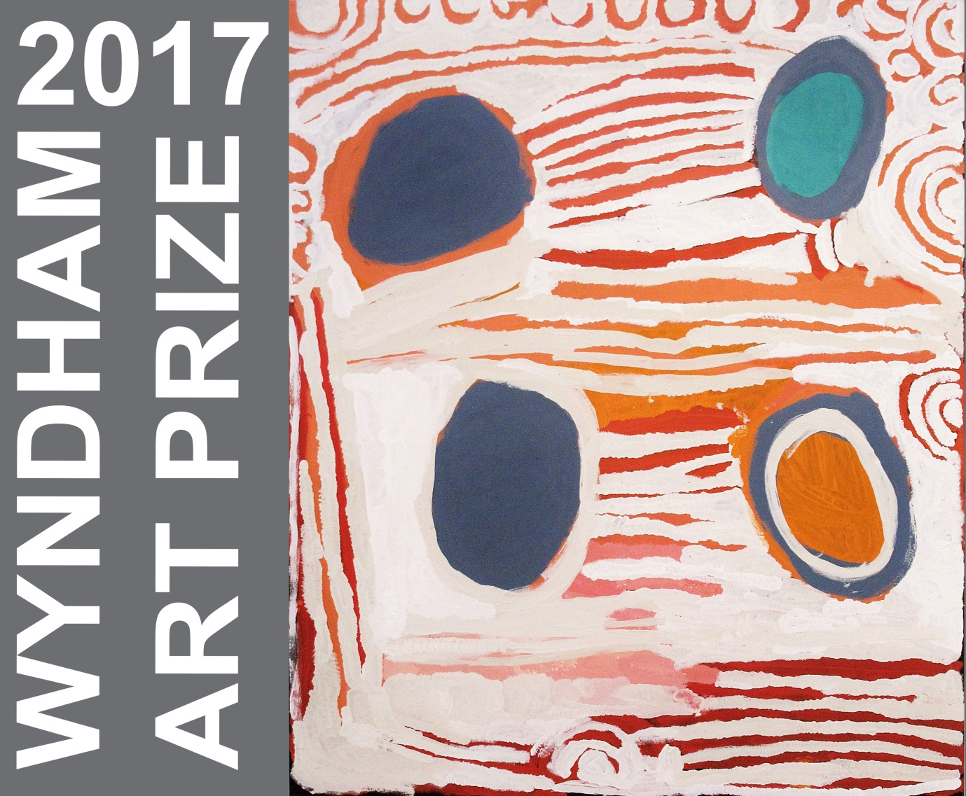
Image: Katjarra Butler – Winner of 2016 Wyndham Art Prize.

Wyndham Art Prize 2017
Wyndham Art Gallery
5 April to 11 June - 2017

Terms and Conditions + Pre-selection Form

Non-acquisitive prize of $10,000
$6,000 of prizes from Deakin University
People’s Choice Award of $2,000

Wyndham Art Prize 2017

Terms & conditions
- The WYNDHAM ART PRIZE (the Prize) is an open prize and exhibition with first prize being awarded as a non-acquisitive prize of $10,000 and a People’s Choice Award of $2,000. Deakin University also offers a bursary prize, CREATE@DEAKIN* of $2,000 for a selected artist to study Honours or Masters of Creative Arts and $4,000 for a selected artist to undertake a PhD candidature at Deakin University.
- The Prize is conducted by Wyndham Art Gallery (the Gallery) on behalf of the Wyndham City Council. The Prize is open to all Australian artists (citizens of Australia or residents for at least 12 months).
- Works chosen for the exhibition will be pre-selected from digital images. Artists may enter a maximum of two works completed since 1 January 2015. All artworks submitted must be available for display.
- The judge’s decision is final and no correspondence will be entered into.
- The judges will award a cash prize to the value of $10,000 for the winning work as well as a $2000 bursary for a selected artist to study Honours or a Masters of Creative arts at Deakin University and/or a $4000 stipend for a Phd candidate of Deakin University. As a recipient of the award, artists must enrol in such courses to be eligible. A People’s Choice Award will also be given of $2,000, judged by votes during the exhibition. The judge reserves the right not to select any work if works are not, in his/her opinion, of sufficient merit. The Gallery has the right to refuse to display any entry.
- Entries must be received by the Wyndham Art Gallery by 5pm Friday 10 February 2017. Entries received after 5pm Friday 10 February 2017 will not be accepted. Entries must consist of no more than two digital images, (remember you are being shortlisted via your photos, so quality images would be great) curriculum vitae (two-page maximum), 100 word artist statement, entry form and administrative fee.
- Administrative fee is $30 per artist. Administrative fee is non-refundable and covers administration and handling. Any entry not accompanied by payment of the fee will be ineligible. Administrative fee to be paid either online through the following link:
http://purchase.tickets.com/buy/TicketPurchase?agency=WYNCC&organ_val=35588&schedule=list&event_val=A030 OR by calling the Wyndham Cultural Centre Box office on (03) 8734 6000. Receipts will not be mailed unless requested.
- Employees of Wyndham City Council, the organisers, and members of their immediate families are ineligible to enter.
- Digital images should be less than two megabytes (when opened), saved as jpgs and able to be opened on PC format.They are to be emailed to megan.evans@wyndham.vic.gov.au AND maree.clarke@wyndham.vic.gov.au with the following details as the file name: artist surname_artist first name_title.jpg (Example: whiteley_brett_lavenderbay.jpg). All images submitted must be of works executed since 1 January 2015. Slides, photographs, photocopied reproductions, or any other representation of the work will not be accepted.
- Completed works should not exceed 1.5 x 1 metres in any given dimension (including frame). Sculptures should not exceed 1 metre in any dimension. A work can consist of multiple parts but must not exceed overall size limits.
- All artists will be notified of pre-selection outcome by Friday 24 February 2017.
- All works selected must be professionally prepared for hanging/installation and must be marked clearly on the back with artist’s name, address, title of work with installation instructions included (if applicable). It is intended that the works selected will be shown in an exhibition at the Gallery. Should space prevent the display of work, the Gallery will advise the entrant.
- The Gallery will not be responsible for any loss or damage suffered to any work in its possession or under its control and each entrant shall indemnify the Gallery against loss or damage suffered to his or her work. Works will not be insured by the Gallery. The Gallery will retain all packaging provided (where ever possible) and reuse to pack work(s) at the close of the exhibition.
- The Gallery will not be responsible for the sale of works. Any enquiries regarding sale of work from the general public will be directed to the artist and/or dealer.
- Works must be delivered during the following dates 19, 20, 21 of March 2017 between 10am and 4pm. Please contact the Visual Art Curators to arrange a suitable time megan.evans@wyndham.vic.gov.au and maree.clarke@wyndham.vic.gov.au Phone 03 8734 6021
- All entries selected for exhibition must be available for continuous display at the Gallery for the period of the exhibition. Artists and/or their representatives cannot remove an artwork from display prior to 11 June 2017.
- Work(s) must be collected from the Gallery on Monday 12 or Tuesday 13 June between 9am and 5pm or by prior arrangement (see 15).
- Artists selected for exhibition will allow their works to be reproduced by print and electronic media in the advertising and promotion of the exhibition. The Gallery reserves the right to reproduce the winning entry in relation to the Prize.
- Freight of artwork. Artworks will not be accepted unless delivered and returned free of all freight and other charges. If an artist shall fail or omit to remove a work from the Gallery within one month of the close of the exhibition, the Gallery, after sending a notice by post to the artist at the last known address of its intention to sell or otherwise dispose of such work, or in the event of no address being known to the Gallery, then one month after advertising such notice of intention in a newspaper, may sell such work. After deducting from the proceeds the cost incidental to the sale shall hold any balance for the artist. Provided however that in the event of such work being in the opinion of the Gallery unsaleable, then the Gallery may in lieu of selling the same, destroy or otherwise dispose in such a manner as it may deem fit; and thereafter the Gallery shall be under no liability whatever to the artist in respect of any work so destroyed or disposed of. All care will be taken, however the Gallery will not be responsible for any loss or damage, howsoever caused. Freight and insurance is the responsibility of the artist.
- All personal information gathered by the Gallery will be used solely for the purpose of administering the Prize.

*CREATE@DEAKIN prize of $2000 for winner who enrols in Hons or Masters (MCA) and $4000 for winner who enrols in PhD - will be paid six months after enrolment in allocations of $1000/6 months, subject to satisfactory progress in studies

Pre-selection form

To be returned via email to Wyndham Art Gallery no later than 5pm Friday 10 February 2017. Please include up to two jpgs no bigger that 2mg, a CV (2 pages) and 100 word artists statement.

Please ensure that payment of administration fee has been made at time of entry.
Please note: any entry that does not include all of the above plus payment of administration fee will be ineligible.

All requested information on this form must be completed.

Your Details

Name :

Address:
State:
Postcode:

Email:

Telephone:

Date of birth:
Country of birth & Nationality

Gallery / Dealer
(if applicable)

Telephone:

Email:

Detail of Entries

1.Title:

Date:

Medium:

Size (h) cm X (w) cm:

2.Title:

Date:

Medium:

Size (h) cm X (w) cm:

Declaration:

I have read the terms, conditions and information accompanying this application and agree to abide by them. I am an Australian citizen or have been a resident of Australia for at least 12 months. I declare that the artwork(s) submitted by me are original and have been executed since 1st January 2015.

Artist’s signature

Artist’s name

Date

Artist checklist

Entry fee paid

EMIALED: Entry form 2 page CV JPEGs Artist’s statement

Wyndham Art Prize 2017
Wyndham Art Gallery
5 April to 11 June 2017

Non-acquisitive prize of $10,000
$6,000 of prizes from Deakin University
People’s Choice Award of $2,000

Important dates:

Entries close - 5pm Friday 10 February 2017
Artists advised of selection by – Friday 24 February 2017
Delivery of artworks 19, 20, 21 of March 2017 between 10am and 4pm.2017
Announcement and opening – Wednesday 5 April 2017
Exhibition dates – 6 April to 11 June 2017
Collection of artworks - Monday 12 or Tuesday 13 June between 9am and 5pm 2017

For further information please contact – Megan Evans or Maree Clarke megan.evans@wyndham.vic.gov.au OR maree.clarke@wyndham.vic.gov.au

Phone: 03 8734 6021

