**[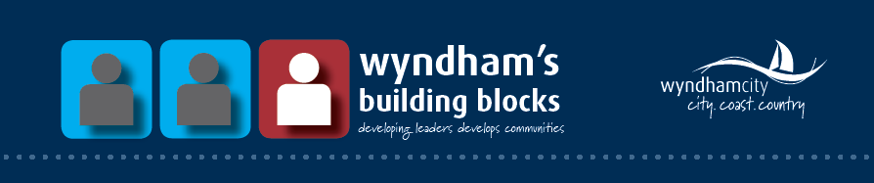](https://www.wyndham.vic.gov.au/residents/community/building_blocks_community_leadership_program)**



**Alumni e-Newsletter**

**Volunteering:**

Thinking about becoming a volunteer? Check out <https://www.wyndham.vic.gov.au/services/volunteering-grants/other-volunteer-organisations-opportunities/wyndham-volunteer> for some general information about finding the right volunteer role for you, as well as some useful websites to help you find a suitable position.

Good news! You can now translate this website into your preferred language, simply by clicking on the ‘Select language’ button in the bottom right hand corner of the page as seen below.

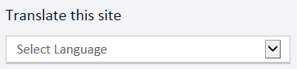

**Wyndham’s Volunteer Directory:**

Wyndham City Council has developed a Volunteer Directory, which can be used to search for new volunteer positions in other not-for-profit organisations, in a range of interest areas. Click the following link to search for opportunities <https://www.wyndham.vic.gov.au/services/volunteering-grants/how-apply-volunteer-opportunities-wyndham-city>

**What’s on in Wyndham?**

**Wyndham Learning Festival:** 8am to 9pm, Thursday 1st September – Thursday 8th September, numerous venues.

This festival will showcase over 100 FREE events across the city for people at all different stages of life. Check out the Facebook page at facebook.com/wynlearnfestival or visit <https://www.wyndham.vic.gov.au/whats-on/wyndham-learning-festival> to download the event flyer and schedule.

**Children’s Week Picnic:** 10am – 4pm, Sunday 23rd October, Werribee Park Mansion. The 16th annual picnic will be a fun, family friendly day full of interactive activities such as sports, crafts, music and dance. Entry to the picnic and activities is FREE. For more information, please see <https://www.wyndham.vic.gov.au/whats-on/childrens-week-picnic>

**Wyndham News:**

**New park for Point Cook:** A new park is set to undergo construction in October, with frog-themed attractions such as a cubby house, ‘tadpole rockers’, and ‘froglet steppers’. The idea behind the theme is to raise awareness of the endangered Growling Grass Frog which is indigenous to the Point Cook area. Check out the full article by Adem Saban here: <http://www.starweekly.com.au/news/leap-of-faith-at-play-for-point-cooks-park/pub/wyndham/>

**Wyndham Volunteer & Community Group Training 2016:**

Wyndham City Council currently offers free training sessions on a range of topics, from fundraising to grant writing. Free to Wyndham residents, volunteers and community organisations.

Upcoming sessions include:

* Governing a Community Organisation (2nd September)
* Managing Volunteers (14th September)
* Facilitating a Strategic Planning Session (6th October)
* Roles of Committee Members (20th October)

Please visit [https://www.wyndham.vic.gov.au/whats-on?dates[min]=&dates[max]=&category=Volunteers&suburb&age&venue&type&provider&query](https://www.wyndham.vic.gov.au/whats-on?dates%5bmin%5d=&dates%5bmax%5d=&category=Volunteers&suburb&age&venue&type&provider&query) for more information and to register.

20th October

**Did you know?**

Wyndham has two ongoing sister city projects. Sister cities promote a relationship between cities in different parts of the world or between different cultures. Wyndham City has been fortunate enough to have an agreement with Chiryu, Japan and Costa Mesa, California. These partnerships aim to provide a forum for cultural, economic and educational interchange between communities. They also encourage global friendship, cultural awareness, goodwill and harmony. Find out more about both cities at the following links:

<http://www.city.chiryu.aichi.jp.e.sh.hp.transer.com/>

<http://www.costamesaca.gov/>



**Facts:**

Wyndham City has a new Seniors Community Directory with details of social hobby groups for Wyndham seniors –Information can be found at <https://www.wyndham.vic.gov.au/community-directory-services-social-hobby-groups>

**More Interesting News:**

**Western Special Needs Dentistry:** Following a launch ceremony on the 19th of July, WSND is a modern, fully-equipped clinic - providing oral health services for people with special needs. The clinic is located at 33 Princes Highway, Werribee VIC, 3030. You can visit their website at <http://www.westernspecialneedsdentistry.com.au/>

**Community Leadership Forum with Special Guest Peter Kenyon:** On the 17th August, Peter Kenyon, a social entrepreneur who has worked with over 1000 communities across Australia and overseas, talked about the ways in which the community can utilise its existing strengths in order to build a stronger and more sustainable Wyndham. According to attendee Karen Howard, 5 tips were offered for building community. These included; 1) have an appreciative mindset, 2) remember success is an inside job, 3) create opportunities for everyone to contribute, 4) build social networks and 5) know the importance of community conversation. For further interesting resources on community development, please see the list provided by Peter below.

[www.abcdinstitute.org](http://www.abcdinstitute.org), “Community Conversations” by Paul Born, “Ripples from the Zambezi” by Ernesto Sirolli, “Deepening Community” by Paul Born, “When People Care Enough to Act” by Mike Green & John O’Brien.

**Tips for more ‘inclusive activities’:** If you are planning a one-off or regular event, or already run an event within the community, you may wish to consider the following tips developed by the Neighbourhood Hubs Team at Wyndham to help minimise barriers to participation. When planning, it is important to take into account issues surrounding language, ethnicity and culture, gender identity, sexual orientation, age, income level and disability. In order to make your activity more inclusive, you can;

**Plan for the comfort of participants:**

1. Think about how the design of your activity; the marketing, seating arrangements, arrival and membership process, decision-making, and pricing could impact on people’s ability to participate

2. Remember, sometimes it’s OK to “agree to disagree”. Everyone has a right to their opinion. Acceptance of different views and methods is all part of inclusion; it is what makes an organisation strong

3. Get to know the demographics of the community which your group is active in. This might highlight sections of the population that you haven’t yet reached. Community Centre staff will be happy to provide you with detailed Suburb Profiles

**Practical examples:**

• Nominate a ‘Welcome Host’ that meets new participants at the door

• Print pamphlets or posters in a format that’s easy to read and understand for people with limited English literacy or vision impairment

• Place seating with arm rests close to the front and closer to doors to assist older people and those with physical disabilities to navigate through crowds

• Vary meeting times to allow parents of young children, full-time workers, or school students to attend outside of their ordinary commitments

• Serve a variety of foods at your functions that take into account people’s personal, cultural and religious dietary requirements

• Describe public transport or car-pooling options to encourage non-drivers to attend

• Create a quieter private space where parents with babies, as well as people with behavioural or autism conditions might prefer to ‘chill-out’

• Host reciprocal ‘outreach’ events, presenting information about who you are, and what you do to other community organisations

**PLEASE NOTE:** As Council elections are happening in October, as you know there is a caretaker period commencing on the 21st of September and ending on the 22nd October 2016. As such, all Building Blocks projects / events CANNOT be promoted or run during this time. Consequently, the next edition of the Alumni e-Newsletter will be distributed towards the end of November/early December following Council elections.

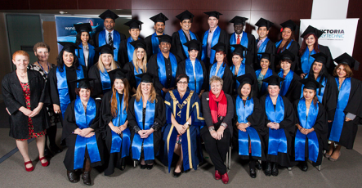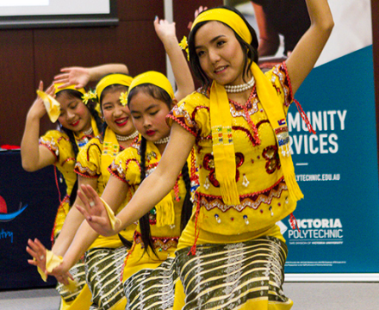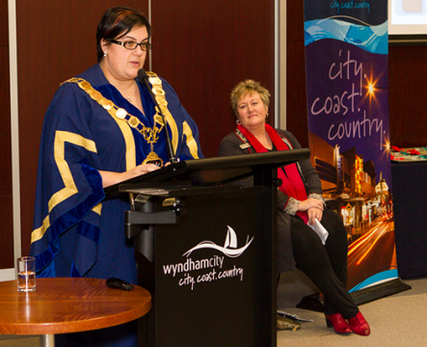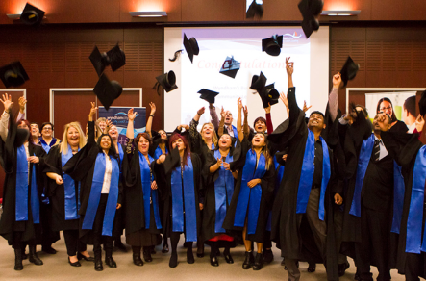

[](https://www.wyndham.vic.gov.au/residents/home/connect_with_us/socialmedia)

Graduation Ceremony

July, 2016