Planning and Environment Act 1987

WYNDHAM PLANNING SCHEME

AMENDMENT C267wynd

EXPLANATORY REPORT

Who is the planning authority?
This amendment has been prepared by the Wyndham City Council, which is the planning authority for this amendment.
The amendment has been made at the request of Wyndham City Council.

Land affected by the amendment
The amendment applies to current and future industrial zoned land within the City of Wyndham municipal boundary.

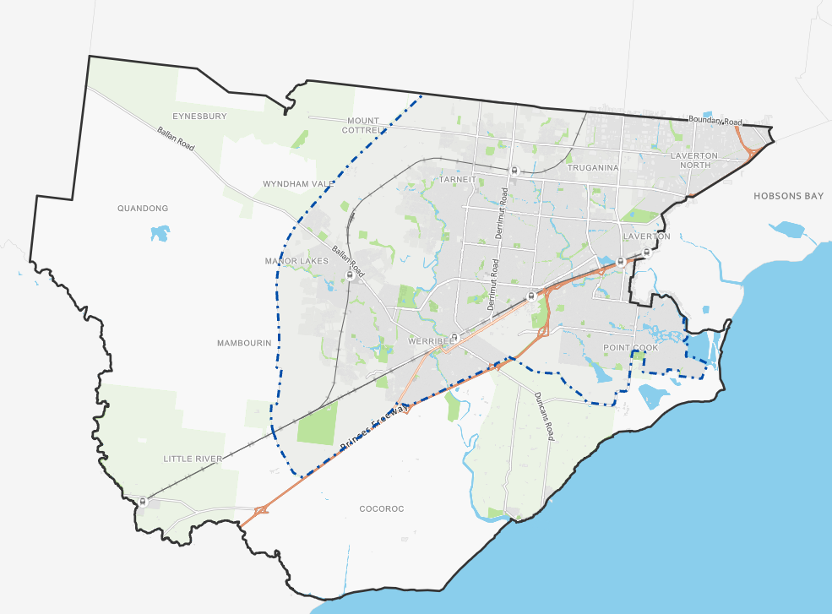

What the amendment does
The amendment will ensure that the Wyndham Industrial Land Use Strategy (WILUS) is considered in all future policy and strategic initiatives as a relevant background document and that the strategy objectives are reflected appropriately in local policy in the Wyndham Planning Scheme. This will enable Wyndham to effectively plan and meet the growing demand for industrial land and the economic and employment opportunities that this will provide. Specifically, the amendment will:

- Insert the Wyndham Industrial Land-Use Strategy 2022 (WILUS) into the Wyndham Planning Scheme as a background document in the Schedule to Clause 72.08.
- Amend the relevant sections of the Municipal Planning Strategy at Clause 02.03-7 and also at Clause 02.04 (Strategic Framework Plan) to include a new map showing the Wyndham City Industrial Precincts.
- Amend local planning policy at. Clause 17.03-1L to reference and align with the WILUS.
- Amend the Schedule to Clause 74.02 (Further Strategic Work) to include further strategic work as identified in the WILUS.

Strategic assessment of the amendment

Why is the amendment required?
The WILUS was formally adopted by Council on 25 October 2022. The WILUS is a strategic document that focuses on the use and development of industrial land over a 20 year period in Wyndham. The intent (vision) of the WILUS is that “Wyndham will provide serviced, accessible, and connected industrial land in appropriate locations to accommodate current and future demand and enhance employment and economic contributions both to Wyndham and Victoria. Our proactive approach to planning, together with our high amenity industrial areas designed with a focus on innovation and sustainability will attract a diverse range of industries and businesses.”

The strategy has been informed by extensive evidence-based research and background work focused on forecasting, feedback, modelling and trend analysis. The strategy uses this research and background information to facilitate the design and implementation of clear guidelines for ensuring that a sufficient supply of attractive, appropriately located industrial land capable of accommodating current and future demand is available.

The WILUS includes an implementation plan with the following objectives:

- To ensure that adequate industrial land will be provided for the next 20 years

- To protect core industrial areas from the encroachment of sensitive uses.

- To provide a planning framework which allows for clarity and certainty to attract more investments and employment to Wyndham

- To attract investment, support innovation and create jobs in Wyndham’s industrial areas.

- To enhance the appearance, environmental performance and connectivity of industrial areas in Wyndham.

- To ensure that the Wyndham Planning Scheme will reflect the changes recommended in this Strategy.

The overall intention of incorporating the WILUS into the Wyndham Planning Scheme is to further facilitate and encourage the provision of appropriately located industrial land that is well serviced, suitably connected and easily accessible. Stronger planning policy will enable Wyndham to effectively plan for and accommodate growth within the region and encourage the economic and employment opportunities that industry provides. Furthermore, the proposed inclusion of the WILUS as a background document will enable the strategic direction and objectives outlined in the WILUS to be considered.

How does the amendment implement the objectives of planning in Victoria?
The amendment supports of the objectives of planning in Victoria and is necessary to implement the following objectives:

- To provide for the fair, orderly, economic and sustainable use, and development of land.

How does the amendment address any environmental, social and economic effects?
The Amendment will have no adverse environmental effects. The Amendment could assist in the concentration of uses in preferred locations. It also makes planning for transport infrastructure and services more effective and reinforces rather than undermines preferred transport networks by encouraging the appropriate location of uses. The distribution of non-industrial uses into industrial precincts disperses activity in a manner that is counter-productive and will result in increased vehicular movements across the city adding to already significant levels of traffic congestion and emissions. The proposed amendment could assist in alleviating this. Furthermore, the proposed amendment will enable the better management, planning and protection of existing and future industrial land and will have a positive impact on job creation and diversity in the municipality.

Does the amendment address relevant bushfire risk?
No bushfire risk has been identified in relation to the proposed Amendment.

Does the amendment comply with the requirements of any Minister’s Direction applicable to the amendment?
Section 12(2)(a) of the Planning and Environment Act 1987 requires that in preparing a planning scheme amendment, a planning authority must have regard to the Minister’s Directions. The following Minister’s directions are relevant to this amendment:

Ministerial Direction – The Form and Content of Planning Schemes
The amendment is consistent with the Ministerial Direction on the Form and Content of Planning Schemes under section 7(5) of the Planning and Environment Act 1987.

Ministerial Direction No. 9 Metropolitan Strategy
The amendment is consistent with Ministerial Direction No.9 Metropolitan Strategy which seeks to ensure that planning scheme amendments have regard to the Metropolitan Planning Strategy. Plan Melbourne 2017-2050 seeks to provide a productive city that attracts investment, supports innovation and creates jobs.

The amendment supports the implementation of Plan Melbourne 2017-2050 by supporting the productive use of land and preventing further development of incompatible land uses within industrial precincts.

Direction No. 11 Strategic Assessment of Amendments
The amendment has been prepared having regard to Direction No. 11 Strategic Assessment of Amendments and Planning Practice Note 46: Strategic Assessment Guidelines.

Ministerial Direction No. 15 – The Planning Scheme Amendment Process
The amendment will be progressed in accordance with Ministerial Direction 15 that seeks to set times for completing steps in the planning scheme amendment process.

How does the amendment support or implement the Planning Policy Framework and any adopted State policy?
The amendment complies with the Planning Policy Framework, with note:

Melbourne Industrial and Commercial Land Use Plan (April 2020)
The Melbourne Industrial and Commercial Land Use Plan builds on the relevant policies and actions of Plan Melbourne 2017-2050 and its associated Plan Melbourne 2017-2050 Five-Year Implementation Plan. The Plan seeks to retain and protect land identified for strategic long-term growth for its intended purposes. It also seeks to ensure that industrial areas support their intended function and user needs.

The Western Industrial Precinct is recognised as a state significant industrial precinct. State significant Industrial precincts provide strategically located land for major industrial development links to the Principal Freight Network and transport gateways. The Melbourne Industrial and Commercial Land Use Plan outlines that they must be protected from incompatible land uses to allow for continual growth in freight, logistics and manufacturing investment.

Clause 17.03-1S (Industrial land supply)

The amendment supports the objective to ensure availability of land for industry. The amendment will introduce the WILUS as a background document which will further assist in implementing the following strategies:

- Provide an adequate supply of industrial land in appropriate locations including sufficient stocks of large sites for strategic investment.

- Protect and carefully plan existing industrial areas to, where possible, facilitate further industrial development.

- Preserve locally significant industrial land for industrial or employment generating uses, unless long-term demand for these uses can be demonstrably met elsewhere.

- Avoid approving non-industrial land uses that will prejudice the availability of land in identified industrial areas for future industrial use.

Clause 17.03-2S (Sustainable industry)

The amendment supports the objective to facilitate the sustainable operation of industry. The amendment will introduce the WILUS as a background document which will further assist in implementing the following strategies:

- Protect industrial activity in industrial zones from the encroachment of commercial, residential and other sensitive uses that would adversely affect industry viability.

Clause 17.03-3S (State significant industrial land)

State significant industrial land strategies include:

- Protect state significant industrial precincts from incompatible land uses to allow for future growth. State significant industrial precincts include but are not limited to:

- Western Industrial Precinct - Laverton North and Derrimut.

How does the amendment support or implement the Local Planning Policy, and specifically the Municipal Planning Strategy?
This amendment is consistent with the vision and strategic directions at Clause 02 of the Wyndham Planning Scheme, in particular:

Clause 02.02 (Vision)
The proposed amendment supports Wyndham City Council’s planning vision for a healthy, liveable city that:
- Is future-focused and plans for sustainable development.
- Consists of connected, vibrant neighbourhoods that provide for the cultural, social, economic and recreational needs of the community.

Clause 02.03-1 (Settlement)
This amendment supports the strategic directions around land use and development in urban growth areas, in particular:
- Protect industrial and residential activities from encroaching on each other.
- Providing jobs closer to where people live especially in the new employment corridor.

Clause 02.03-7 (Economic development – Industry)
The amendment proposes updates to clause 02.03-7 to reference and align with the Wyndham Industrial Land Use Strategy 2022.

Clause 02.04 (Strategic framework plan)

The amendment proposes to update clause 02.04 with the addition of Map 7 – Wyndham Industrial Precincts.

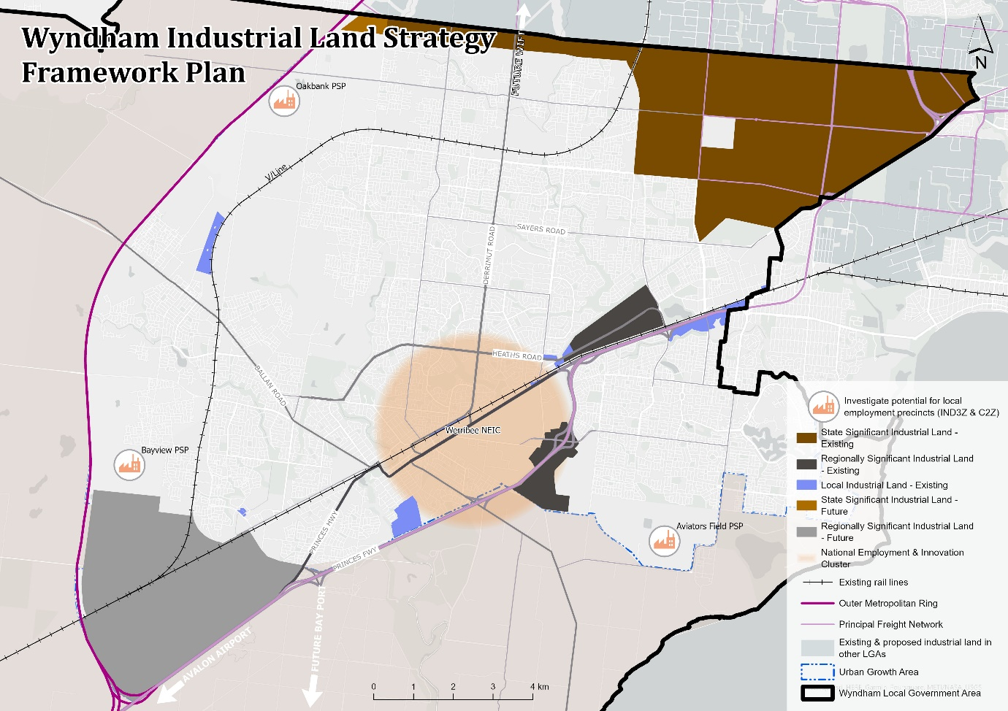

Clause 17.03-1L (Industrial land supply)

The amendment proposes updates to clause 17.03-1L to reference and align with the Wyndham Industrial Land Use Strategy 2022.

Note: it is proposed that the following existing strategy is deleted from the clause 17.03-1L so as not to detract from all the other viable industrial precincts available within the municipality:

‘Promote Laverton North as the preferred location for industrial uses’

Does the amendment make proper use of the Victoria Planning Provisions?
Updating the schedule to clause 72.08 (background documents) to include the Wyndham Industrial Land Use Strategy (WILUS) is the appropriate mechanism to ensure that the WILUS is a background document in the Wyndham Planning Scheme.

How does the amendment address the views of any relevant agency?
Given that the proposed amendment is for the incorporation of a land-use strategy that is relatively policy neutral as a background document within the Wyndham Planning Scheme, it is not considered that there are any relevant agencies. However, the views of the DTP will be taken into consideration throughout the Amendment process.

Does the amendment address relevant requirements of the Transport Integration Act 2010?
The Amendment is not anticipated to have a significant impact on the transport system as it will not modify the physical, service, labour or management components of the existing system.

Resource and administrative costs

What impact will the new planning provisions have on the resource and administrative costs of the responsible authority?

The proposed Amendment will have minimal impact on Council’s resource and administrative costs. The proposed Amendment is not expected to increase the number of planning applications within the municipality to a significant extent. No additional staff resources will be required because of the implementation of this Amendment.

Where you may inspect this amendment
The amendment can be inspected free of charge at the Wyndham City Council website at [https://www.wyndham.vic.gov.au/]

The amendment is available for public inspection, free of charge, during office hours at the following places:
Wyndham City Council
Civic Centre
45 Princes Highway
Werribee VIC 3030

The amendment can also be inspected free of charge at the Department of Transport and Planning website at www.planning.vic.gov.au/public-inspection or by contacting 1800 789 386 to arrange a time to view the amendment documentation.

Submissions
Any person who may be affected by the amendment may make a submission to the planning authority. Submissions about the amendment must be received by Sunday 3 March 2024.

A submission must be sent to:

Wyndham City Council
Strategic Planning Department
Civic Centre
45 Princes Highway
Werribee VIC 3030

OR
mail@wyndham.vic.gov.au

Panel hearing dates
In accordance with clause 4(2) of Ministerial Direction No.15 the following panel hearing dates have been set for this amendment:

- directions hearing: 3 June 2024
- panel hearing: 1 July 2024

