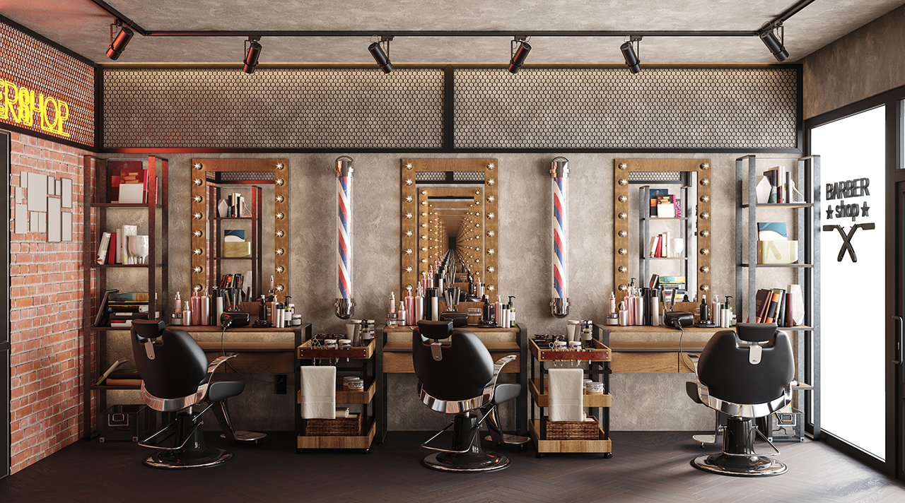
2023-24

Beauty Premises Application Form

Starting a beauty business
What permits do I need?
If you are starting a new beauty business or buying an existing beauty business, you will need to obtain certain permits from Wyndham City Council before you commence trading. Anyone undertaking any beauty treatments needs to be registered with their local Council under the Public Health and Wellbeing Act 2008.
You may also require permits from Town Planning and Building in addition to a Public Health and Wellbeing Act 2008 registration with the Public and Environmental Health Unit. Our Small Business Support Officer will assist you in determining whether you require permits from these departments.
Is this form right for me?
If you are operating a beauty therapy business either from home or from a commercial store, use this form. Hair, beauty and skin penetration businesses must be registered with their local Council. This includes, but is not limited to; hairdressing, makeup application, hair removal, facials, tattooing, piercing, skin needling, colonic irrigation, scarification and so forth.
If you are undertaking cosmetic injectables, massage, or are a Chinese Medicine practitioner this form is not right for you. Contact our Small Business Support Officer or your registering body for further information.
Lodging your application
By email | In person | By mail
mail@wyndham.vic.gov.au | Wyndham City Council  45 Princes Hwy  Werribee VIC 3030  8.00am to 4.00pm Monday to Friday | P.O Box 197  Werribee VIC 3030
If you need assistance, please call 1300 023 411 to speak with a Small Business Support Officer.
Next steps
Our Small Business Support Officer will review your application and advise if we need further information.
Once your application is lodged, we will send you an invoice for the registration fees. A fee schedule is attached at the end of this form for your reference.
An Environmental Health Officer will contact you to book an initial site inspection within 10 working days after fee payment. If your premises is compliant upon inspection, your registration will be granted until the expiry date on the certificate. Yearly renewal fees and inspections will be applicable.
Your details
Applicant details
Is the applicant completing this form as the business owner, or are you completing the application on behalf of the owner? | ☐ Business owner  ☐ On behalf of owner  Insert role title:
Title
First Name(s)
Surname
Phone Number
Mobile Number
Email Address
Postal Address
Business owner details (if different to above)
Title
First Name(s)
Surname
Phone Number
Mobile Number
Email Address
Postal Address
Business details
Company name (if applicable)
(Please include Pty Ltd.)
Beauty Business Trading Name
(Name of the shop)
Beauty Business Trading Address
(Address of business)
Australian Business Number (ABN)
(ABN must be provided if applicable)
Australian Company Number (ACN)
(ACN must be provided if applicable)
Primary language spoken at business
Expected date for business to start operating
Anticipated operating hours
Secondary contact
if different to listed Business Owner
Title
First Name(s)
Surname
Phone Number
Mobile Number
Email Address
Declaration
I understand and acknowledge that the information provided in this application is true and complete to the best of my knowledge.
Business Owner name | Signature | Date
Applicant name | Signature | Date

Transferring a beauty business
Are you buying an existing registered beauty business and are looking to transfer their registration into your name? The current business owner must complete this section to confirm the transfer. To transfer a business successfully, you must submit the details of the current business owner (or owners if there is more than one), their signature and the proposed date of settlement.
Note: Low-risk businesses cannot be transferred as they require the proprietor to have a one-off, ongoing registration.

Current business owner details | Business owner #1 | Business owner #2
Title
First name(s)
Surname
Company Name
(must include Pty Ltd)
Business trading name
(Name of the shop)
Trading Address
(Address of the shop)
Current registration number (e.g. HLHBXXXX/XX)

By signing the declaration below, I provide authority and consent for Wyndham City Council to disclose business details, information and documents to the applicant.
Declaration
Print business owner name/Company Name |  | Signature | Date
Print business owner/director of company name |  | Signature | Date
The application to transfer a registration must be submitted 15 business days prior to settlement.
Proposed settlement date
Risk classification & fees
RISK GROUP | EXAMPLES (NOT LIMITED TO) | TICK | FEE (for new businesses a pro-rata fee may apply.)
Low Risk | Hairdresser/barber | ☐ | $324 compulsory non-refundable plan assessment fee  +  $402 ongoing registration fee
 | Makeup – applications of cosmetics that does not involve skin penetration or tattooing | ☐
 | Spray tans | ☐
 | Facials (steaming and cream application) | ☐
 | Eyebrow tinting | ☐
Medium Risk | Hair removal (waxing, threading, epilation, laser hair removal) | ☐ | $324 compulsory non-refundable plan assessment fee  +  $144 new registration fee  or;  $299 registration transfer fee
 | Laser tattoo removal | ☐
 | Eyelash tinting | ☐
 | Eyelash extensions | ☐
 | Microdermabrasion | ☐
 | Manicures/pedicures | ☐
 | Ear piercing with a gun only | ☐
High Risk | Body piercing or other skin penetration procedures including skin needling | ☐ | $324 compulsory non-refundable plan assessment fee  +  $419 new registration fee  or;  $299 registration transfer fee
 | Tattooing, including permanent or semi-permanent makeup or cosmetic tattooing | ☐
 | Dry needling | ☐
 | Colonic irrigation | ☐
 | Electrolysis | ☐
Other treatments (fee TBD):
Is your business a mobile business? Yes ☐ No ☐
Note: Medium and high-risk businesses are not permitted to perform mobile procedures.

Floor plans
I have included floor plans with my application form.  A formal assessment response of these plans will be provided by Wyndham City Council’s Public and Environmental Health Unit. The below areas within your site plan must be clearly labelled and shown. If these are not shown on your plans, assessment of your application may be delayed. Note: For mobile businesses, please attach a detailed plan of your business proposal including equipment storage and cleaning processes.  Floor plans to show:  - Surface finishes of all walls, floors, ceilings, and work areas – e.g., white tiles, gloss paint of light colour, stainless steel, floor coving.  - Handwash basins (required in each room and each area).  - Equipment washing sinks.  - Hair wash basins.  - Treatment/nail tables.  - Treatment chairs.  - Toilet/vanity areas.  - Sharps disposal location.  - Equipment storage area.  - Chemical storage area.  - Lighting.  - Shelving. | ☐
Disclaimer – Wyndham City Council will only use the personal information you provide in or with this form for matters relating to your registration in accordance with the information Privacy Act 2001 (Vic) and Wyndham City Council Privacy Policy

Further requirements

