Instructions
joining online programs using teams

STEP 1
To join the meeting click on the link sent in your reminder.

STEP 2
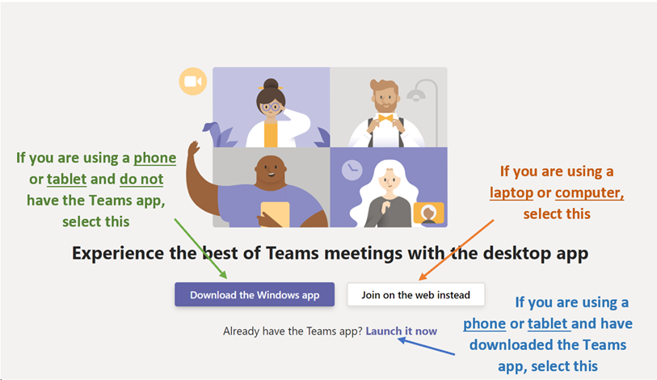
After clicking on the link, you will then be asked how you want to enter Microsoft Teams. Follow the instructions on your screen. See the guides below to help you join the chat:
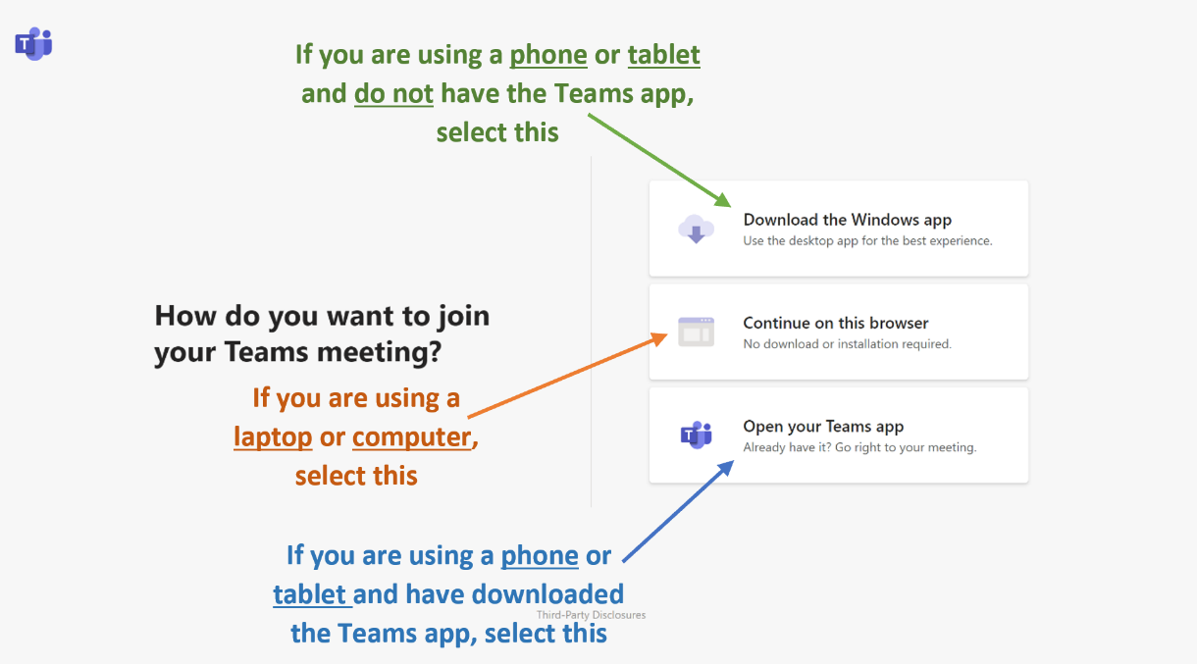
STEP 3
Once you have made your selections, a page like this will appear where you can choose your microphone and camera settings and join the meeting:
