Water Quality Treatment Asset Plans
Engineering design plans for water quality treatment assets are required to be prepared and lodged to Wyndham City for all large scale subdivisions in accordance with the relevant planning permit condition(s).
In order to obtain Council approval, complete the following application form and submit it together with all the necessary supporting documentation to subdiveng@wyndham.vic.gov.au. Alternatively, you may use Objective Connect.

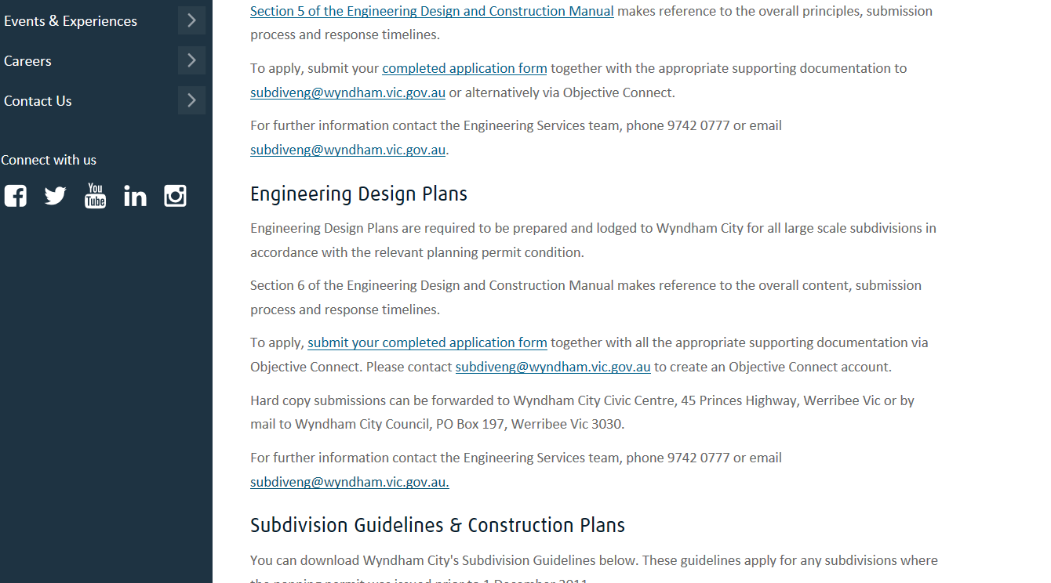
Insert paragraph here

