1 Bronzewing Street

Responsibilities & Access

**Storm Water Pipes & Easements**

**Wyndham City Council - Storm water pipes and easements - Responsibilities and access**

## The drainage network

The drainage network takes storm water flows away from private property into waterways with minimal impact on residents and roadways. There are times of extreme rainfall when underground drains are not adequate for the high demand. During these times, roads are designed to act as floodways.

Each property is allocated with a location in the network to which the property’s stormwater drainage should be directed. Typically this location will be in a Council underground drain or in the channel of the adjacent road. This discharge location is known as the legal point of discharge. The property stormwater pipe drainage belongs to the owner of the property. All drainage issues beyond this point are the responsibility of either the local government or the regional drainage authority.

## Council’s responsibilities

Wyndham City Council is a designated drainage authority along with Melbourne Water and has responsibilities conferred on it by state legislation. Illustration 1, below, shows an extract from the Local Government Act relating to Councils functions and powers for drainage.

**Illustration 1 – An extract from the Local Government Act**

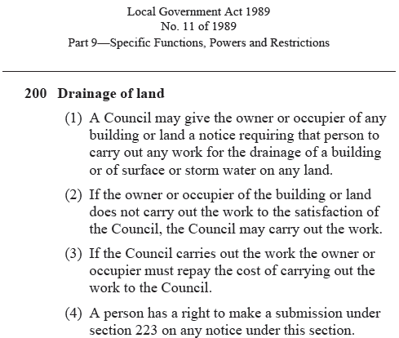

Council is responsible for the care and maintenance of the local public storm water drainage network including pipes and pits. This does not include property stormwater drainage pipes connecting to the legal point of discharge.

Any problem with drainage downstream of the Legal Point of Discharge can be reported to Wyndham City Council on (03) 9742 0777 or by using the Submit a Customer Service Request Page, which is accessible on <http://www.wyndham.vic.gov.au/residents/home/submit_request>

Wyndham City Council will either respond directly or refer the query to the appropriate authority.

Drainage sewers are the responsibility of City West Water. Faults and emergencies with sewers should be reported to City West Water on 132642. Further information is available on https://www.citywestwater.com.au/contact_us.aspx)

## Property Owners responsibilities

All drain’s related to the drainage of private properties up to and including connection to the legal point of discharge is the responsibility of the property owner. This responsibility holds no matter what property that drain is in. This includes a neighbour’s easement and the adjacent road reserve. Illustration 2, below, shows different responsibilities.

It is the property owner’s responsibility to ensure that the property’s drainage is maintained and operational and that the property’s storm water runoff does not adversely affect other properties.

It is recommended that a licensed plumber be engaged to resolve property drain issues. Should this require works outside the property in the road reserve then Council consent is required. This can be applied for at the Civic Centre, 45 Princes Highway, Werribee.

Where the property includes an easement, the property owner has responsibilities in that easement.

## Easements

An easement is a section of land registered on the property title that gives Council or service authorities right of access to this land. An easement may have a storm water drain, pits, a sewer or other services in it. A title search of the property should reveal easements and relevant authorities. Searches for *“easement”* on City West Water’s and Wyndham City Council’s web sites reveal related topics.

Council or the relevant service authority is entitled to access the easement to repair infrastructure, perform inspections or do other work.

Access must not be blocked by the property owner. Anything planted or constructed over the easement or covering easement pits is the responsibility of the property owner. Should access to the infrastructure in easements require removal or relocation of property items then all works associated with the removal, relocation, reinstallation will be at property owner’s expense.

Wyndham City Council will give at least two weeks’ notice to property when access is required. This allows time for the removal of items restricting or preventing access. This two weeks’ notice will not be applicable in cases of emergencies. If access is refused at the end of the notice period Wyndham City Council has the right to engage in a formal process for access and associated costs may be payable by property owner.

**Illustration 2 – Properties, Drains and Responsibilities**

