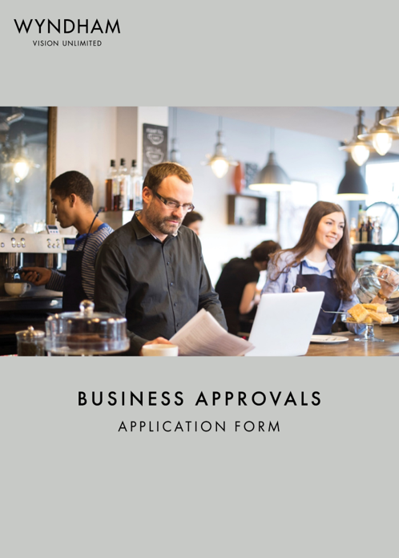
FOOD BUSINESSES

Receiving approval from Council to open your business.
If you are starting a new business or buying an existing business, you may need to obtain certain permits from Wyndham City Council before you commence trading.

Once you have lodged this application form, it will be forwarded to the relevant business units for review/assessment as required and you may be contacted by them for more information.

How to lodge your application

By email | In person | By mail
mail@wyndham.vic.gov.au | Wyndham City Council  45 Princes Hwy  Werribee VIC 3030  9:00am to 4:00pm Monday to Friday | P.O Box 197  Werribee VIC 3030

If you need to speak with someone from the Small Business Permits Team, please call 03 8734 4579

Fees and payment methods
A fee schedule is attached at the end of this form.
Once your application is lodged, we will send you an invoice for the fees. Payment options will be included on the invoice.

Register a fixed-location food business.

Opening a food-related business, you will need to register your premises. For a fixed-location food business (including home-based premises), please complete this form.
- For a temporary or mobile premises, you need to apply for a permit using: https://foodtrader.vic.gov.au/
- If your business primarily involves the manufacturing or production of dairy, red meat, poultry, or seafood, you will need to register your business with Dairy Food Safety Victoria (dairysafe.vic.gov.au) or PrimeSafe (primesafe.vic.gov.au) instead of Council.

1-Steps to applying for a registration

Application process
Step 1: Submit application and relevant documentation.

Step 2: Councils, Small Business Liaison Officer, will review the application and advise if you need any additional permit or registration.

Step3: Public and Environmental Health team will lodge your application in our system,

Councils Public and Environmental Health team will contact you for payment.
Step 4: After payment has cleared it will be referred to a Environmental Health Officer (EHO) who will contact you to arrange a time to inspect.

Step 5: After inspection/s and the EHO is satisfied the premises is suitable to open a Certificate of Registration will be posted out to the nominated address.

All fields in the next section must be completed.
Please submit your personal details and the details of your business.

1 - Applicant Details
Applicant Details | Business Owner(s)/company
Is the applicant completing this form as the business owner, or are you completing the application on behalf of the owner? | ☐ Business owner  ☐ On behalf of owner  Insert role title:
Title
First Name(s)
Surname
Phone Number
Mobile Number
Email Address
Postal Address
Business owner details
Title
First Name(s)/ Company name
(Please include Pty Ltd.)
Surname
Phone Number
Mobile Number
Email Address
Postal Address
Business Details
Food Business Trading Name
(Name of the shop)
Food Business Trading Address
(Address of business)
Do you intend to also operate a mobile business? | ☐ Yes ☐ No  (If yes please also complete an online application on Food Trader https://foodtrader.vic.gov.au/ )
Australian Business Number (ABN)
(ABN must be provided to progress application)
Australian Company Number (ACN)
(ACN must be provided to progress application)
Primary language spoken at business
Expected date for business to start operating
Anticipated operating hours
Secondary contact
if different to listed Business Owner
Title
First Name(s)
Surname
Phone Number
Mobile Number
Email Address
Declaration
I understand and acknowledge that the information provided in this application is true and complete to the best of my knowledge.
Business Owner name | Signature | Date
Primary Contact name | Signature | Date

2 - Checklist of documents to include with application:

Checklist
☐ | Select class of food from fee schedule (pages 8 & 9)  Classes of food are based on the type of foods you are preparing, supplying, and selling.  If you are not sure of your class, please discuss with the Small Business Liaison Officer or Public and Environmental Health Team.
☐ | Food Safety Supervisors Certificate: Food Safety Supervisors Certificate complete with relevant codes.  Class 1 and 2 food businesses require at least one person who has completed food safety supervisor training.  If you are required to have a nominated Food Safety Supervisor; then you must submit a copy of their certificate of competency to Council PRIOR to commencing trading. Some businesses are exempt from nominating a Food Safety Supervisor. To find out more, see information about Food Safety Supervisors on the DHHS website: Food Safety Supervisor Training
☐ | Trade Wastewater Agreement/Consent: Trade Wastewater Agreement/Consent letter. See Trade waste Consent information on page 7 of this form.
☐ | Floor Plan: Premises floor plans, drawn to scale with dimensions and showing every part of the premise including yards and outbuildings.  - Indicate specific use/work processes to be carried out in each room or part of establishment.  - Include the location and type of all fittings and fixtures, surface finishes, furniture, shelving, benches, etc.  - Specify the finishes of walls, floors, ceiling, benches, shelves, splash backs throughout the premises.  - Indicate the location and proposed use of sinks and basins throughout the premises.  Note: Plans may differ from plans submitted to Town Planning/Building
☐ | I would like a formal assessment of plans and agree to the additional fee/time involved.  A formal assessment will review your plans and provide written advice on the suitability of your layout and fit out of your premises to meet the requirements of the Food Act 1984 and Australian and New Zealand Food Standards Code.  And additional fee of $400 will be required and may take and additional 10 working days.
☐ | I have attached full floor plans to enable a formal assessment of plans to be undertaken – plans must be included with application to progress.
Please provide the floor area of the premises. _______m²
Please describe the type of business you are proposing to operate e.g. café, restaurant, bar, manufacturer, etc. Indicate the types of food/drinks you intend to prepare/sell at the food premises. Please include a copy of proposed menu if available.

CLASS 1 AND 2 PREMISES ONLY
Name of Food Safety Supervisor
☐ I confirm I have submitted a copy of the food safety supervisor’s certificate with this application.

Food Safety Program (FSP) Declaration

☐ Department of Health Class 2 Food Smart Food Safety Program
- https://www.foodsmart.vic.gov.au/en
☐ Non-Standard Food Safety Program (Independent FSP) – Requires annual third-party audit

All Class 1 businesses must have an independent Food Safety Program.

Sale or consumption of liquor
If you plan on selling liquor at your food business, please contact Council’s Town Planning Department to discuss any further approvals that may be required.

Trade waste consent
Whether your business is food related or industrial or other, you may be creating some form of wastewater (or trade waste) that needs to be treated before it can be discharged to the sewer network. Different types of businesses will have different trade waste responsibilities covered by different consent agreements between your business and Greater Western Water.

All food related businesses will need to provide a copy of this consent to Wyndham Council upon applying for a fixed location and mobile food premises permit.

For more information visit the Greater Western Water website, or for clarification specific to your business, contact Greater Western Water: by phone on 13 44 99, or via email: tradewaste@gww.com.au.

4 – Fee Schedule

 | Class | Description | Examples include (but not limited to) | Fees
 |  |  |  | New business Note: For new businesses a pro-rata fee may apply.
☐ | Class 1 | Food being prepared or served exclusively for vulnerable groups. | ☐ Aged care service  ☐ Hospital  ☐ Childcare  ☐ Meals on wheels service | $1373
☐ | Class 2 | Food premises selling or handling unpackaged food requiring temperature control. | ☐ Cafés, delis, take-away premises, restaurants.  ☐ Home business manufacturing high risk products that require refrigeration such as cakes containing cream, custard, homemade ganache  ☐ Community group – food cooked, refrigerated and then re-heated or food served does not involve a kill step such as home-made mayonnaise - non-profit, all food handlers are volunteers.  ☐ Supermarket or manufacturer  ☐ Sporting club - no restaurant or gaming - not for profit community groups such as volunteer run school canteens  ☐ Other food business handling unpackaged high-risk food | $1418  $728  No fee  $2979  $161  $1418
☐ | Class 3 | Food premises selling or handling unpackaged food that does not require temperate control and/or pre-packaged food requiring temperature control | ☐ Greengrocer that only sells cut fruit, vegetables and/or packaged food.  ☒ Home business selling low risk baked products that do not require refrigeration such as cakes without cream, custard.  ☐ Wholesaler / distributor / importer of food - food is sold to other food businesses.  ☐ Sporting club - No restaurant or gaming - not for profit community groups such as volunteer run school canteens  ☐ Community group – cooked on site and served immediately - non-profit, all food handlers are volunteers.  ☐ Other food business that:  - Handles pre-packaged food that requires temperature control and/or,  - Handles un-packaged food that does not require temperature control and/or,  - Re-package food that does not require temperature control. | $1030  $502  $1815  $161  No fee  $1030
 | Class 3A | Food premises selling or handling unpackaged food that does require temperate control and/or pre-packaged food requiring temperature control | ☐ Home business selling low risk baked products that do not require refrigeration such as cakes without cream, custard.  ☐ Other food business that:  - Preparation and/or cooking of potentially hazardous foods which are served to guests for immediate consumption at an accommodation getaway premises.  - Food is made using a hot-fill process resulting in a product such as chutney, relish, salsa, tomato sauce or any other similar food | $502  $1030
☐ | Class 4 | Activities considered to be very low risk such as the sale of shelf stable pre-packaged foods, sale of uncut fruit and vegetables, and fundraising activities. | ☐Pre-packaged low risk food such as confectionery, crisps, frozen ice cream, bottled drinks. For example, newsagents, pharmacies, video stores and some milk bars; or  ☐ The sale to members of the public or the wholesale of whole (uncut) fruit or vegetables; or the handling of low risk food or cut fruit or vegetables and the serving of that food to children at a sessional children's service.  ☐ The serving of coffee, tea (with or without milk, soy, almond or any other liquid), alcohol (including the addition of sliced fruit, pasteurised dairy products), water, soft drink (except fermented soft drinks containing a live culture) intended for immediate consumption but does not include unpasteurised processed fruit or vegetables (for example, fresh juice) or any drink which has any other potentially hazardous food added, such as unpasteurised egg. | No fee

